**Competitive Position**

Bharti Airtel holds a dominant position in the telecom industry worldwide. It is the second-largest mobile network in the world and is currently the second-largest operator in India holding a market share of 28.35% compared to the largest operator Reliance Jio which holds a market share of 32.99% as of data obtained in February 2020. Airtel has been able to achieve profits by outsourcing most of its business operations and focusing heavily on marketing, sales, and finance and focusing on a ‘minutes factory’ model which helps in maximizing profits by offering its services at very low cost in order to attract and retain customers.

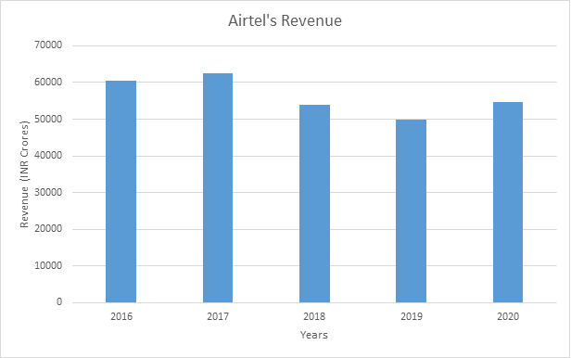

Exhibit 1: Airtel’s Revenue for the past five years [2016–2020]

Some of the major competitors of Airtel in the telecom industry are Reliance Jio, Vodafone Idea (Now Viu from their merger in 2018). Apart from telecom services, Airtel also offers services such as fixed-line services, high-speed broadband, DTH, and enterprise services such as long-distance services to carriers. The threat of new entrants is low as Bharti Airtel has established trust among the consumers since its long-term provision of services, and its effective marketing strategies which make any new entrant difficult to compete even if they aim to offer low-cost services.

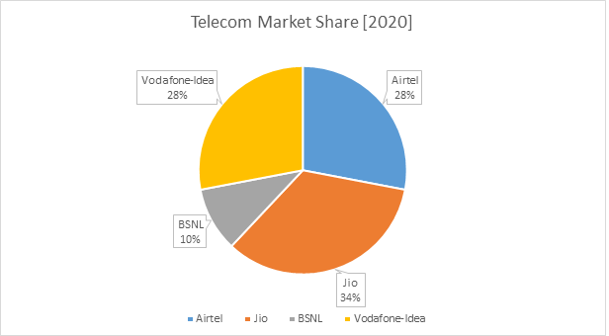

Exhibit 2: Airtel’s market share in the year 2020

**Key Factors for Airtel’s Competitive Position**

Rich brand heritage has been one of the major reasons for the success of Bharti Airtel. Established in 1995, the company has made use of innovative and well-designed marketing strategies for selling its services. It has tied up with some of the major players in the telecom field for its hardware and outsources most of its intermediate tasks. Bharti Airtel also owns a lot of the transmission towers throughout the country, which has helped it reduce costs on intermediaries for their cellular networks. By following an innovative business model where the consumers pay on the basis of their usage, gives Airtel the ability to offer low prices to the people and yet achieve growth in its revenue. Airtel takes advantage of being one of the earlies telecom networks in India, and its ability to provide telecom services at extremely low cost.

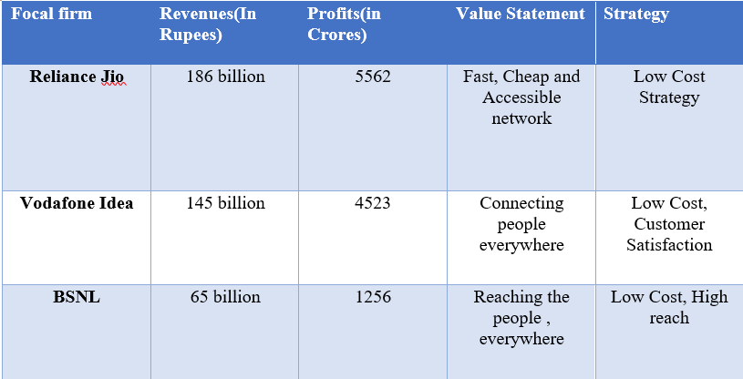

Exhibit 3: Analysis of Airtel’s Competitors

By being an early mover to the telecom industry, and by outsourcing its significant tasks, Airtel has been able to advance faster compared to other telecom companies with its full focus on marketing and sales to drive its revenue. Airtel holds a lot of licenses over transmission towers in India and other countries, which prohibits new entrants from just entering and stealing market share. Further, Airtel holds committed contracts with some of the major players in the field of telecom hardware, and over time, has been able to achieve a high position in the learning curve. This has allowed Airtel to achieve more success compared to its competitors and roll-out features much faster than its competitors. In fact, this can be seen when Airtel was the first network provider in India to roll out 4G in 2015, which enabled Airtel to get more subscribers. A complete and detailed analysis of the industry has been provided using the Five Forces Analysis below.

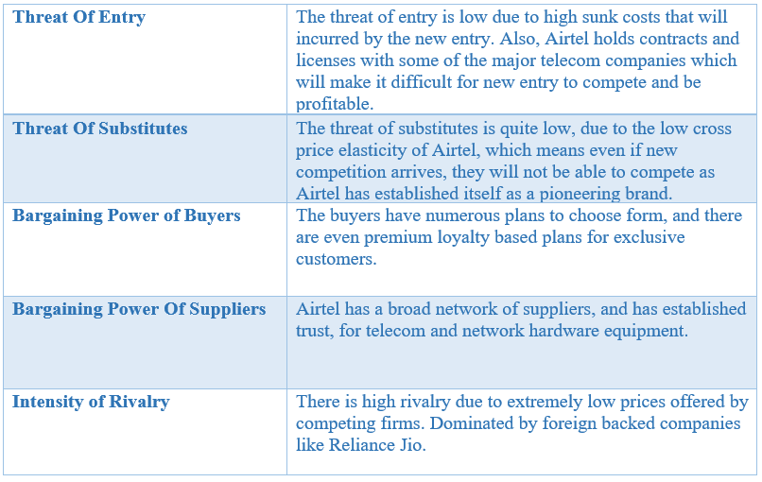

Exhibit 4: Five Forces Analysis

**Airtel’s Capabilities**

Airtel’s competitive position and assets allow it to offer extremely low prices to the consumers which help in reducing the threat of new entry, and also has a very low cross-price elasticity because of its ability to offer services, that can’t be offered with the same level of performance by its competitors6. Also, because of its commitments with several other companies, they have high switching costs which help Airtel to stay in the market and fight for share. With limited options in the telecom market, Airtel has a competitive advantage in order to capture the maximum subscriber base with its low-cost strategy. Airtel’s alliances with some of the major telecom equipment providers and its customer loyalty programs have allowed Airtel to stay ahead of its competitors. Airtel’s diverse pool of talent focusing on the commerce perspective such as marketing and sales has been a critical factor in Airtel’s success and growth. Airtel’s relationships with its partners allow Airtel to rollout major features with great ease compared to other telecom companies.

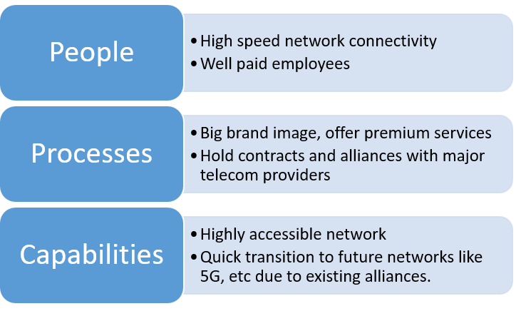

Exhibit 5: Analysis of Airtel’s Capabilities

**Airtel’s war with Jio**

Even though Airtel has held a very high competitive position in the following years, it is beginning to lose its market share to Reliance Jio telecommunications due to the extremely low prices offered by Jio due to large capital injected by the founder, and external investors. Jio has been able to capture a very large market segment due to its extremely low prices and its marketing strategies. With the large foreign investment, Jio has also been able to achieve a very large economy of scale over a very short period exclusively because of its foreign investments of over 30 billion USD.

**Conclusion**

Airtel has a competitive advantage mainly because of its rich brand heritage and its early entry into the telecom market. However, with new entrants like Jio who have a wide array of foreign investments and capital ready to spend, Airtel’s competitive position might be at risk. Unless Airtel manages to offer faster and broader connectivity than its competitors, it will be hard for Airtel to sustain its competitive position. Hence, Airtel must invest in R&D and marketing in order to drive future growth.

**References**

[1]<https://www.ibef.org/industry/telecommunications.aspx#:~:text=Gross%20revenue%20of%20the%20telecom,creating%20opportunities%20for%20new%20businesses>.

[2] <https://www.financialexpress.com/industry/bharti-airtel-overtakes-vodafone-idea-to-become-second-largest-telco-in-terms-of-subscribers/2007984/#:~:text=As%20in%20February%202020%2C%20Reliance,BSNL's%20share%20increased%20to%2010.32%25>.

[3] <https://www.airtel.in/about-bharti/equity>

[4] <https://www.siliconindia.com/shownews/bharti-airtels-success-secret-reverse-innovation-nid-67942-cid-7.html>

[5] <https://www.businessinsider.in/small-business/companies/bharti-airtel-success-story/slidelist/53681519.cms#slideid=53681390>

[6] <https://m.economictimes.com/c/cross-elasticity-of-demand/articleshow/19340205.cms>

[7] <https://www.airtel.in/press-release/06-2020/airtel-promises-to-go-the-extra-mile-for-its-customers>

[8] <https://marker.medium.com/how-jio-became-the-darling-of-silicon-valley-4ad5aab7949f>

[9] <https://economictimes.indiatimes.com/bharti-airtel-ltd/yearly/companyid-2718.cms>

[10] <https://www.airtel.in/airtel-annual-report-2016-17/financial-highlights.html>

[11] <https://www.airtel.in/airtel-annual-report-2016-17/product-wise-performance.html>