**Create a Physical Schema**

The following instructions and screen shots will enable the student to create a physical schema from a Physical ERD. We will use as a tutorial example the Physical Schema Model as shown below

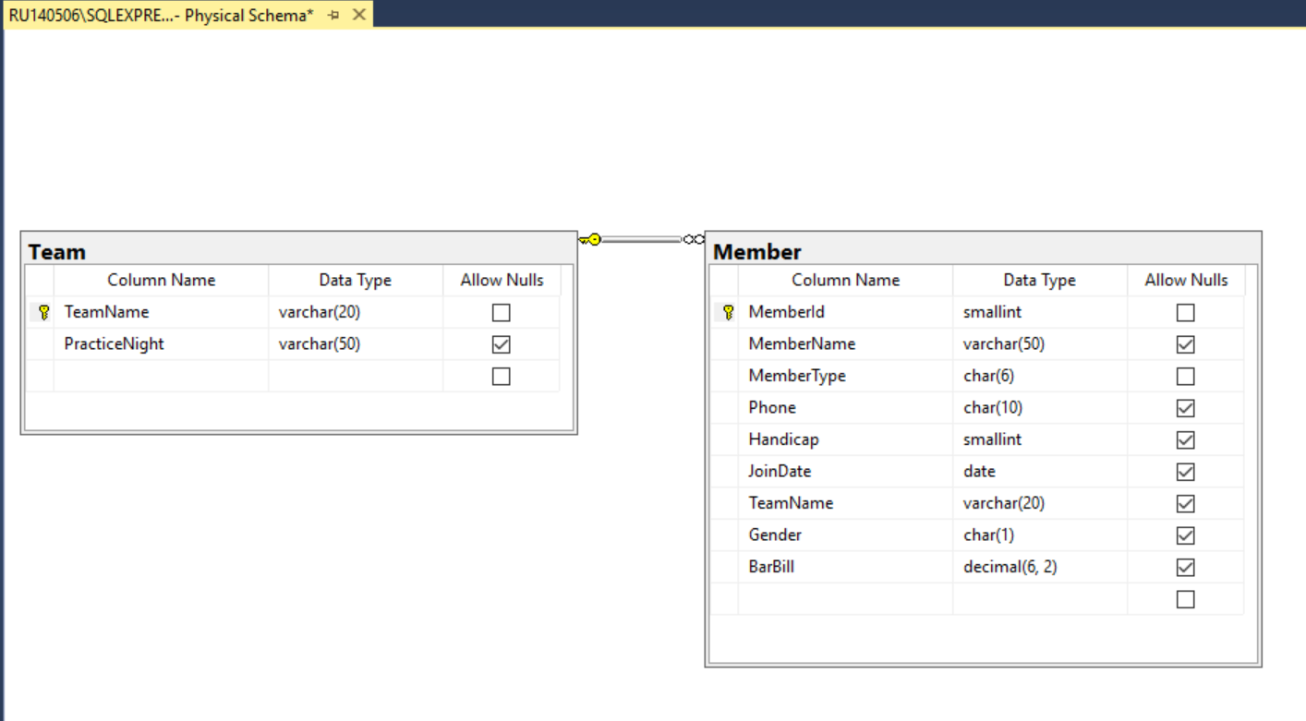

With the SQL Server Management Studio loaded select the “Databases” directory and right mouse click to open the short cut menu. Click on “New Database”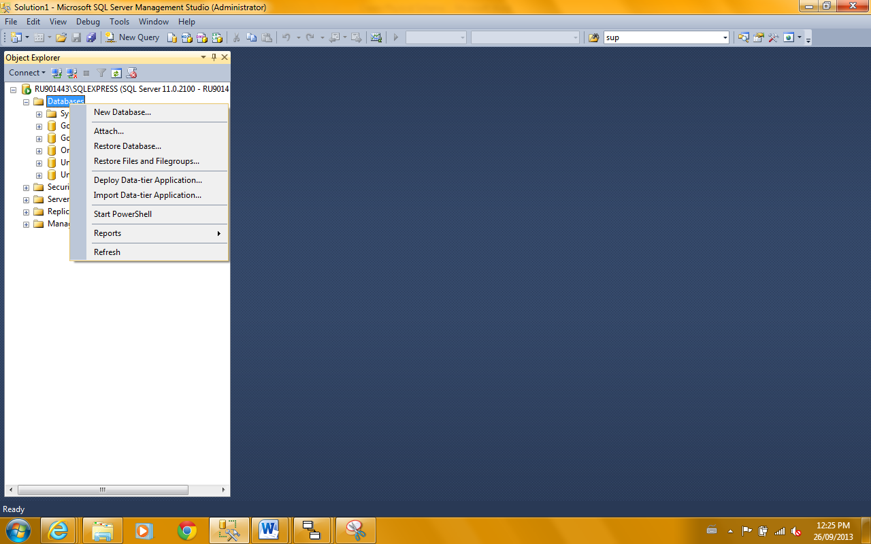

The following screen should appear.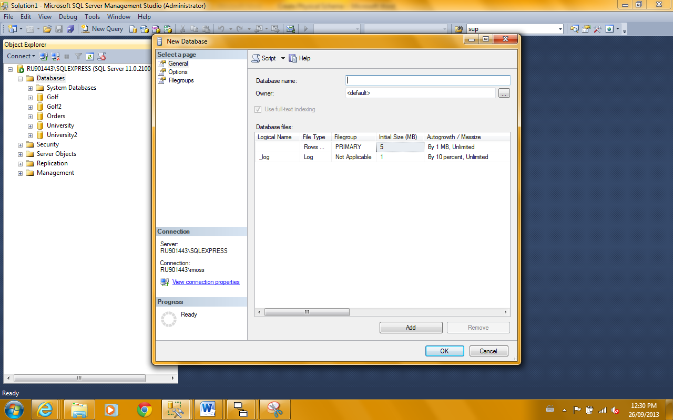

1. Enter the name for the Database name: “Module 7 Tutorial”.
2. Then change the Owner from <default> to sa. This stands for system administrator.
3. Then using the horizontal scroll bar, scroll until the file browser button is visible (the small grey shaded quasi rectangle with the ellipses)

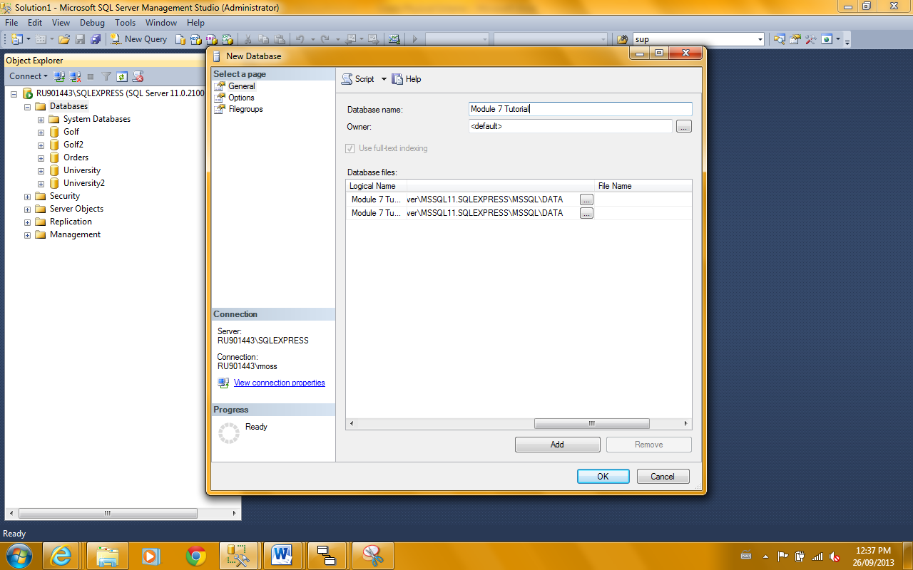

We now want to relocate where the new database files will be created (the files with the mdf and ldf extensions). If we do not change the directory they will be created deep in the SQL directory structure and may be hard then to relocate for copying and moving. I have already set up a directory on my C: drive to receive the files. You will need a similar pre-defined location.

(Note: If you are creating the DB in TMU labs then DON’T change the directory setting because this is the only place where you can access the DB files later.

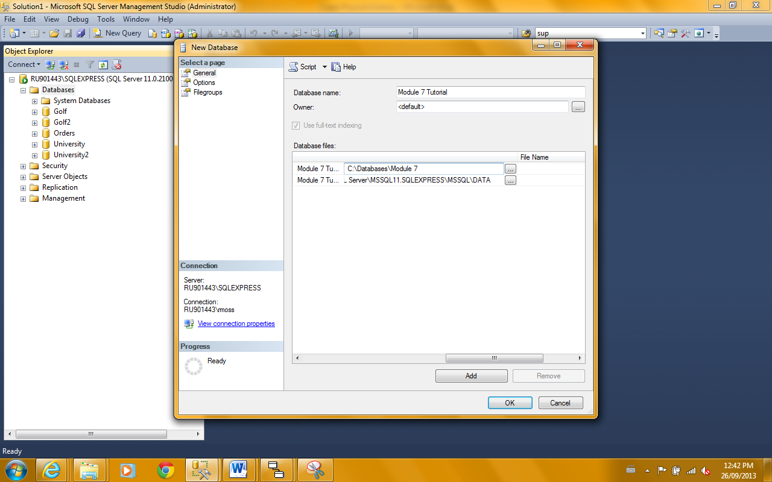

Both files will need to be set up. Using the browser button I have changed the directory for just 1 file so far. When both have been changed all other default parameters for the new database can be accepted and you can click OK.

The new database should now be shown in your Databases directory. If it does not appear try right mouse click on “Databases” and “Refresh”.

1. We now have an empty database. Before we proceed to start creating the tables there is a default setting that should be changed to facilitate our ability to make subsequent corrections and changes to our design input.

From the “Tools” menu entry select “Options” and then click on “Designers”. The following screen should be visible.

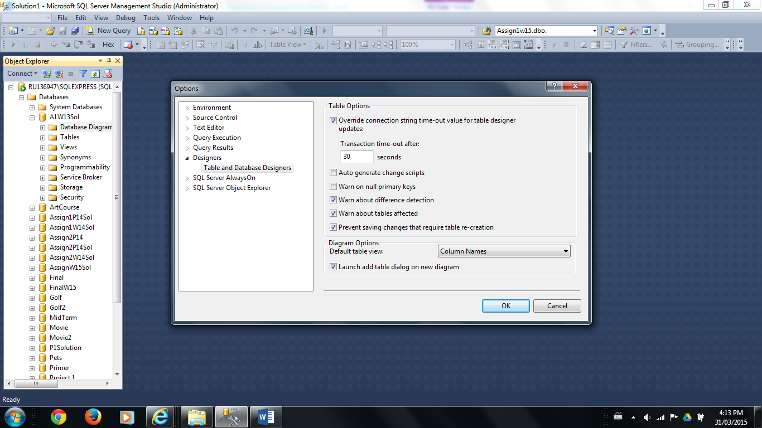

Click the marked box “Prevent saving changes that require table creation”. Once this box is unchecked, click “OK”.

1. We are now ready to define our first table. Open the “Module 7 Tutorial” directory under “Databases”. Select “Tables” and right mouse to open the short cut menu. Click on “New Table”.

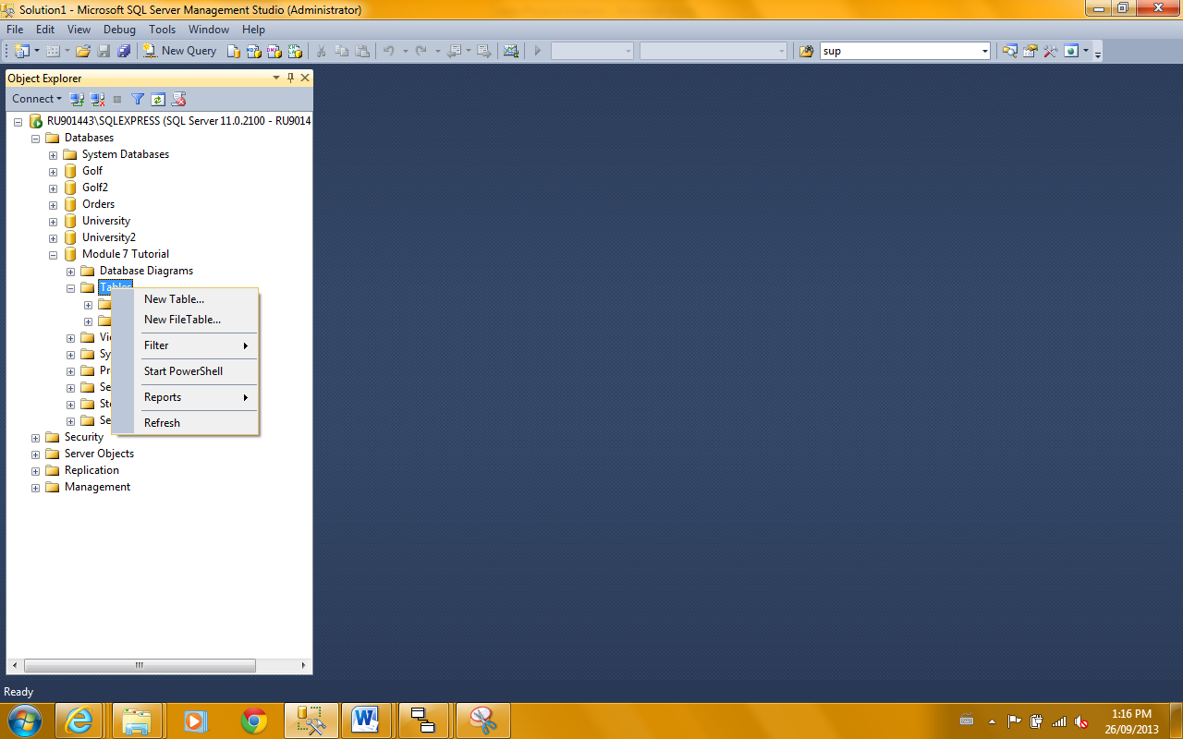

1. Enter the columns for the Team table. To indicate the primary key, select the grey square box to the left of the column “TeamName” and then click the golden key icon (bottom row of icons on top left – “set primary key”)

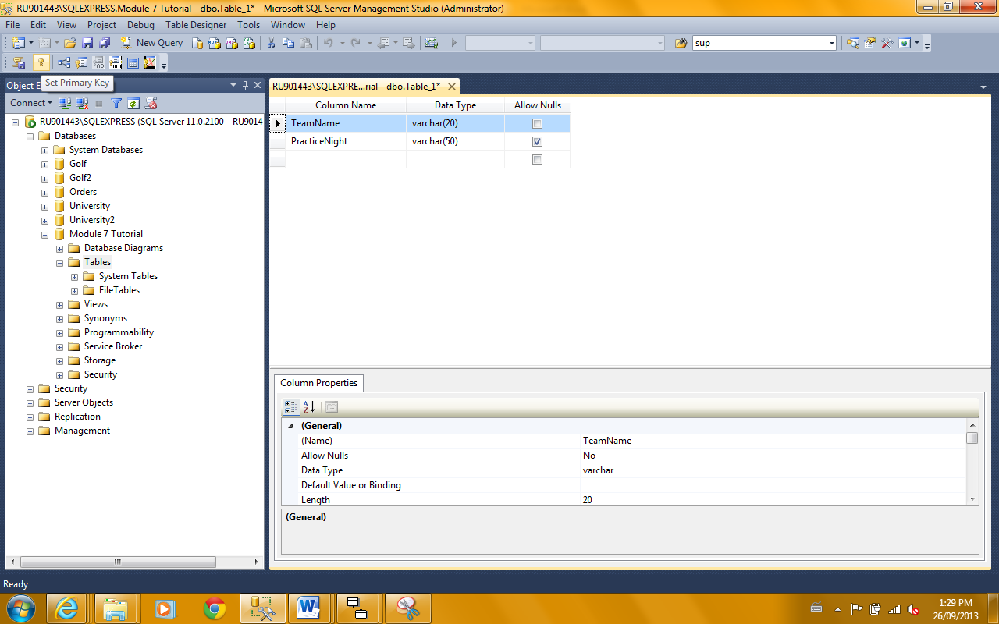

1. Then as the table definition is now complete click “Save table_1” under “File” and save as “Team” and close the panel.

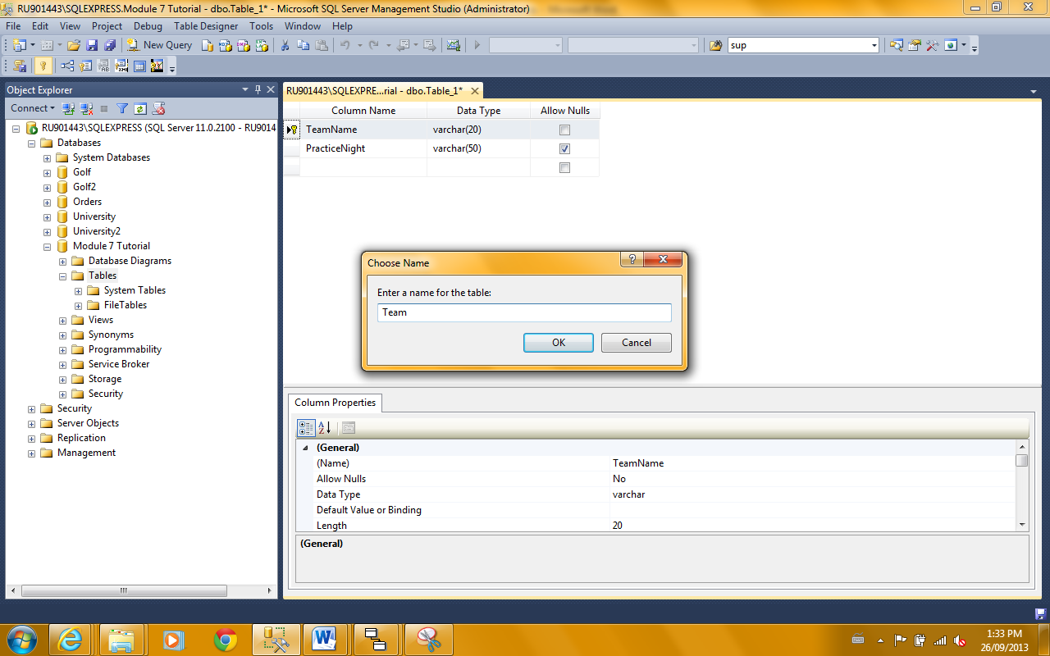

1. Repeat the “New Table” process for all the other tables. In this tutorial we will only now define the Member table. When completed it should look like this.

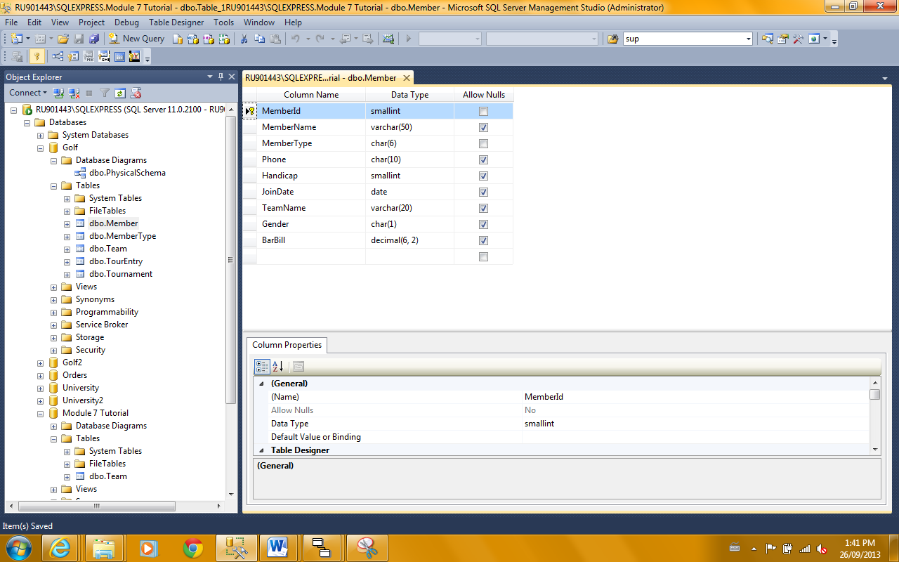

1. Assuming that all tables are now created we will now define the foreign key constraints (what were the relationships in the logical model). Again there are a number of physical design considerations around the rules for maintaining referential integrity which we will not address in this course. Rather what is presented here are the “bare bones” mechanics.

Right mouse click on “Database Diagrams” and select “New Database Diagram”. The first time you will receive a message telling you that you are missing objects to complete this task and asking you if you want to create them. Answer “Yes” and the follow screen appears.

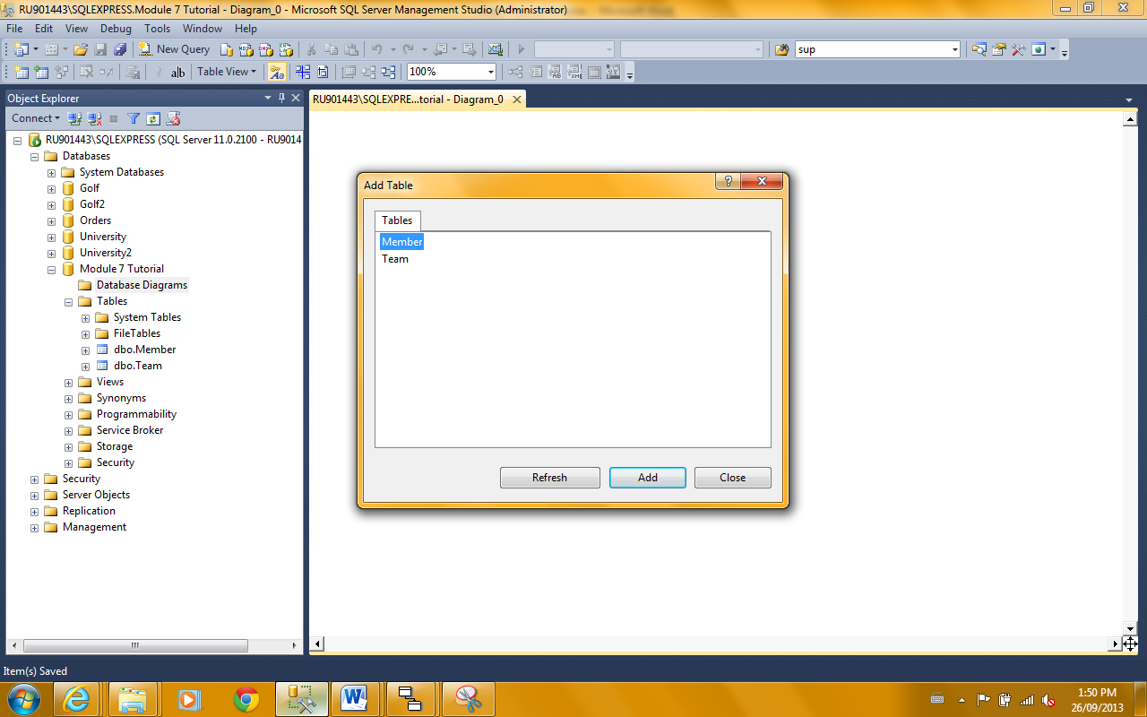

Select all tables listed and click on “Add” and then “Close” the dialogue box. The following screen appears.

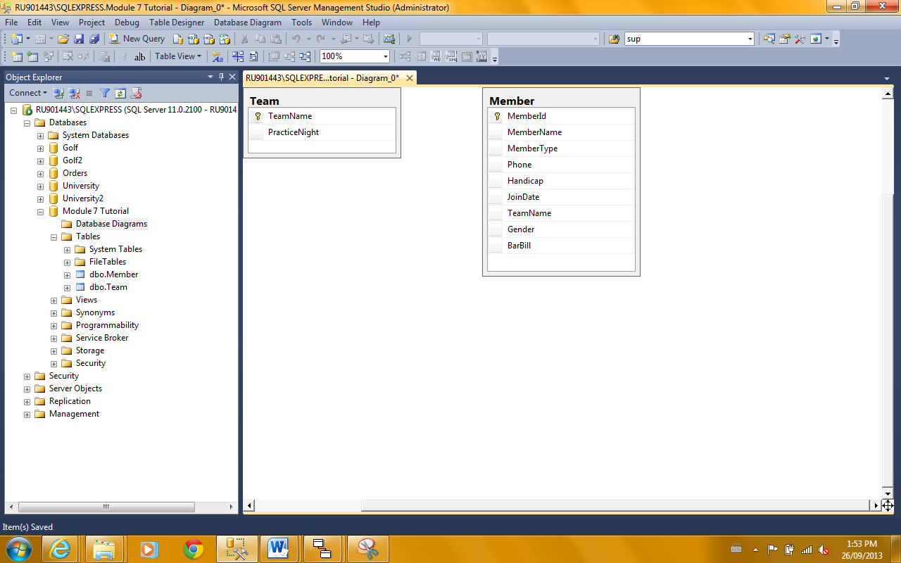

We will use the diagram to implement the “relationships” and also we can use it to make corrections/changes to the table definitions if necessary. There are other graphical interfaces provided to accomplish these tasks but here only the diagram interface will be used. Understand that changes are only checked and finalized when the diagram is saved. If there are a lot of changes made and just one change generates an error then none of the changes will take effect. It is recommended then that you save (but don’t close) the diagram periodically when making many changes. To show the column attributes select all tables (Edit – Select All)and then from the drop down “Table View” box ( bottom row of tool bar icons) select “Standard”. You may need to adjust your diagram layout to accommodate the new table data displayed.

1. The major feature that will be demonstrated here is implementing the primary key – foreign key relationships. In this example this is the “plays on” relationship between the parent table “Team” and the child table “Member”. Select, click and hold on the primary key symbol next to the “TeamName” column in the Team table. Drag the cursor and drop it on the foreign key column “TeamName” in the Member table. The following popup window should appear.

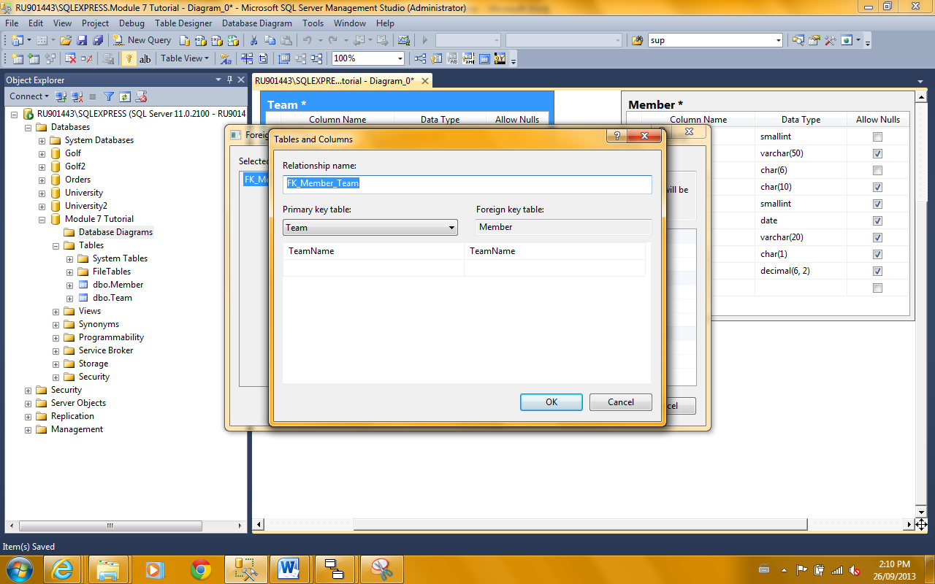

This is to confirm that your drag and drop selection is correct. Verify that the “Primary key table” (parent) and the Foreign key table (child) are correct and that the primary and foreign key columns are also correct. You have the ability here to modify the choice with drop downs or you could cancel and attempt to re-drag if the selected parameters are incorrect. Assuming all is correct click “OK”.

A second “Foreign Key Relation” dialogue box is revealed. We will accept all the defaults so click “OK”.

This process would be repeated for all relationships. Once the diagram is saved the Physical Schema is fully implemented and the database is ready to be used.

**Important Note:** concerning attaching and detaching your database.

After attaching a Database a database created by another user you need to run the following command in a query window against the database in order to access the database diagram.

SP_CHANGEDBOWNER 'SA'

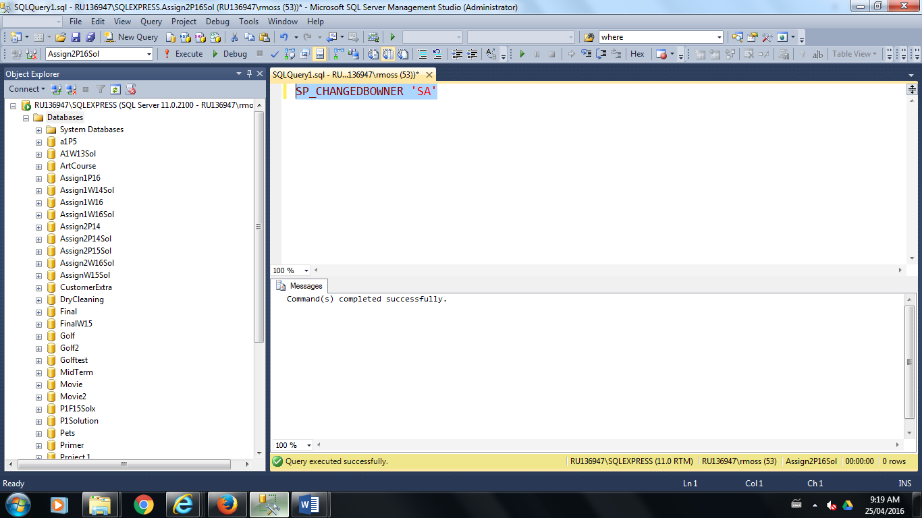

Remember that in order to move or copy the database files in Windows Explorer it must first be detached. Close all activity associated with the database. Select the database to be detached from the database directory. Right click menu then Tasks\ Detach.