QUALIFI ASSESSMENT DOCUMENT

|  |  |  |
| --- | --- | --- |
| Qualification | **Level 3 Diploma in Early Years Education and Care (Early Year Educator)** | |
| Qualification No (RQF) | **610/0013/6** | |
| Unit Name | **Supporting healthy lifestyles for children through food, nutrition and exercise** | |
| Unit Reference/Code | **L/650/0038** | |
| No of Credits | **4 Credits** | |
| Learner’ Name | **BHOYRO** | **BIBI OUMERAH** |
| Assessor’s Name | Click here to enter text. | Click here to enter a date. |
| Internal Verifier’s Name | Click here to enter text. | Click here to enter a date. |
| Study Center Name & Number | **TMC MANAGEMENT & SAFETY TRAINING (INSTITUTE) QCN001401** | |

**Introduction**

Prior to attempting this coursework assignment, Learners must familiarise themselves with the following policies:

* Centre Specification
* Qualifi Quality Assurance Standards
* Qualifi Quality Policy Statement

**Plagiarism and Collusion**

* In submitting the assignment Learner’s must complete a statement of authenticity confirming that the work submitted for all tasks is their own. The statement should also include the word count.
* Your accredited study centre will direct you to the appropriate software that checks the level of similarity. Qualifi recommends the use of <https://www.turnitin.com> as a part of the assessment.
* Plagiarism and collusion are treated very seriously. Plagiarism involves presenting work, excerpts, ideas, or passages of another author without appropriate referencing and attribution. Collusion occurs when two or more learners submit work which is so alike in ideas, content, wording and/or structure that the similarity goes beyond what might have been mere coincidence.
* Please familiarise yourself on Qualifi’s Malpractice and Maladministration policy, where you can find further information.

**Referencing**

* A professional approach to work is expected from all learners. Learners must, therefore, identify and acknowledge ALL sources/methodologies/applications used.
* The learner must use an appropriate referencing system to achieve this. Marks are not awarded for using English; however, the learner must express ideas clearly and ensure that proper terminology is used to convey accuracy in meaning.
* Qualifi recommends using the **Harvard Style** of Referencing throughout your work.

**Appendices**

* You may include appendices to support your work. However, appendices must only contain additional supporting information and must be referenced in your assignment.
* You may also include tables, graphs, diagrams, Gantt charts, and flowcharts that support the main report. These should be incorporated into the back of the submitted assignment report.
* Any published secondary information such as annual reports and company literature, should be referenced in the main text of the assignment, in accordance with Harvard Style Referencing, and referenced at the end of the assignment.

**Confidentiality**

* Where a Learner is using organisational information that deals with sensitive material or issues, they must seek advice and permission from that organisation about its inclusion.
* Where confidentiality is an issue, Learners are advised to anonymise their assignment report so that it cannot be attributed to that organisation.

**Word Count Policy**

* Learners must comply with the required word count, within a margin of **+10%.** These rules exclude the index, headings, tables, images, footnotes, appendices, and information contained within references and bibliographies.
* When an assessment task requires learners to produce presentation slides with supporting notes, the word count applies to the supporting notes only.

**Submission of Assignments**

* All work is to be submitted on the due date as per the Centre’s advice.
* All work must be submitted in a single electronic document **(.doc file)**, or via Turnitin, where applicable.
* This should go to the tutor and Centre Manager/Programme Director, plus one hard copy posted to the Centre Manager (if required)

**Marking and grades**

* Qualifi uses a standard marking rubric for all assignments, and you can find the details at the end of this document.
* Unless stated elsewhere, Learners must answer all questions in this document.

# STUDENT DETAILS & DECLARATION

### Assessment – EYE1: Supporting healthy lifestyles for children through food, nutrition and exercise- L/650/0038

Please complete the following activities and hand them to your trainer/assessor for marking since this document is a part of your assessment.

|  |  |
| --- | --- |
| **Name** | BIBI OUMERAH BHOYRO |
| **Learner ID (Qualifi)** | Click here to enter text. |
| **Learner ID (T M C)** | Click here to enter text. |
| **Email** | Oumerah.bhoyro@gmail.com |
| **Date** | Click here to enter a date. |

**Declaration**

*I declare that no part of this assessment has been copied from another person’s work, with the exception of where I have listed or referenced documents or work, and that no part of this assessment has been written for me by another person. I also understand the assessment instructions and requirements and consent to being assessed.*

Signature: ____OUMERAH BHOYRO_________________

**FORMATIVE ASSESSMENT**

|  |
| --- |
| Unit EYE1 Formative Assessment |

|  |  |
| --- | --- |
| Dear Learner,  As you prepare your responses for the assignment, ensuring that your answers reflect the learning outcomes and assessment criteria outlined in the respective unit is important. This will showcase your understanding of the concepts and demonstrate your ability to address the key points effectively. Read the scenario carefully first, then start attempting the assignment questions.  Guidelines:   * Single-spaced, justified alignment, 12pt Font size, Times New Roman font type; use an appropriate referencing system for footnotes and citations.  |  | | --- | | **QUESTION 1: 1200-1500 words in total for questions (**a, b, c, d, and e) |   SCENARIO:  Imagine you are a Nutrition Consultant at a renowned Child Development Research Institute. You've been approached by Bright Beginnings day care Centre, a well-established childcare provider that serves children from infancy through age 6. They seek a comprehensive evaluation of their current nutrition and food service programs. You are tasked with critically analysing these programs, assessing the centre's current practices, and providing valuable recommendations for improvement.  Assessment Criteria:   1. Explain what is meant by ‘healthy eating’ and the impact of poor diet on children’s health and development in the short- and long-term. 2. Explain national and local initiatives that promote healthy eating and the food and drink requirements about current frameworks. 3. Explain the impact on health and development of food choices during:    * + pre-pregnancy      + pregnancy      + breastfeeding 4. Explain the nutritional needs of:    * + a weaning programme      + babies until they are fully weaned      + children (1-2 years; 2-3 years; 3-5 years; 5-7 years)      + Explain the nutritional value of the main food groups. 5. Explain strategies to encourage healthy eating.   Assignment:  You can explain your role as a Nutritional Consultant in a company-wide meeting. Your explanation should encompass the following three (a, b, c, d, and e) critical aspects of your job: |
| 1. ****Impact of Poor Diet:****   *Begin by defining healthy eating. Explain what it means and how poor diet impacts children’s health and development in the short—and long-term. Please provide examples of positive practices demonstrating a solid commitment to children’s nutritional health and areas where improvements are needed.* |
| Answer: |

|  |
| --- |
| 1. **Evaluation of Current Nutritional Programs and Practices:**   *Provide examples of positive practices demonstrating a solid commitment to children’s nutritional health and areas where improvements are needed.* |
| **Answer:** |
| 1. **Integration of Nutritional Planning into Maternal and Infant Health Programs:**   *Identify and analyse the critical nutrients during pre-pregnancy, pregnancy, and breastfeeding. How do these nutrients contribute to the health outcomes of the mother and infant?* |
| **Answer:** |
| 1. **Nutritional needs of a weaning programme:**   *Outline the evolving nutritional needs from a weaning program to children aged 7, covering key stages (until fully weaned; 1-2 years; 2-3 years; 3-5 years; 5-7 years). What are the critical nutrients and dietary adjustments required at each stage?* |
|  |
| 1. **Strategies for Nutritional Well-being in Early Childhood**   *What are effective strategies for promoting healthy eating habits in young children, and how can these strategies be implemented in various settings such as homes, schools, and community centres to foster a lifelong appreciation for nutritious food?* |
|  |

**SUMMATIVE ASSESSMENT**

|  |
| --- |
| EYE1: Summative Assessment |

|  |  |
| --- | --- |
| Dear Learner,  As you prepare your responses for the assignment, you must ensure that your answers reflect the learning outcomes and assessment criteria outlined in the respective unit. This will showcase your understanding of the concepts and demonstrate your ability to address the key points effectively. Read the scenario carefully first, then start attempting the assignment questions.  Guidelines:   * Single-spaced, justified alignment, 12pt Font size, Times New Roman font type; use an appropriate referencing system for footnotes and citations.   ------------------------------------------------------------------------------------------------------------   |  | | --- | | **QUESTION 1: 900-1000 words in total for questions** (a, b, and c) |   SCENARIO:   * Imagine you are an Early Years Practitioner at Little Explorers Childcare, a facility that prides itself on providing tailored nutrition programs to meet the diverse needs of children. The centre is hosting an Early Childhood Nutrition Conference to enhance understanding and management of children's dietary needs. You have been selected to lead a workshop on understanding and supporting children's nutritional requirements and preferences. * This session focuses on the medical, cultural, and preference-based reasons behind special dietary requirements in children. The discussion will cover common dietary restrictions such as allergies, vegetarianism, and religious dietary laws. * Assessment Criteria:  1. Explain the reasons for:    * special dietary requirements    * keeping and sharing coherent records 2. Explain the role of the Early Years practitioner in meeting children’s dietary requirements and preferences. 3. Describe the benefits of working in partnership with parents/carers.   Assignment:   * In your analysis, you are expected to cover the following key aspects: |
| 1. ****Understanding Special Dietary Requirements:****   ***What are the primary reasons children have special dietary requirements, and how can understanding this help plan appropriate meals?*** |
| Answer: |

|  |
| --- |
| 1. **Importance of Coherent Record-Keeping:**   ***Why is it crucial to keep and share coherent records of children’s dietary requirements, and what systems can be implemented to ensure these records are maintained effectively?*** |
| **Answer:** |
| 1. **Role of Early Years Practitioners**   ***Explain the role of the Early Years practitioner in meeting children’s dietary needs and preferences. How can practitioners ensure these needs are met consistently in a childcare setting?*** |
| **Answer:** |
| **SCENARIO:**   * Imagine you are an Early Years Practitioner at Little Explorers Childcare, a facility that prides itself on providing tailored nutrition programs to meet the diverse needs of children. The centre is hosting an Early Childhood Nutrition Conference to enhance understanding and management of children's dietary needs. You have been selected to lead a workshop on understanding and supporting children's nutritional requirements and preferences. * **Assessment Criteria:**   1. Describe the features of an effective healthy eating plan.   2. Implement healthy eating activities in accordance.   3. Make recommendations for improvements in healthy eating. |
| Assignment:   * In your analysis, you are expected to cover the following key aspects:   **QUESTION 1: 900-1000 words in total for questions (**a, b, and c) |
| 1. **Designing an Effective Healthy Eating Plan**   ***What are the key features of an effective healthy eating plan for young children, and how can these features cater to diverse dietary needs and preferences?*** |
| **Answer:**   1. **Implementing Healthy Eating Activities**   ***How can you implement healthy eating activities with the newly developed plan? Provide examples of activities that both educate and engage children in nutrition.*** |
| **Answer:** |
| 1. **Continuous Improvement and Feedback**   ***What methods can be used to gather feedback on healthy eating activities, and what criteria would you use to recommend improvements?*** |
| **Answer:** |
| **SCENARIO:**   * Imagine you are the Program Coordinator at Greenfield Preschool, recognized for its commitment to fostering holistic child development. The preschool has launched the "Active Kids Campaign," an initiative focused on enhancing physical activity among children through well-structured exercise programs and strong parent partnerships. You are responsible for implementing and assessing this campaign's effectiveness in promoting regular exercise and ensuring inclusivity in indoor and outdoor activities. * **Assessment Criteria:**   4.1 Explain the benefits of exercise and working in partnership with parents/carers.  4.2 Evaluate national and local initiatives which promote children’s exercise  4.3 Identify the requirements of current frameworks for:   * + - outdoor access     - regular exercise   4.4 Explain the benefits of inclusive practice in the provision of indoor and outdoor  Exercise. |
| Assignment:   * In your analysis, you are expected to cover the following key aspects:   **QUESTION 1: 1000-1200 words in total for questions (**a, b, c, and d) |
| 1. **Importance of Exercise and Parental Collaboration**   ***What are the key benefits of regular exercise for children, and how can collaborating with parents enhance these benefits?*** |
| **Answer:** |
| 1. **Benefits of Exercise and Parental Involvement**   ***Evaluate the impact of national and local initiatives on promoting physical activity among children. How can these initiatives be integrated or improved within our preschool setting?*** |
| Answer: |
| 1. **Outdoor Access and Regular Exercise Requirements**   ***Identify the requirements for outdoor access and regular exercise for children as outlined in current educational frameworks. How does Greenfield Preschool meet these standards?*** |
| **Answer:** |
| 1. **Inclusive Exercise Practices**   ***Explain the benefits of inclusive practice in providing indoor and outdoor exercise for children. How can inclusivity be ensured in our exercise programs?*** |
| **Answer:** |
| **SCENARIO:**   * Imagine you are a Physical Education Teacher at Maple Tree Elementary School, known for its dedication to student health and active lifestyles. The school has identified a need to revamp its outdoor exercise programs to engage students better and promote physical wellness. You have been tasked with developing, implementing, and refining an outdoor exercise plan that maximizes the school’s extensive outdoor facilities. * **Assessment Criteria:**   5.1 Describe the features of an effective exercise plan.  5.2 Implement exercise arrangements by the plan  5.3 Make recommendations for improvements in exercise arrangements |
| Assignment:   * In your analysis, you are expected to cover the following key aspects:   **QUESTION 1: 900-1000 words in total for questions (**a, b, and c) |
| 1. **Designing an Effective Outdoor Exercise Plan**   ***What are the essential features of an effective outdoor exercise plan for elementary students, and how can these features be adapted to a diverse student population?*** |
| **Answer:** |
| 1. **Executing the Exercise Plan**   ***How can exercise arrangements be implemented effectively according to the developed plan? What logistical considerations are necessary to ensure smooth operation?*** |
| **Answer:** |
| 1. **Implementing Outdoor Exercise Programs**   ***What methods can be used to evaluate the effectiveness of outdoor exercise arrangements, and how can this feedback lead to tangible improvements in the program?*** |
|  |

**Learner’s record to be completed by assessor**

The trainer/assessor should use this to document the learner’s skills, knowledge, and performance as relevant to the overall unit. Indicate in the table below if the learner is deemed passed or failed for the unit or if reassessment is required.

|  |  |  |
| --- | --- | --- |
| Learner’s name |  | |
| Assessor’s name |  | |
| Unit Name | **Unit EYE1: Supporting healthy lifestyles for children through food, nutrition and exercise** | |
| Unit Reference/Code | **L/650/0038** | |
| Has the learner completed all required assessment questions to a satisfactory standard? | | Yes No |
| Has the learner provided sufficient evidence and information 610/0013/6 to prove their competency across the unit? | | Yes No |
| **Learner’s score** | | |
| |  |  |  |  |  |  |  | | --- | --- | --- | --- | --- | --- | --- | | Distinguished | Excellent | Good | Proficient | Basic | Marginal | Unacceptable | | 80+ | 70 | 60 | 50 | 40 | 30 | 0 | |  |  |  |  |  |  |  |   **Assessor’s Comments:**  **Internal Verifier’s Comments:** | | |
| Assessor’s Signature |  | |
| Date | Click here to enter a date. | |
| Internal Verifier’s Signature |  | |
| Date | Click here to enter a date. | |

**Rubric:**

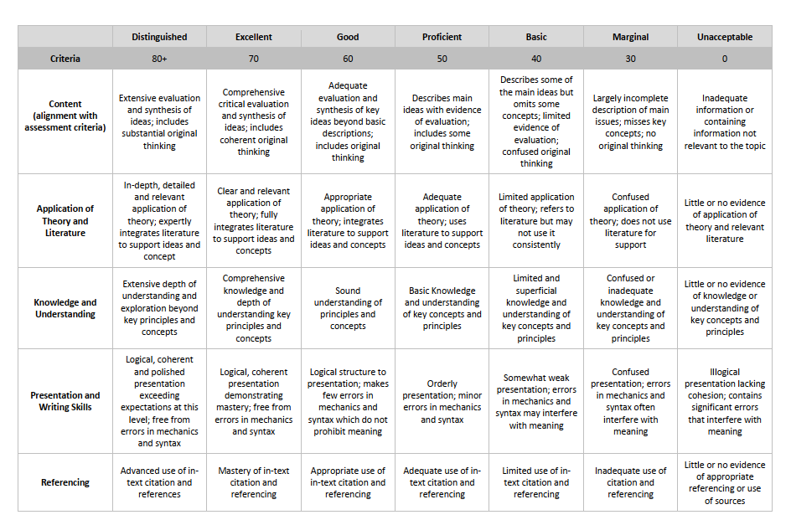**Directions:**

1. For each of the criteria listed in the first column, circle one box in the corresponding column to the right which best reflects the student’s work on this assessment activity (e.g., project, presentation, and essay).
2. Provide specific feedback to a student about each of the criteria scores he/she earned by writing comments and suggestions for improvement in the last row titled “Instructor’s comments.”
3. To arrive at a mark, total the boxes and divide by 5 to arrive at final mark.

**Example:**

|  |  |
| --- | --- |
| **Criteria** | **Score** |
| Content | 50 |
| Application of Theory and Literature | 40 |
| Knowledge and understanding | 50 |
| Presentation/Writing Skills | 40 |
| Referencing | 40 |

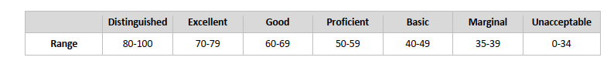

**Total Score** 220/5 = **44, Basic**

