

**Department of Mechanical Engineering**

**Project Stage – II** **Synopsis**

|  |  |
| --- | --- |
| **Group No: 35** | |
| **Roll No.** | **Name of the Students** |
| **ME4146** | **Pratik Kinniwadi** |
| **ME4142** | **Vipul Kohinkar** |
| **ME4141** | **Shreyas Paraspatki** |
| **ME4317** | **Shubham Ware** |
| **Name of the Guide:** | **Dr.Ashish Kumar** |
| **Title of the Project:** | **Design and Development of Automatic Tyre Inflation System for Two-Wheeler** |
| **Project Category:** | **Manufacturing** |

**Project Guide**  **Project Coordinator**  **Head, Dept. of Mech. Engg.**

**Design and Development of Automatic Tire Inflation System for Two-Wheeler**

1. **Introduction**

When your tires are under-inflated, they can’t perform well on the road. The National Highway Authority of India (NHAI) reports that tires under-inflated by 25% cause three times as many car accidents as correctly inflated tires. While low tires probably won’t cause any serious problems for you while driving short distances, they can if you leave them that way for too long. AAA reports that low tire pressure has many negative effects on your motorcycle. Tire inflation pressure affects the structural properties of the tire, and therefore changes the way tire forces and moments are generated. Under-inflating the tire risks compromising its structural integrity, causing the sidewalls to ‘fold over’ or cause damage to the tire.

An automatic tire inflation system, often referred to as ATIS, is a cutting-edge technology designed to enhance vehicle safety, performance, and efficiency. This innovative system constantly monitors and adjusts the air pressure in a vehicle's tires, ensuring they remain at the optimal level for various driving conditions. By maintaining proper tire pressure automatically, ATIS not only improves fuel economy but also reduces the risk of accidents caused by underinflated or overinflated tires. In this discussion, we will delve deeper into the benefits, components, and working principles of automatic tire inflation systems, highlighting their significance in modern transportation.

**Real-time Monitoring:** ATIS constantly monitors tire pressure and temperature, providing instant feedback to the driver and vehicle management systems.

**Automatic Inflation:** When tire pressure falls below the recommended levels, the system automatically inflates the tires to the desired pressure, reducing the risk of blowouts and accidents.

**Fuel Efficiency:** Maintaining proper tire pressure improves fuel efficiency, reducing operational costs for fleet vehicles and personal automobiles.

**Tire Longevity:** Correct tire pressure extends the lifespan of tires, reducing the frequency of replacements and the associated costs.

**Convenience:** Automatic tire inflation eliminates the need for manual pressure checks and adjustments, making it more convenient for vehicle owners.

**Environmental Impact:** Improved tire pressure reduces tire wear and, subsequently, the release of microplastics from tire abrasion, contributing to environmental sustainability.

**Fig.1:- Graph of Motorcycle Accidents in 2018**

If you drive your vehicle with low tire pressure, you can expect lowered fuel efficiency, compromised tire performance and lifespan, and elevated risk to the driver’s safety and the safety of others on the road. When a tire’s air pressure is low, the handling is compromised and there is an increased risk of tire failure. A tire blowout is the most dangerous risk associated with low tire pressure. With more of the tire’s surface touching the road and warming up the rubber, this can cause the tire to overheat and blowout. Cornering while low tire pressure can result in instability of bike as the tire gets deformed easily. The delayed response of under-inflated tires can be particularly noticeable during cornering. The tires may not respond as quickly to steering inputs, making it challenging to navigate turns with precision.

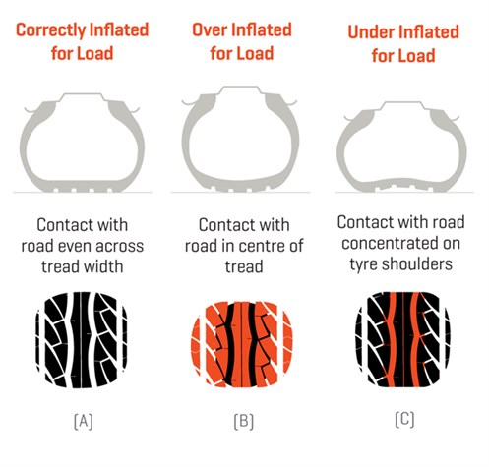

**Fig.2:- Tire Thread contact as per the pressure**

**2. Relevance of Project**

An automatic tire inflation system (ATIS) is relevant for several reasons

**Handling:** Tire pressure affects handling by changing the stiffness and responsiveness of the tire. If the tire pressure is too low, the tire becomes softer and more sluggish, which makes it harder to respond to steering changes and maintain a proper alignment.

**Fuel Efficiency:** Maintaining the correct tire pressure improves fuel efficiency. An ATIS can save money on fuel costs and reduce the environmental impact of vehicles.

**Tire Longevity:** Correct tire pressure extends the lifespan of tires, reducing the frequency of replacements and the associated costs.

**Convenience:** Automatic tire inflation eliminates the need for manual pressure checks and adjustments, making it more convenient for vehicle owners.

**Environmental Impact:** Improved tire pressure reduces tire wear and, subsequently, the release of microplastics from tire abrasion, contributing to environmental sustainability.

**Regulatory Compliance:** Some industries and regions require vehicles to have ATIS as part of safety and emissions regulations.

**Safety:** Properly inflated tires are essential for vehicle safety. An ATIS can help maintain optimal tire pressure, reducing the risk of accidents caused by underinflated or overinflated tires.

**3.Literature Survey**

**Stephen McClelland et al.(2011)**, has defined ‘Remote tire pressure monitoring system’. A system which monitors a vehicle's tire pressure and displays real-time pressure values on a dashboard display while the vehicle is on the road. An electronic unit with pressure sensor, roll switch, reed switch, tilt switch, battery and control electronic, mounted to the valve stem inside each tire uses the pressure sensor to periodically measure the tire pressure, and uses a transmitter to transmit the measured pressure values via RF transmission to a dashboard mounted receiver. The receiver controls a display which indicates to the driver the real-time tire pressure in each wheel. The display also indicates an alarm condition when the tire pressure falls below certain predefined thresholds. The pressure values are compensated for temperature changes inside the tire, and also may be compensated for altitude changes.

**Jan Einar Nornes et al.(2009)**, has defined ‘Tire pressure monitoring system telegram with suppressed ID’. A tire pressure monitoring system receiver includes a storage unit to store transmitter IDs associated with a plurality tire pressure monitoring system transmitters, a receiving unit to receive a transmitted tire pressure monitoring system telegram and a transmitted checksum, a calculating unit to calculate a test checksum from the received telegram and one of the stored IDs, a comparing unit to compare the test checksum with the transmitted checksum, and an identification unit to identify a source transmitter from the test checksum in response to finding a match between the test checksum and the transmitted checksum

**Mark Reiter et. al(2010)**,The under inflation of pneumatic tyre is a typical problem which is seen in light duty vehicles, cars etc. which affects the vehicle handling characteristics in an adverse manner. A lane change test shows that the required steering wheel angle increased up to 47.7% for front axle tyre inflation pressures at 70% of the nominal values. All tyres were inflated to 70% of the recommended tyre pressure when vehicle slip angle was up to 77.8%.

**Harshal Junankar et. al(2015)**, The paper studies on the basis of air inflation systems are used to maintain tyre pressure in running condition of vehicle. The environmental conditions changes in different seasons because of this, it is necessary to maintain tyre pressure at optimum level for better performance of the vehicles. This project deals with the design & fabrication of the automatic tyre inflation system and study of the effect of pressure variation on tyre life.

**Garcia George E et. al(2013)**, has defined ‘Tire Pressure Monitoring System’. A Tire pressure monitoring system for providing an indication in a vehicle that one of its tyres is losing its normal inflation pressure. The system comprises a pressure responsive actuator within each tyre in the system including an extensible portion that is normally retracted and shielded when tyre pressure is normal. The extensible portion of the actuator is covered with a material sensitive to R.F. energy. Mounted adjacent to each tyre of the system is an R.F. energy transmitter directed toward the tyre and an accompanying receiver. Loss of pressure in a tyre causes the actuator to extend and expose its R.F. sensitive portion, thereby causing a signal disturbance in the R.F. receiver which is connected to an indicator in the vehicle.

**4.Methodology**

After referring several papers, we got many ideas. This system consists of centralized compressor, rotary joint, pressure sensor, electronic control circuit, wheel and a motor to run that wheel. After getting ideas of different components needed, we will start making rough design and after that we will draw a 3-D model in Auto CAD. By referring this 3D model, we will buy the standard component required for the projects. After this we will start manufacturing work in workshop. Along with this electronics part will also be done. In electronics we will have to build controller circuit to get signal from pressure. Later testing will be started for getting various results.

**Procedure** (Designing) - Designing is the process of creating or planning the structure, appearance, and functionality of something, often with the intent of solving a problem or achieving a specific goal. Design can encompass a wide range of disciplines, from graphic design and industrial design to interior design, fashion design, web design, and more. The goal of designing is typically to find creative and effective solutions that meet the needs and preferences of users or clients while also considering practical and aesthetic aspects.

Designing an Automatic tire inflator involves various considerations, including functionality, safety, user experience, and aesthetics. Here's a conceptual design of a basic tire inflator:-

1) Form Factor

2) Mechanism

3) User Interface

4) Safety Features:

i. Overpressure protection prevents over-inflation.

ii. Overheat protection ensures safe operation.

iii. A cooling system dissipates heat generated during operation.

**Fig.3: - Isometric view of Rotary Joint Designed on CREO Software**

**Prototyping:-**

We will be using Fused Deposition Modelling (FDM) which is widely employed for prototyping parts due to its versatility, cost-effectiveness, and rapid prototyping capabilities. FDM technology utilizes thermoplastic filaments, which are melted and layered to construct three-dimensional objects layer by layer. One of the primary advantages of FDM for prototyping is its accessibility, as these machines are widely available and relatively affordable. The process allows for quick iterations and modifications to designs, facilitating a more efficient development cycle. Additionally, FDM enables the creation of functional prototypes with reasonable accuracy and good surface finish, providing a tangible representation of the final product. Its compatibility with a variety of materials further enhances its applicability for simulating the mechanical and thermal properties of end-use parts. Overall, FDM's accessibility, speed, and versatility make it an ideal choice for cost-effective and iterative prototyping in various industries.

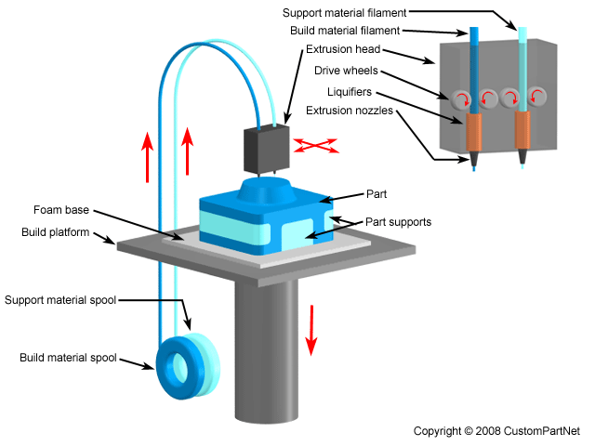

**Fig.4:- Fused Deposition Modelling**

**Basic components: -**

**Air Compressor**

An **air compressor** is a machine that takes ambient air from the surroundings and discharges it at a higher pressure. It is an application of a gas compressor and a pneumatic device that converts mechanical power (from an electric motor, diesel or gasoline engine, etc.) into potential energy stored in compressed air, which has many uses. A common application is to compress air into a storage tank, for immediate or later use. When the delivery pressure reaches its set upper limit, the compressor is shut off, or the excess air is released through an overpressure valve. The compressed air is stored in the tank until it is needed. The pressure energy provided by the compressed air can be used for a variety of applications such as pneumatic tools as it is released. When tank pressure reaches its lower limit, the air compressor turns on again and re-pressurizes the tank. A compressor is different from a pump because it works on a gas, while pumps work on a liquid.

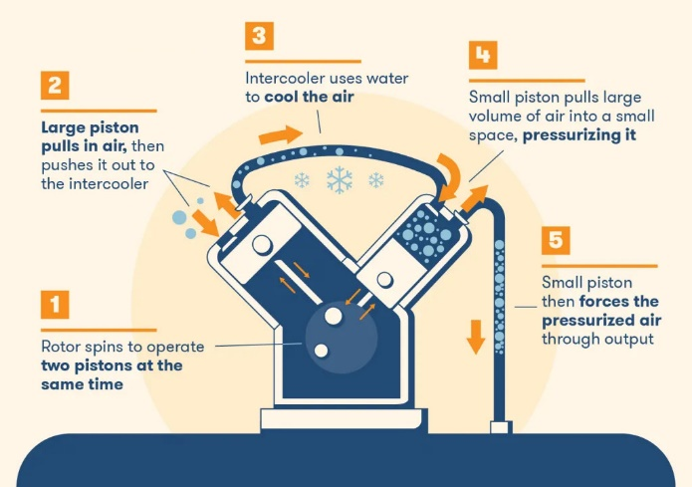

**Fig.4: - Mini Air Compressor and its working**

**Rotary joint**

Rotary joint or a Rotary Union is a device that provides a seal between a stationary passage and a rotating part. Stationary passage may be a pipe or tubing; whereas rotating part can be a drum, spindle or a cylinder. Thus it permits the flow of the fluid into and/or out of the rotating part. Generally, the fluids that are used with the rotary joints and rotating unions are steam, water, thermal oil, hydraulic fluids etc.

A rotary union will lock onto an input valve while rotating to meet an outlet. During this time the liquid and/or gas will flow into the rotary union from its source and will be held within the device during its movement. This liquid and/or gas will leave the union when the valve openings meet during rotation and more liquid and/or gas will flow into the union again for the next rotation.

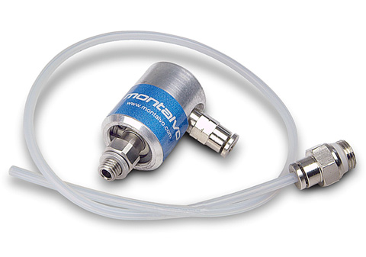 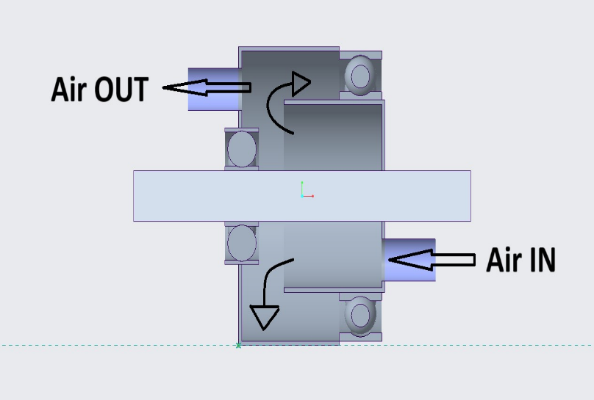**Fig.5: - Rotary Joint**

**Tyre Pressure Monitoring Sensors:** Tyre Pressure Monitoring Systems (shortened to TPMS) are fitted to modern vehicles to monitor tyre pressures and report low pressures or tyre pressure imbalances on a vehicle.

Within the TPMS is a sensor that is able to show a warning light when there is a drop in pressure of between 6-7PSI. This is now a legal requirement, though some manufacturers set their warning lights to come on when sensors detect much smaller decreases for additional peace of mind. These devices can be used to determine whether your tyre is frequently leaking air, either through the trim or because of a slow puncture. Solving this problem quickly could reduce the chances of an accident occurring due to a blowout or a flat tyre.

There are two main types of TPMS: direct and indirect - and both work slightly differently.

1.Direct TPMS

Direct TPMSs are the most common as they’re more reliable. This system uses pressure sensors that are located within the tyre to track the pressure. Because of their location, they can track the exact pressure within the tyre, making them accurate and reliable. When the pressure drops past a set parameter – usually 25% – a warning alert will appear on your dashboard. At this point, the car should be taken to a petrol station to have its tyres pumped up. Some TPMSs will specify which tyre is low so you don’t have to manually check them all. These sensors are fitted with an internal battery, however, battery failure is the main reason TPMSs stop working. The more miles you do, the quicker the sensor will run down. Unfortunately, for them to work properly, they need to be sealed units – so you can’t simply replace the battery when it runs out

2.Indirect TPSM

Indirect TPMSs don’t have their own sensor. Instead, they use another sensor that’s located inside the wheel, usually the anti-lock braking system’s sensor. It works by tracking the tyres as they revolve.

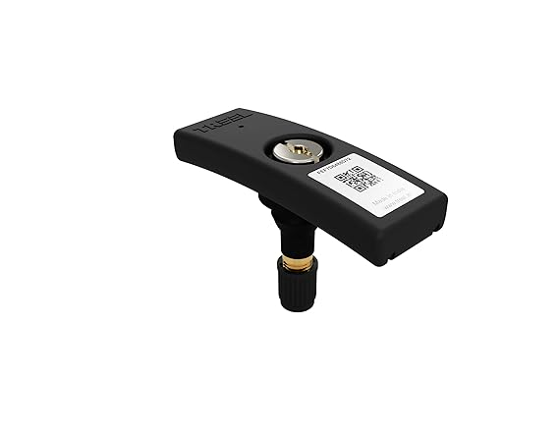 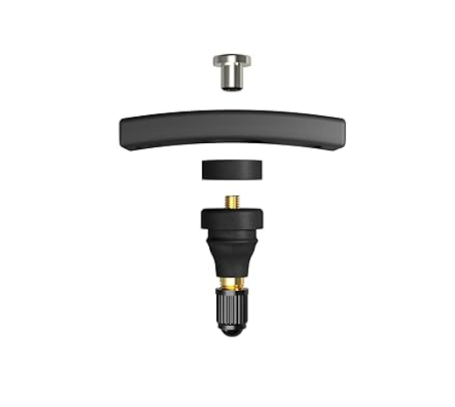

**Fig.6: - Tyre Pressure Monitoring Sensor**

**Micro-Controller:** ESP-32 Wi-Fi Bluetooth combo module is an ultra-high performance and ultra-low-power consumption Wi-Fi and Bluetooth combo wireless platform based on ESPRESSIF ESP32 chipset. ESP-32 integrates the dual-core processor, 448 Kbyte ROM,520 Kbyte SRAM,16 Kbyte SRAM in RTC, 802.11 b/g/n/e/I Wi-Fi, Bluetooth v4.2 BR/EDR & BLE, clocks & Times, abundant peripheral Interfaces and security mechanism.ESP-32S Wi-Fi Bluetooth combo module provides SDK Firmware for fast on-line programming and open source toolchains based on GCC for development support. It is designed for Generic low power IoT sensor hub, loggers, video streaming for the camera, Wi-Fi & Bluetooth enabled devices, Home automation and mesh network applications, aimed at makers, hardware engineers, software engineers and solution provides.ESP32 is a single-chip 2.4 GHz Wi-Fi and Bluetooth combo chip designed with TSMC ultra-low power 40 nm technology. It is designed and optimized for the best power performance, RF performance, robustness, versatility, features, and reliability, for a wide variety of applications, and different power profiles.ESP32 is the most integrated solution for Wi-Fi + Bluetooth applications in the industry with less than 10 external components. ESP32 integrates the antenna switch, RF balun, power amplifier, low noise receive amplifier, filters, and power management modules. As such, the entire solution occupies a minimal Printed Circuit Board (PCB) area.ESP32 is designed for mobile, wearable electronics, and the Internet of Things (IoT) applications. It has many features of state-of-the-art low-power chips, including fine-resolution clock gating, power modes, and dynamic power scaling.



**Fig.7: - Micro-controller (ESP 32)**

**Programming:** In this project, Python is chosen as the programming language for the ESP32 microcontroller due to its simplicity and accessibility. Python's intuitive syntax and extensive libraries facilitate rapid development and prototyping, crucial for a project involving Tyre compressor control. The ESP32's hardware capabilities, combined with Python's flexibility, empower this project to not only control the tyre compressor but also potentially incorporate additional features like real-time data analysis or integration with external systems. While ESP 32 uses Micro Python which works similar to Python but it’s used for Microcontroller.

Code: The code is used to control the tyre inflator with the help of microcontroller.

class AirCompressor:

    def __init__(self, current_pressure):

        self.current_pressure = current_pressure

        self.max_pressure = 24

        self.time_to_fill_full_tire = 4.8  # Time to fill from 0 to 24 psi

    def start_compressor(self):

        if self.current_pressure < self.max_pressure:

            print("Air compressor started.")

            self.fill_tire()

    def stop_compressor(self):

        print("Air compressor stopped.")

    def fill_tire(self):

        time_per_psi = self.time_to_fill_full_tire / self.max_pressure

        time_elapsed = 0.20

        while self.current_pressure < self.max_pressure:

            print(f"Current pressure: {self.current_pressure} psi")

            print(f"Time required to fill from {self.current_pressure:.1f} psi to {self.current_pressure + 1:.1f} psi: {time_elapsed:.2f} minutes")

            self.current_pressure += 1

            time_elapsed += time_per_psi

        self.stop_compressor()

def main():

    current_pressure = float(input("Enter the current tire pressure (in PSI): "))

    if current_pressure >= 24:

        print("Air compressor is not turned on as the current tire pressure is already at or above 24 PSI.")

    else:

        compressor = AirCompressor(current_pressure)

        compressor.start_compressor()

if __name__ == "__main__":

    main()

Output: The Output given is the pressure and time required to fill tire from the current tire pressure to max value permitted for tire.

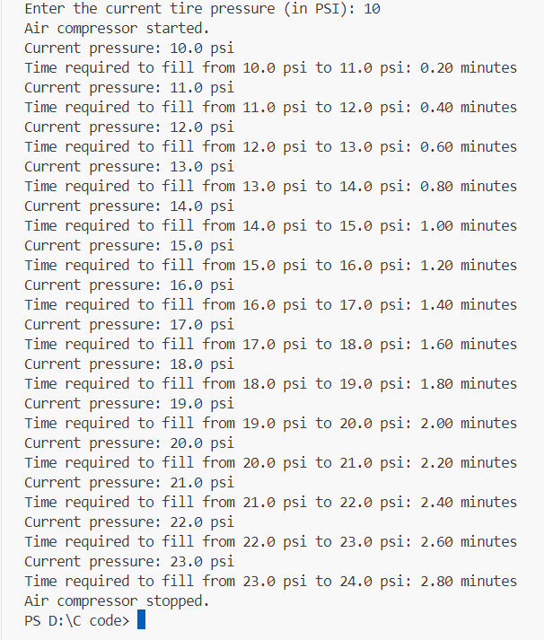

**Bearing:** A bearing is a machine element designed to support and facilitate the smooth rotation or movement of mechanical components. Bearings are crucial in machinery and equipment where one part needs to move relative to another while minimizing friction, wear, and the generation of heat. They serve as a type of "interface" between two moving or rotating parts, allowing them to move with reduced resistance. There are various types of bearings, but some of the most common include:

1.Ball Bearings

2.Roller Bearings

3.Needle Bearings

4. Thrust Bearings

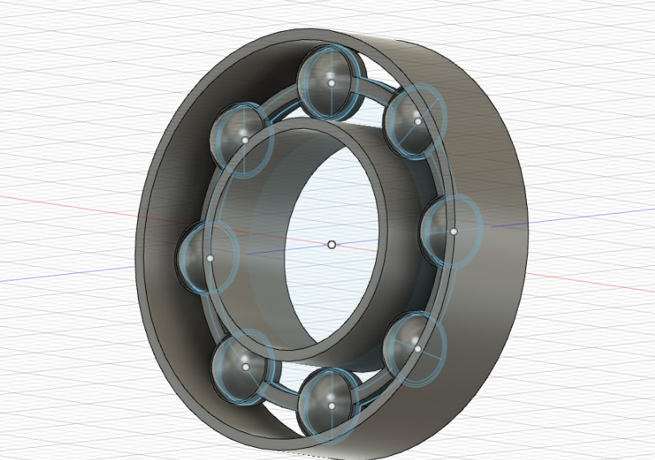 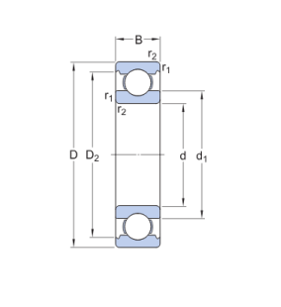

**Fig.8:- Bearing and its dimensions**

Bearing Measurement: Bearings are measured by their inner diameter, outer diameter, and width; the size of a bearing is normally listed as such: ID x OD x W. These measurements are normally taken in millimetres, but can be converted to inches. In fact, most manufacturers and suppliers offer bearing measurements in both imperial and metric systems. Each combination of these measurements corresponds to a series number, usually located directly on the bearing. Ball bearing size charts are widely available, and can be used to find the measurements of a specific bearing. Different Series of bearings available are6000 Series,6200 Series,6300 Series,6700 Series,6800 Series,6900 Series.

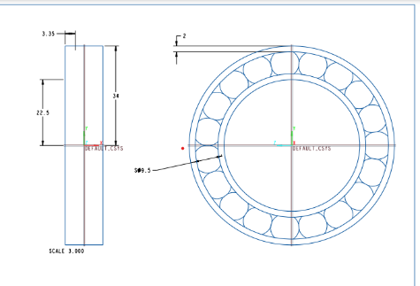

**Fig.9:- Draft of 6810 series Bearing**

|  |  |  |  |  |  |  |
| --- | --- | --- | --- | --- | --- | --- |
| Size | Inner Dia.(mm) | Outer Dia.  (mm) | Width (mm) | Dynamic (cr) | Static (cor) | Weight  (lb) |
| 6200 | 10 | 30 | 9 | 1147 | 535 | 0.070 |
| 6201 | 12 | 32 | 10 | 1533 | 686 | 0.077 |
| 6202 | 15 | 35 | 11 | 1720 | 836 | 0.099 |
| 6203 | 17 | 40 | 12 | 2154 | 1075 | 0.141 |
| 6204 | 20 | 47 | 14 | 2878 | 1495 | 0.227 |
| 6205 | 47 | 52 | 15 | 3147 | 1771 | 0.279 |
| 6206 | 30 | 62 | 16 | 4384 | 2585 | 0.440 |
| 6207 | 35 | 72 | 17 | 5733 | 3417 | 0.634 |
| 6208 | 40 | 80 | 15 | 6632 | 4047 | 0.810 |
| 6209 | 45 | 85 | 19 | 7081 | 4609 | 0.915 |
| 6210 | 50 | 90 | 20 | 7868 | 5216 | 1.019 |

Table 1: Table of 6200 Series Bearing with their Dimensions, Dynamic load and Static load rating

The 6200 series includes a range of sizes, making it easier to find the right bearing for a specific application. The series typically includes bearings with bore diameters ranging from 10mm to 100mm or more. The 6200 series is used because it can handle high-speed rotation, making them suitable for applications where components need to move quickly. They are typically sealed or shielded, which helps keep contaminants out and lubrication in, reducing the need for frequent maintenance. The design of 6200 series bearings minimizes noise and vibration, making them suitable for applications where quiet operation is necessary. Deep groove ball bearings in the 6200 series are known for their low friction, which reduces energy consumption and heat generation. This makes them suitable for applications where efficiency and minimal heat buildup are crucial. They can handle radial and axial (thrust) loads in both directions, making them suitable for applications where there are both radial and axial forces present.

The 6200 series ball bearings are used in various industries and applications: Electric motors, Fans and blowers, automotive components, Agricultural machinery, Industrial pumps, Conveyors, Household appliances, Skateboards and bicycles.

**Computational Fluid Dynamics (CFD)**

Computational Fluid Dynamics (CFD) is the process of mathematically predicting physical fluid flow by solving the governing equations using computational power. When an engineer is tasked with designing a new product, e.g. a winning race car for the next race season, aerodynamics plays an important role in the overall performance of the design. That said, aerodynamic performance is not easily quantifiable during the concept phase. Traditionally, the only way for an engineer to optimize his/her design is to conduct physical tests on product prototypes. With the rise of computers and ever-growing computational power (thanks to Moore’s law), the field of CFD has become a commonly applied tool for predicting real-world physics. In a CFD software analysis, fluid flow and its associated physical properties, such as velocity, pressure, viscosity, density, and temperature, are calculated based on defined operating conditions. In order to arrive at an accurate, physical solution, these quantities are calculated simultaneously.

Every CFD tool, both commercial and/or open source, uses a mathematical model and numerical method to predict the desired flow physics. The most common CFD tools are based on the Navier-Stokes (N-S) equations. While the bulk of the terms in the Navier-Stokes equations remains constant, more terms can be added or removed based on the physics. For example, if heat transfer, phase change, or chemical reactions need to be considered, more terms will be introduced into the governing equations.It is very important that the proper operating conditions, numerical methods, and physics are considered in order to conduct an accurate and successful CFD analysis. If this is done correctly, performance insights can be obtained quickly that will result ultimately in a better performing and more efficient final product.

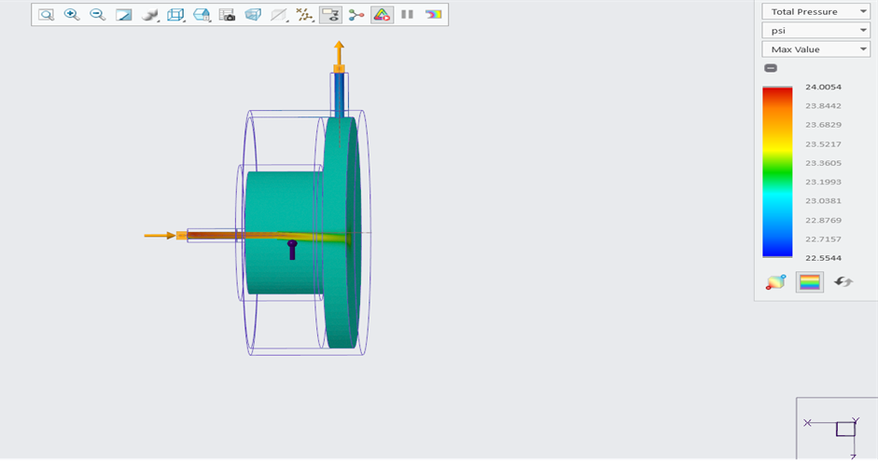

**Fig.10:- Internal flow of Rotating joint**

**Fig.11: - Flow Chart of Design and Development of Automatic Tire Inflation System**

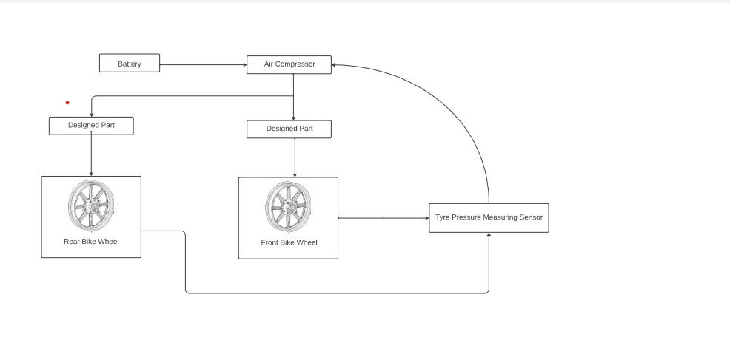**Fig.12: - Block Diagram of Automatic Tyre Inflation System**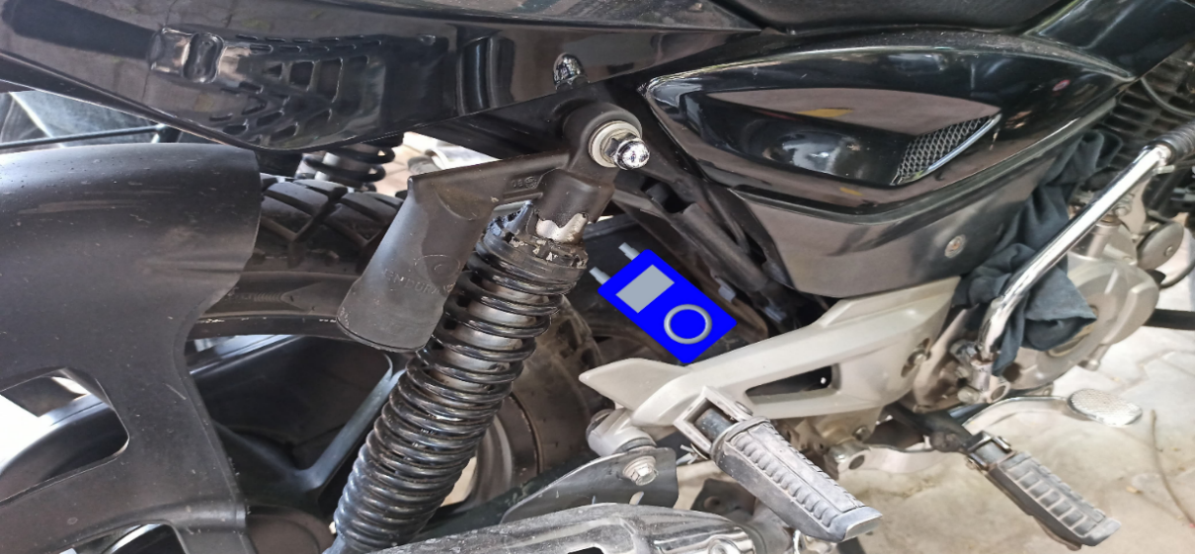 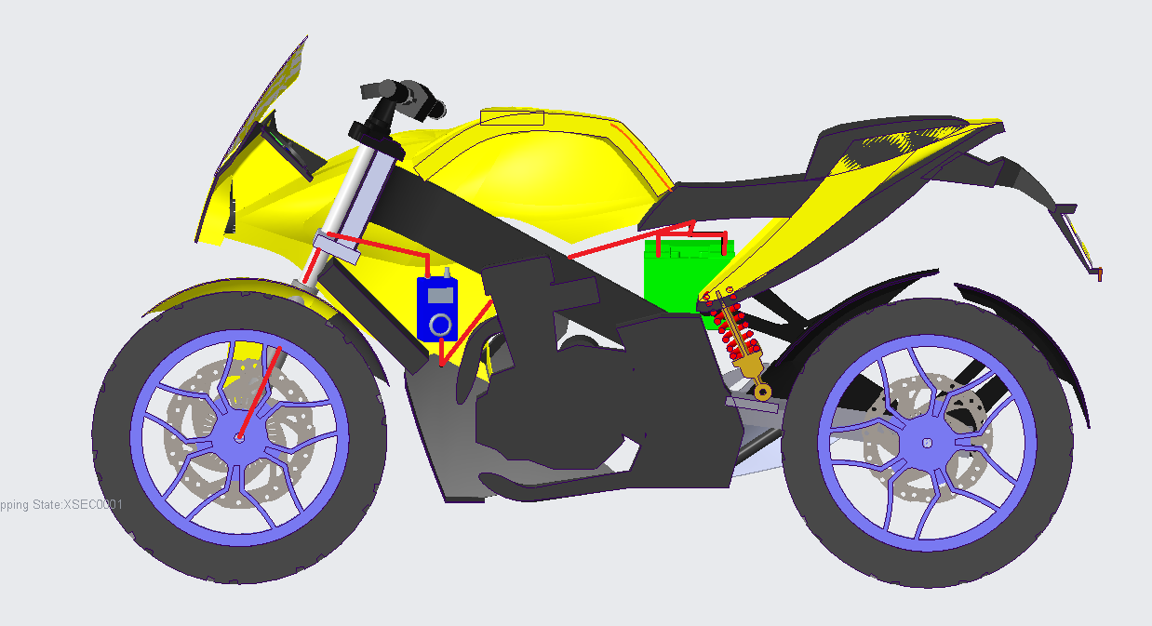

**Fig.13: - Location of Automatic Tyre Inflation System in Bike**

**Material Selection:**

|  |  |  |  |  |
| --- | --- | --- | --- | --- |
|  | PVC | Brass | Stainless Steel | Aluminium |
| Cost | Low | High | Very High | High |
| Durability | Average | High | Very High | High |
| Corrosion Resis. | High | Average | Very High | Low-Average |
| Operating temperature and pressure | Low | High | Very High | High |
| Weight | Light | Heavy | Heavy | Light |

Table.2 Material details

**PVC:** Polyvinyl Chloride (PVC or Vinyl) is an economical and versatile thermoplastic polymer. It is widely used in the building and construction industry to produce door and window profiles. It is a white, brittle solid material available in powder form or granules. The chemical formula is (C2H3Cl)n, where n represents the number of repeating units. PVC is produced through the polymerization of vinyl chloride. The polymerization process involves linking together the vinyl chloride monomers to form long chains. PVC is an extremely versatile material with a wide range of applications. It can be formulated to be rigid or flexible, making it suitable for various products and industries. PVC is a lightweight material, which makes it easy to handle and install. This characteristic is particularly advantageous in construction applications, such as piping and roofing.

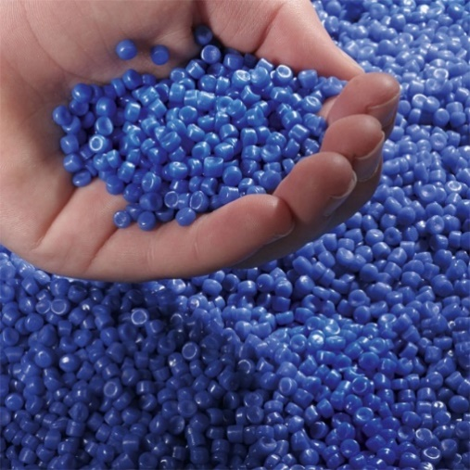

**Fig.14:- Polyvinyl Chloride (PVC)**

**Stainless Steel:** Stainless steel is a type of austenitic stainless steel, which is one of the most widely used and versatile types of stainless steel. Stainless Steel contains about 18-20% chromium and 8-10.5% nickel. Small amounts of carbon (less than 0.08%), manganese, and other elements are also present. It belongs to the austenitic stainless steel family, characterized by a face-centered cubic crystal structure, which provides excellent corrosion resistance and strength at both high and low temperatures. Stainless Steel is known for its excellent corrosion resistance in a wide range of environments, including corrosive media and atmospheric conditions. The presence of chromium forms a protective oxide layer on the surface, preventing rusting and corrosion.

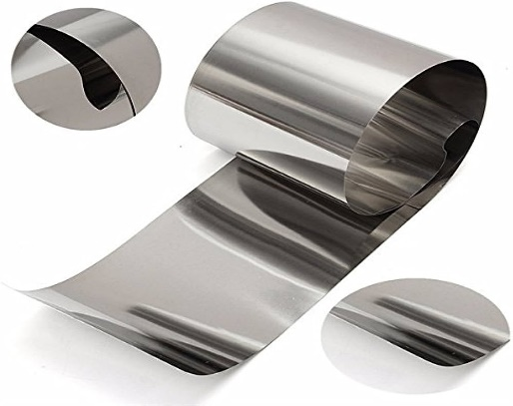

**Fig.15:- Stainless Steel**

**Costing:** Table.3 Total Costing of all the material

|  |  |  |
| --- | --- | --- |
| Material | Quantity | Cost |
| Pneumatic Connector | 5 | 400Rs |
| Pneumatic pipe (PVC) | 3 meter | 300Rs |
| Air Compressor | 1 | 2,000Rs |
| Tire pressure monitoring system | 1 | 1,400Rs |
| Custom Rotating Joint | 1 | 1,000Rs |
| Micro-Controller (ESP 32) | 1 | 300Rs |
| **TOTAL** |  | 5,400RS |

**5.REFRENCES**

1. Inderjeet Singh, Bhupendra Pratap Singh, Hari Shankar Sahu, Raunak Chauhan, Novel Kumar Sahu. To Study on Implementation of Tyre Inflation System for Automotive Vehicles.Volume 5 Number 4 2016.
2. Ajas.M.A, Aishwarya.T.G, Adersh Vinayak, Surya Balakrishnan, Janahanlal P.S. Tire Pressure Monitoring and Air Filling System. International Journal of Research in Engineering and advanced Technology. Volume 2 Number 2 2014.
3. Hemant Soni, Akash Lahurgade, Sourabh Relkar, SourabhBadhulkar. Automatic Tire Inflation System. Golden Research Thoughts Volume 3 Number 10 2014.
4. Kunjan Shinde, Sagar Asari, Vighnesh Nayak, Pranav Kadam and Anand Dalvi (Project on Vehicle Automation) Automatic Tire Inflation System.
5. Tawanda Mushiri, Allan T.Muzhanje, Charles Mbohwa. A Literature review on Design of an automatic tyre pressure inflation for small vehicles.
6. Harshal Junankar, Vishnusagar Bihare, Nishant Giradkar, Chetal Gupta. A review: Automatic Tire Inflation System, International Journal for Scientific Research and Development. Volume 3 Number 1, 2015.
7. Balashanmugam.P, Balasubramaniyam.K "Fabrication of high speed indication and automatic pneumatic braking system."International Journal of Engineering Trends and Technology 5 (2013): 40-46.
8. Jordan Lewis, Karthik B.M. "Fabrication of an Automated Collison Avoidance System Using Ultrsonic Sensor." Journal of Mechanical Engineering and Automation 06, no. 5A (2016): 97-101.
9. Rohit P Jain, Dr.V.Singh. "Automatic Hydraulic Bumper and Speed Limiting System." IJSRD-International Journal for Scientific Research & Development 03, no. 06 (2015): 357-361.
10. Shinde Abhijeet, Panase Prathmesh. "Automatic Pneumatic Braking System." IJSRD- -International Journal for Scientific Research & Development 04, no. 01 (2016): 806-809.
11. Patil Pratik, Pitale Chetan. "Study of Pneumatic Braking system with Pneumatic Bumper Protection." International Conference on Emerging Trends in Engineering and Management Research, 2016: 305-312.
12. Taoka, George T. (March 1989). "Brake Reaction Times of Unalerted Drivers" ITE Journal. 59 (3): 19–21.