MKT 4156 CW 2 Individual Report
Due Date: April 19th 2024
Word Count: 2,500
Weighting: 80%
Students are expected to respond to a project brief that covers the development of advertising and campaign, creation of content using different channels and evaluation of key metrics for measurement.
The content page of communication plan: 2500 words excluding tables, figures, appendices, and bibliographies
- Introduction
- Brand and its positioning
- Background to the job
- Campaign objectives and Measures
- Customers to be targeted/ Target Audience Analysis
- Key Messaging
- Creative strategy/ Big Idea
- Media plan
- Budgetary considerations
- Scheduling considerations
- Discussion of campaign effectiveness testing
- Conclusion

Appendix: Creative Brief, Mock up of your creative work
Deadline to Approve Creative Brief: April 3rd 2024

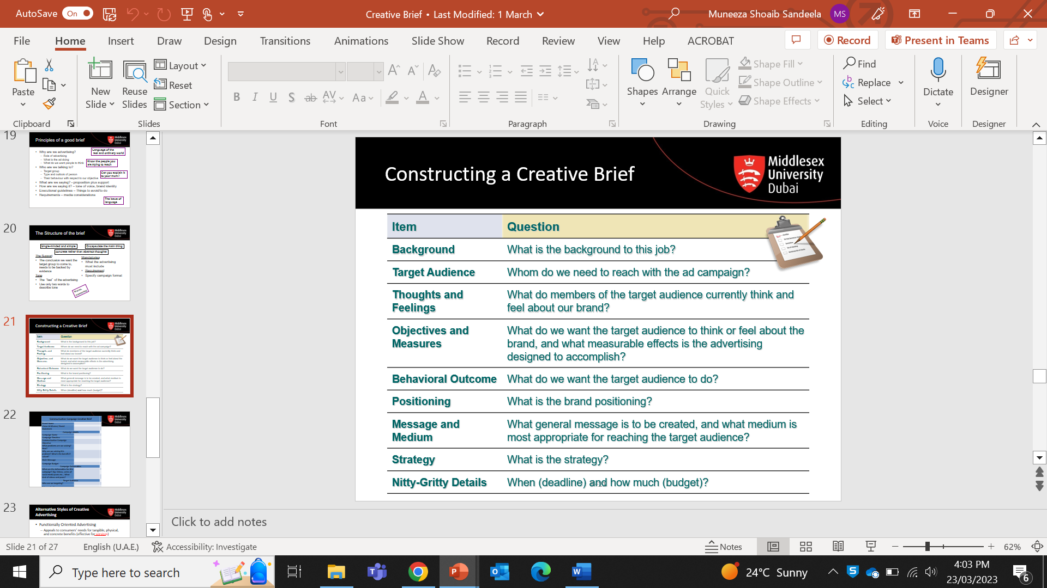

CW2 formatting requirements:
- Times New Roman or Arial font, size 12
- No double spacing
- Professionally presented and well bound
- Avoid repetition
- Sound grammar and spelling
- Use Harvard Referencing System

Assignment marking criteria rubric (Individual report)
Section/ criteria | 1-4 First | 5-8 Upper Second | 9-12 Lower Second | 13-16 Third | 17-20 Refer
Introduction: A clear rationale for the topic choice | Outstanding discussion and justification of topic selected | Thorough discussion and justification of topic selected | Evidence of some discussion and justification of topic selected | Adequate discussion and justification of topic selected | Discussion and justification of topic selected is inadequate
Discussion: Content:  relevant and informative, applying depth of knowledge and understanding | Excellent and well-informed understanding of theories and concepts involved | Good understanding of theories and concepts involved | Demonstrates satisfactory knowledge and understanding theories and concepts | Adequate content; limited depth of knowledge and understanding shown | Inadequate content; limited depth of knowledge and understanding shown
Conclusion:  Clear conclusions from the literature | Tightly structured, logical and draws coherent conclusions to the topics covered | Undertakes a systematic analysis of the issues and draws coherent conclusions to the topics covered | Sound conclusions to the topics covered | Adequate conclusions to the topics covered | Inadequate conclusions to the topics covered
References: Reference to sources including directions for further study | Broad and relevant readings examined and used selectively in the work | Good range of appropriate references used during the review | Conventional references and readings used within the review | Adequate but limited use of references during review | Review relies on no or one reference; evidence of unexamined personal opinion
Presentation:  Clearly presented with limited spelling and grammatical errors | Very well expressed and understanding of content with limited spelling or grammatical errors | Very well expressed; good understanding of content with some spelling and/ or grammatical errors | Well expressed; understanding of content with several spelling and/ or grammatical errors | Unclear expression of information; little understanding of content; several spelling and grammatical errors | Several spelling and grammatical errors

