Assignment Briefing
Module Name | International Business
Word Count | Minimum 1100 to Maximum 1500. References and appendix are excluded from word count. Font style – Times New Roman, Font text – 12, headers – 14

Assignment Task
A hypothetical UK company is considering entering a developed market, Canada, or Australia. The type of company including industry, size and products is up to you, but you will need to state clearly in your introduction the characteristics of your hypothetical company. Write a business report for this company’s top management detailing how the assessment of opportunities in these two countries should be done (i.e., what models, factors or data need to consider/included in the assessment). Discuss how the company could choose an appropriate entry mode using John Dunning’s Eclectic Paradigm to show how to enter the chosen country.
Checklist for the assignment
- Business introduction (product detail, product specification, presence in domestic market / country, company name) * company currently based in the UK.
- Internationalisation of the company (talk about why internationalisation [ is it market seeking, resource seeking, leveraging global network or mobility of product] followed by country risk in both the counties Canada and Australia – this has 4 types of risk political risk, economic risk, competitive risk and operational risk out of these 4 talk about the one which is dominant) also touch upon market and industry opportunity
- To evaluate further use Porter’s Diamond minimum 5 attributes, must be covered (in a table format, indicate information for both the countries Canada and Australia, analyse market for the product)
- Summarise the chosen country out of the two with arguments, why we think one is better than the other between Canada and Australia
- Use OLI Framework to define mode of entry (in a chart format advantages and disadvantages of that mode) {given modes of entry in my module – Import/Export, Licensing, Franchising, Management Contract, Joint Venture, FDI- Greenfield and Merger or Acquisition out of these give arguments pros and cons as to which mode will be best for my product}
- Summarise the decision on the favourable mode of entry with arguments.
- Conclusion- summarise all the decisions and state how these decisions will benefit my company also how will internationalisation help the company.
- References – research papers, newspaper article of valid sources supporting or proving my decisions (should be of 1 page at least and referencing style is Harvard Only)
- Appendix – Table and figures

Use relevant academic theories and models / terminologies in the essay wherever needed pertaining to international business but do not explain them.

Note the table that u create for the porters diamond you should put that in the appendix and only put the written conclusion in the main part since there is a word limit
This is a sample for your reference this table should be made and must have minimum 5 attributes and should come in the appendix Create a similar one for Canada and Australia with reference to my product and industry.

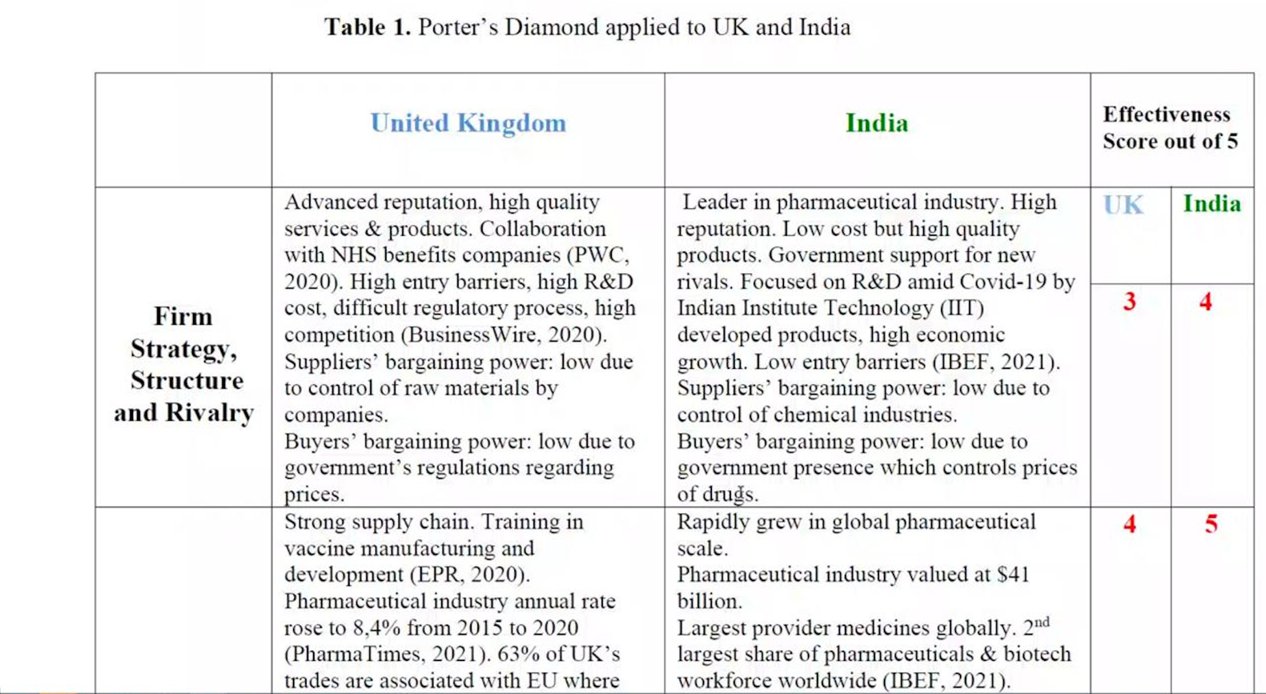

This is a conclusion table of the porters diamond a similar one should be made here she is scoring out of 10 above the score is out of 5 you can do either 5 or 10 doesn’t really matter but this should also be there, and this should be in the main part of assignment.
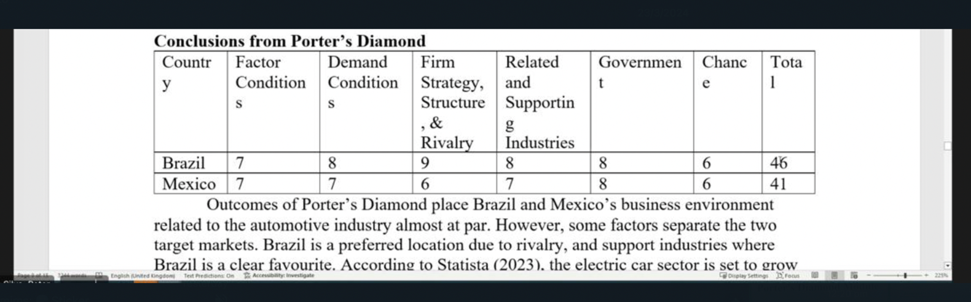

FOR OLI FRAMEWORK PLEASE REFER TO THIS FOR THE POINTS TO BE COVERED

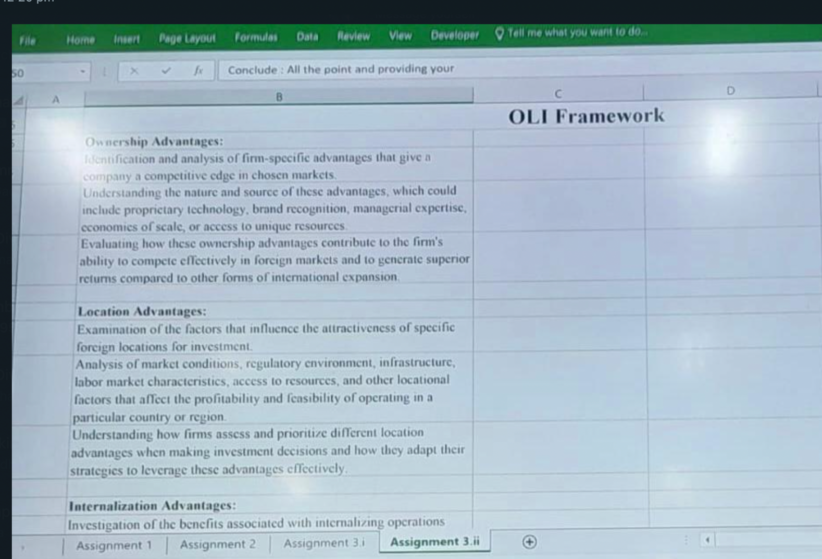
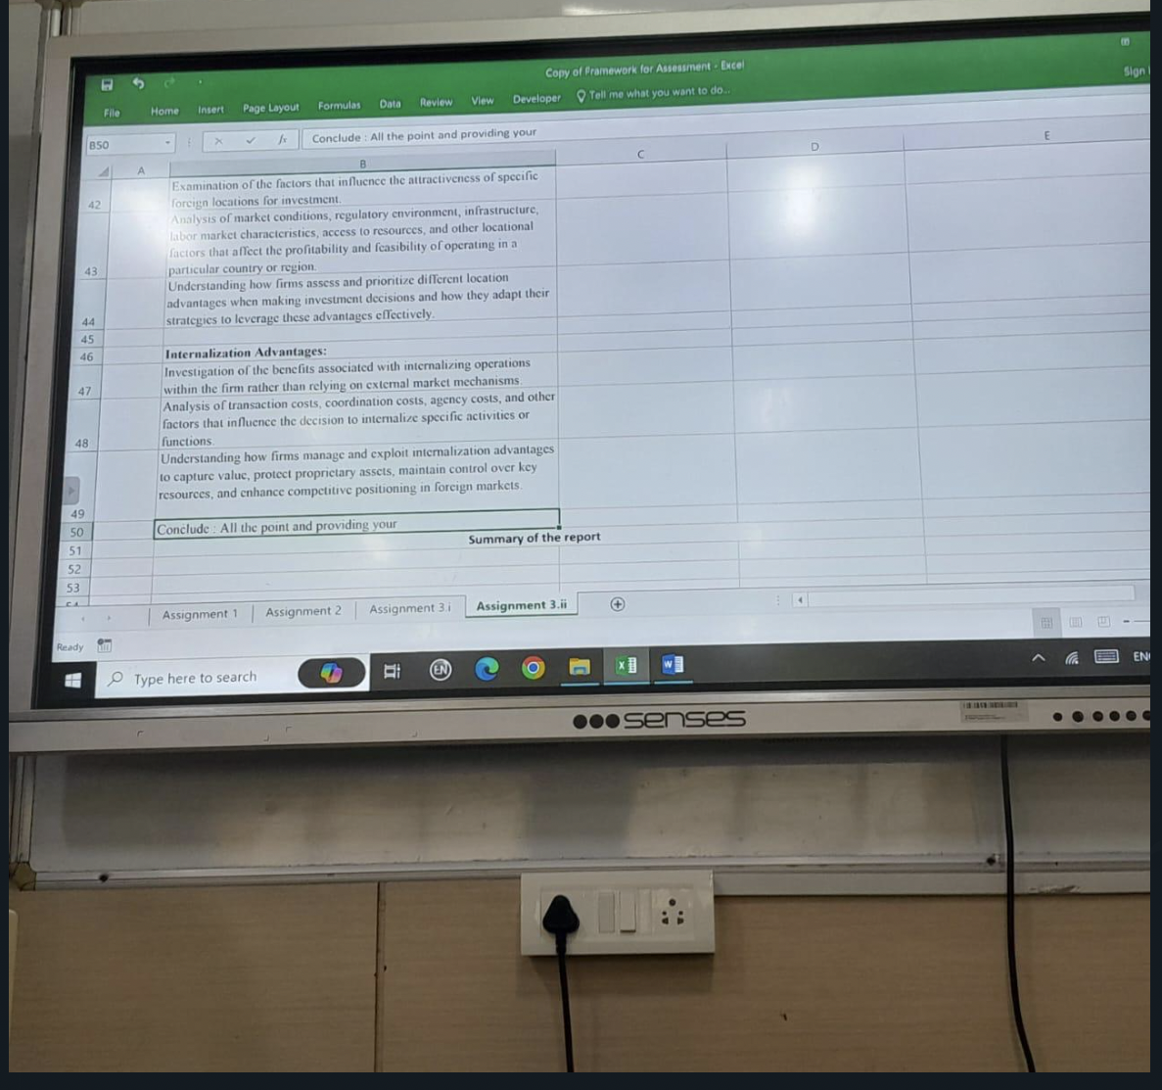

THIS IS AN EXAMPLE
