As you work these problems, consider and explain:

1. What type of question is it?
2. How do you know what type of question it is?
3. What information are you looking for?
4. What information do they give?
5. How will you go about solving this?
6. Show how to solve the problem.
7. Be able to answer for a different reaction, number, set of conditions, etc.

### Questions

Consider the following choices when answering questions 1–2:

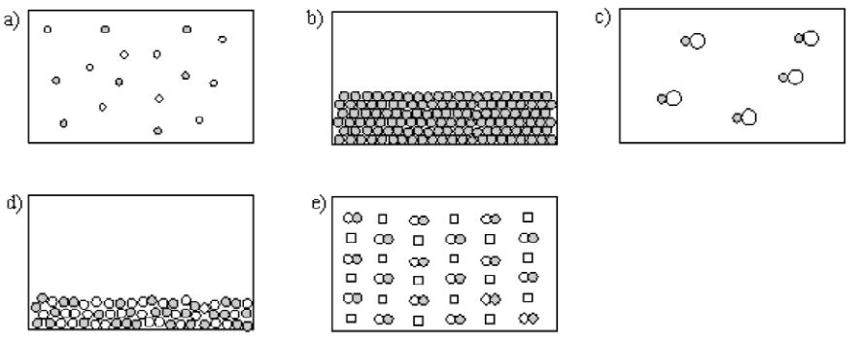

1. Which best represents a gaseous compound?
2. Which best represents a homogeneous mixture of an element and a compound?
3. A solution is also called a
   1. homogeneous mixture
   2. heterogeneous mixture
   3. pure mixture
   4. compound
   5. distilled mixture
4. An example of a pure substance is ________.
5. ________ are substances with constant composition that can be broken down into elements by chemical processes.
6. The state of matter for an object that has a definite volume but not a definite shape is ________.
7. Explain if the boiling of water is a physical or a chemical change and why.
8. The melting point of a certain element is 391°C. What is this on the Fahrenheit scale?  
   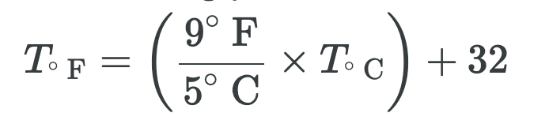
9. What is 409 Kelvin in Fahrenheit and in Celsius?
10. How many grams are in 8.1 kilograms?
11. Consider the following three archery targets:  
    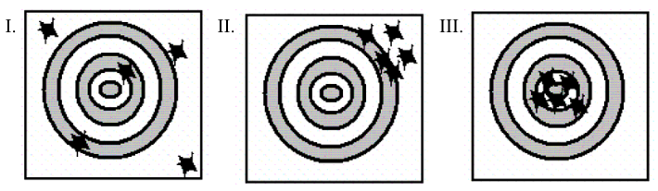  
    Which of the figures represent a result with high precision?
    1. Figure I only
    2. Figure II only
    3. Figure III only
    4. Figure I and Figure III
    5. Figure II and Figure III
12. As part of the calibration of a new laboratory balance, a 1.000-g mass is weighed with the following results:

| **Trial** | **Mass** |
| --- | --- |
| 1 | 1.201 ± 0.001 |
| 2 | 1.202 ± 0.001 |
| 3 | 1.200 ± 0.001 |

The balance is

* 1. Both accurate and precise.
  2. Accurate but imprecise.
  3. Precise but inaccurate.
  4. Both inaccurate and imprecise.
  5. Accuracy and precision are impossible to determine with the available information.

1. A scientist obtains the number 0.045006700 on a calculator. If this number actually has four (4) significant figures, how should it be written?
2. Express the number 0.000333 in scientific notation.
3. Express 165,000 in exponential notation.
4. You are asked to determine the perimeter of the cover of your textbook. You measure the length as 39.36 cm and the width as 24.83 cm. How many significant figures should you report for the perimeter?
5. Consider the numbers 23.68 and 4.12. The sum of these numbers has experting significant figures, and the product of these numbers has stimulating significant figures.
6. How many significant figures are in 0.00110?
7. Convert 0.3980 m to mm.
8. The distance of 21 km equals how many meters?
9. Convert 59.4 mi to km. (1 m = 1.094 yard, 1 mi = 1760 yd)
10. For spring break you and some friends plan a road trip to a sunny destination that is 2105 miles away. If you drive a car that gets 33 miles per gallon and gas costs $3.199/gal, about how much will it cost to get to your destination?
11. Convert 7.9 kg to lb. (1 kg = 2.205 lb)
12. A wavelength of red light is measured at 655 mm. What is this measurement in cm?
13. A 20 mL sample of glycerol has a mass of 25.2 grams. What is the mass of a 57-mL sample of glycerol?