MECH 5130 Theory of Finite Element Method Scott Stapleton

Homework 5: Load Vector

**Complete (1), (2) and (3a) for pre-homework submission.**

1. Create a “bubble diagram” of the functions needed for this homework. Make sure to find the most abstract tasks and create one bubble chart that works for both elements. Show the interdependency of the functions, using arrows connecting functions as shown below, where an incoming arrow should be labelled with the inputs for the function and an outgoing arrow labeled with the outputs. Indicate in RED the functions which will need to be customized for each element.

Function Name 1

Brief description of what function does or key equations

Function Name 2

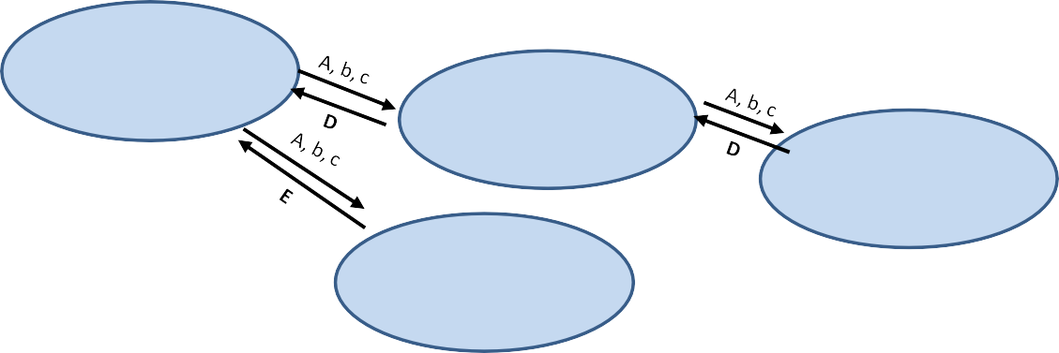Brief description of what function does or key equations

Function Name 3

Function Name 4 Brief description of what

function does or key equations



Brief description of what function does or key equations

1. Write pseudo-code for each of the new functions in the bubble chart. Get to enough detail that you have worked out all the indices and dimensions of any arrays needed. Look up key functions needed and show that the arrays you give to the functions are in the right form.
2. 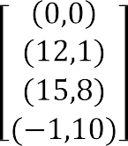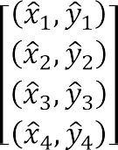For the 4-noded 2-D element shown below (*E*=70,000, 𝜈𝜈=0.33, plane stress, 𝑡𝑧 = 1.3).



4

3



1 2

* 1. Derive the force vector for 𝑓𝑠 (𝑥) = �𝑓0 + 𝑓1𝑥� in terms of the nodal locations, 𝐱𝐱�, the natural

𝑓2 + 𝑓3𝑦

coordinate 𝜉 and the thicknesses without performing the integral. How many integration points would you need to get an exact vector using Gaussian Quadrature?

* 1. Find the force vector using 𝑓0 = 4, 𝑓1 = 3, 𝑓2 = 5, 𝑓3 = 1, and the nodal coordinates above. (Hint: use this as a unit test)

1. For the 8-noded 2-D element shown below (*E*=70,000, 𝜈𝜈=0.33, plane strain, 𝑡𝑧 = 1.3), find the force vector. State which degree of integration you used and why. State whether the integral solution is exact or not.

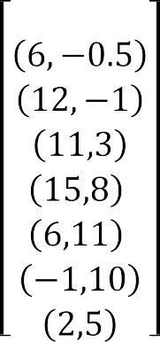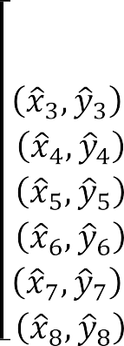





8 4

1 2 3

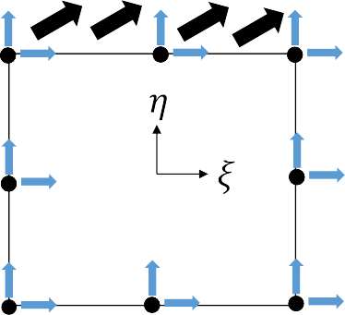

7

6

5