Assignment

You will be given two scenarios which you must respond to based on a given energy mix.

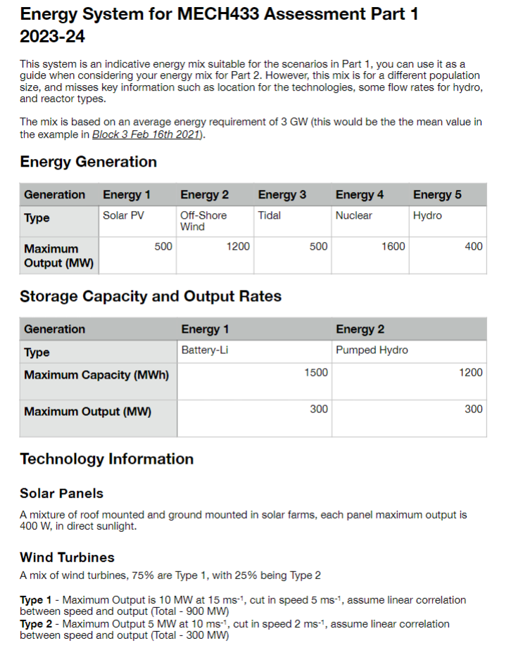

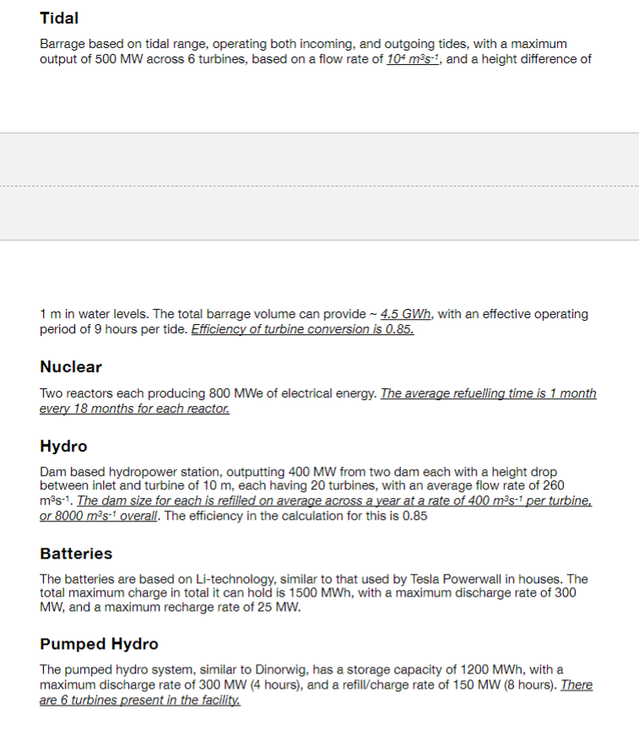

The scenario weather conditions are broadly based on the conditions observed on the dates in question.

You need to complete the following:

*****For the system******- Critically appraise the energy system design, is it suitable to provide expected demand across the day/month/year? Back up your response with suitable justification, if you think there is a flaw highlight it. (< 1000 words)*

*****For each scenario******- How would/could the energy system meet the scenario? If it cannot maintain supply for the scenario, why? What changes would you make the mix to enable it to meet the scenario, or what could you do with regards to demand management to meet the scenario? (each < 1000 words)*

****Suggestions****

* Read carefully the scenario and take note of the comments on the criteria as they have been set
* Carefully consider what changes you would make to your system, critically appraise your system and discuss options that could be used.
* Look at the information in the energy mix, and pay close attention to the date given (useful for solar).
* Strongly advise not to use AI to help critically appraise, it won’t help very much.

For a normal demand cycle across a day, you can use the example one in Block 3 as a guide (the one for 16th of Feb 2021). More information on solar output during a day, can be also be found in Block 3.

****Point of Clarification****: If you have a scenario that refers to a drop in capacity, such as 30%, it is 30% of the facilities, ie 30% of the wind turbines, not the overall output. For nuclear power as there are two plants, the lowest drop you would have is 50%, as it is the facility that is down ****NOT**** the output.

****Scenario 2****

Your generation system has been cyberattacked with 40% of your generation capacity affected, and unable to supply electricity for 18 hours. This attack occurs at 9am on December 13th 2022, where the daytime temperature drops to 1º C, the overnight temperature drops to -3º C with an average wind speed of 3 ms-1. The relevant tide times are high tide at 9:30am and 22:00, and the low tides are at 15:30 and 03:40 (14th). The daytime conditions for the 13th are mainly cloudy with only 2 hours of cloud free daylight.

The 40% drop is across all your generation technologies, and is a reduction in your capacity.

You are required to respond to this scenario in a manner that reduces the impact on the well being of the population. You can use demand management for this scenario, as long as it does not put at risk human health and safety.

****Scenario 3****

A major sporting event occurs at 8pm on July 16th 2022, this event leads to a short term increase in demand of 50%, for 3 hours due to the event being shown live on TV, but this corresponds to a shutdown for maintenance equal to 20% of total generating capacity. The average wind speed at this time is 3 ms-1, with the skies being cloudy. The tidal times are high tide at 21:30, low tide 15:40 and 04:00 (17th July).

The 20% of your capacity down for maintenance is taken across all your technologies. Demand management cannot be used for this scenario, and it must not impact household energy use.