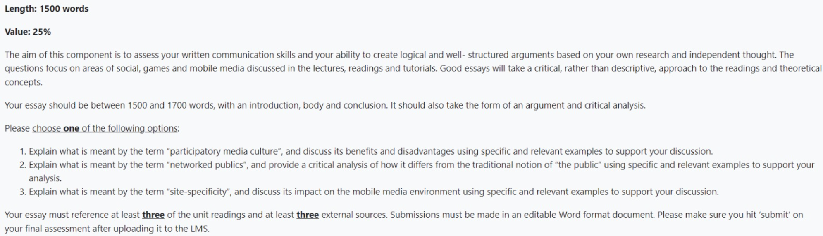

Question One: Explain what is meant by the term “participatory media culture” in relation to its benefits and disadvantages.
Introduction
A sense of direction about the essay, state the argument (stance) (no references – no citations) – 100-150 words
Body
Define participatory media culture – 2/3 references – social media / gaming
Examples of participatory media culture (Henry Jenkins) – what is it? Since when? What is the impact?
What are the benefits? – example / case study
What are the disadvantages? – example
What is your argument – critical analysis? Do you argue negative or positive? Not too descriptive.

Conclusion
Summarise your essay (arguments) and your stance (no references – no citations) )200-250 words

