Build an AI model for detecting “HEART DISEASE” based on images.

- Scope Statement and Objectives
The aim of this project is to develop an AI model for the detection of “heart disease” based on medical images. This AI model analyzes the medical images and provide accurate diagnoses, which helps assisting the healthcare professionals in early detection and treatment planning.
Objectives:
- Train the Convolutional neural network (CNN) model on a different dataset of medical images.
- Optimize the model for providing high accuracy in disease detection.
- Validate the model’s performance using different test datasets.
- Deploy the model in a user-friendly interface for healthcare professionals for use.
- Project Timeline/Schedule
- Week -1: Data collection and Preprocessing
- Week 2-3: Train the model and development
- Week 4-5: Model optimization and validation
- Week 6-8: Creating a User-friendly interface.
- Week 9: Testing and deploying in production.
- Documentation: Ongoing throughout the project

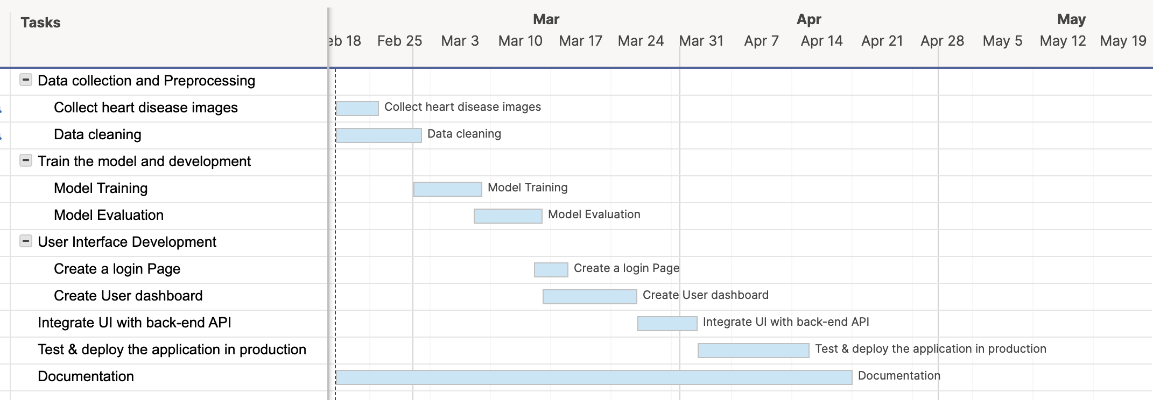

- Budget
Role | Estimated hours | Hourly Rate | Total Cost
Project Manager | 100 | $100 | $10000
Software Developers | 250 | $90 | $22500
Data Scientist | 300 | $80 | $24000
Healthcare Professional | 50 | $150 | $7500
QA Specialist | 100 | $100 | $10000
Total Cost |  |  | $74000

Additional Expenses:
Cloud Cost: $200 - $300
Data Acquisition and Licensing fees: Variable
- Requirements
Functional Requirements:
- Users will be able to upload images in the format of JPEG, PNG.
- The User Interface should be able to support uploading single or multiple images.
- UI should provide the feedback of uploaded image either it is successfully uploaded or not.
- Train the CNN Model for detecting the “heart disease” by using different images.
- AI model should classify/separate the images into diseases or healthy categories.
- Make sure the model is trained to handle different imaging modalities like X-rays, MRIs.
- Deploy the trained model and integrate with UI for accessible to users.
Non-Functional Requirements:

- This website should process the images faster and provide results within shorter time.
- Create a mechanism that can process automatic error detection and store it in logs.
- Implement security standards to protect patient’s data and prevent unauthorized access.
- Make sure that this system follows GDPR rules related to healthcare systems.
- Create a website user-friendly that requires minimal training for healthcare professionals and users.
- Provide technical support and troubleshooting assistance to users, healthcare staff.

Software Requirements:
- Deep learning framework: TensorFlow
- User Interface development tools: HTML, CSS, JavaScript, Python
- Project Tracking Tool: Trello
- Data/Project Storage: GITHUB
- Quality Criteria/ Success Criteria
- Model can handle variety of input medical image formats and resolutions.
- It should meet sensitivity and specificity metrics as per the industry standards.
- User interface should be friendly and easy to use.
- Model accuracy should be above 90%.
- Project Resources
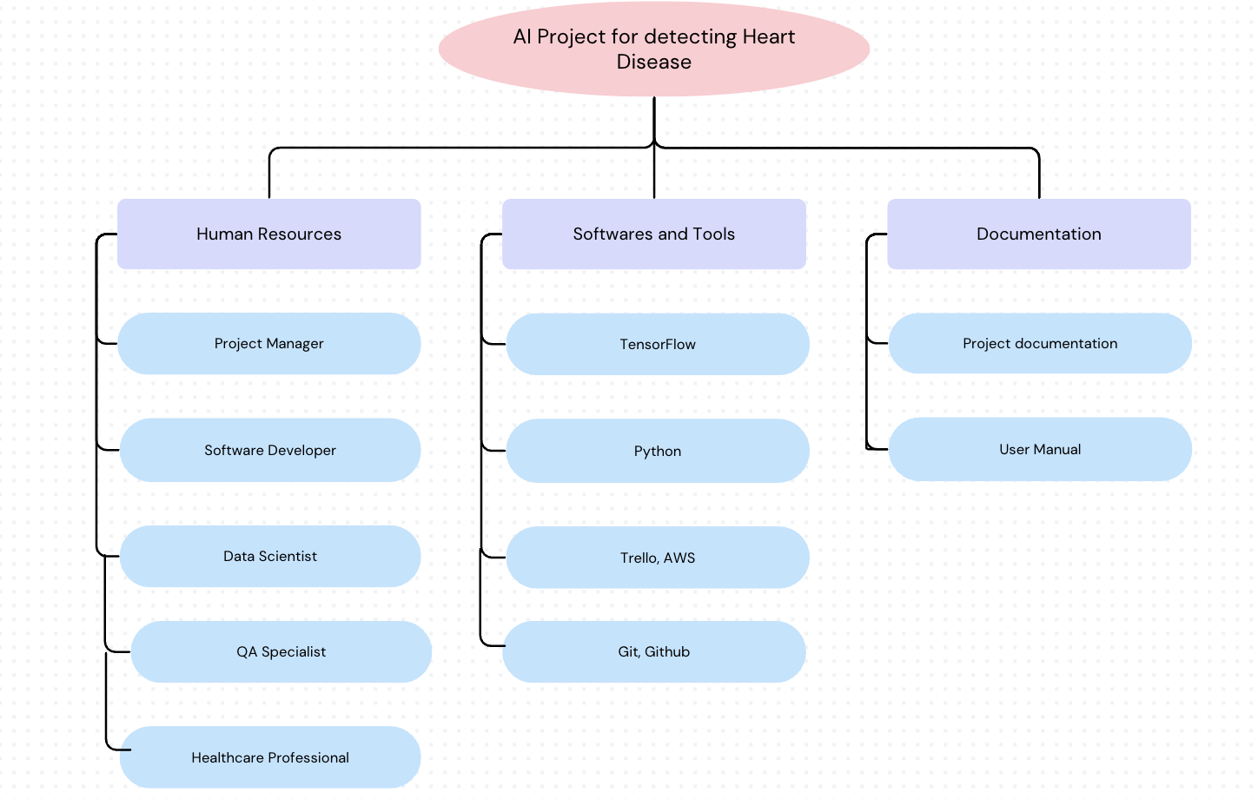
- Stakeholder list
- Project Sponsor
- Project Manager
- Data Scientist
- Software Developer
- Healthcare Professional
- QA Specialist
- End Users
- Risk Management
Identification of Risk:
Problems with Data Quality:
An incomplete or wrong labeling of medical images may result in biased model training and incorrect disease detection.
Impact: High
Mitigation: We will use data augmentation techniques, domain experts in labeling, and stringent data quality checks to address this.

Overfitting of the model:
The model may have overfitted to the training set, which would have resulted in poor generalization to new images.
Impact: moderate
Mitigation: We will use early halting during model training, cross-validation, and regularization techniques to help reduce this.
Concerns Regarding Regulatory Compliance:
When healthcare regulations (such as HIPAA and GDPR) are broken, there could be legal consequences.
Impact: High
Mitigation: To handle problems with regulatory compliance, we will thoroughly audit the situation, engage legal professionals, and review and update compliance procedures on a regular basis.
Changes in Project:
Project timeliness and resource management may be impacted by ambiguous or frequent changes in project scope.
Impact: Moderate
Mitigation: To handle changes to the project's scope, we will develop a change management protocol, have clear communication with stakeholders, and keep track of all scope modifications.

Risk Analysis:
Problems with Data Quality: Moderate likelihood, high impact.
Overfitting of the model: High likelihood, moderate impact.
Concerns Regarding Regulatory Compliance: Low likelihood, high impact.
Changes in Project: Moderate likelihood, moderate impact.

Risk Prioritization:

Priority 1: Problems with Data Quality
Priority 2: Overfitting of the model
Priority 3: Concerns Regarding Regulatory Compliance
Priority 4: Changes in Project

Response Plans:
Problems with Data Quality: Involve domain experts in data labeling and apply stringent quality checks. Increase the diversity of your datasets by using data augmentation techniques. Perform routine dataset audits and adjust labeling as necessary.
Overfitting of the model: Make use of regularization strategies like weight decay and dropout. Use cross-validation to evaluate the performance of the model on unknown data. Keep a close eye on the model's performance during training and tweak the hyperparameters as necessary.
Concerns Regarding Regulatory Compliance:
- Stay informed about relevant healthcare regulations (e.g., HIPAA, GDPR).
- Involve legal experts to ensure compliance with regulatory requirements.
- Conduct regular audits to identify and address any compliance issues.
Changes in Project: Create a change management procedure to assess and rank modifications to the scope. Manage expectations by having effective communication with stakeholders. Keep track of all scope adjustments and their effects on the project's resources and schedule.

- WBS
- Data Collection
- Data Preprocessing
- Model Training
- Model Evaluation
- User Interface Development
- Model Deployment
- Testing and Quality Assurance
- Documentation
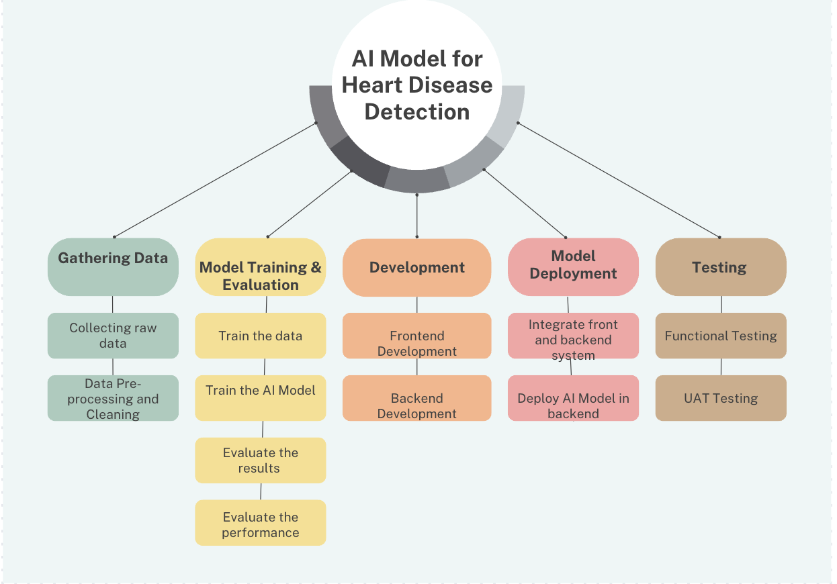

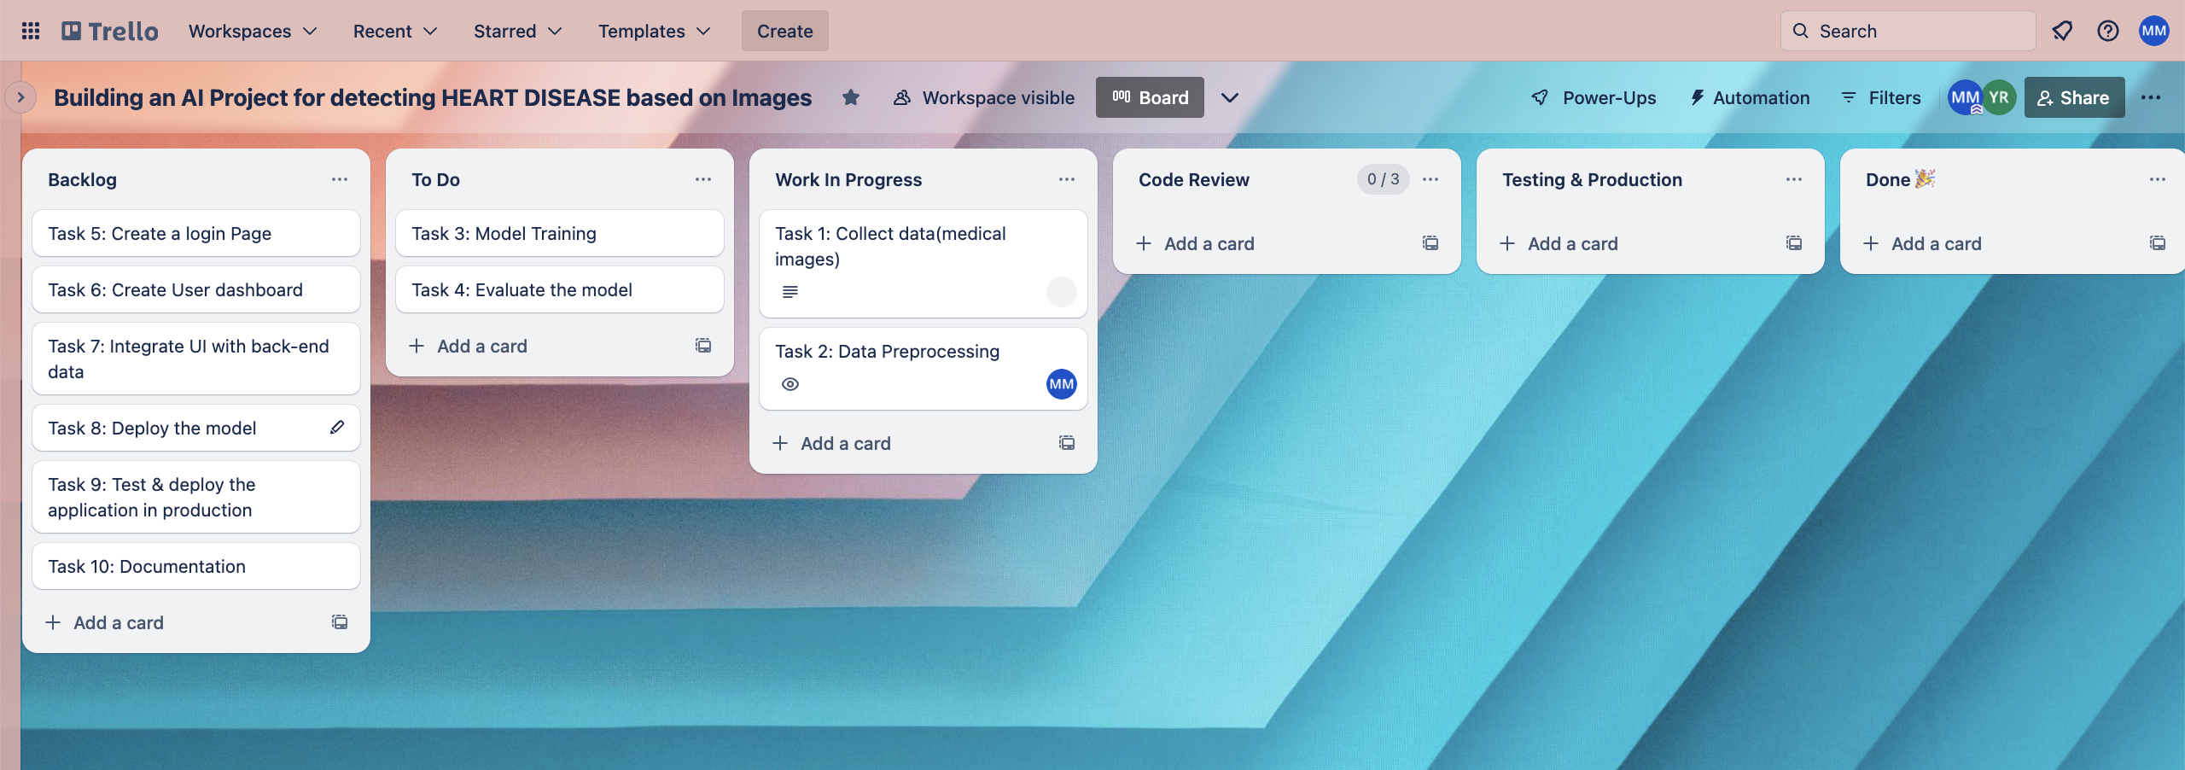
- Responsibility Assignment Matrix

Task | Data Scientists | Software Developers | QA Specialist | Healthcare  Professionals | Project Manager
Data Collection | P
Data Preprocessing | P
Model Training | P
Model Evaluation | P |  |  | A
UI Development |  | P
Model Deployment | S | P
Testing and QA |  |  | P
Documentation | P | P | S | S, A | A
P = Primary responsibility
S = Secondary responsibility
A = Approval

