Refer to step one preamble requirements as all elements in Step One fully apply to step two.

**1. Define your website strategy.**

**Part A**

* Name and explain The E-Commerce *hosting/platform* you will use and why.

**Part B**

* Name and explain the hosting /platform website *template* you will use and why.

**Part C**

* Explain how this chosen template *appeals* to your target market segment / persona.

**Part D**

* Create, develop, and present your own *example* using this website template featuring the assigned product. (Include this in the formal part of your presentation, not in your appendices)

**Part E**

* Based off your target market segment / persona analysis - What type of messages/content will you post on your website that will appeal to them?

**Part F**

* Explain how you will create positive eWOM, or C2C or EARNED media with a few examples of specific activities you will employ. *(NO theory here – I want real implementable activities that will encourage followers to share content about your business/product.)*

Please READ the Wikipedia Links provided as these are provided to remind you of the marketing terms and concepts you should be using in this presentation. Each link directly relates to a specific section of the marketing plan and is designed to help you achieve the best grade possible.

Please read the website types explained in the link [Wikipedia website](https://en.wikipedia.org/wiki/Website)

**2. Define your pricing strategy.**

Explain your pricing strategy and why it will be effective with your target customers. (Do not simply copy what is already posted for the assigned product with regards to pricing, be able to defend your choice(s). Depending on your target audience, you may have different pricing strategies.

**Part A**

* List your retail selling price in Canadian dollars.

**Part B**

* List the **ONE** or **BEST** pricing model you plan to use that will resonate best with your target audience. *(Remember this is a one-year plan and multiple strategies will only confuse your target audience.)*

**Part C**

* Explain why this pricing model is appropriate for your target market / persona.

**Part D**

* Describe any influences that may change or influence your pricing structure. *(This may include bulk purchase discounts, paying in advance, installments or financing, customer accounts…)*

NOTE: Ensure that your pricing strategy enables you at least to return the seed capital at the end of the first year of operation.

Please read the various pricing models explained in the link [Wikipedia Pricing Strategy](https://en.wikipedia.org/wiki/Pricing_strategies)

**3. Define your distribution / fulfillment strategy.**

Distribution / fulfillment strategy refers to the process of tangibly getting your product, using a 100% online website business model, to your customer. ASSUMPTION: Customers will only order one product and not multiple. (NOTE: ***NO drop shipping is permitted***. You must take **ownership** of the products you plan to sell, warehouse the items, and manage your inventory in conjunction with your online orders.)

Clearly outline how you will fulfill your online orders. This must include all aspects from the moment the order has been received online to the moment the customer receives the item in their hands. Please address the following:

**Part A**

* Which shipping service will you use from your warehouse to the customer’s location and explain why this service is best.

**Part B**

* Who pays for shipping? Is it you, the customer, or some combination of these two options? Explain why you have chosen this approach.

**Part C**

* Shipping costs to ship one item of the assigned product for sale, to the two addresses listed below using your chosen shipper using the lowest cost option.
  + - 1925 Indian River Crescent, North Vancouver, BC V7G 2P8
    - 100 Great Eastern Avenue, St. John's, Newfoundland, A1B 0J7

**Part D**

* Shipping cost alternatives available to the customer for faster shipping times to overnight shipping if available from your shipper of choice. Outline these costs in Canadian dollars.

**Part E**

* Detailed Flow Chart Diagram that assumes you have inventory-at-hand that includes:
  + All steps / processes in your fulfillment process.
  + Time associated with each step / process.
  + How often will shipments be shipped each week to your shipper of choice.
  + Total number of days for the entire process with timelines shipping to the following two addresses – one local and one far away:
    - 1925 Indian River Crescent, North Vancouver, BC V7G 2P8
    - 100 Great Eastern Avenue, St. John's, Newfoundland, A1B 0J7

**Part F**

* Explain if the total number of days, for the lowest cost option, to ship to the 100 Great Eastern Avenue, St. John's, Newfoundland, A1B 0J7 address and explain if this is acceptable to your target market /persona based on your research. If not, what are your options?

Please read the various distribution strategies and order fulfilment links in Wikipedia: [Order Fulfillment](https://en.wikipedia.org/wiki/Order_fulfillment) and [Wikipedia distribution strategy](https://en.wikipedia.org/wiki/Distribution_(marketing))

**4. Define your Marketing Channel strategy.**

Over the course of [*current year*], we will launch/ramp up our use of the following channels for educating our customers, generating leads, and developing brand awareness:

**NOTE:** social media platforms are tools to deliver messages – **not strategies**. Go deeper to address how social media is utilized to define your message and distribute to a targeted audience. Develop your campaign ideas, uses of #hashtags, a list of influential @followers that refine and articulate your overall *social media strategy*.

**Part A – Marketing channels table**

Complete the table below as it pertains to your “owned” **Website / Publications / Social Media Platforms; Hard Metrics to Measure Success of each channel; and the significance or purpose of this activity to your target market for each channel.**

|  |  |  |  |
| --- | --- | --- | --- |
| **Channels** | **Purpose of the Channel** | **Metrics to Measure Success** | **Significance to your target market** |
| Website:  *(product pages, catalogs, descriptions, content to promote your product)* | [Example: Brand Awareness] | [Example: 50,000 unique page views per month] | [Example: according to research by Stanford University, 75% of users judge a company's credibility based on its website design. *]  [Example: 84% agree that a website makes a business more credible. *] |
| Social Platform #1 *(name of SM platform goes here)* | [Example: Brand Awareness] | [Example: 50,000 unique page views per month] | [Example: Research indicates that the primary, 90%, SM platform used by this persona is Instagram **] |
| Social Platform #2 | [Example: Conversion] | [Example: 50,000 unique page views per month have a conversion rate on Tik Tok 1.1%] *** | [Example: Research indicates that the secondary, 60%, SM platform used by this persona is TikTok] |
| Social Platform #3 |  |  |  |
| *Add other channels as needed* |  |  |  |

Citations:

* <https://www.linkedin.com/pulse/15-essential-web-design-statistics-every-business-owner/>

** <https://founderpal.ai/user-persona-generator?persona=79VCVCCNMY>

*** [https://upbeatagency.com/tiktok-ads-conversion-rates/#:~:text=The%20average%20TikTok%20ad%20conversion,vary%20wildly%20between%20different%20sectors.](https://upbeatagency.com/tiktok-ads-conversion-rates/%23:~:text=The%20average%20TikTok%20ad%20conversion,vary%20wildly%20between%20different%20sectors.)

*NOTE: See Publications information at the end of this document for more detail.*

**5. Define your Online Promotion Strategy and Costs**

Online advertising strategies have the same purpose, to educate online consumers and persuade them to buy a product.

“Over the course of the [current *year*], given the cash allotted to the Marketing team, we expect to invest in the following items to ensure we meet the objectives outlined in this marketing plan.”

**Part A – Push/Pull Strategy**

Explain which strategy, Push or Pull, is appropriate for your B2C business model and why this is appropriate.

**Part B – Influencer table**

|  |  |  |  |  |  |
| --- | --- | --- | --- | --- | --- |
| **Influencer Name / Specialization*/link** | **Category\*\***  **/Followers** | **SM Platform** | **Significance to your target market** | **Estimated Annual Cost with Proof** | **Total Annual Forecasted Unit Sales** |
| [***Example****:* [@bostondynamicsfan](https://hypeauditor.com/instagram/bostondynamicsfan/)]1 / robotfluencer | Micro / 358.4K | IG | [Example: The Engagement Rate is 0.60% for @bostondynamicsfan] |  |  |
| Influencer # 2 |  |  |  |  |  |
| Influencer # 3 |  |  |  |  |  |
| Etc. |  |  |  |  |  |

*Specialization: finfluencers, skinfluencers, petfluencers, etc.

**Category: Nano(10K), Micro(100K), Macro(1M) or Mega(>1M).

Citation: 1 <https://hypeauditor.com/instagram-category-robotics/>

Links: @bostondynamicsfan <https://www.instagram.com/bostondynamicsfan/?hl=en>

Please read [social media strategies](https://en.wikipedia.org/wiki/Social_media_marketing) explained in the link as well as [Social Media](https://en.wikipedia.org/wiki/Social_media) and [Online Advertising](https://en.wikipedia.org/wiki/Online_advertising)

**Part C – Online Promotional Mix table**

Define how you will introduce, promote, and support your products in the marketplace using the table below. What will you highlight about your business/products. Consider campaigns, messaging, advertisements that can connect you with your audience.

Online advertising may include any of the following: Affiliate Marketing; Display advertising; Email Advertising; Content Marketing; SEM Campaigns; SEO; Digital PR; Video Advertising; Mobile Advertising; and *Social Media & Influencer Marketing (Both of which have already address in Section 4 Marketing Channels so do not repeat that information here)*

*See* *Promotional mix information at the end of this document for more detail.* Citation: <https://www.webfx.com/digital-advertising/learn/best-online-advertising-strategies/#39-1>

|  |  |  |  |  |
| --- | --- | --- | --- | --- |
| **Promotional Strategy** | **Purpose of the strategy** | **Hard Metrics to Measure Success** | **Estimated Annual Cost with Proof** | **Total Annual Forecasted Unit Sales** |
| [***Example****:* *Display advertising* on Google search for Social Robots] | Exposure / Awareness / Conversion | *CTR of 6.11%  *CPC of $4.22  *Conversion rate of 7.04% | [***Example:*** Budget of $500 per month at 100% utilization yields $500/$4.22= 118 Clicks. At a conversion rate of 7.04% 8 sales per month should occur.] |  |
| [***Example****:Affiliate Marketing* |  |  |  |  |
| [***Example****:Email Advertising* |  |  |  |  |
| [***Example****: Digital PR* |  |  |  |  |
| [***Example****:SEM Campaigns* |  |  |  |  |
| [***Example****:Video Advertising* |  |  |  |  |
| [***Example****:Mobile Advertising* |  |  |  |  |
| [***Example****:* etc. |  |  |  |  |
|  |  |  | ***[Add up all promotional costs for the current Year and put your total here. Each Advertising Strategy will be a separate line item reflected in your pro-forma spreadsheet and the numbers here must be identical to those in the pro-forma.*** |  |

*Citation: <https://www.wordstream.com/blog/ws/2023/05/15/google-ads-benchmarks>

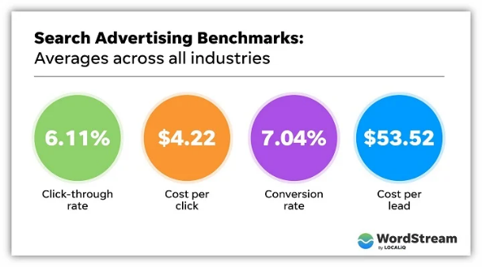

**Part D - Make your personas ACTIONABLE.**

**(Source:** [**https://founderpal.ai/user-persona-generator?persona=79VCVCCNMY**](https://founderpal.ai/user-persona-generator?persona=79VCVCCNMY)

Now that you have information about your *Persona* from Step One of the Marketing Plan AND information about your *Advertising Strategy* from the table and analysis above, combine this information to make your persona **actionable** bydeveloping THREE IDEAS that you could implement in the first year of operation.

**Example:**

***User Acquisition Idea 📣***

*• Partner with student organizations and online learning platforms to promote the social robot companion as a valuable tool for enhancing remote learning. Offer special discounts or incentives for students who join through these partnerships.*

***Conversion Rate Optimization Idea 💸***

*• Implement a referral program that rewards students for referring their classmates to purchase the social robot companion. Offer incentives such as discounts exclusive content or even cash rewards to encourage word-of-mouth marketing.*

***Content Marketing Idea 💌***

*• Create a series of YouTube videos featuring tutorials and demonstrations of different ways the social robot companion can assist students in their learning journey. Cover topics such as personalized study plans interactive quizzes and virtual study groups.*

The following [Wikipedia Online Advertising](https://en.wikipedia.org/wiki/Online_advertising) link may help.

The following [Public Relations](https://en.wikipedia.org/wiki/Public_relations) link may help.

**7. Define your after the sale strategy.**

“Over the course of [*current year*], we will launch/ramp up our use an after-sales strategy for educating our customers, generating leads, developing brand awareness, remarketing, email, order confirmation, etc.”

Define how you will introduce After-Sales activities to support your products in the marketplace using the table below.

|  |  |  |  |  |
| --- | --- | --- | --- | --- |
| **After Sales Strategy** | **Purpose of the strategy** | **Hard Metrics to Measure Success** | **Estimated Annual Cost with Proof** | **Total Annual Forecasted Unit Sales** |
| [***Example****:* *Remarketing on* Google] | Awareness / conversion | *CTR of 6.11%  *CPC of $4.22  *Conversion rate of 7.04% *Plus 10% = 7.74%* | ***Example:*** average cost for remarketing on Google is $0.66 to $1.23 per click. The average is $0.95.  25% of the display advertising budget of $500 per month is $125 per month for remarketing. At 100% utilization yields $125/$4.22= 29 Clicks. | **Example:** At a conversion rate of 7.74% 2 sales per month should occur. Therefore, 2 X 12 = 24 sales generated per annum. |
| [***Example****:* etc. |  |  |  |  |
|  |  |  | ***[Add up all Advertising costs for the current Year and put your total here. Each Advertising Strategy will be a separate line item reflected in your pro-forma spreadsheet and the numbers here must be identical to those in the pro-forma.*** |  |

Citation: [https://www.webfx.com/ppc/pricing/google-remarketing/#:~:text=Our%20Happy%20Customers-,How%20much%20does%20Google%20remarketing%20cost%3F,however%2C%20that%20these%20are%20averages.](https://www.webfx.com/ppc/pricing/google-remarketing/%23:~:text=Our%20Happy%20Customers-,How%20much%20does%20Google%20remarketing%20cost%3F,however%2C%20that%20these%20are%20averages.)

*Source: The click-through rate (CTR) of a retargeted ad is 10x higher than the CTR of a typical display ad. [Source: AdRoll] The engagement advertisers can get from retargeting is significantly larger. While the average CTR for display ads is 0.07%, the average for retargeting ads is 0.7%.

Source:

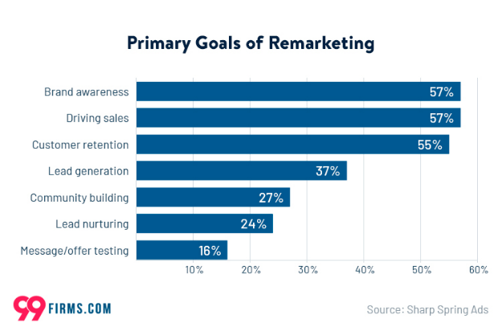

#### Source: Retargeting can increase conversion rates up to 10% across industries.

Source: For most brands, we recommend putting 60-90% on prospecting budget toward prospecting, with the remaining 10-40% toward retargeting. Using an average of 25% of the budget for remarketing for use in table above.

**8. Define your content calendar strategy?**

Over the course of a **typical Week** **Only**, our content calendar will be our map as to what, when, how, where we will employ a specific marketing activity to help achieve our sales goals and objectives. Please do so for only one week.

Choose a week in the year that has a variety of activities / posts that support your products in the marketplace using the table below.

**A social media calendar is an overview of your upcoming social media posts, organized by date.** Social marketers use content calendars to plan posts, manage campaigns, and review ongoing strategies. Complete the table below to outline how you will map out your marketing activities using the information from your Website, Marketing Channels, Social Media, Promotion, and after-sales strategies.

**Part A – Content Calendar Table**

|  |  |  |  |  |  |  |
| --- | --- | --- | --- | --- | --- | --- |
| **Post** | **Social Network / Account where it will be Published** | **Date and time it will go live** | **Objective / purpose of the Post** | **Campaign /Theme** | **Copy, Creative. Links, Assets/Required** | **Hard Metrics to Measure Success** |
|  |  |  |  |  |  |  |
|  |  |  |  |  |  |  |

[Example: Typical weekly content calendar – free template from SEMRUSH

Source: [https://docs.google.com/spreadsheets/d/19IREYexAm391_fRIJWQgk6s4xSJPVdJZGgMub8ai_98/edit#gid=1742421606](https://docs.google.com/spreadsheets/d/19IREYexAm391_fRIJWQgk6s4xSJPVdJZGgMub8ai_98/edit%23gid=1742421606)

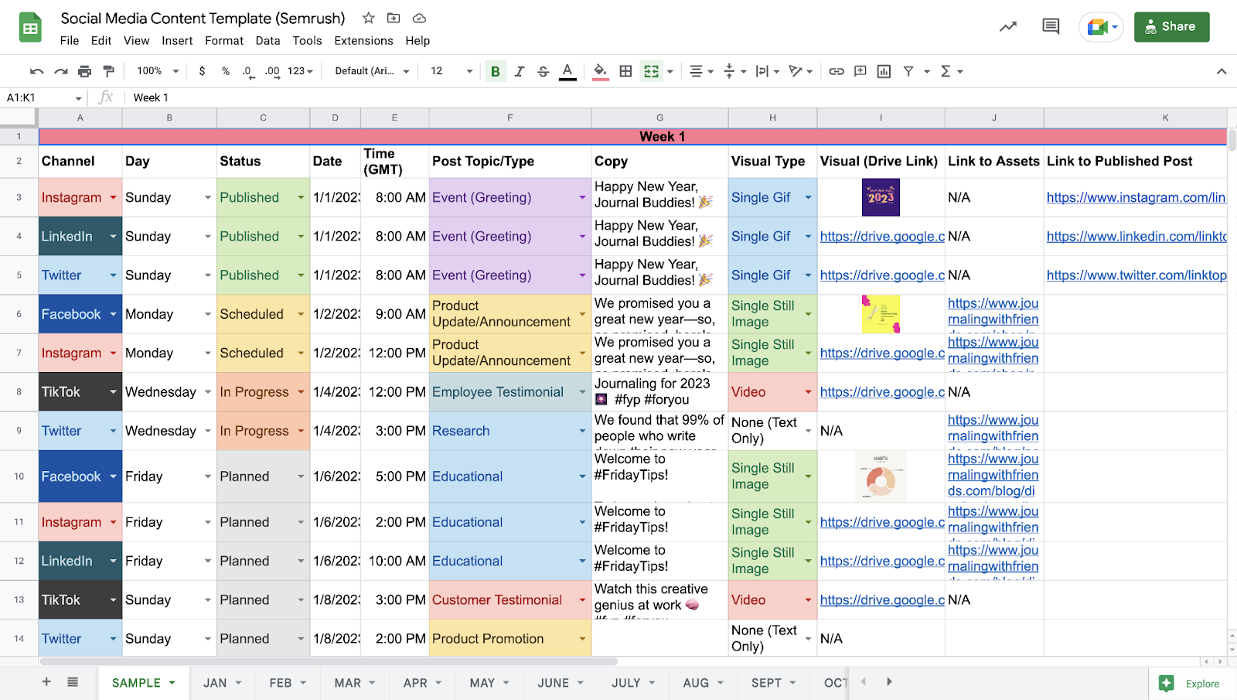

**Part B – Mockup examples**

* Provide two mockup examples of posts on social media that you may complete. For example, if you say you will use FB, then put together a sample FP post that incorporates your product, and your themes and messages.
* Explain why this mockup will resonate with your target market / persona.

**Appendices.**

Additional useful information, supporting research/analysis/calculations, industry benchmarks, infographics, etc. that might clutter the plan should appear in an appendix. **The maximum PowerPoint slides permitted for appendices is 5 slides.**

**General information**

***Information for online publishing***

*There are several different ways that you can publish online, and the method that you choose will depend on your specific goals and needs. Here are some common examples of online publishing:*

**Blogs:**A blog is a personal website or web diary where you can share your thoughts and ideas with the world. You can set up a blog for free using platforms like WordPress or Blogger.

**Podcasts:** A podcast is audio content usually published on third-party platforms like Spotify or Apple Podcasts. Podcasts are great because they can be collaborative; you can invite guests and experts to join you in discussions.

**Social media:**Social media platforms like Facebook, Twitter, and Instagram are great ways to share your content with a large audience. You can use social media to promote your blog posts, articles, or other forms of content.

**E-commerce:**If you sell products or services online, then you’re already engaged in e-commerce publishing for retailers. This type of publishing involves creating product pages, catalogs, descriptions, and other forms of content that help promote and sell your products or services.

**Press releases:** Press releases are short announcements that are often used to promote events or product launches. They can be published on your website or distributed to news outlets and other websites to generate publicity for your business.

**Apps:**You may decide to design and promote your own mobile app, whatever that might look like for your unique product/service. The app then becomes your published content, and you would manage and promote it accordingly.

***Here are some popular types of content for online publishing:***

**Blog Posts:** Blog posts are a great way to share your thoughts and ideas with the world. They can be about any topic you like, and you can easily incorporate images, videos, and links into your post to make it more engaging.

**Articles:**Articles are like blog posts, but they tend to be more informative in nature. If you have expertise on a particular subject, writing articles can be a great way to share your knowledge with others.

**Digital Magazines:** Digital or online magazines generally follow the format you would expect from a traditional, in-print magazine…only, they are entirely online. An example would be [The Ecclesiestical Review](https://www.ecclesiastical.com/latest-news/review/), an arts and culture magazine.

**eBooks:** eBooks are a great way to share longer pieces of writing with your audience. They can be downloaded and read on various devices, increasing functionality and convenience for busy people who want to learn more about a certain topic.

**Audio Files:**Audio files are another popular type of content for online publishing. You can create podcasts or simply record yourself talking about a particular subject. This is a great option for people who prefer to listen to information instead of reading it.

**Interactive Content:** This may include something simple like the ability to “zoom in/out” on a product photo but it can also go more in-depth with multimedia elements. Think: reader instigated animations, [parallax scrolling](https://www.w3schools.com/howto/howto_css_parallax.asp), or embedded tutorials/wizards.

***The Promotional Mix in the digital era***

**Source:** [**https://4dp.com.au/pillars-of-promotions-mix/**](https://4dp.com.au/pillars-of-promotions-mix/)

The digital age has allowed for new ways of communicating and buying things. This provides marketing managers with many new channels and marketing tactics they can utilise. Some of these channels include affiliate marketing.

**Affiliate Marketing**

Affiliate marketing is a type of performance-based marketing in which a business rewards affiliates for each visitor or customer that they bring in. Affiliates receive payment based on measurable actions such as sales generated through their individual sales and marketing efforts.

**Display Advertising**

Display advertising is a way to show ads on websites or apps or social media. The goal is to show promotional advertisements and brand messages to people who might be interested. You can use text, images, flash, video, and audio in your ads. Display advertising is a great way to be creative and reach a lot of people.

**Email Marketing**

[Email marketing](https://blog.hubspot.com/marketing/email-marketing-guide) is the act of sending emails to customers for the purpose of developing a better relationship with them, encouraging loyalty and repeat business, acquiring new customers, and persuading current customers to buy something immediately. Email marketing can also involve sharing ads from third-party companies.

**Content Marketing**

Content marketing is a way to get new customers and keep old ones. You do this by creating content and sharing it with people. This can be in the form of blogs, videos, articles, or any other type of media. When you create good content, people will trust you more and be more likely to do business with you.

**SEM Campaigns**

[SEM](https://blog.hubspot.com/marketing/search-engine-marketing) (Search Engine Marketing) is a form of marketing that uses the internet to help promote a website. This is done by increasing the visibility of the website in search engine results pages (SERPs). This is usually done through paid advertising on websites like Google and Bing. Although SEM usually focuses on paid advertising, it can also involve using SEO to get higher rankings and more attention from search engines.

**Search Engine Optimisation (SEO)**

[SEO](https://4dp.com.au/what-is-seo-and-why-the-heck-to-i-need-it/) refers to the work you do to improve the ranking of your website in unpaid search engine results. This excludes people who visit your website directly, people who come from other websites, and people who buy ads on search engines to promote their website. There are many different types of SEO, including work done on image search, video search, academic search, news search, and industry-specific vertical search engines.

**Social Media**

Using social media platforms and websites to promote a product or service is called social media marketing. Companies use social media marketing to communicate with different kinds of people including customers, employees, journalists, bloggers, and the public. On a high level, social media marketing includes creating a plan for a marketing campaign, setting rules (active or passive use), and deciding the culture and tone of the company’s desired social media presence.

**Influencer Marketing**

Influencer marketing is a type of marketing where experts or people with a lot of social influence promote a product or service. This can be done by making videos, writing articles, or just talking about it on social media.

**Digital PR**

Online public relations are the way companies communicate with the public on the internet. This type of PR uses different platforms, like search engines and social media, to talk to people about the company and its products. Compared to traditional PR methods (like TV, radio, and newspapers), online PR is more varied and reaches more people.

**Video Advertising**

This type of advertising is when you put an ad on a video that people can watch online. This type of marketing has become more and more popular over time. There are three kinds of online video ads: pre-roll ads, which play before the video starts; mid-roll ads, which play during the video; and post-roll ads, which play after the video has finished.

**Mobile Advertising**

Some people see mobile advertising as being like online advertising. However, mobile advertising is much bigger. It includes SMS and MMS advertising, in addition to the types of advertising that are done online. Mobile ads can be things like click-to-download ads, click-to-call ads, and click-to-message ads. They can also be videos, text ads, or banner ads.

***Actionable Persona Ideas***

**Part F - Make your personas ACTIONABLE.**

**(source:** [**https://founderpal.ai/user-persona-generator?persona=79VCVCCNMY**](https://founderpal.ai/user-persona-generator?persona=79VCVCCNMY)

***3 User Acquisition Ideas 📣***

*• Create engaging social media content showcasing how the social robot companion can make studying fun and interactive for students like Emma. Use platforms like Instagram and TikTok to reach a younger audience.*

*• Partner with student organizations and online learning platforms to promote the social robot companion as a valuable tool for enhancing remote learning. Offer special discounts or incentives for students who join through these partnerships.*

*• Collaborate with influential education bloggers and vloggers to create sponsored content that highlights the benefits of using the social robot companion in remote learning. Provide them with demo units to try out and review on their platforms.*

***3 Conversion Rate Optimization Ideas 💸***

*• Offer a limited-time free trial of the social robot companion to students allowing them to experience its benefits first-hand. Collect feedback and testimonials from trial users to build trust and credibility.*

*• Implement a referral program that rewards students for referring their classmates to purchase the social robot companion. Offer incentives such as discounts exclusive content or even cash rewards to encourage word-of-mouth marketing.*

*• Streamline the purchasing process by implementing a simplified checkout system with multiple payment options. Reduce friction by offering installment plans or discounted pricing for students with limited budgets.*

***3 Content Marketing Ideas 💌***

*• Host a live webinar or online workshop specifically tailored to the challenges faced by students studying remotely. Share tips strategies and case studies that showcase how the social robot companion can address and overcome these challenges.*

*• Create a series of YouTube videos featuring tutorials and demonstrations of different ways the social robot companion can assist students in their learning journey. Cover topics such as personalized study plans interactive quizzes and virtual study groups.*

*• Develop a comprehensive blog post series that tackles common questions and concerns related to integrating a social robot companion into remote learning. Provide data testimonials and real-life examples to showcase the effectiveness and benefits.*