**MSc Management**

**Global strategy and Sustainability**

Contents

Introduction 4

Task 1- The external and Internal Environment Analysis 5

External environment analysis 5

PESTLE Analysis of Yakult 5

Porter’s Five Forces Model 7

Yakult’s Internal Environment Analysis 8

Life cycle Model 8

Product Life Cycle of Yakult: 8

Sources of Yakults’s Competitive Advantage 9

Task 2 – Strategy in the Global Environment 11

Yip's Globalization Drivers for Yakult 11

Entrystrategies of Yakult to compete in the Europe, South Africa and Asian Markets 13

Task 3 – Corporate Strategy 15

Analyzing Yakult's Supply Chain Improvement Strategies 15

Ansoff matrix to improve profitability 15

Task 4- Strategic purpose- Ethics and CSR 17

YAKULT Inc’s CSR strategy using Caroll’s Pyramid 17

Recommendations 18

Conclusion 19

Bibliography 20

# Introduction

Yakult is a multinational probiotics firm established by Dr. Minoru Shirota in 1935 with the intention of advancing good bacteria. The company's main offering, is a fermented milk beverage with a high Lactobacillus casei Shirota concentration. The company's main goal is to encourage healthy living by means of probiotic use (yakultusa.com).To address the unique requirements of the Indian market, Yakult and Danone collaborated to enter the Indian market in 2007. Yakult's standing as a major force in the probiotics market is a result of its dedication to quality, scientific research, and international growth (Dawson, Kulkarni, et al, 2017). The report will discuss the external- internal environment of Yakult through PESTLE analysis and utilizes Porter's Five Forces model to evaluate the industry forces and also discuss the Life cycle of Yakult. Yip's Globalization Drivers to understand the motives behind Yakult's international strategy, analyze Yakult's supply chain improvement strategies to enhance its supply chain efficiency and use the Ansoff Matrix to offer insights to enhance profitability in a changing market.

# Task 1- The external and Internal Environment Analysis

## External environment analysis

### PESTLE Analysis of Yakult

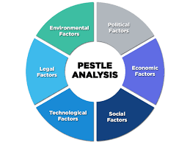

***Figure 1.1PESTLE Analysis***

***Source-***(Bhavya mangla, 2022)

**Political**

***Opportunities*-** The market for probiotic goods like Yakult may increase if the government supports programs promoting healthy eating. Trade agreements may allow Yakult to expand into new markets (Amitrano,et al, 2017).

***Threats-*** Strict laws governing food safety and labeling specifications may raise the price of compliance. Government regulations pertaining to dairy or probiotics changing might have a detrimental effect on Yakult's sales (Cusi,et al, 2023).

**Economic**

***Opportunities*-**Developing nations with rising disposable income have the potential to attract new clients. Consumer spending power is guaranteed by economic stability in key markets (Amitrano,et al, 2017).

***Threats-*** Downturns in the world economy may result in lower consumer spending and a decline in the market for luxury goods like Yakult. Changes in currency rates may have an impact on exports and profitability (Cusi,et al, 2023).

**Social-cultural**

***Opportunities****-* Demand for Yakult may rise as people become more conscious of the importance of probiotics and gut health. Yakult's health claims are consistent with the growing emphasis on natural cures and preventative healthcare (Yang,et al, 2015).

***Threats****-* Shifting dietary habits and the rising acceptance of plant-based substitutes may provide difficulties. Product modifications and marketing tactics are necessary due to cultural variations in consumer tastes and preferences (Yang,et al, 2015).

**Technology**

***Opportunities-*** Yakult's product line might be improved by developments in probiotic research and fermentation technology. Digital marketing and data analytics have the potential to enhance consumer interaction and personalize marketing efforts (Amitrano,et al, 2017).

***Threats-*** Upheaval from creative rivals providing substitute probiotic goods or distribution strategies. To remain competitive, businesses must continually engage in research and development due to the rapid progress of technology (Yang,et al, 2015).

**Technology**

***Opportunities***-Advances in fermentation technology and probiotic research may enhance Yakult's product line. Data analytics and digital marketing have the power to improve customer engagement and tailor advertising campaigns (Amitrano,et al, 2017).

***Threats*-** Disruption from innovative competitors offering replacement probiotic products or delivery methods. Because technology is advancing so quickly, organizations need to be constantly (Gill, 2018).

**Legal**

***Opportunities*-**Yakult's production technique and probiotic strain's intellectual property protection might provide it a competitive edge.Legal frameworks can be utilized for cooperative research and development through partnerships with universities and research institutions (Amitrano,et al, 2017).

***Threats-*** Modifications to the laws governing food safety or the specifications for product labeling may call for expensive revisions. Conflicts over intellectual property between rivals may result in court cases and harm to one's image (Yang,et al, 2015).

**Environmental**

***Opportunities****-* Yakult's brand image may be improved by using eco-friendly production methods and sustainable packaging efforts. Yakult's dedication to sustainability may be further strengthened through collaborations with environmental groups (Amitrano,et al, 2017).

***Threats-*** Yakult's supply chain may be impacted by climate change and extreme weather occurrences that interfere with dairy production. Consumer preferences for regional and eco-friendly goods may put strain on Yakult's international business activities (Yang,et al, 2015).

## Porter’s Five Forces Model

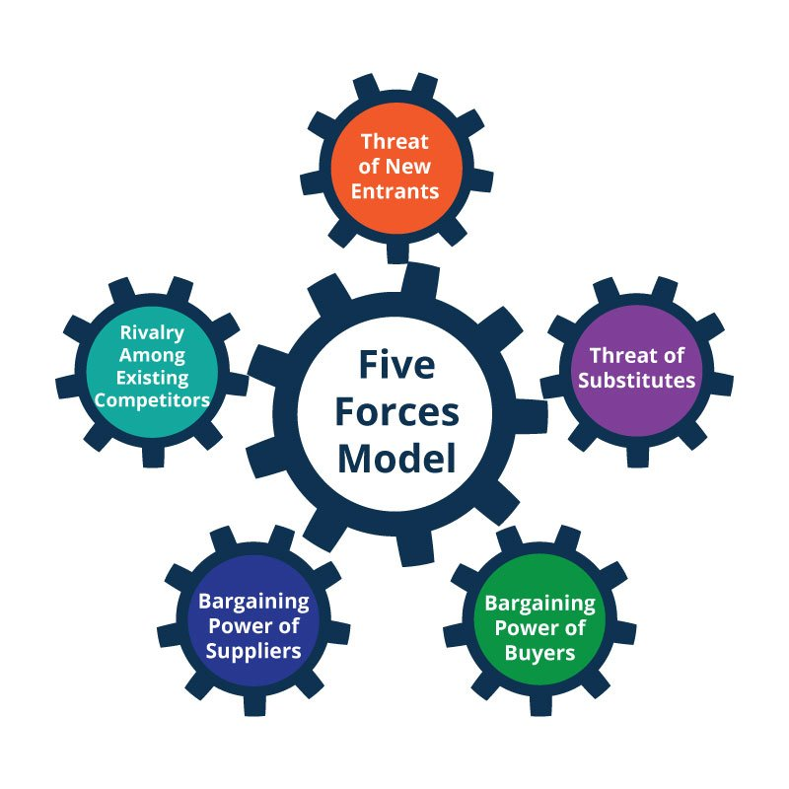

***Figure 1.2 Porter’s Five forces Model***

***Source-***(Bob Stanke, 2023)

An industry's competitive forces may be examined using Porter's Five Forces methodology. **Threat of New Entrants-**Low: Yakult has little competition from new competitors. Developing a brand, expanding distribution channels, and investing heavily in research and development are all necessary when entering the probiotic beverage market (Catanoze, et al, 2022).

**Buyers' Bargaining Power-**Modest: Buyers have a modest amount of bargaining power. Although there are other probiotic beverage options available to customers, Yakult has some price power because to its well-known brand, distinctive product line, and claimed health advantages (Catanoze, et al, 2022).

**Bargaining power of Suppliers-** Low to Moderate: Yakult's suppliers have a comparatively moderate amount of negotiating leverage. Important components of probiotic drinks, including certain bacterial strains, could only have a few numbers of suppliers, which gives them considerable clout. Yakult's size and well-established supplier ties, however, can somewhat offset this strength (Belussi, et al, 2015).

**Threat of Substitutes-** Low: There is little risk of Yakult replacement goods. Although there are numerous drinks on the market, Yakult stands out due to its special probiotic recipe and health advantages. It could be difficult for customers searching for certain probiotic benefits to locate direct replacements (Catanoze, et al, 2022).

**Competitive Rivalry within the Industry**- Moderate to High: There is moderate to high levels of competitive competition in the probiotic beverage market. Similar goods from both domestic and foreign companies compete with Yakult. In this competitive where there are products like Activia and Goodbelly giving cut throat competition, price, promotion, and innovation are vital. (Catanoze, et al, 2022)

## Yakult’s Internal Environment Analysis

### Life cycle Model

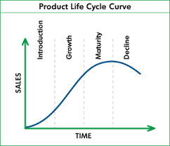

***Figure1.3 Life Cycle Model***

***Source-***(Tom Spencer, 2009)

Product Life Cycle of Yakult: This would analyze the stages of Yakult's journey as a product in the market, following the traditional product life cycle model:

***Introduction*:** Launched in 1935, Yakult faced initial challenges due to its unfamiliar concept and high price. It relied on direct sales and targeted marketing to educate consumers about its probiotic benefits (Taninaka,et al , 2015).

***Growth:*** Yakult had fast expansion in the 1950s and 1960s as a result of diversifying its product line with flavored varieties, growing distribution networks, and establishing a strong brand with mascots and catchy jingles (Taninaka, et al , 2015).

***Maturity:*** Yakult has been the market leader in its primary areas, such as Southeast Asia and Japan, since the 1970s. It focuses on expanding into new markets, innovating products with health-focused variants, and maintaining brand loyalty (Mellentin, and Heasman, 2014).

***Decline (potential):*** Although it hasn't yet reached decline, Yakult might be threatened by factors such shifting customer tastes in favor of plant-based substitutes, fierce rivalry in the probiotic industry, and reductions in disposable income brought on by economic downturns (Taninaka,et al , 2015).

## Sources of Yakults’s Competitive Advantage

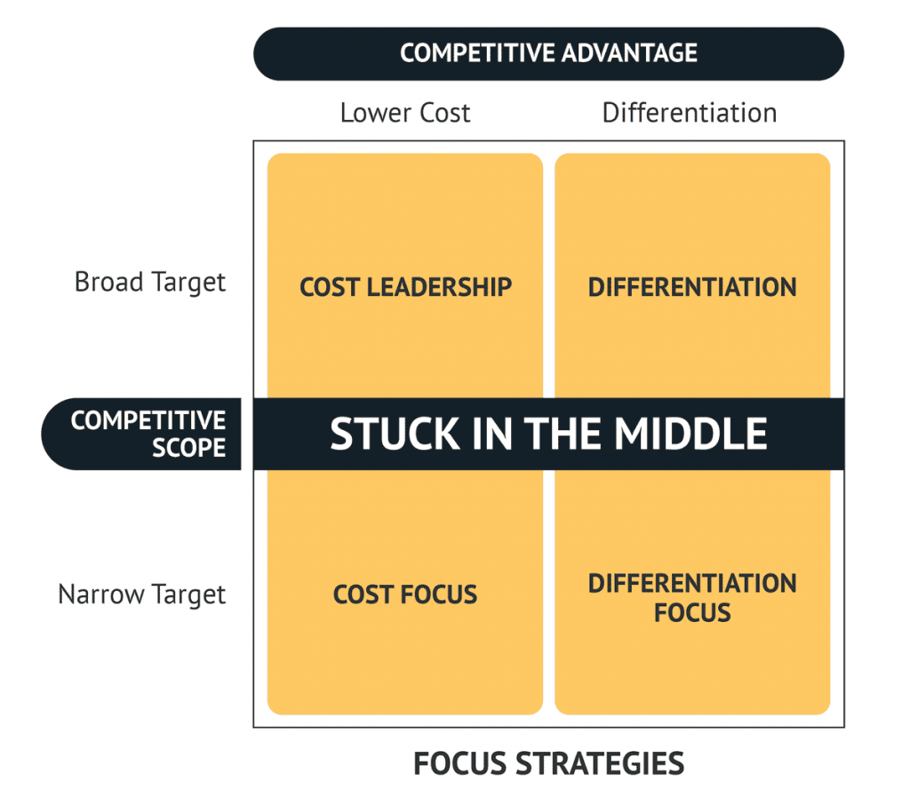

***Figure 1.4 Competitive advantage and Scope***

***Source-*** (Consulterce.com)

**Cost Leadership-** Yakult maintains strict control over prices and quality since it owns its manufacturing facilities and dairy farms through its effective supply chain their distinctive compact bottle size reduces the need for packing and shipping. Yakult focuses its iconic probiotic drink above unnecessary diversification, which enables efficient production methods and economies of scale (Sanders, et al, 2015).

**Differentiation**- Yakult distinguishes itself from rivals selling generic probiotics with its well-researched L. casei Shirota strain. This scientific validation fosters brand loyalty and confidence. Personalized home delivery is provided by the committed "Yakult Lady" network, which builds connections with customers and guarantees constant consumption (Sanders, et al, 2015).

**Cost Focus-** Yakult saves money on product development and marketing by focusing on their flagship probiotic drink. They are able to reinvest in cost-cutting projects as a result. Yakult can command premium pricing without spending a lot of money on marketing thanks to their well-established brand image. This well-established brand recognition reduces the expense of acquiring new customers (Sanders, et al, 2015).

**Differentiation Focus:** Yakult creates a unique value proposition that goes beyond simple refreshment by utilizing consumer health ambitions and scientific knowledge. Yakult aggressively funds social responsibility programs to foster goodwill and bolster brand recognition. This builds a favorable brand image and encourages client loyalty (Sanders, et al, 2015).

**Maintaining and Building this Competitive Advantage:**

To keep these benefits, you must always evolve:

***Research and development never stops:*** funding probiotic studies bolsters their competitive advantage in science and creates opportunities for new product categories, so Yakult should be heads on when it comes to R &D (Cusi,et al, 2023).

***Increasing the number of distribution channels:*** In addition to the "Yakult Lady" system, investigating retail alliances and internet platforms can connect with new customer groups. Exploring other possible options can be an aid (Cusi,et al, 2023).

***Changing with the times:*** Providing plant- or sugar-free choices can appeal to customers who are health-conscious and meet changing dietary trends. Coming up with new flavors, forms and creativity can lead to a new customer base (Cusi,et al, 2023).

# Task 2 – Strategy in the Global Environment

## Yip's Globalization Drivers for Yakult

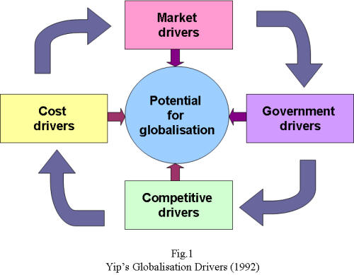

***Figure -2.1 Yip’s Framework***

***Source-*** (Helled.org)

**Market Motivators-**Determining if a company's goods or services are in demand around Yakult’s probiotic bacteria and portable packaging address the global need for gut health and consumption while on the go, potentially making it a marketable product in a variety of contexts. The degree to which consumer demands and tastes are the same across national borders is known as market homogenization (Nakagawa, et al, 2018).

**Cost-raising factors:** The possibility of lowering costs by producing and distributing goods on a big scale. Yakult's tiny, single-serving bottles and uniform production method provide for economies of scale, which facilitate the company's international development. Yakult may be able to reduce costs throughout its international operations by sourcing ingredients and manufacturing in strategically placed geographic areas (Nakagawa, et al, 2018).

**Drivers of competition:**Yakult competes with both regional rivals like Nutrigen and Vitagen and well-known brands like Danone in the probiotic beverage industry. Yakult's competitive advantage in the worldwide probiotic industry may stem from its well-known brand, well-established distribution network, and exclusive probiotic strain (Lactobacillus casei Shirota) (Nakagawa, et al, 2018).

**Drivers of the Government:** Yakult must negotiate the trade laws of several nations and modify its marketing and distribution plans as necessary. Government should take initiatives that stimulate foreign investment and commerce and find nations with welcoming business rules for foreign companies. This can help Yakult expand internationally (Nakagawa, et al, 2018).

Yakult's expansion into Europe, Africa, the Middle East, and Asia (EAMA) is motivated by a variety of factors that impact the company's overarching business plan. Now let's explore these motivations.

**Motives for Expansion**

***Market Saturation:*** Yakult's main product has attained saturation in the domestic Japanese market. Japan's growth prospects grew scarce, which increased the necessity for market research in hitherto unexplored areas (Mellentin, and Heasman, 2014).

***Diversification:*** Reducing reliance on any one market and reducing economic risks are achieved by diversifying between markets with different geographic distribution. Due to this variety, there is protection against regional shifts in customer tastes or economic downturns (Mellentin, and Heasman, 2014).

***Growth Potential:*** With big, expanding populations and rising disposable incomes, the EAMEA region has a great deal of room to develop in terms of sales and market share (Mellentin, and Heasman, 2014).

***Building Brand:*** Yakult's international growth enhances its reputation and fortifies its worldwide brand image, providing opportunities for more market expansion (Mellentin, and Heasman, 2014).

**Impact on Company Strategy**

***Turning towards Globalization:*** Yakult is becoming a worldwide player by modifying its manufacturing, marketing, and distribution methods to suit a variety of markets. It is moving from being a mostly domestic corporation (Yotova, et al, 2022).

***Allocation of Resources:*** Funds are going toward creating new avenues for distribution, increasing local recognition for the brand, and carrying out market research in the EAMEA area (Yotova, et al, 2022).

***Product diversification:*** Yakult is creating new product variants outside of the basic drink, such yogurt, sweets, or fermented milk products, in response to regional tastes (Yotova, et al, 2022).

***Partnership Strategies:*** Collaborations with local companies and distributors become crucial for navigating regulatory hurdles and gaining effective market access (Yotova, et al, 2022).

## Entrystrategies of Yakult to compete in the Europe, South Africa and Asian Markets

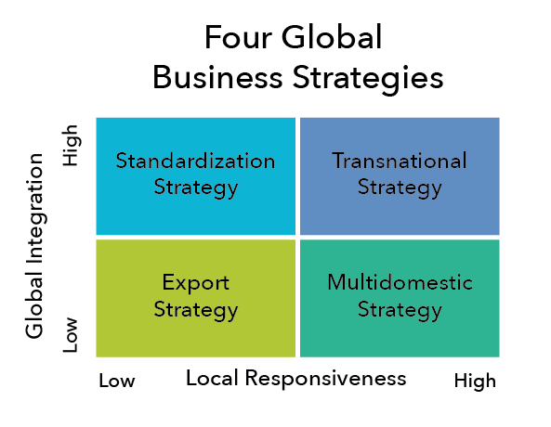

***Figure- 2.2 Global Integration and Local Responsiveness***

***Source-*** (Lumen )

**Standardization Strategy-** Makes production and marketing easier and establishes a unified brand image. Ignores regional and cultural variations, which can make it less appealing in some areas. Ideal for goods in markets with comparable consumer tastes that are broadly appealing and require little adjustment, such as the original Yakult beverage (Belussi, et al, 2015).

**Transnational Strategy:** Include centralized authority over important decision-making, effective resource management, and worldwide brand management. Less sensitivity to the demands and preferences of the local market, this might result in less than ideal performance. Good when a basic product is kept constant but marketing and distribution are adjusted for local circumstances (Belussi, et al, 2015).

**Export strategy:** Relatively cheap to implement in comparison to alternative tactics. Depends on regional partners and distributors, which may limit control over product positioning and brand image. May be susceptible to changes in trade barriers and exchange rates. Fit for first forays into untapped areas when comparable items already have established distribution networks (Belussi, et al, 2015).

**Multidomestic strategy** -Increased product relevance and market share due to a high degree of responsiveness to the demands and tastes of the local market. More complexity as a result of dispersed processes. Might result in inconsistent product quality and brand perception among various markets. Best suited for markets with notable cultural and legislative variances that necessitate considerable modifications to marketing and product offerings (Belussi, et al, 2015).

# Task 3 – Corporate Strategy

## Analyzing Yakult's Supply Chain Improvement Strategies

**Horizontal Integration-** In order to improve its market position or diversify its product line, Yakult may think about purchasing or merging with other probiotic or dairy businesses if it decides to pursue horizontal integration (Vanden, et al, 2016).

It can be done through acquiring probiotic food Producers, merging with Probiotic Supplement Companies and Partnering with probiotic ingredient Suppliers

**Vertical Integration-**. The application of vertical integration to Yakult can be divided into two categories: backward integration, which involves acquiring dairy farms, investing in probiotic strain cultivation and partnership with packaging suppliers and forward integration, which involves opening Yakult retail stores, direct distribution network and online selling (Vanden, et al, 2016).

**Outsourcing**- Yakult, despite its strong brand and unique probiotic strain, can still benefit from strategic outsourcing approaches to optimize its operations and gain a competitive edge. It can outsource production in certain regions which will help in cost reduction and market entry acceleration. Yakult can also outsource logistics and distribution which will lead to increased efficiency, scalability and focus on marketing. The research and development activities also can be outsourced to better researchers and experts and the cost can be divided(Vanden, et al, 2016).

**Strategic Alliances:** Strategic alliances can be highly effective tools for companies like Yakult to expand reach, access new markets, and accelerate innovation. Partnership with research institutions for advance probiotic research and joint invention of new products can be done. Joint ventures with complementary companies for market expansion and ingredient co-development can be initiated. Partnership with distribution channels for retail partnerships and tie ups with health care services can be done (Vanden, et al, 2016).

## Ansoff matrix to improve profitability

The Ansoff Matrix is an approach that aids businesses in identifying growth strategies by analyzing the relationship between products and markets.

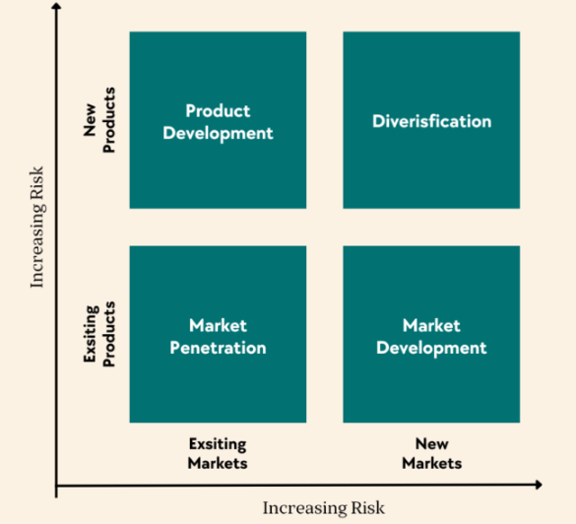

**Figure 4: Ansoff Matrix**

**Source:**(Zandt, 2023)

**Market Penetration-** This plan calls for increasing sales of Yakult's present probiotic products to its intended market. By stepping up marketing initiatives, broadening distribution networks, or launching marketing campaigns to entice current customers to drink more frequently, Yakult might concentrate on growing its market share in its current markets(Amitrano,et al, 2017).

**Product development-** It is bringing new or modified versions of already-existing items to the market (Mellentin, and Heasman, 2014).In order to adapt to changing customer tastes or to target certain market segments, Yakult may create and launch new probiotic products or changes or expansions of its present product line.

**Market development**- It is the process of introducing current items into new markets.

Application to Yakult: In areas or nations where probiotic product demand may be rising, such as Europe, Africa, the Middle East, or Asia, Yakult might broaden its market reach. This might entail changing its offerings to accommodate local consumers' tastes.

**Diversification-** It entails launching new goods in untapped areas. Yakult might introduce completely new product lines like flavored Yakult, Yakult light or Yakult Ace are either unconnected or linked to its present line of probiotics. This might entail going after markets unrelated to its main line of business, including those for functional foods or dietary supplements A new range of Yakult Jelly also has been introduced.

# Task 4- Strategic purpose- Ethics and CSR

## YAKULT Inc’s CSR strategy using Caroll’s Pyramid

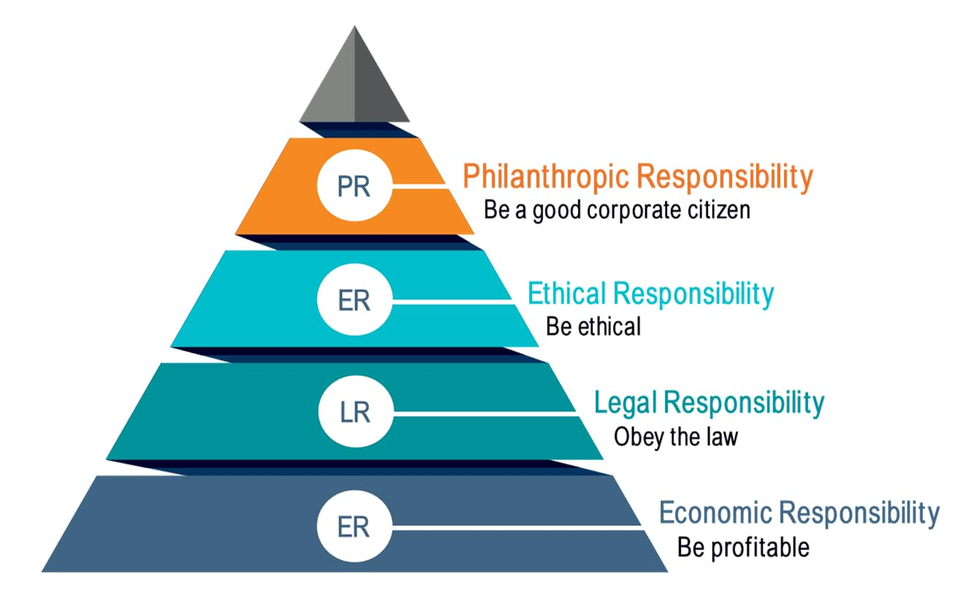

***Figure 4.1***

***Source-*** The CSR Journal

A framework for examining CSR at several levels—economic, legal, ethical, and philanthropic—is offered by Carroll's Pyramid Model.

**Economic responsibility-** Yakult recognizes its economic responsibility not only towards shareholders and employees but also broader communities where it operates. By having a responsible supply chain, sustainable sources, fair labor practices and supporting the local community it stays ahead in ensuring that all the economic responsibilities are shouldered well.

**Legal Responsibility-** Yakult operates within a complex web of legal responsibilities across various countries and regions. These responsibilities encompass diverse areas, impacting how they conduct business and ensuring consumer safety and fair practices. Compliance to food and safety regulations, accurate and transparent labeling and protection of proprietory technology and brands are some of the legal practices of Yakult.

**Ethical Responsibility**- Yakult demonstrates accountability and transparency in its financial procedures and decision-making by publishing regular sustainability reports and abiding by international corporate governance norms. Yakult has stringent anti-corruption rules and processes in place to guarantee moral behavior at all levels of the business. Yakult follows stringent guidelines for food safety and makes research and development investments to guarantee the quality and safety of its products.

**Philanthropic Responsibility-** Yakult takes its philanthropic responsibility seriously, engaging in various initiatives that contribute to the well-being of communities and address global challenges. By actively engaging in diverse initiatives like health and nutrition, environmental sustainability, disaster relief and collaborating with local communities, Yakult strives to make a positive difference beyond just commercial success.

## Recommendations

* Create a thorough CSR plan that is in line with the pyramid model.
* Establish precise objectives, targets, and plans of action for every responsibility level.
* Involve stakeholders in CSR projects and work together to develop and carry out effective initiatives involving staff, communities, and non-governmental organizations.
* Track and share CSR advancements Track your progress and show responsibility and transparency by using pertinent KPIs.
* Review and enhance your CSR plan on a regular basis. Respond to changing stakeholder expectations and rearrange priorities in light of impact and performance evaluations.

# Conclusion

The secret to Yakult's success is not just its tasty probiotic product but also its all-encompassing strategy for sustainability and international growth. Through the integration of these pillars into its fundamental strategy, Yakult can secure sustained growth, bolster the value of its brand, and have a good influence on the lives of people worldwide. In summary, Yakult has a bright future ahead of it—one in which probiotic research and global reach collide, sustainability and profitability grow hand in hand, and gut health is seen as a universal sign of wellbeing. Yakult can ensure its place as a global leader in the probiotic market, leaving a lasting legacy of health, well-being, and social responsibility for generations to come. **Yakult's success story is far from over. With its unwavering commitment to quality, innovation, and sustainability, Yakult is poised to rewrite the rules of the global beverage market and inspire future generations of entrepreneurs.**

# Bibliography

Amitrano,et al. (2017). Knowledge sharing in innovation ecosystems: a focus on functional food industry. *International Journal of Innovation and Technology Management* , 14(05), p.1750030.

Belussi, et al. (2015). *Alliances, and Networks in High-Tech Environments.*

*Bhavya mangla*. (2022, April 10). Retrieved from https://bhavyamangla.com/pestle-analysis-political-economic-social-technological-legal-environmental/

*Bob Stanke*. (2023, February 14). Retrieved from https://www.bobstanke.com/blog/porters-five-forces-competitive-markets

Catanoze, et al. (2022). Antagonistic effect of isolated and commercially available probiotics on the growth of Candida albicans on acrylic resin denture surfaces. *The Journal of Prosthetic Dentistry* , pp.338-344.

*Consulterce.com*. (n.d.). Retrieved from https://consulterce.com/business-strategy/

Cusi,et al. (2023). a bidimensional diagnostic tool, to a new 3D strategic model. *The TQM Journal* .

Dawson, Kulkarni, et al. (2017). *Comparative evaluation of probiotic drink containing lactobacillus casei strain Shirota with plain curd on salivary Streptococcus mutans count* , pp.381-383.

Di Cerbo,and Palmieri. (2015). The market of probiotics. *Pakistan journal of pharmaceutical sciences* , 28(6), pp.2199-2206.

Gill. (2018). *Designer probiotics as a novel therapeutic against inflammatory bowel disease (Doctoral dissertation, ).* University of British Columbia.

*Helled.org*. (n.d.). Retrieved from http://hel.org.uk/studies/international%20management/strategicmanagement/gsmirstonehouse.htm

Lalitnorasate and Miyazaki . (2014). Core technological competence and knowledge accumulation in the functional food industry. *An empirical study of Japanese food firms.* , 1072-1081.

*Lumen* . (n.d.). Retrieved from https://courses.lumenlearning.com/wm-principlesofmanagement/chapter/responding-to-cultural-differences/

Mellentin, and Heasman. (2014). *The functional foods revolution: Healthy people, healthy profits.* Routledge.

Nakagawa, et al. (2018). Japanese management styles: To change or not to change? A Subsidiary Control Perspective. *Journal of International Business and Economics,* , pp.1-10.

Okuno, A. (2020). The philosophy of the Yakult Group and its propagator, the Yakult Lady. . *Cultural Translation of Management Philosophy in Asian Companies: Its Emergence, Transmission, and Diffusion in the Global Era* , pp.91-104.

Sanders, et al. (2015). Bringing a probiotic-containing functional food to the market: microbiological, product, regulatory and labeling issues. 76, pp.293-315.

Taninaka, et al . (2015). Analysis of the economic viability of a beef cattle herd the Wagyu breed in full cycle. 1(2), pp.44-58.

Taninaka,et al . (2015). Analysis of the economic viability of a beef cattle herd the Wagyu breed in full cycle. 1(2), pp.44-58.

*Tom Spencer*. (2009). Retrieved from https://www.spencertom.com/2009/01/25/product-life-cycle-model/

Vanden, et al. (2016). A quantitative key-opinion-leader analysis of innovation barriers in probiotic research and development: valorisation and improving the tech transfer cycle. *PharmaNutrition* , pp 9-18.

*yakultusa.com*. (n.d.). Retrieved from yakultusa.com: https://www.yakultusa.com/

Yang,et al. (2015). Development of a stable genetic system for Chlorella vulgaris—A promising green alga for CO2 biomitigation. . *Algal research* , pp.134-141.

Yotova, et al. (2022). Acceptance of milk and dairy products in rice-centered food cultures: A comparative study of consumer practices in South Korea and Japan. *Journal of Ritsumeikan Gastronomic Arts and Sciences* , 7.

Zandt, P. V. (2023). *Analysis and Advantages of Ansoff Matrix*. Retrieved from https://ideascale.com/blog/analysis-and-advantages-of-ansoff-matrix/