Guidance and Example Structure for IBM7020 – Portfolio Part 3

Below, we provide an example of an approach to structuring your submission for the Portfolio Part 3 Report.

Please note the following:

This is not the only way to structure a report, and that other formats may score very well.

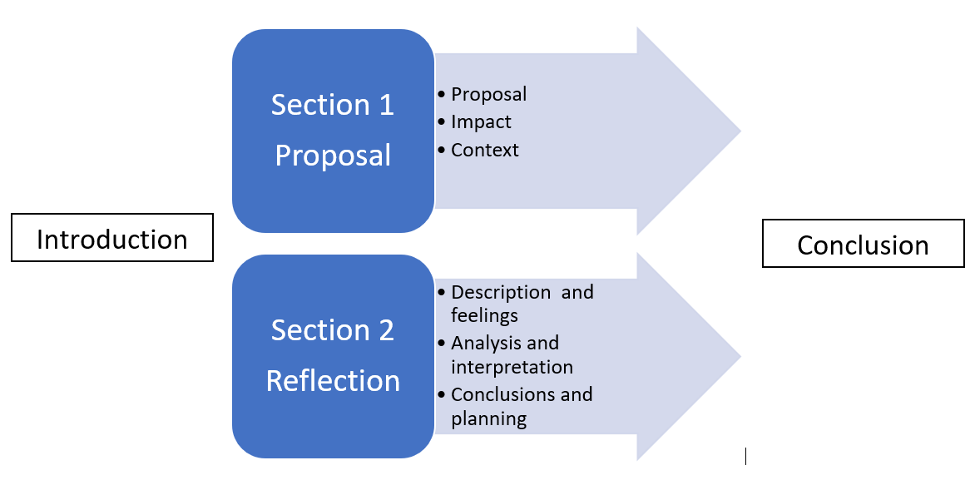

# Introduction

A well-structured report must have an **introduction**. The main purpose of an introduction is to provide an overview of how you will argue, and how that argument responds to your **problematisation**. The author will first explain why they think this is a problem, and then describe how the arguments that they are about to make can help solve this problem. In this module, the introduction will be concise. The problem statement may define the problem to address in a narrower way than that expressed in your Part 1 video. This can be explored and justified to provide a more focused problem to address.

It is common for students to give too little detail in their introduction. Try and avoid this mistake by giving as much detail as possible about exactly how you will argue, and use your introduction to show how your arguments are part of a wider, coherent line of argument or ‘**through-line**.**’**

# Substantive sections

After the introduction, a report will have a **substantive section**, or **‘main-body**’, in which the author makes most of their argument. In the example diagram above, the substantive section of the report is made up of two parts: the proposal and the reflection.

In the first paragraph of **Section 1**, labelled **Proposal paragraph** in the diagram, the author introduces the design thinking principles that they have applied in making this proposal. In this paragraph they will use evidence from **academic**, **journalistic or professional sources** to explain the approach taken and demonstrate its user-centricity. The author will demonstrate creativity and innovation by making a proposal which can help mitigate the ‘wicked problem’ they have been working on. The proposal draws on design thinking principles as it takes a user-centric approach and demonstrates empathy.

In the following paragraph, **Impact paragraph** in the diagram, the author will demonstrate conceptualisation, meaning making sense of something in a new way. Elements of the ‘Impact Ladder’ will be included within this paragraph. An Appendix might be used and referred to. This paragraph conceptualises the impact that the proposal seeks to achieve: the ‘lasting social impact’, ‘near term outcome(s)’ and ‘key shifts’.

*Note*: the author is not limited to using the content of the lectures on this module. The author might reflect that the design thinking perspective that they have taken could be complemented by their understanding from another subject area. They might decide to use some complementary literature from another field of relevant research to enhance their argument in this section, provided they think doing so is coherent with their argument overall.

In the following paragraph, **Context paragraph** in the diagram, the author explores the context around the ‘user’. The author will demonstrate conceptualisation by identifying the ‘barriers’ and ‘enablers’ which are present within the ‘Ecosystem Mapping’ and the shifts which need to take place. This paragraph will also demonstrate an understanding of context by referring back to the work being done by other organisations which was critically appraised in Part 2 of the Portfolio.

*Note* the author may prefer to present their ‘proposal’ paragraph after the ‘impact’ and ‘context’ paragraphs.

Having completed **Section 1**, the author then moves onto **Section 2**.

Since **Section 2** is reflective writing, it is **written in the first person,** meaning ‘I’, ‘we’, ‘me’, ‘us’. Succinct, clear formal language should be used throughout the report, including the reflective section. The reflective writing brings into consideration the author’s approach to, and achievements in, Parts 1, 2 and 3 of the Portfolio including the peer feedback the author has received. It will discuss Dr Sarasvathy’s ‘Effectuation Theory’ which can be used to consider the proposal provided by the author.

In the first paragraph of Section 2, labelled **Description and Feelings**, the author will provide just enough description for the reader to understand what is going on. The author will then present feelings recalled from the time and/or felt at the time of writing. This will be a considered response providing an accurate account of what happened and the author’s feelings about it.

In the second paragraph of Section 2, labelled **Analysis and Interpretation**, the author will use comparative (for example ‘similarly’ or ‘in contrast to’) and causal (for example ‘due to, or ‘because of this’) language to make sense of the experience and interpret its significance for learning.

In the third paragraph in Section 2, labelled **Conclusions and Planning**, the author will explain what they have learned from the experience and how this will inform future actions and what value that contains.

*Note on sections*: there is no firm rule regarding how many sections a report contains. When deciding how many sections to include, the author considers the quality and depth of their overall argument.

*Note on paragraphs*: there is no firm rule regarding how many paragraphs a section contains, and indeed, in this guidance the different substantive sections are only referred to as ‘paragraphs’ illustratively. **Proposal paragraph**, **Impact paragraph, and Context paragraph** for example, may all extend over multiple paragraphs if the author thinks that this will improve the clarity of their report.

# Conclusion

The report will end with a **conclusion**. The main purpose of a conclusion is to restate your argument, reiterating how it responds to your problematisation. It is common for students to give too little detail in their conclusion. Try and avoid this mistake and use the conclusion to show how your arguments were part of a wider, coherent argument or ‘through-line’.

_________________________________________________________________________

Other points to remember

The report must be referenced in Harvard style which will include comprehensive accurate in-text citations and a reference list. All sources accessed online should include the URL and date accessed.

The report should display evidence of reading. You must read and make use of at least eight sources on the Course Resources List.

The Reflection may be structured using a theoretical model and for example students may wish to consider Kolb’s experiential learning cycle, or its development by Gibbs.

Spelling, punctuation and grammar are important – the ‘Review’ function in Microsoft Word should be used, including ‘ABC Spelling & Grammar’.

The wordcount must be adhered to. The report should be 2000 words (+/- 10%) and the marker will stop reading at 2200 words.