**A study on work-life-balance of corporate employees**

***A Dissertation Submitted in Partial Fulfilment of the Requirements for the Degree of***

**Master of Science in Strategic Management**

Christ University

Submitted By

J S Punith  
Reg. No: 2118102

Under the Guidance of  
Dr. CHIDAMBARAM N  
MBA, MPhil, PhD  
Associate Professor



# DECLARATION

I, **J S PUNITH** here by declare that the dissertation, titled “**A STUDY ON WORK-LIFE-BALANCE OF CORPORATE EMPLOYEES”** is a record of original research work undertaken by me for the award of the degree of **MASTER OF STRATEGIC MANAGEMENT**. I have completed this study under the supervision of **Dr. CHIDAMBRAM N**, Associate Professor, and the Department of Professional Studies.

### I also declare that this dissertation has not been submitted for the award of any degree, diploma, associate ship, fellowship, or other titles. It has not been sent for any publication or presentation purpose. I hereby confirm the originality of the work and that there is no plagiarism in any part of the dissertation.

Place: Bengaluru Date

J S PUNITH  
 RegNo.2118102

Department of Professional Studies Christ University, Bengaluru

**Certificate by the Head of Department**

This is to certify that the dissertation submitted by J S Punith (Reg. No: 2118102) titled **“A study on work-life-balance of Corporate employees”** in partial fulfilment of the requirement of the Master of Science in Strategic Management Programme of Christ University, for the academic year 2019- 2021.

Prof. T.V Joseph

Head of the department

CBCS

Christ (Deemed to be University)

Bangalore

Place: Bangalore

Date:

**Certificate by Guide**

This is to certify that the dissertation submitted by Vinaya Shree K (Reg. No: 2118102) titled **“A study on work-life of Corporate employees”** is a record of research work done by him during the academic year 2021- 2023 under my supervision in partial fulfillment for the award of Master of Science in Strategic Management. This dissertation has not been submitted for the award of any degree, diploma, fellowship, or other title. It has not been sent for any publication or presentation purpose.

Dr. Chidambaram N

Faculty Guide

Department of Professional Studies

Christ (Deemed to be University)

Bangalore

Place: Bangalore

Date:

# ACKNOWLEDGEMENT

The successful completion of this project would be incomplete without mentioning the people who made it possible those who made it possible and whose constant guidance and encouragement secured our success. Not just doing the project, but doing it right is critical. First, I would like to express my sincere thanks to my college CHRIST (DEEMED TO BE UNIVERSITY). My acknowledgment would be incomplete without mentioning the kind support and guidance my guide Dr. Chidambaram N provided for her suggestions, guidance, and direction in carrying on the project and providing the formal sanction required to carry out the study.

### **J S Punith**

**Table of content**

|  |  |  |
| --- | --- | --- |
| **Sl. No** | **Content** | **Pg. No** |
| **1** | **Chapter 1: Introduction** |  |
| 1.1 | Introduction | **11** |
| 1.2 | Global Scenario | **12** |
| 1.3 | Indian Scenario | **13** |
| 1.4 | State Scenario | **14** |
|  |  |  |
| **2** | **Chapter 2: Literature Review** |  |
|  | Review of literature | **15-28** |
| **3** | **Chapter 3: Research Design** |  |
| 3.1 | Significance of the study | **29** |
| 3.2 | Statement of problem | **29** |
| 3.3 | Objective of the study | **30** |
| 3.4 | Scope of the study |  |
| 3.5 | Limitations of the study | **30** |
| 3.6 | Hypothesis | **31** |
| 3.7 | Research Design | **31** |
| 3.8 | Source of data | **32** |
| 3.8.1 | * Primary data | **32** |
| 3.8.2 | * Secondary data | **32** |
| 3.9 | Population | **32** |
| 3.10 | Sample size | **33** |
| 3.11 | Sample design | **33** |
| 3.12 | Sampling method | **33** |
| 3.13 | Methods of data collection | **33** |
| **4** | **Chapter 4: Data Analysis** |  |
| 4.1 | Factor analysis (Data analysis) | **34-36** |
|  | Interpretation | **37-50** |
| **5** | **Chapter 5: Findings & Suggestions** |  |

|  |  |  |
| --- | --- | --- |
| 5.1 | Findings | **51** |
| 5.2 | Suggestions | **52** |
| **6** | **Chapter 6: Conclusion** | **53-54** |
| **7** | **Chapter 7: Bibliography** | **55-56** |
| **8** | **Chapter 8: Annexure** | **57-59** |

**LIST OF GRAPHS**

|  |  |  |
| --- | --- | --- |
| **Graph No** | **Name of the Graph** | **Pg No** |
| 4.2.1 | Age | 37 |
| 4.2.2 | Gender | 37 |
| 4.2.3 | Marital status of respondents | 38 |
| 4.2.4 | Qualification of the respondents | 38 |
| 4.2.5 | Current employment position of the respondents | 39 |
| 4.2.6 | Type of family of respondents | 39 |
| 4.2.7 | Transmission to more work from a home satisfactory level | 40 |
| 4.2.8 | Appropriate work-life-balance level | 40 |
| 4.2.9 | Sufficient Flexibility in work | 41 |
| 4.2.10 | The balance between task and time availability | 41 |
| 4.2.11 | WFH Satisfactory level | 42 |
| 4.2.12 | Negative stress | 42 |
| 4.2.13 | Overtime working | 43 |
| 4.2.14 | The strain on family relationship | 43 |
| 4.2.15 | Feeling isolated | 44 |
| 4.2.16 | Self-management | 44 |
| 4.2.16 | Lack of privacy | 45 |
| 4.2.18 | Not enough space to work | 45 |
| 4.2.19 | Separating work and family | 46 |
| 4.2.20 | Being not able to work at all | 46 |
| 4.2.21 | Communication barriers | 47 |
| 4.2.22 | Manage your expectations | 47 |
| 4.2.23 | Dedicated workspace | 48 |
| 4.2.24 | Take regular breaks | 48 |
| 4.2.25 | Establish transition time | 49 |
| 4.2.26 | Establish a routine | 49 |
| 4.2.27 | Communicate your needs | 50 |
| 4.2.28 | Be kind to yourself | 50 |

**ABSTRACT**

Life is moving very fast. People are not able to balance their work/life. They are facing a lot of problems in their daily life. Tight schedules, the pressure of the boss to do the work within the stipulated time, never-ending meetings, etc. makes the person tired and he/she does not remain able to enjoy his life at home with their spouse and children. Can the existence of work-life balance programs be attributed to a realization of social responsibility by employers towards their employees or to a realization of the competitive advantage it offers to employers? Before we can answer this question, we need to define what work-life balance is and the various factors associated with it, which is also the purpose of this article. This study is focused on examining the employee’s behavior and adaptability to this current environment by adjusting towards the availability of resources, shift timings, the scope of work completion (successful, tasks), and time constraints (sometimes overtime time effect). Based on the data collected from 130+ respondents, the study found that most of the employees were willing to work from home, performing the appropriate test to provide the developed hypothesis.

**Chapter 1**

**Introduction**

* 1. **INTRODUCTION**

In the intricate tapestry of contemporary society, the quest for equilibrium between professional commitments and personal life has emerged as a paramount concern. The rapid evolution of technology, globalization, and the ever-accelerating pace of modern life have ushered in an era where the boundary between work and personal spheres has become increasingly blurred. As individuals find themselves entwined in the demands of a dynamic and competitive professional landscape, the imperative to strike a harmonious balance between career aspirations and personal well-being has never been more pressing.

The pursuit of work-life balance, a concept that transcends the dichotomy of labor and leisure, resonates with individuals across diverse professions and socioeconomic backgrounds. It encapsulates the delicate negotiation between the demands of one's professional pursuits and the desire for a fulfilling personal life. Beyond a mere temporal division, the notion of work-life balance encompasses a multifaceted interplay of physical, emotional, and social dimensions. It delves into the psychological impact of prolonged work hours, the challenges of maintaining meaningful relationships, and the implications for overall health and well-being.

This research paper embarks on a comprehensive exploration of the complex terrain of work-life balance, delving into the myriad factors that contribute to its elusive nature. By examining the evolving paradigms of work in the digital age, the paper seeks to unravel the intricate web of challenges and opportunities that professionals encounter in their quest for equilibrium. Moreover, it endeavors to shed light on the organizational policies, cultural influences, and individual strategies that can either foster or hinder the attainment of a sustainable work-life balance.

In an era where burnout and stress-related disorders are on the rise, understanding the nuances of work-life balance becomes not only a matter of individual concern but also a crucial consideration for businesses and policymakers. As we navigate the intricate tightrope between career aspirations and personal fulfillment, this research paper aims to contribute valuable insights that can inform discussions, shape policies, and inspire a revaluation of societal attitudes toward the delicate interplay of work and life. Through an in-depth analysis of existing literature, empirical studies, and real-world experiences, we embark on a journey to unravel the complexities surrounding work-life balance and its profound implications for the well-being of individuals and the vitality of our collective societal fabric.

* 1. **GLOBAL SCENARIO:**

In the interconnected tapestry of the global workforce, the discourse on work-life balance has transcended the boundaries of individual professional national borders. As the world hurtles forward into the 21st century, marked by unprecedented technological advancements and a relentless pace of change, the dynamics of work and life have undergone a profound transformation on a global scale. The nexus between professional engagements and personal well-being now resonates universally, as diverse cultures grapple with the challenges posed by an evolving employment landscape that is both borderless and boundary-blurring.

The globalization of economies and the advent of digital technologies have given rise to a paradigm shift in the traditional structures of work. The proliferation of remote work, coupled with the demands of a 24/7 digital economy, has dismantled conventional notions of a fixed workplace and standardized working hours. This seismic shift has ushered in a new era where professionals navigate a virtual landscape, seamlessly blending professional responsibilities with the contours of their personal lives. The implications of this transformation are felt not only in the realm of individual lifestyles but also resonate within the very fabric of societies, impacting societal norms, familial structures, and cultural values. Against this backdrop, this research paper embarks on a comprehensive exploration of the global scenario surrounding work-life balance, seeking to unravel the commonalities and variations that characterize the experiences of individuals across diverse regions and cultures. By examining the impact of globalization on work cultures, societal expectations, and individual well-being, the paper aims to provide a nuanced understanding of how the interconnectedness of our world shapes the pursuit of balance between professional endeavours and personal fulfilment.

The challenges and opportunities inherent in achieving work-life equilibrium are magnified on the global stage, where the interplay of cultural, economic, and technological factors creates a complex mosaic. From the bustling metropolises of developed nations to the burgeoning economies of emerging markets, the paper delves into the multifaceted dimensions of work-life balance, recognizing that a one-size-fits-all approach is untenable in the face of diverse realities.

In navigating the dynamic landscape of 21st-century employment, this research paper aspires to contribute valuable insights that extend beyond the confines of individual workplaces or national boundaries. By synthesizing existing research, case studies, and cross-cultural analyses, the paper endeavors to provide a holistic understanding of the global challenges and opportunities surrounding work-life balance, laying the foundation for informed discussions, strategic policymaking, and the cultivation of workplaces that foster the well-being of the global workforce.

**Chapter 3**

**Research Design**

## 2.1 REVIEW OF LITERATURE

1. (**Machuca**, **2016**) the purpose of this paper explores the relationship between work-life-balance, organizational pride and job satisfaction. When it comes to evaluating the work-life balance of employee’s paper mainly takes two relevant antecedents, firstly it considers supervisor support and secondly considers the job autonomy, and these factors help to explore their link with organizational pride and job satisfaction. Spanish pharmaceutical organizations data was collected by the questionnaire survey to verify the hypothesis. From the findings data confirms the relationship between the analyzed constructs. The results we can know the support for the hypothesized relationships of supervisor work-life balance and shows that the employee work-life balance is positively related with organizational pride and job satisfaction. From the practical implications of the study provides a useful measurement model were both employers and employees can use to evaluate and improve work life balance through job autonomy and supervisor support. From this it is understood that the companies should give importance and pay attention to employee work-life balance to enhance organizational pride and job satisfaction. This tries to help companies to more effectively use their human capital resources. This would be beneficial and serve the managers to better enhance employee job satisfactions in the organizations.
2. **(Gopalan, 2020)** The researcher has done a case study on Mediating roles of work-family balance, job satisfaction and family satisfaction in work-family dynamics are not completely explored and their intervening effects. The objective is to test a model to identify the role of these factors in work family conflict, career satisfaction and perceptions of life success.

Responses obtained through an online survey from a final sample of 344 academic faculty, across different educational institutions in India, tend to suggest that work-family balance mediated work- family conflict and its potential influence on life success as well as career satisfaction, and the relationship between work-role ambiguity and both life success and career satisfaction. While job satisfaction also showed similar results except for non-significant mediation between work-role ambiguity and life success, family satisfaction mediated only between work role ambiguity and life success. The importance of job satisfaction and work-family balance is highlighted in the context of reducing the negative impact of work-family conflict and work-role ambiguity on one’s

career and life satisfaction. Results and their practical and theoretical implications, and future directions of research to further our understanding of work-family dynamics, etc., are discussed. The significant role of job satisfaction and work-family balance in improving career satisfaction and perception of life satisfaction was confirmed through the results.

1. **(“A Study on Work Family Balance and Challenges Faced by Working Women,” 2013)** Demands and pressures of work make difficult to stretch time for balancing work-life activities. Women taking up work life balance challenge have an impact on women's advancement. Organization also may create workplace culture and climates that reflect concern for employees' lives outside of work. It is important for organizations to periodically review current work processes and practices to determine which ones lead to work in efficiencies and employee stress. In this background the present study was undertaken to determine the work-life balance and challenges faced by working women. The sample consists of 200 career women working in Kerala, India. The overall conclusion is that long-term exposure of workers to excessive work hours and high levels of work-to-family interference elevates their risk of mental and physical health problems. Moreover, it is clear that solutions to these potential problems must address workload and job demands, employee choice and flexibility in work hours and arrangements, organizational cultures, and the behaviors of managers at all levels. From this research it is understand that women faced several challenges to balances work and family. Both private and public sector must reframe the policies in order to balances family and life.
2. **(Gregory, 2014)** Work–life balance has come to the forefront of policy discourse in developed countries in recent years, against a backdrop of globalization and rapid technological change, an ageing population and concerns over labor market participation rates, particularly those of mothers at a time when fertility rates are falling (Organization for Economic Co-operation and Development [OECD], 2004). Within the European Union the reconciliation of work and family has become a core concern for policy and encouraged debate and policy intervention at national levels. In formulating the call for papers for the special issue they decided to focus particularly on issues of choice and constraint. Work–life balance policies are predicated on perceived or recorded employee preferences for certain types of work arrangement, relating to their time and presence, and in policy discourse today it is often taken for granted that the work–life balance should be formulated in terms of a win–win situation, where employees’ preferences coincide with their employers’ desire for greater flexibility of working practices, particularly working time. However,

many of the papers presented in 2005 raised questions about such assumptions; whether in relation to entrenched gender attitudes in organizations (notably, the choice between male career patterns or the ‘mommy track’: see also Smithson and Stoke, [2005]), gendered sectorial cultures, the advantages and disadvantages of work–life balance measures, or cultural attitudes and the negotiation of gender roles in the household and at work.

1. **(Sucheta, 2015**) The main purpose is to review and conceptually explain the work-life balance of women entrepreneurs. By making use of secondary data the selected papers have analyzed to prepare a conceptual framework which depicts the work-life balance of women entrepreneurs. The findings of entrepreneurship have emerged a global concept and has contributed for the economic development of the country. In general, we know that working women suffers the problem of work-life balance, women are involved in developing family responsibilities as well as their potential roles, generates the issue role of conflict. In order to overcome their role women, need to balance between work and personal lifestyle. To gain more flexibility and control over their work and personal obligations, women have the tendency to start their own business. They contribute to job creation, innovation and economic development of nation through their entrepreneurial activities.
2. **(Arntz, 2020**) The COVID-19 pandemic causes a record number of people to work from home, this disruptive event would likely have a long-lasting impact on work arrangements. Given existing research on the effects of working from home on hours worked and wages, an increased availability of working from home may provide a chance for women to catch up with their male counterparts. Yet, the need to simultaneously care for children during the COVID-19 lockdown may also revive traditional gender roles, potentially counteracting such gains. They mainly highlight the work–life balance challenges posed by new organizational practices and strongly gendered organizational and national cultures. At the same time, they give us some pointers for improving employees’ work–life balance. Most importantly perhaps, they demonstrate the limitations of adaptive strategies for achieving work–life balance and the need for collective rights to back up individual choice, as in the case of parental leave in the Nordic context. Giving fathers specific leave entitlements and framing rights to, for example, working-time reduction in a gender-neutral way can both represent a way forward for men and for women and help to rebalance the gender division of labor.
3. **(Raisiene,2020)** The virtual way of working is becoming increasingly popular due to its potential for cost savings; it is also a way for an organization to be more agile and adapt to crises such as global pandemics. The innovative way of working brings new challenges to organizations that suddenly must switch to telework. In fact, telework raises quite a few issues for employees, related to communication, collaboration, and the application of ICT (Information and Communication Technologies). This examined the evaluation of telework through a questionnaire by different conditional groups of 436 teleworkers in Lithuania. Through a correlation analysis between the variables, the findings suggest that there are differences in the evaluation of factors affecting telework efficiency and qualities required from a remote worker, depending on gender, age, education, work experience, and experience of telework. The results here are discussed in terms of the characteristics of the most satisfied and the most dissatisfied teleworkers. In general, there are differences in the assessment of the advantages and disadvantages of telework as well as of the individual characteristics required from a remote worker, depending on gender, age, education, work experience, and experience of telework. After considering all the findings of the study, the following portrait of the most satisfied teleworker emerges she is a millennial woman holding a higher education degree, with 4–10 years of professional experience, and working from home two days a week in the management and administration field.
4. **(Sakthi Vel Rani, 2013)** The relationship between employee satisfaction and work/life balance is main motive of the study. The whole construction of this is to understand the career opportunity, recognition, work tasks, payments, benefits, superior subordinate relationship, employee satisfaction and work-life balance. With the help of 210 respondents working in IT organization. This contributes to two different employee streams namely employee satisfaction and work-life balance. From the findings, it suggests that there exists a high correlation between the work task and employee satisfaction with the variable that acts as a mediator known as work-life balance. In any organization employee satisfaction is the main driving force, this research strongly states that there is a strong relationship between work-life balance and employee satisfaction. From today’s human resource we can come to conclusion that there is a relationship between the employee satisfaction and the best results. This has made organizations to focus, and they must develop company policies and programmers on work/life issues. It is best when the company’s uncertainties are matched by changing, developing and by promoting the human resource.
5. **(Bick & Blandin, 2020)** The workers who were highly educated, who were earning high income were more likely to shift to working from home and continue their employment in following covid-

19 pandemic. Also, individuals who were working from home before the pandemic lost employment at a similar rate as a daily commuter. This also suggests that apart from the potential home-based work, the demand conditions also mattered for the job losses. This helps us know how US workers shifted to home-based work in months after the outbreak of Covid-19 pandemic. The evidence of this study is based on the Real-time population survey and a bi-weekly online survey with the core questions as the Population survey. The results show that supplemental questions commuting behavior in recent months that are not available in CPS. From the predictions based on work-from-home capacity regarding which the workers would be able to switch to working from home, and which the workers would lose employment are broadly borne out by the evidence. The findings also show work from home prior to the virus outbreak which highlights the little relationship with the post crisis employment outcomes, which we view as evidence for demand- side effects. These series should be relevant and should be continued evaluation of containment policies to mitigate the current pandemic and if possible, the future ones. To end with this the results would provide real-time insights on extent to which initial months of pandemic would have affected work-from home in the long run.

1. **(K.M & J, 020)** COVID-19 has disrupted organizations and work across the globe. It integrates and applies prior research in work and organizational psychology as well as related fields in its examination of emergent changes for work practices as well as workers. Also considering the disproportionate impacts of pandemic on workers which depends on demographic characteristics, individual differences, and relevant organizational norms. The review of these results features roadmap for future research and actions to help employees make sense of the implications of Covid-19. When considering the long-term effects of Covid-19, organizational researchers should also dive deeper into the history to learn about how the epidemics and pandemics are been handled in the past. The longer one can look back, the further you can look forward. There are some parallels between the current crisis and previous threats. Covid-19 being a global health threat and thus this requires a different set of adaptive responses. Therefore, theory development is needed is to know how different kinds of global threats and crisis shape workplaces in varied ways. Infectious diseases have been a common aspect of human evolution and have shaped the psychology, behavior and culture in surprising but predictable ways. As now the people live and

work in globally interdependent communities, infectious diseases act as a threat such as Covid-19 need to be recognized as a part of the works cape. To continue to reap the benefits from global co- operation it will be so much necessary to find smarter and safer ways of working together.

1. **(D & S, 2020)** almost one third of the world on a lockdown, the offices and corporates have now rapidly shifted to working from home concept. Since there is no specific treatment has been suggested by any medical institution so far, WHO i.e., world health organization has recommended that the only possible solution is to be safe and to self-isolate and stay at home. Due to pandemic the world has come to a screeching halt and the businesses must be shifted to remote work. For most of them work-from-home is a very new experience and the sentiments of the people and their perceptions on work-from home is analyzed by their twitter activities. These activities range from being very excited to very hopeless from the interpretations we know that total 100,000 tweets were analyzed for the study. From the results it draws a conclusion that the emotions associated with most of the tweets were of trust and anticipation indicating that the concept is being welcomed by the people. Research work aimed at analyzing the sentiments and emotions of people towards work-from-home concept during the Covid-19. From the results we can say that 73% people had a positive sentiment towards work-from home and 27% people had a negative perception towards work-from-home experience. From the view we can say that work-from home had a positive perception worldwide. The future works can study and analyses the changing emotions and sentiments of people and check whether there are major shifts in them over a period.
2. **(Predeteanu-Dragne & I, 2020)** The complex and very dynamic progress of information and communication technologies became more increasingly mobile. By covid-19 consequence, the companies across the world have already adapted their work arrangements, which offers more and more flexibility to their employees. The scientific approach represents an in-depth analysis of working from home trend within the EU member states, by factors such as country and genders. Had it not been for the technological progress made in the last 15 years, people would not have the opportunity today to connect anytime, from any location, so easily. It is technology which brought into employee’s lives the possibility of remote work, starting with fast Internet, mobile devices such as laptops and tablets, progressing to the ability to chat via instant messaging, share screen during meetings, synchronize tasks lists with the help of special software such as Basecamp, to loading and storing files with the help of cloud platforms. Being successful as a remote worker

requires a specific set of skills, as being away from colleagues and supervisors also presents some opportunities. This would contribute to companies that decide to offer employees work from home schedules and want to understand what the main skills employees are needed to have to be able to perform at their peak from a non-traditional office as well, ensuring at the same time enhanced productivity and efficiency.

1. **(Dolot A, n.d.)** This is based on how Covid-19 created unpredictable surroundings all over the world. This caused the significant changes in the work environment. To cut down the spread risks of corona virus there came lockdown and social distancing rules were the educational institutions shut down completely and the employees started working remotely. The objective is to assess the remote work- its scale and frequency, its selected characteristics, and crucial impediments before and during the Covid-19 pandemic. From the quantitative research on the group 327 deliberately chosen respondents proved that the number of employees working exclusively from the distance has significantly increased. From this we can understand some of the positive effects which indicates the time saving, work adjustments to personal life that is work-life balance. Not meeting the co-workers, blurring life between work and personal life, feeling of being permanently at home were some of the negative impacts of working remotely. We can say that lack of social relationships and isolation were pointed as the most significant impediment of remote working during the whole pandemic. It is very difficult for the respondents who have children below 18, and this is one of the greatest problems to maintain children at home. The results show the significance of interpersonal relationships in employees functioning within the organization. Respondents should declare the willingness to more often work remotely after the end of Covid- 19.
2. **(T.O, 2020)** in modern socio-economic conditions, there is an issue of achieving a balance between family obligations and work functions, this has been an indicator of satisfaction with person’s life a whole and this becoming and extremely important. The balance between two important spheres of life can only be achieved if the quality of working life is high, which is subjected to serious fluctuations in context of widespread remote forms of environment. This mainly aims to know the current state of family-work balance in the conditions of changes in the quality of working life under the influence of pandemic. The theoretical part of the study mainly focuses on defining the approaches and the main elements of quality of working life and their

indicators are considered. Also ration of working and non-working life is included in the indicators are considered for the quality of working life. But within the framework, the cause-and-effect relationship is considered from the point of view of how the quality of working life has an impact on achieving a balance between work and family as an element of non-working activity. In the practical part , based on the author's survey, the main factors affecting the balance and quality of working life were analyzed in the context of two-time intervals i.e., before the introduction of the self-isolation regime and during the period of fulfilling work obligations under the conditions of forced remote work.

1. **(Sana shabir, 2020)** To examine the linkage between work-life balance (WLB) and organizational commitment (OC) among women employees in healthcare sector. By using quantitative methodology this paper has drawn 580 health-care sector employees working in the health care sector of Jammu and Kashmir in India. A structured questionnaire was administered to gather the required information. SMART PLS and statistical package were used to analyses the data, in which descriptive statistics, t-test, analysis of variance and structural equation modelling were conducted to achieve the objective of the study. Findings of the results indicate a significant positive relationship between WLB and OC. When component analysis was done the analysis revealed a positive relationship between the WLB and affective and normative commitment. But however, WLB demonstrated a negative association with continuance commitment. They also brought the causes and potential consequences of the work-life imbalance and stresses upon the role of organizational policies in managing the relationship between work and non-work domains and subsequently the development of OC among the employees.
2. **(Kelliher C, 2019)** The focus is on the work-life-balance and to know about the restriction conception of both work and life, which does not take into consideration of the recent developments in life worlds, working arrangements and employment relationships. ‘Life’ in this concept is viewed has a largely comprising caring activities for the dependent children, whereas ‘work’ has been premised largely on a traditional model of work, which is indeed characterized by full-time, permanent employment with one employer and conventional understanding what work involves. By this we can know that research and theory only provide a partial view of the work- life needs and experiences of the workforce. The main objective is to propose extending conceptions of both work and life to incorporate different life worlds and social groups and

Different working arrangements and employment relationships. They do not, however, in any sense wish to argue that balancing parental care responsibilities with a traditional mode of employment is not a legitimate focus of study. Indeed, there is much still to be done to extend this dimension of work‐life balance research. Rather, our aim has been to argue that for some employees, “life” involves things other than childcare responsibilities including activities that are important to them, such as hobbies, education, exercise, religious or community activities, and other types of caring. Our central argument, therefore, is that work‐life balance scholarship and policy making needs to develop a more holistic understanding of contemporary life and contemporary work. They urge work‐life scholars to respond to this challenge in future work.

1. **(T & P, 2020)** Working from home it seems to be pleasant, but it is not that easy. Amidst novel coronavirus almost all business houses, enterprises firms or institute switched from 'work at office' to 'work from home'. Lockdown provides most of working people get chance to work from home, in busy life get some time for family but it is not that easy especially for women. Most of working women especially married women took help of helper/ maids to get household chores but due to lockdown no one except health workers, police force & people providing essential services, go to their work so all work must be get done by itself. Balancing office work & household work all together is becoming challenging for working women. Apart from this, objective to find out that there is relationship between "Being women, it is more challenging to work from home than work at office" and "Working more as that of normal hours". This concludes that household responsibilities & financial needs were positively associated with the work family conflict being faced by women. More particularly researchers should address that to which extent perception for support of management, work culture and how work from home option related to the work and family conflict. Researchers must also address the gender differences in context of experience of conflict in between work & family is faced more by women than men. Data had been collected via multilevel survey at 259 organization, 11011 employees and 869 teams. This draws a conclusion for us that for both men and women, work culture increased the conflict at work and family level because of work from home option. Exploring general reference in emotional exhaustion in the Indian setting.
2. **(Bhumika, 2019)** To explore the nature of relationship between work–life balance and emotional exhaustion experienced by the employed individuals while working from home during the pandemic COVID-19 induced nationwide lockdown in the Indian setting. Design/methodology/approach: Data were collected from 180 working professionals in North India who were working from home during the lockdown. PROCESS macro developed for SPSS was used to test the hypotheses. Findings of the paper depicted that in comparison to men, women felt more emotional exhaustion due to personal life interference in work during work from home period. But to our surprise, the relationship between work interference with personal life, and emotional exhaustion did not differ by gender. It was found that the participative leadership could contribute to reduction of work interference with personal life, and through such an influence, emotional exhaustion experienced by an employee could be reduced to some extent. Many previous studies have explored the nature of the relationship between work–life balance and emotional exhaustion, but rarely any study could cover any Pandemic affected working scenario. This has mainly attempted to investigate such a relationship when employees were obligated to mandatorily work from home during the countrywide lockdown.
3. **(Gautam et al., 2018)** Work-life balance is important for both, business practice and academic research. The work-life balance is a central issue affecting wellbeing, as family and work are the most important elements of everyone's life. Any competing demands of work and family life cause conflict and negatively affect the wellbeing of workers. The focus on assessing the impact of work- life balance determined by work-family conflict and family work conflict on the wellbeing of individuals employed in the private sector in India. Wellbeing was measured by levels of family satisfaction, work satisfaction and psychological distress. Quantitative research methods were used for the study, and a sample population was chosen amongst participants who were single and, in a relationship, female and male, with and without children, by using a convenient sampling method. Study has identified the existence of negative effects of poor work life balance determined by high levels of work-family conflict and family-work conflict on family satisfaction. It has also confirmed negative effects of poor work life balance due to high levels of work-family conflict on work satisfaction and psychological health. Negative impacts of family-work conflict on work satisfaction and psychological health were not supported. We can say that the main causes of work family conflicts were excessive working hours and inflexibility of work schedule. It was recognized that employers can improve work life balance by implementing family friendly

Initiatives such as flextime, time off in lieu, compressed working week, childcare support and eldercare support.

1. **(M. R & C. M, 2018)** the work-life-balance challenges for Nigerian female medical doctors. In Nigeria, its peculiar socio-cultural, institutional and professional realities constitute work-life- balance as well as social sustainability. Design and approach used for this are relying on qualitative, interpretive approach informed by the institutional study. In total there were 43 semi- structured interviews and focus group session involving eight participants and an empirical analysis was done. Findings convey that factors like work pressure, cultural expectations, unsupportive relationships, challenging work environment, gender role challenges and high stress level moderate the ability of female doctors to manage work life balance and social security. The identification of socio-cultural and institutional demands on women show that these challenges are very common to female physicians in other countries but different and more intense in Nigeria because of their unique professional, socio cultural and institutional frameworks. The work-life balance and social security requires deep and extended knowledge on the disparities and understanding concepts from developing countries perception which is not yet studied or understudied. For fresh insights into work-life balance and social security concepts from the north western context like Nigeria are highlighting the previous challenges of work-life balance and their implications for their female doctors.
2. **(C & Koekemoer, 2011)** This helps employees to balance their work and family lives in business imperative. Policies like flexible work time aim to make work-life balance and to support employees. But this policy seems to be problematic. The aim of this is to focuses on the challenges and benefits associated with implementing flexible time as a work-life balance policy. Motivation of the study speaks that the organizations must develop and implement work-life balance policies. Here the researcher as used a qualitative design with an exploratory approach. Researcher has drawn a non-probability purposive and a voluntary sample from the financial sector and semi- structured in-depth interviews to collect the data and they have conducted content analysis to analyses and interpret them. We can say that the challenges are maintaining productivity. The identifies requirements that human resource practitioners should attend to in order to ensure that organizations use flextime more effectively. From obtained unique findings about the minimum

requirements for implementing flextime effectively. The organizations should voluntarily address the challenges that employees face.

1. **(V. R & V, 2011)** One of the significant changes witnessed in the labor markets in India has been the entry of women IT professionals in the rapidly growing software services sector. As the women take on the role of working professional in addition to their traditional role of the homemaker, they are under great pressure to balance their work and personal lives. This attempts to understand how work and family related factors influence the work-family balance of Indian women IT professionals. The is mainly based on an exploratory qualitative study of 13 women IT professionals in the software sector in Bangalore, India. The narratives reveal six major themes: familial influences on life choices; multi-role responsibilities and attempts to negotiate them; self and professional identity; work-life challenges and coping strategies; organizational policies and practices; and social support. Indian women IT professionals can achieve the work family balance by setting priorities in their work and personal lives and by having support systems both at work, formally through HR policies and programmers, and informally through supervisor and co-worker support and at home. The identified dimensions could serve as a platform for further research on women IT professionals and the work life balance which will serve as a guide for organizations to address the work family balance issues of working women by designing and implementing HR policies and practices for facilitating the work family balance. This, in turn, would go a long way in enabling women to perform better at work, be more committed to the organization, and ultimately contribute to the growth of the economy and positively impact society as whole.
2. **(J & A, 2019)** Work Life Balance has emerged as an important and significant aspect in present organizational environment. For balancing personal and professional life, organization must and should implement some strategies that can resolve the issues related to work-stress, workplace conflict, employee commitment, employee retention, job satisfaction, etc. In this study, secondary data has been used to create a hypothesized model depicting the influencing factors behind work- life balance and primary data has been used to support the model. The responses of 484 employees were collected from 5 types of manufacturing companies (Industrial and Commercial Machinery Industry, Electronic & Electrical Equipment Industry, Petroleum Refining & Chemical Industry, Food & Beverage Industry and Textile & Apparel Companies) in India. The critical factors (Organizational Facility, Familial Positive Interference, Employee’s Mental Strength) having

impact on work life balance and job satisfaction. Exploratory Factor Analysis (EFA) and Structural Equation Modelling (SEM) using SPSS and AMOS Software have been used here. Also, this investigates the issues and challenges regarding work life balance in manufacturing companies.

1. **(P & A, 2019)** Today, India is witnessing the emergence of a considerable number of women entrepreneurs, which has broken the myth that entrepreneurship is a male prerogative. But, despite changing socio-cultural environment and paradigm shift in terms of better access to higher education, employment, empowerment and economic independence to women; female entrepreneurship in India is still at its nascent stage, while there is potential for many more. The reasons: The hurdles and hindrances that women face to walk the extra mile and their struggles that hamper the entry and growth of women entrepreneurs need to be explored. While women experience the same phases of entrepreneurship as do men: Setting up a venture, its sustainability and growth; unlike their male counterparts, they face several intrinsic barriers that first block their entrance as businesspeople, and later their survival and growth as women entrepreneur. The main obstacle in their journey of entrepreneurship is to maintain balance between Work and family life: Family support, stress and health. A Quantitative research method is being used for gathering the data. Findings of the study indicate that the significance value is 0.0001 (i.e., p =.0001), which is less than 0.05. And, therefore, there is a statistically significant difference between the variables. (p value is.007) i.e., P>0.05. Therefore, we accept the null hypothesis and can say that, for women entrepreneurs, to maintain Work and life balance is stressful and that it impacts their entrepreneurial success. The research in this field is limited and the Area needs to be explored.
2. **(L & B, 2020)** COVID-19 the associated lockdowns meant many working parents were faced with doing paid work and family care at home simultaneously. Asking how much time respondents spent in paid and unpaid labor, including both active and supervisory care, and about their satisfaction with work–family balance and how their partner shared the load. Overall, paid work time was slightly lower and unpaid work time was very much higher during lockdown than before it. These time changes were most for mothers, but gender gaps somewhat narrowed because the relative increase in childcare was higher for fathers. More mothers than fathers were dissatisfied with their work–family balance and partner’s share before COVID-19. For some the pandemic improved satisfaction levels, but for most they became worse. Again, some gender differences narrowed, mainly because more fathers also felt negatively during lockdown than they had before.

Enforced restrictions during COVID-19 were associated with increases in fathers’ time with children and somewhat narrowed the gendered childcare gap between parents in dual-earner households. However, here again there was more gender equality, of a sort. With everyone’s workload higher, more fathers than hitherto reported the high levels of subjective time stress, unfairness and dissatisfaction with actively juggling (too much) paid work and unpaid domestic labour and care, that women have long felt.

**Chapter 3**

**Research Design**

## 3.1 TITLE

A study on work-life-balance of IT employees during Covid-19 pandemic.

## 3.2 STATEMENT OF PROBLEM

Covid-19 and the global shift to remote work has made many employers and employees more understanding of the need for work-life-balance, even as it made that balance harder to achieve. This has implications or impacts on the family as well as the mental health of the employees. There is a lot of difference when it comes to work-life-balance in normal situation and work-life-balance in pandemic situation. When the whole world is undergoing the pandemic with countries bringing new awareness changes in every sector it is very hard for an employee to maintain stress and impacts of new changes in both personal and professional life.

The pandemic has also brought conversations around mental well-being out into the open. With the crisis and the abrupt change to remote work intensifying stress on employees, companies have become increasingly willing to acknowledge the need for mental health support—if not through tangible benefits like a mental health day off, then through strong messaging making it clear that employees will be supported in managing their personal situations.

WFH have challenged many negative preconceptions around the commitment of employees who desire such flexibility, such as working mothers, part-time employees, or people with disabilities

who may find a face-time culture more challenging. Work from home has its own merits and limitations, especially at the time of emergency and pandemic lockdown situation. A quite space with good internet connection at home is the conditions for effective work from home. Though the guarantee and the quality of performance was not assured. The study gives an exposure to all the problems and challenges encountered by the IT employees and analyses and interprets the major issues which had a very wide impact on their work-life-balance during Covid-19 pandemic.

## OBJECTIVES OF THE STUDY:

1. To understand the level of satisfaction of IT professionals towards work-life-balance during Covid-19 pandemic.
2. To understand the significant relationship between factors affecting work-life-balance and job satisfaction.
3. To understand the strategies to overcome work-life-balance.

## SIGNIFICANCE OF THE STUDY

The pandemic caused by Covid-19 is creating havoc around the world. India, second most populous country in world, is no exception for Covid-19. However, the Indian Govt. was prompt in taking some bold preventive measures to contain the deadly virus. Due to such measures, business entities having operations in India are finding it difficult to manage their operations during these testing times Indian Government have been promoting work-from-home. Depending upon their work conditions and HR policies, the commercial and private establishments in India can ask employees to work-from-home. This study dives to show the exact picture of how the IT employees made a way to maintain their work-life-balance during pandemic and also highlights about the challenges faced by the IT sector employees who were made to work-from-home which in-turn work-life-balance impacting their mental and physical stability towards the pandemic situation.

## OBJECTIVES OF THE STUDY:

1. To understand the level of satisfaction of IT professionals towards work-life-balance during Covid-19 pandemic.
2. To understand the significant relationship between factors affecting work-life-balance and job satisfaction.
3. To understand the strategies to overcome work-life-balance.

## LIMITATIONS OF THE STUDY:

* The current study has some limitations as well. As the qualitative data is collected from a small number of people working in different companies, the finding may not be generalized.
* The data is self-reported in the survey conducted which might be subject to the moods and situations of the participants.
* Another limitation of the study includes the limited responses collected for the study, so basically the study is conducted based on the responses collected from 200 IT employees.
* The study contributes to the literature of work-life-balance and the understanding of challenges faced by IT employees in the time of crisis like Covid-19 pandemic.
* The findings of the survey are substantially based on the opinion of the respondents. Therefore, subjective bias may exist.

## SCOPE OF STUDY:

The study mainly focuses on the IT sector and its employee’s work-life-balance during Covid-19 pandemic. This analysis would help the future researchers to know about the challenges faced by IT sector during pandemic and this would help them adopt better measures when it comes to work- from-home or maintain the work-life-balance of company employees. The basic understanding of the challenges faced by IT employees and by providing the facilities required the productivity would be increased even when it comes to future adaptation on work-from-home in any situation.

The need for work-life-balance during not so normal situation or pandemic situation would make employees to get themselves motivated for any kind of situation; it would bring in a sense of awareness amongst the employees.

To reduce the fear of uncertainty and perceived threat, organizational communication should be improved thereby shaping a positive perception among employees. Therefore, regularly checking in with the remote employees and counselling them on how to adjust their behavior to accomplish their performance goals is a highly effective means of boosting their engagement. Empowering employees is an essential ingredient of stressful and high-trust teams. Organizations should establish work schedules that are compatible with demands and responsibilities of the job.

Description. Therefore, the organizations should take an extra step and invest in trainings, mentoring and coaching to provide support. Employers or managers responsibility required at this time are to be more compassionate, keeping connected with the team and caring not only about the physical but also mental wellbeing. The new reality must be embraced with this new reality, from this study we can also dispose many conventional ways of management and rethink of many work ethics, but the main requirement is that the change needs to be properly planned and communicated

.

## HYPOTHESIS

**H0** – There is low level of satisfaction of IT professionals towards work life balance during covid- 19 pandemic

**H1**- All the IT Professionals are satisfied towards work life balance during covid-19 pandemic

**H0** – There is no significant relationship between factors affecting work life balance and job satisfaction

**H1** – There is a strong significant relationship between factors affecting work life balance and job satisfaction

## RESEARCH DESIGN

The study focuses on “The study of work-life-balance of IT employees during Covid-19 pandemic”. The research was carried out by conducting a survey among the IT employees. The following section would clearly state the methodology of research adopted for the study. The research design is descriptive and analytical in nature and makes use of primary data.

## SOURCE OF DATA

#### 3.8.1 Primary data

Primary data is the first-hand information collected by the researcher for the study. Information here is collected through distribution of Google forms filled with relevant questionnaire to IT employees. The Google forms were circulated by using major social platforms like LinkedIn and Face Book groups. 200 responses were collected only from IT employees. These 200 respondents are of different age group, gender, different positions, different companies and different locations.

#### 3.8.2 Secondary data

The data is collected from various sources which includes journals, articles and news articles published for public reference. The numerical data is collected from government published reports during the Covid-19 pandemic situation. Other related information was sourced from company’s norms and regulations which was changed at the time of pandemic.

#### Population

The population for the study consists of IT employees in Karnataka, which includes respondents from different districts and working for different companies but under IT industry.

#### Sample Size

Majority of the responses taken was from professional platform that is LinkedIn were the relevant candidates from IT sector have filled the form. According to the study demand 200 genuine responses were collected from various IT candidates only.

#### Sample Design

* + - **Target Population**

The population for the study consists of IT employees in Karnataka, which includes respondents from different districts and working for different companies but under IT industry.

#### Sample Size

Majority of the responses taken was from professional platform that is LinkedIn were the relevant candidates from IT sector have filled the form. According to the study demand 200 genuine responses were collected from various IT candidates only.

#### Sampling method

* + - Clustered sampling is been observed, where it is a type of probability sampling, sample being drawn from that part of the population that is close to groups, subgroups, similar characteristics.

#### Methods of data collection

* + - Data is collected in form of surveys i.e. questionnaire format
    - Instrument used to collect the data is Google forms.

# CHAPTER 4: DATA ANALYSIS AND INTERPRETATION

##### SYSTEMATIC ANALYSIS OF PRIMARY AND SECONDARY DATA

* 1. **DATA ANALYSIS:**

For this research study I am going to do FACTOR ANALYSIS TEST by using IBM SPSS Software.

The purpose of factor analysis is to reduce many individual items into a fewer number of dimensions. Factor analysis can be used to simplify data, such as reducing the number of variables in regression models. Most often, factors are rotated after extraction.

* In factor analysis I am going to run Kaiser-Meyer-Olkin (KMO)
* This test measures the sample adequacy and variance
* This KMO and Bartletts test ranges from 0 to 1, the value greater than 0.6 is to be considered and it implies that this test is effective enough for this study
* Using Varimax Rotation method (Including loading points) which clarifies the relationship among factors
* For Extraction PRINCIPAL COMPONENT METHOD will be used
* Keeping Eigenvalue greater than **1** – This indicates how many factors to retain

|  |  |
| --- | --- |
| **KMO** |  |
| **Kaiser-Meyer-Olkin Measure of Sampling Adequacy.** | **.944** |

The above table represents that Kaiser-Meyer-Olkin (KMO) measure of sampling adequacy ranges from 0 to 1, the value which is closed to 1 or the minimum value to be considered for the test to be effective is **0.6,** our test results indicates the value of **0.944** which means it is very much closer to the 1 (According to KMO value) the test we conducted is very much effective for this study.

**Total Variance Explained**

|  |  |  |  |  |  |  |
| --- | --- | --- | --- | --- | --- | --- |
| **Component** | **Initial Eigenvalues** | | | **Extraction Sums of Squared Loadings** | | |
| **Total** | **% of Variance** | **Cumulative %** | **Total** | **% of Variance** | **Cumulative %** |
| **1** | **12.160** | **55.275** | **55.275** | **12.160** | **55.275** | **55.275** |
| **2** | **2.392** | **10.874** | **66.148** | **2.392** | **10.874** | **66.148** |
| **3** | **1.300** | **5.909** | **72.057** | **1.300** | **5.909** | **72.057** |
| 4 | .784 | 3.564 | 75.621 |  |  |  |
| 5 | .607 | 2.758 | 78.379 |  |  |  |
| 6 | .545 | 2.475 | 80.854 |  |  |  |
| 7 | .503 | 2.284 | 83.139 |  |  |  |
| 8 | .418 | 1.899 | 85.037 |  |  |  |
| 9 | .415 | 1.887 | 86.924 |  |  |  |
| 10 | .351 | 1.593 | 88.518 |  |  |  |
| 11 | .318 | 1.444 | 89.962 |  |  |  |
| 12 | .295 | 1.343 | 91.305 |  |  |  |
| 13 | .274 | 1.245 | 92.549 |  |  |  |
| 14 | .255 | 1.159 | 93.708 |  |  |  |
| 15 | .238 | 1.080 | 94.788 |  |  |  |
| 16 | .213 | .968 | 95.756 |  |  |  |
| 17 | .194 | .883 | 96.639 |  |  |  |
| 18 | .181 | .824 | 97.463 |  |  |  |
| 19 | .166 | .754 | 98.217 |  |  |  |
| 20 | .143 | .651 | 98.868 |  |  |  |
| 21 | .138 | .629 | 99.497 |  |  |  |
| 22 | .111 | .503 | 100.000 |  |  |  |

The above represents that eigenvalues greater than 1 is to be considered according to the components, in the above test results the eigenvalue greater than 1 is clubbed into 3 components which means component 1, 2 and 3 holds the total variance of **72.057%** of this entire study.

**Rotated Component Matrix**

|  |
| --- |
| .815 |
| .703 |
| .756 |
| .647 |
| .653 |
| .693 |

|  |  |  |  |
| --- | --- | --- | --- |
|  | Component | | |
| 1 | 2 | 3 |
| Q1 | -.221 | .225 |  |
| Q2 | -.320 | .342 |  |
| Q3 | -.291 | .325 |  |
| Q4 | -.374 | .415 |  |
| Q5 | -.324 | .214 |  |
| Q6 | -.362 | .325 |  |
| Q7 | .654 | -.237 | -.222 |
| Q8 | .818 | -.189 | -.274 |
| Q9 | .786 | -.270 | -.300 |
| Q10 | .835 | -.202 | -.236 |
| Q11 | .823 | -.193 | -.286 |
| Q12 | .791 | -.248 | -.236 |
| Q13 | .775 | -.229 | -.356 |
| Q14 | .783 | -.201 | -.154 |
| Q15 | .823 | -.256 | -.210 |
| Q16 | -.252 |  | .453 |
| Q17 | -.184 |  | .310 |
| Q18 | -.186 |  | .279 |
| Q19 | -.179 |  | .214 |
| Q20 | -.261 |  | .191 |
| Q21 | -.254 |  | .204 |
| Q22 | -.312 |  | .189 |

The above table eigenvalues value which is greater than 0.5 is be considered, in the above test results the eigenvalue greater than 1 is clubbed into 3 components which means component 1, 2 and 3 holds the total variance of **72.057%** of this entire study, and these components holds some amount of weightage to each sub components i.e.

|  |
| --- |
| .685 |
| .761 |
| .719 |
| .832 |
| .815 |
| .799 |
| .653 |

* In component 1- Q7, Q8, Q9, Q10, Q11, Q12, Q13, Q14 and Q15 is been clubbed into 1st category
* In component 2 - Q16, Q17, Q18, Q19, Q20, Q21 and Q23 is been clubbed into 2nd category
* In component 3 – Q1, Q2, Q3, Q4, Q5 and Q6 is been clubbed into 3rd category
  1. **INTERPRETATION:**

1. Graph showing the age of respondents.

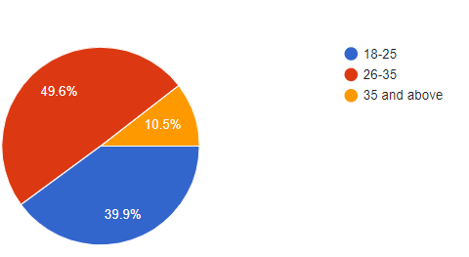

#### Figure 4.2.1

Interpretation: The study covered the demographics of different age groups as follows: The above analysis says that majority of respondents who have responded to the survey are people who come under 26-35 years of age i.e., 49.6%. Almost 39.9% of respondents come under 18-25 years of age. Only 10.5% of respondents come under 35 and above age.

1. Graph showing the gender of respondents.

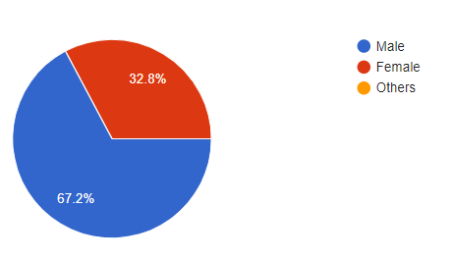

#### Figure 4.2.2

The above analysis says that majority of respondents who have responded to the survey are Male i.e., 67.2% who are working for IT sector. Responses received from female is 32.8% who are working in IT sector.

1. Graph showing the marital status of respondents.

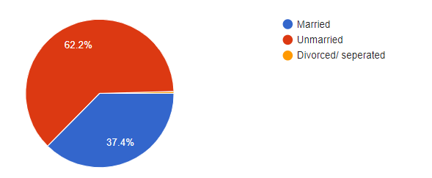

#### Figure 4.2.3

For this study even the marital status of the respondent (i.e., person working in the IT sector) acts as a major demographic factor to be considered. From the analysis we get to know that 62.2% respondents are unmarried and 37.4% respondents are married. There is very small percentage of response is given by divorced/separated.

1. Graph showing the educational qualification of the respondents.

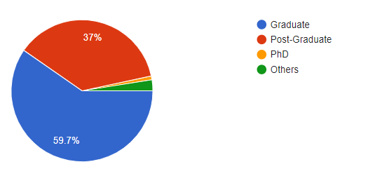

#### Figure 4.2.4

The above analysis says that majority i.e., 59.7% of the responses are from Undergraduate students who are now working for various IT companies. 37% of the responses are from post graduates. Very small percentage of responses is obtained by PhD holders and others.

1. Graph showing the duration respondent employed in the current position.

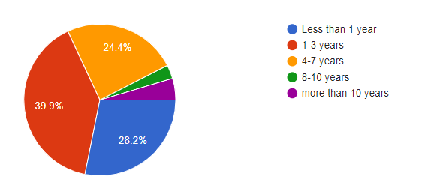

#### Figure 4.2.5

From the analysis we can know that majority of the respondents i.e., 39.9% come under 1-3 years of duration stay in their current company. 28.2% respondents are having less than one year duration stay. 24.4% respondents are having 4-7 years of duration stay in their current company. The respondents from senior IT professionals who is having more than 10 years of duration stay are quite adding value for this study.

1. Graph showing the type of family respondent is from.

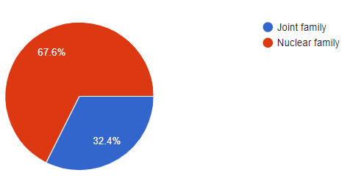

#### Figure 4.2.6

From the above graph we can know that majority i.e., 67.6% of the respondents are from Nuclear family and 32.4% of the respondents are from joint family.

1. Rating level of satisfaction towards work-life-balance during covid-19 pandemic.

* Scale of 1-5, 1- strongly disagree, 2- disagree, 3- undecided, 4- agree, 5- strongly agree.

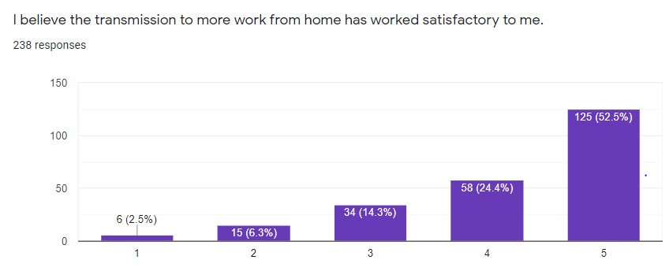

#### Figure 4.2.7

From the above bar graph we can say that out of 238 responses, 125 (52.5%) respondents strongly agree that transmission to more work from home as being more satisfactory when compared to work from office. Very less respondents have strongly disagreed for work from home. By this analysis we can conclude that most of the IT employees feel safe and are very much comfortable as well as happy working from during pandemic.

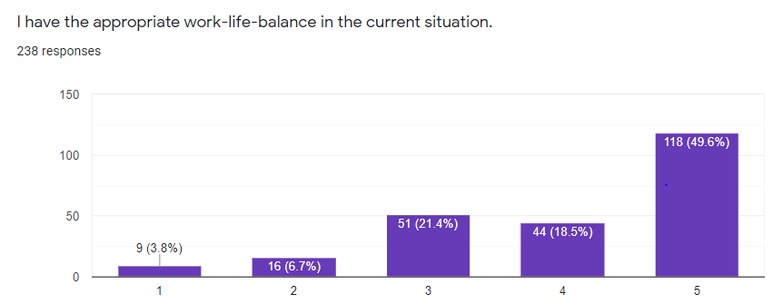

#### Figure 4.2.8

From the above graph we can say that when coming to work-life-balance context 118 (49.6%) respondents say that their work-life-balance was strongly appropriate during covid-19 pandemic. 44 (18.5%) agree that work-life balance is appropriate. Where 51 (21.4%) respondents has are still in dilemma whether their work-life-balance is achieved or not. 9 (3.8%) respondents strongly disagree that work-life-balance is not achieved during pandemic. 16 (6.7%) disagree that work- life-balance is not appropriate.

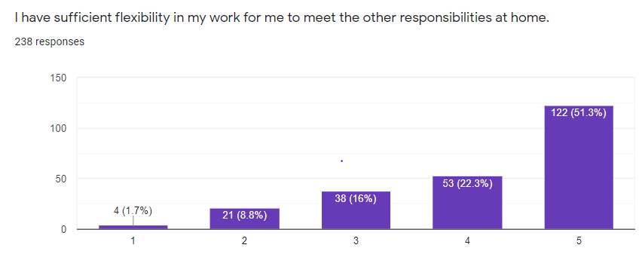

#### Figure 4.2.9

From the above bar graph 122 (51.3%) respondents strongly agree and 53 (22.3%) respondents agree, that due to work-from-home they are having flexibility of time to work as well as meet their responsibilities at home. 4 (1.7%) respondents strongly disagree and 21 (8%) respondents disagree that there was no time to meet their responsibilities at home while working-from home. 38 (16%) are yet to decide if they were genuinely getting time to manage office and house responsibilities.

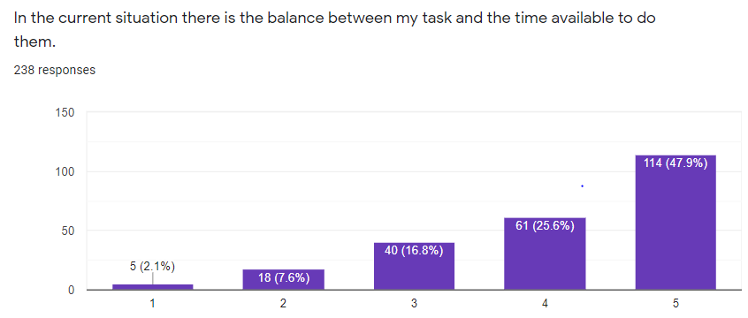

#### Figure 4.2.10

From the above bar graph 114 (47.9%) respondents strongly agree and 61 (25.6%) respondents agree, that they are having the balance between the task assigned to them as well as they are getting sufficient time to do them. 5(2.1%) respondents strongly disagree and 18 (7.6%) respondents disagree that there is no sufficient time balance to complete the task assigned to them. 40 (16.8%) respondents are still not sure whether they are finding enough time to manage the work assigned and time assigned to complete them.

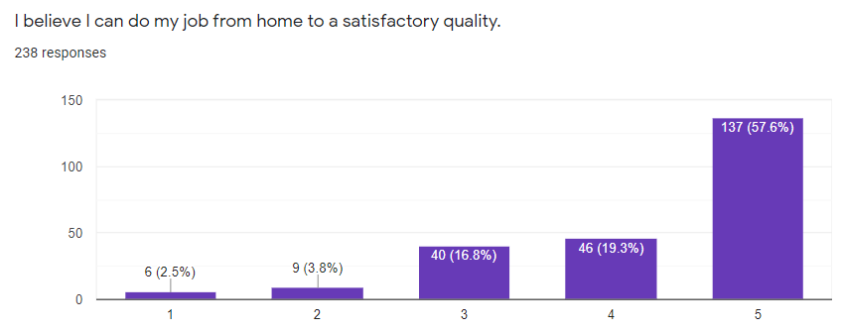

#### Figure 4.2.11

From the above bar graph 137 (57.6%) respondents strongly agree and 46 (19.3%) respondents agree, that the job done by working from home are of satisfactory quality. 6(2.5%) respondents strongly disagree and 9(3.8%) respondents disagree that job done by working from home is not of satisfactory quality. 40 (16.8%) respondents are still not decided whether the work quality is satisfactory or not.

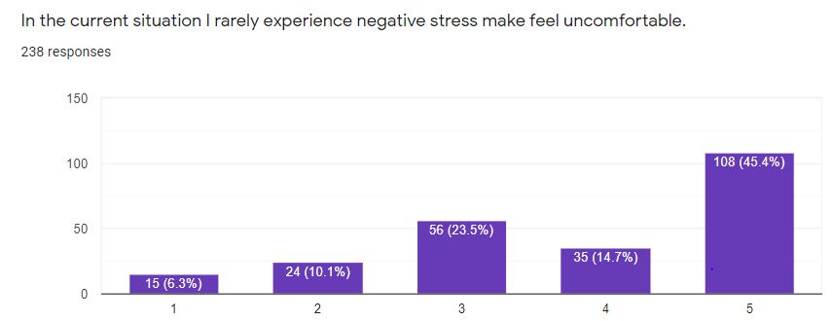

#### Figure 4.2.12

From the above bar graph 108 (45.4%) respondents strongly agree and 35 (14.7%) respondents agree, that they rarely experienced the negative stress because of pandemic and sudden shift to remote work. But at the same time 15 (6.3%) of respondents strongly disagree and 24 (10.1%) disagree the statement saying that they very often experienced the negative stress working from home. 56 (23.5%) respondents who have undecided in the sense they have been on both sides i.e., stressful and not so stressful situations.

1. Factors affecting work-life-balance during covid-19 pandemic.

* Scale of 1-5, 1- strongly disagree, 2- disagree, 3- undecided, 4- agree, 5- strongly agree.

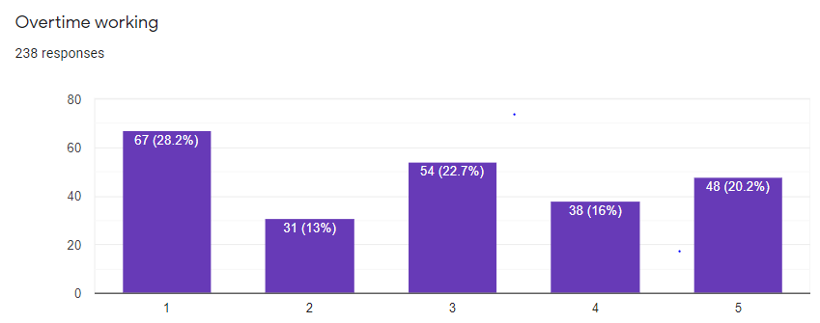

#### Figure 4.2.13

The major factor affecting IT employees i.e., overtime working during covid-19 pandemic. 48 (20.2%) respondents strongly agree and 38 (16%) respondents agree that overtime working was affecting their work-life-balance during covid-19 pandemic. 67(28.2%) respondents strongly disagree and 31(13%) respondents disagree saying that overtime working was not affecting their work-life-balance during pandemic. 54 (22.7%) respondents are not sure if or whether the overtime working affecting the work-life-balance.

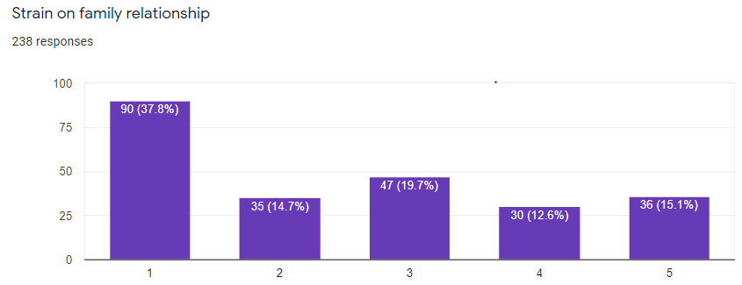

#### Figure 4.2.14

In the above graph which shows the strain on family relationship factor, 36 (15.1%) respondents strongly agree and 30(12.6%) agree that there was strain in managing and maintaining family relationships during pandemic. In the same way majority of the respondents i.e., 90 (37.8%) strongly disagree and 35 (14.7%) disagree that even during pandemic and work-from-home situation there was no strain on family relationship. 47(19.7%) of respondents are not clear whether it should be considered as the affecting factor or not.

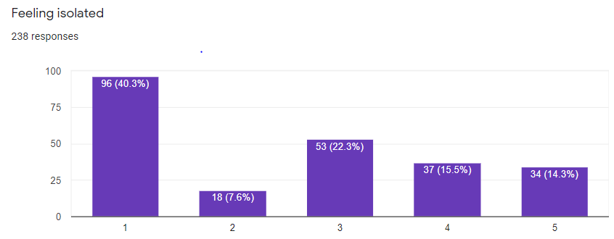

#### Figure 4.2.15

In the above graph which shows feeling isolated as an affecting factor, 34(14.3%) respondents strongly agree and 37(15.5%) agree that during pandemic and remote work mode they were feeling isolated and lonely. Whereas on the other end 96(40.3%) respondents strongly disagree and 18(7.6%) disagree that feeling isolated was not the major factor affecting since everyone were at house and spending quality time with family. 53(22.3%) of the respondents not sure if they were feeling isolated or not.

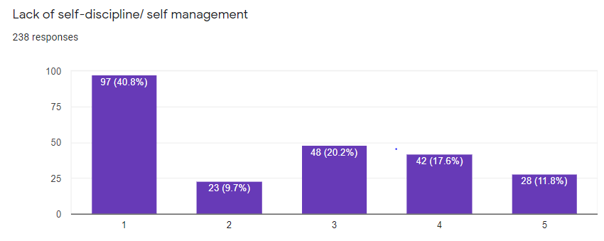

#### Figure 4.2.16

In the above graph which shows lack of self-discipline/self-management as an affecting factor, were 28(11.8%) respondents strongly agree and 42(17.6%) agree that they were not able to manage their own selves and give time for their schedules as everything was changed and it just felt like starting a new whole life with different scenario that is working from home. Whereas on the other end 97(40.8%) respondents strongly disagree and 18(7.6%) respondents disagree to the factor which shows that they were able to manage their selves well during pandemic. 48(17.6%) respondents are not sure if they could manage it or not.

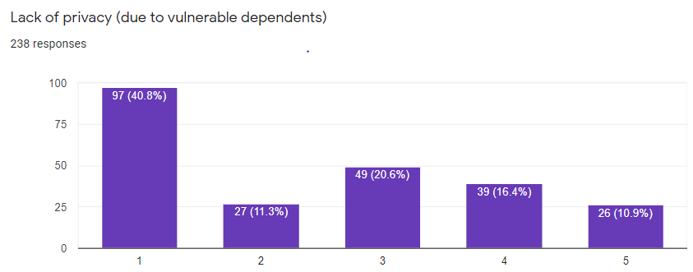

#### Figure 4.2.17

In the above graph which shows lack of privacy as an affecting factor, were 26(10.9%) respondents strongly agree and 39(16.4%) agree that due to work-from-home setup their privacy was hindered and this was also one of the factor which was employees major concern. Whereas on the other end 97(40.8%) respondents strongly disagree and 27(11.3%) respondents disagree saying that their privacy was not hindered and that did not affect them during the pandemic. 49(20.65%) respondents are not sure if their privacy was affected due to vulnerable dependents.

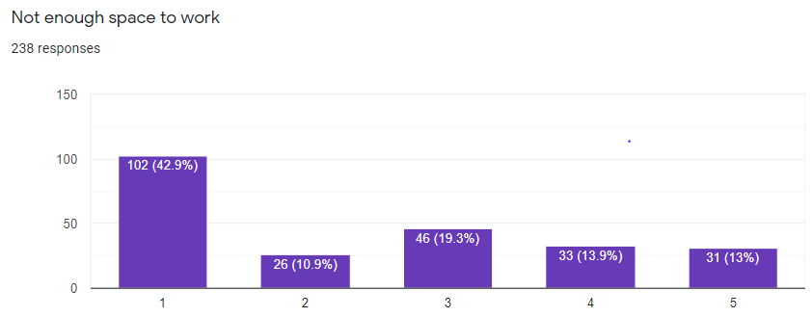

#### Figure 4.2.18

In the above graph which no enough space to work as an affecting factor, were 31(13%) respondents strongly agree and 33(13.9%) agree that lack of working space was one major issue faced by these employees. But majority of the employees that is 102 (42.9%) strongly agree and 26(10.9%) have not considered to be a major problem since they are happy and satisfied with their home working space. 46(19.3%) of the respondents are having the moderate opinion on working space.

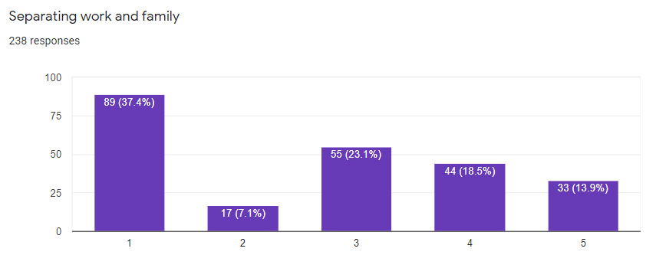

#### Figure 4.2.19

In the above graph shows separating work and family as an affecting factor, were 33(13.9%) respondents strongly agree and 44(18.5%) agree that separating work and family during covid-19 was a major challenge. But majority of the respondents that is 89(37.4%) strongly disagree and 17(7.1%) disagree that they could maintain the balance between work and family. Whereas 55(23.1%) respondents are remaining moderate to their decisions.

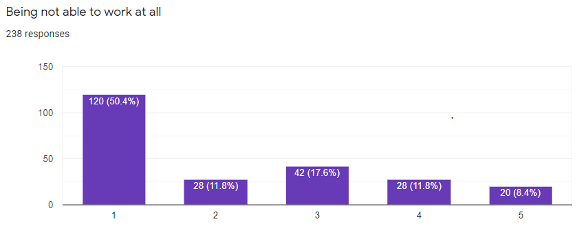

#### Figure 4.2.20

In the above graph shows being not able to work at all as an affecting factor, were 20(8.4%) respondents strongly agree and 28(11.8%) agree that during lockdown and pandemic they were not able to work at all due to lack of focus and external changes. Whereas 120 (50.4%) strongly disagree and 28(11.8%) disagree saying that they were comfortable with working from home during pandemic. From the majority of the response we can say that respondents were able to work satisfactorily from home.

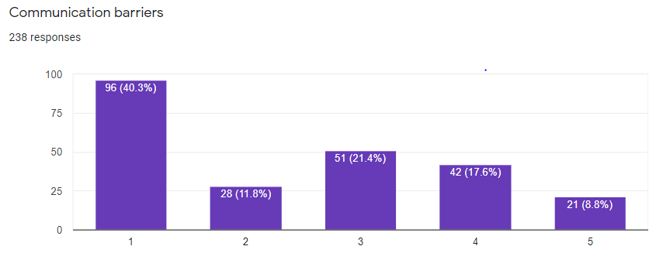

#### Figure 4.2.21

In the above graph shows being not able to work at all as an affecting factor, were 21(8.4%) respondents strongly agree and 42(17.6%) agree that the major affecting factor was communication barrier. Whereas 96(40.3%) strongly disagree and 28(11.8%) disagree saying that communication barrier was not an affecting factor for them. Whereas 51(21.4%) respondents are remaining moderate to their decisions.

1. Strategies that help to overcome work-life-balance during covid-19 pandemic.

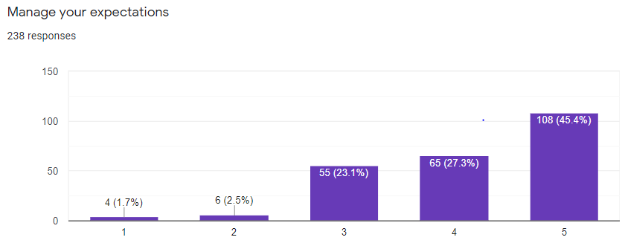

#### Figure 4.2.22

From the above graph we can say that majority of the respondents that is 108(45.4%) respondents strongly agree and 65(27.3%) agree that by managing our expectations we can achieve work life balance.

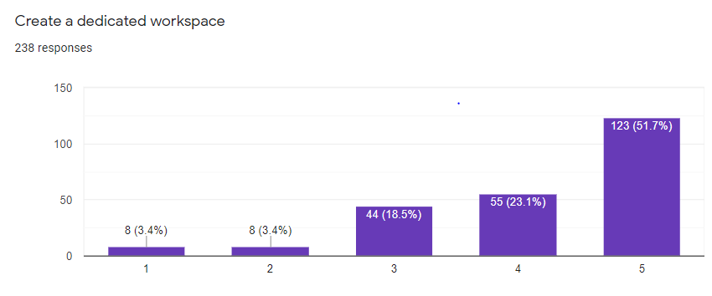

#### Figure 4.2.23

From the above graph we can say that majority of the respondents that is 123(51.7%) respondents strongly agree and 55 (23.1%) agree that by dedicating the proper workspace we can focus on work without any distractions or factors affecting the work. This is one strategy were the employees can achieve work life balance.

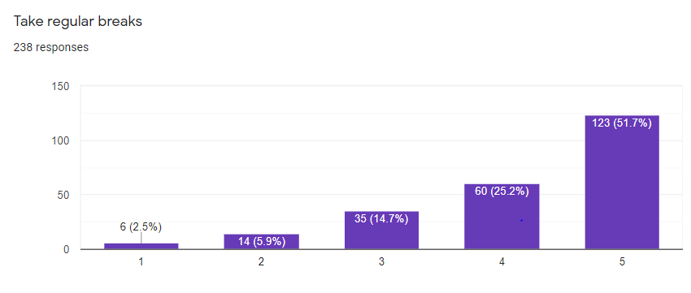

#### Figure 4.2.24

From the above graph we can say that majority of the respondents that is 123(51.7%) respondents strongly agree and 60 (25.2%) agree that by taking regular breaks there would be sufficient time given for work as well as family life and this can serve as a best strategy to attain work-life-balance.

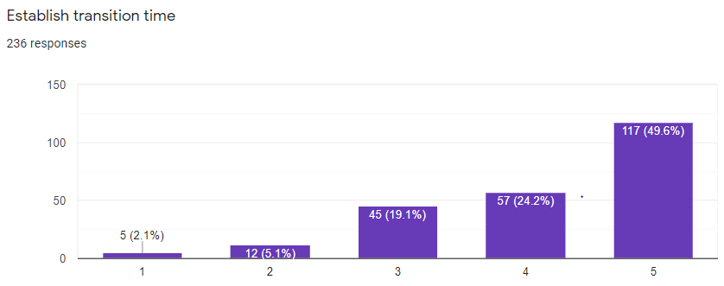

#### Figure 4.2.25

From the above graph we can say that majority of the respondents that is 117(49.6%) respondents strongly agree and 57(24.2%) agree that by establishing transition time employees can get some time to accept the change and can think how they can move about managing the work-life-balance. So from the survey we can know that majority of the respondents or the employees expect the transition time.

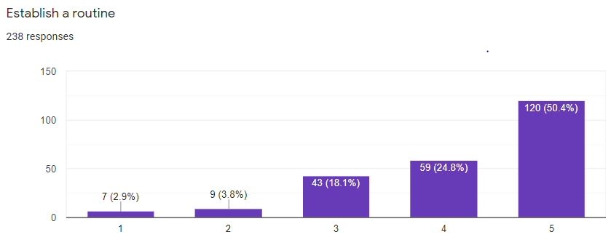

#### Figure 4.2.26

From the above graph we can say that majority of the respondents that is 120(50.4%) respondents strongly agree and 59(24.8%) agree that by establishing a proper routine the balance of work and personal life can be maintained. Also the routine in fact bring in the productivity

into work as well as maintains a good work-life-balance.

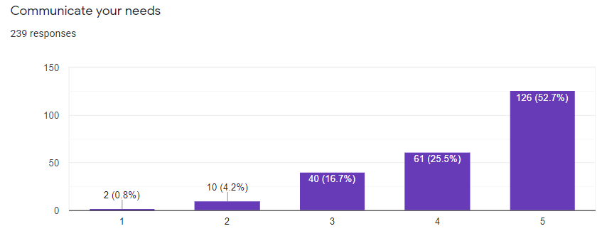

#### Figure 4.2.27

From the above graph we can say that majority of the respondents that is 126(52.9%) respondents strongly agree and 61(25.6%) agree to the point that clear communication and by communicating the needs to employer or to the family members regarding the situations would be a best option of experiencing less stress and this can help the employees to achieve work-life-balance.

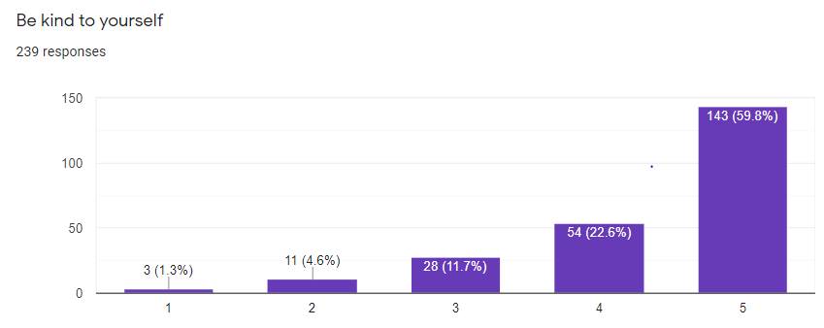

#### Figure 4.2.28

From the above graph we can say that majority of the respondents that is 143(60.1%) respondents strongly agree and 53(22.3%) agree that by being kind to oneself would be the best psychological therapy since the employee would have patience to deal with external situation as well as to drastic change in work-life also. This can help the employee to attain work-life-balance

# CHAPTER 5: FINDINDS AND SUGGESTIONS

#### SUMMARY OF THE FINDINGS

In this research paper, we assess the heterogeneity in the effects of maintaining a proper work-life- balance during covid-19 pandemic of IT employees. Based on our research we have drawn conclusions on following criteria, to check the level of satisfaction of IT employees working from home as well as how the factors are affecting IT employees to maintain their work-life-balance. In the context of work-life balance, the direction of remote work’s effects is not changed. Covid -19 gave the world an option to experience work-from-home, which had long been a desired option for many especially in a place like India where increasingly dual family workforce exists. The responsibility of aged parents and/or young children coupled with demanding work environment has been a challenge questioning the work-life-balance of India’s IT employee workforce. Based on sourcing of few articles and the survey conducted the employers and employees reaction to work-from-home in India during pandemic, appears that the initial reactions to the changed working format has been favorable. However, looking past this superficial satisfaction, there are few gaps in work-from-home structure to maintain work-life-balance, and at the same time, there is some amount of dissatisfaction with the lack of priorities and policies to conduct effective work- life-balance. With the effectiveness of the work-from-home practices, the opinion of the people to work-from-home is to be considered. Compared to the opinions received in the early days of the practice, an overwhelming majority of the opinions were positive. From this study and findings it shows that more than 50% of IT employees are happy being working-from-home and also their satisfied the work-life-balance is achieved. Also when it comes to factors affecting the work-life- balance, majority of the IT sector respondents have disagreed which eventually means that IT employees were happy with what they were doing during covid-19 and there was no much issue by working from home. When addressed about the strategies to overcome imbalance 80% of the respondents are positive about those strategies implication in their current life so that they can maintain a proper work-life-balance. While this was the most popular opinion, it does not express the majority view, but when highlighting about the results we can draw a conclusion that majority of the IT employees felt relaxed while working at home during Covid-19 pandemic.

#### SUGGESTIONS

In past few years, personal and family lives have become critical values for the individuals. Employees are not willing to ignore their family and personal life, for the sake of work. Due to pandemic workforce has begun to change the working time and also the working place. The present study also support that work-life-balance has a very strong impact on the family of the employees during the pandemic. Consequently people are looking for options that allow for a both a personal and professional life, which may seek ways to have a work-life-balance during this pandemic. The present study reflects that the employee-driven solutions for balancing work-life, will help organization to design and implement work-life balance policies. It will help to reduce overtime, stress, and workloads on the work front and increase flexibility and family and leisure time on domestic front. Organizations have to take the challenge of work-life-balance seriously, as it affects their professional success and personal well-being. Welfare of employees and their satisfaction should be the topmost priority of the organizations.

**CHAPTER 6: CONCLUSION**

**6.1 CONCLUSION**

The entropy balancing procedure leads to comparable results to those of conventional ordinary least squares estimates, where the estimated coefficient of home offices on job satisfaction is absolutely larger and that of work-life balance is absolutely smaller. We document substantial heterogeneity that depends on the causes of work-life imbalance. Job-conditioned reasons, but not private ones, are decisive for the outcome that telecommuting has negative effects on work-life balance. The introduction of remote work raises job satisfaction. This is a hint that not only unobserved characteristics but also remote work itself contribute to higher satisfaction in the beginning. However, this effect is not permanent. Neither the introduction nor the termination of remote work reveals a significant, specific influence on work-life balance, while permanent remote work and work-life balance are negatively associated. Therefore, we conclude that unobserved characteristics are mainly responsible and not causal remote work effects. In other words, these unobservable variables determine the preference for working from home and, coincidentally, work-life imbalance. For job satisfaction it is relevant whether a strict contract exists for remote work. In this case, remote work and job satisfaction are positively correlated. It does not make a statistically significant difference whether remote work is performed within or outside of the contracted working hours, although the signs of the coefficients are not the same – the former is positive and the latter is negative. This seems plausible. Longer working hours are accompanied by less job satisfaction. These results raise the question, which policy might be helpful to nudge those employees to work from home that are more satisfied and have a better work-life balance under this type of work? Firms should extend the possibilities of remote work and supply strict contracts under which remote work is allowed. They should restrict remote work outside of the contracted working hours to a minimum. They should recommend that their remote workers discuss the advantages of remote work with those who want to work from home. Firms should reduce job conditioned factors that contribute to work-life imbalances. For instance, they should not make timing too tight so that the tasks can be handled by employees within the prescribed timeframe without resulting in job strain. More job satisfaction increases work motivation and leads to higher performance. Further research requires more detailed information concerning remote work. Longer time series are necessary demonstrating the development and changes of

home office effects. Although the consideration of job conditions has given us new insights avoiding biased estimates, detailed information on the assignment of personal skills to tasks required at the workplace are helpful. A more specific analysis of job characteristic, commitment, and collegiality effects can reveal conditions that are advantageous for employers and employees. Further interaction effects between remote work and job conditions, as well as between personal and job features should be studied. If home-office information on employer-employee level is available, if a comparison before, during and after the corona crisis is possible, we can learn whether COVID-19 has contributed to a substantial structural change.

#### SUGGESTION FOR FUTURE RESEARCH.

Future research may be conducted as to why work-life-balance is important during Covid-19 pandemic. Since this study is limited only to IT sector in India. Future studies can be done on different industries and brief about the various factors affecting them, by collecting of primary data. Also can come with new strategies where the implications and impact of those strategies would help employees of that industry.

# CHAPTER 7: BIBILOGRAPHY

## BIBILOGRAPHY

1. Journal article: Work-life-balance and its organizational pride and job satisfaction

B. Mas-Machuca, Berbergal: -2016

1. Journal article: role of work and family factors in predicting career satisfaction and life success. Neena Gopalan
2. Journal article: IOSR journal of business and management

*Article (Anonymous)*

1. Journal article: Work-life-balance: a matter of choice

*Gregory A, Milner*

1. Journal article: Study of work life of women entrepreneurs

*U. Sucheta Agarwal.*

1. Journal article: Working from home and Covid-19: the chance and risks for the gender gaps.

*M. Arntz****.***

1. Journal article: Work-from-home- who is happy? A survey of employees during covid-19 quarantine period.
   1. *Raisiene.*
2. Journal article: Work-life-balance reflections on employee satisfaction

*Sakthi Vel Rani.*

1. Journal article: Work-from-home after Covid-19 outbreak

*A Bick, A. Blandin*

1. Journal article: Covid-19 and workplace: implications, issues and insights for future research and actions.

*K. M, Kniffin; J Narayan.*

1. Journal article: Analyzing the sentiment towards work-from-home experienced during Covid-19 pandemic.

*D, Dubey A; S, Tripathi.*

1. Journal article: Is homeworking a better option in the digital era? An empirical research across EU member states

*Predeteanu- Dragne, T.I*

1. Journal article: The influence of Covid-19 pandemic on the remote work-an employee perspective.

*Dolot A*

1. Journal article: Work-life-balance under conditions of changes in the quality of working life.

*T.O, Razumova*

1. Journal article: Impact of Work-life-balance on organizational commitment of women health care workers.
   1. *Sana Shabir.*
2. Journal article: All of work? All of life? Re-conceptualizing work-life balance for the 21st century.

*Kelliher C, Richardson*

1. Journal article: A study of working women and work from home amid coronavirus pandemics.

*T, Kaut; P, Sharma*

1. Journal article: Challenges of work-life balance during Covid-19 induced national wide lockdown: exploring general reference in emotional exhaustion in the Indian setting.

*Bhumika*

1. Journal article: A study of work-life balance: challenges and solutions

*Gautam, Indu, Jain*

1. Journal article: The impacts of work-life balance challenges on social media sustainability

*R, Mushquir; C, Mordi*

1. Journal article: Work -life balance policies: challenges and benefits associated with implementing flextime.

*Downes C; Koekemoer*.

1. Journal article: Work- life balance of Indian women software professionals: a qualitative study.

*R, Valk; V, Srinivasan*

1. Journal article: Factors affecting work-life-balance of employees in Indian manufacturing companies: An empirical analysis using structural equation modelling.

Authors: - *J, Majunder; A, Giri.*

1. Journal article: Women entrepreneurs and work life balance; intrinsic challenges of family support, stress and health.

*P, Verma; A, Chaturvedi*

Journal article: Dual-earner parent couples, work and care during Covid-19 *Craig L; Churchill B*

# CHAPTER 8: APPENDICES/ANNEXURES

## QUESTIONNAIRE:

##### Basic information of the respondent:

1. ***Name*** -
2. ***Age*** -
3. ***Sex*** – a) male b) female c) others

##### Marital status –

* married
* Un-married
* Divorced/separated.

##### Education –

* Graduate
* Post- graduate
* PhD
* Others

**6. *Designation in Office***- ----------------------

##### How long have you been employed in your current position?

* Less than 1 year
* 1-3 years
* 4-7 years
* 8-10 years
* More than 10 year

##### Type of family

* Joint family
* Nuclear family

9.

|  |  |  |  |  |  |  |
| --- | --- | --- | --- | --- | --- | --- |
| **Scoring of remote working participants, level of satisfaction of IT professionals towards work- life-balance during Covid-19 pandemic.** | | | | | | |
| Sl No. | Questions | Rating scale of 1 to 5 | | | | |
| 1 | I believe the transmission to more homework has  worked satisfactory for me | 1 | 2 | 3 | 4 | 5 |
| 2 | I have an appropriate work life balance in the current  situation. | 1 | 2 | 3 | 4 | 5 |
| 3 | I have sufficient flexibility in my work for mw to meet  the other responsibilities at home | 1 | 2 | 3 | 4 | 5 |
| 4 | In the current situation there is the balance between my  task and the time available to do them | 1 | 2 | 3 | 4 | 5 |
| 5 | I believe I can do my job from home to a satisfactory  quality | 1 | 2 | 3 | 4 | 5 |
| 6 | In the current situation I rarely experience negative  stress make feel uncomfortable | 1 | 2 | 3 | 4 | 5 |

10.

|  |  |  |  |  |  |  |
| --- | --- | --- | --- | --- | --- | --- |
| **Scoring of remote working participants on factors affecting work life balance.** | | | | | | |
| Sl  No. | Questions | Rating scale of 1 to 5 | | | | |
| 1 | Over time working | 1 | 2 | 3 | 4 | 5 |
| 2 | Strain on family relation ship | 1 | 2 | 3 | 4 | 5 |
| 3 | Feeling isolated | 1 | 2 | 3 | 4 | 5 |
| 4 | Lack of self-discipline/ self-management | 1 | 2 | 3 | 4 | 5 |
| 5 | Lack of privacy (due to vulnerable depends) | 1 | 2 | 3 | 4 | 5 |
| 6 | Not enough space to work | 1 | 2 | 3 | 4 | 5 |
| 7 | Separating work and family | 1 | 2 | 3 | 4 | 5 |
| 8 | Being not able to work at all | 1 | 2 | 3 | 4 | 5 |

11.

|  |  |  |  |  |  |  |
| --- | --- | --- | --- | --- | --- | --- |
| **Scoring of remote working participants on the strategies to overcome work-life balance.** | | | | | | |
| Sl  No. | Questions | Rating scale of 1 to 5 | | | | |
| 1 | Manage your expectations | 1 | 2 | 3 | 4 | 5 |
| 2 | Create a dedicated workspace | 1 | 2 | 3 | 4 | 5 |
| 3 | Take regular breaks | 1 | 2 | 3 | 4 | 5 |
| 4 | Establish transition time | 1 | 2 | 3 | 4 | 5 |
| 5 | Establish a routine | 1 | 2 | 3 | 4 | 5 |
| 6 | Communicate your needs | 1 | 2 | 3 | 4 | 5 |
| 7 | Be kind to yourself | 1 | 2 | 3 | 4 | 5 |

**CATEGORY PARAMETERS**

|  |  |
| --- | --- |
| **1** | **Strongly Disagree** |
| **2** | **Disagree** |
| **3** | **Undecided** |
| **4** | **Agree** |
| **5** | **Strongly Agree** |