**Experiment 1 (noise removal):** The noisy image shown below (i.e., can be downloaded from course's webpage) has been generated by adding “cosine” (i.e., periodic) noise to the original image. **(a)** Using frequency domain filtering, use (i) a band-reject filter and (ii) a notch filter to remove the noise and show your results in each case. When presenting your results, make sure that you discuss how you chose the parameters of the filters and show the spectra for all images (before and after filtering) and filters. For comparison purposes, attempt to remove the noise in the spatial domain using Gaussian filtering (e.g., 7 x 7 or 15 x 15 filters). Compare your results between the spatial and frequency domains. **(b)** Instead of removing the noise pattern, devise a procedure using frequency domain filtering to extract the noise pattern and show your results. **(c)** Systems that perform face verification and recognition (see definitions below) can greatly benefit from high quality face image inputs. What are some possible implications on face verification and recognition performance of failing to remove/reduce noise in face images or introducing artifacts due to algorithmic errors? This is a **free response question**; you can discuss both safety and economic implications. Provide proper citation for any information obtained from other sources.

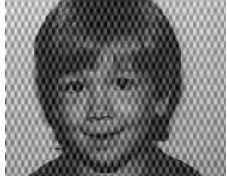

Definitions: Face verification is concerned with validating a claimed identity based on the image of a face (**one-to-one matching**). Face recognition is concerned with identifying a person based on the image of a face (**one-to-many matching**).

**Experiment 2 (homomorphic filtering):** Many times, images suffer from shading problems due to uneven illumination. The role of homomorphic filtering is to alleviate such problems. In your experiments, use the image shown below (i.e., can be downloaded from the course's webpage). As discussed in the class, the main idea behind homomorphic filtering is to separate the illumination and reflectance components by applying the logarithmic function on the image. You would then need to apply an appropriate high-pass filter, which will emphasize high frequencies and attenuate lower ones, preserving fine detail at the same time.

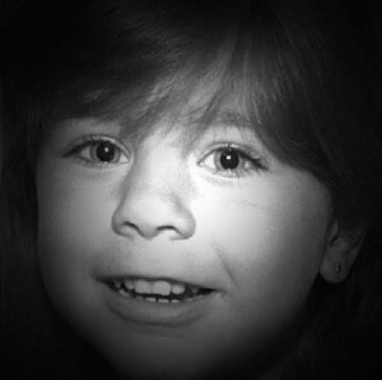

The high-pass filter to be used in your experiments is a **high-frequency emphasis** filter:

*H* (*u*, *v*)  (

−  ) 1 *e*  0    

*c*(*u*2 *v*2 )/ *D*2 

*H L*   *L*

where D0 is the cutoff frequency of the filter and γL γH are the gains for the low and high frequencies correspondingly. Note that before you apply the filter on the image, you must first **center** it so that its center coincides with the center the spectrum of the image.

Experiment with different parameter values. As a starting point, choose D0=1.8, c=1, γL=0.5 and γH =1.5. Then, keep the cutoff frequency the same and increase/decrease γL and γH. For example, assume combinations of γL and γH, with γL taking values from [0.0-1.0] and γH taking values from [1.0-2.0]. Show and comment on your results. Which set of parameters seems to be

working the best? Is there a consistency in your results as γL increases/decreases? What about γH? When presenting your results, make sure that you show the spectra for all images (before and after filtering) and filters.

**Laboratory Write-up:** For each programming assignment, you are to turn in a report (please, follow closely the instructions posted on the course’s website). **The report is very important in determining your grade for the programming assignment.** Be well organized, type your reports, and include figure captions with a brief description for all the figures included in your report. Motivation and initiative are greatly encouraged and will earn extra points.