**Formative Report Instructions**

Follow these instructions to write your formative report. Save this file with a different name and modify the sections accordingly.

Modify the blue text accordingly

Read and then change all red text (that is used as example) to your writing.

**Delete this instruction page before submission!**

Submit your report to the Report submission folder on the module Blackboard site

For your formative report you are asked to use the **experiment from Practical 4: Thin layer chromatography of sugars.** You are asked to write Introduction about the experimental technique, to present your results (TLC plate(s), write your calculations, summarise the data in a table, and describe your results. You are also asked to use external literature sources (mainly in the introduction) and properly acknowledge the sources (cite in text and reference in the bibliography).

**Structure of your report.**

**Maximum 500 words total** (excluding references).

Introduction & Aims 40 marks

Results and report presentation 50 marks

References 10 marks

**Please see full marking scheme on Blackboard.**

The purpose of this formative assessment to give you an opportunity to try report writing before your Summative assessment in trimester 2. This is a short report aiming to evaluate your writing skills, data presentation skills, and referencing. Use your skills obtained in the computer class for report presentation.

**Biochemical & Pharmaceutical Skills L4**

**Thin layer chromatography of sugars**

Lab partner name(s)

**INTRODUCTION & AIMS**

In this report we ask you to write a brief introduction to the TLC experiments that you used in your practical. Provide background information about the experiments, explaining what those experiments for, important steps to carry them out, where they are used in science. Find also information about your staining reagent. You will need to find literature sources to support your statements. Cite your sources in text and add them to your References section at the end of the file. We ask you to focus on **primary** sources (text books, scientific papers or dedicated reliable web sources). You must cite the sources in text and add them to your Bibliography at the end.

Note: **DON’T copy the text from the Lab booklet!** *This is Academic Misconduct - write with your own words! The aim of this formative assessment is to assess* ***your*** *writing skills and provide you feedback for improvements in future.*

Finish the sections with writing **AIMS** of the experiment.

You can present here images supporting your explanations. The images should be presented as Figures, numbered sequentially along the report, with appropriate Figure titles and Notes indicated the source (if the image is taken from an external source). See Figure examples in the RESULTS section. You MUST follow APA 7th format for your presentation of Figures.

The text above is 210 words.

**RESULTS**

In this section you **should present & describe your TLC results.** Your results may have with different formats such as graphs, tables, drawings, data records, calculations, etc.

At the beginning of this report, before presenting the main results, write clearly what compounds you were investigating and what results you will present. You should aim to start each section with a short overview / explanation what the section is about. Beginning a section with a Figure is not a good style.

Then, present a drawing of your TLC plate(s), indicating all key components such as: origin line with marks for compounds, solvent front, all spots, and distances from the spots to the origin line. Use your drawings from the practical and your skills from the computer session to draw your TLC plate(s). Present the plate image as a Figure. Each figure in your report should contain Figure number and title (above the Figure) and a note with more explanation (if needed) below the Figure. See example and more explanations below.

**Figure 1.**

*Example of Figure Presentation*

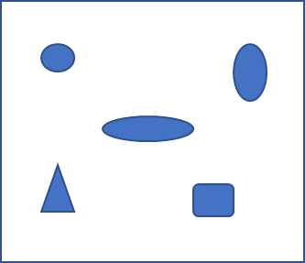

*Note*. This is just a random drawing presented as example. You will need to draw ***your***(!) TLC plate here.

**Note that presentation format of Figures is important!**

Figures and Tables should be presented using APA 7th format following these components:

* **number:** The figure or table number (e.g., Figure 1, Table 4) appears ***above*** the figure in **bold**. Number figures in the order in which they are mentioned in your report.
* **title:** The figure title appears one double-spaced line below the figure number. Give each figure a brief but descriptive title and **capitalize the figure title in italic title case.**
* **image:** The image portion of the figure is the graph, chart, drawing, or other illustration itself. If you have text in your image (like axis labels, legends), use appropriate font (between 8 and 14 points).
* **legend:** A figure legend, or key, if present, should be positioned within the borders of the figure and explains any symbols used in the figure image.
* **note:** Below the figure (table) to describe contents of the figure (table) that cannot be understood from the figure title, image, and/or legend alone (e.g., definitions of abbreviations, copyright attribution, citation of the source used). Include figure notes only as needed. The note should start with the word *Note.* in italic.
* **reference to a figure or table in text:** Refer to every figure or table by its number in text.

The most important principle to follow when creating a figure is to present information in a way that is easy for readers to understand.

Figure 1 presents an Example of a Figure created by the user and Figure 2 presents an Example of a Figure taken from an external online source.

**Figure 2**

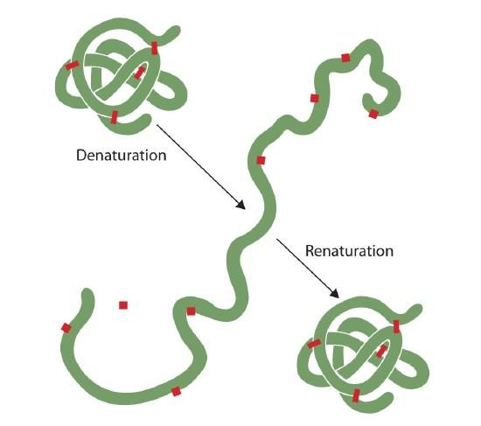*Denaturation and Renaturation of a Protein*

Note. The illustration showing a schematic diagram of denaturation and renaturation of a Protein. From: Chemistry LibreTexts, 2021. (<https://chem.libretexts.org/Bookshelves/General_Chemistry/Map%3A_Chemistry_-_The_Central_Science_(Brown_et_al.)/24%3A_Chemistry_of_Life-_Organic_and_Biological_Chemistry/24.09%3A_Proteins>). CC BY-NC-SA 3.0 licence.

**Comment:** you need cite your source (and then reference it, see examples in the Bibliography) and write copyright information (if you can find it).

After that present your calculations of the Rf values. Write the formula for Rf values in equation editor (Insert 🡪 Equation 🡪 choose one the closest type and edit it accordingly). Show all your workout.

Last, summarise your Rf values in a Table. Presentation of the tables is similar to one of the Figures. Example of a table in given below.

**Table 1**

Molecular composition of the membrane

|  |  |  |
| --- | --- | --- |
| **Compounds** | **Mol %** | **N of molecules** |
| POPC | 65 % | 84 |
| PSM | 10 % | 12 |
| CHOL | 25 % | 32 |
| H2O |  | 5120 |

It is not enough to simply insert a Figure or Table in this section without explaining what it shows and what does it mean! You **MUST** describe what your result shows.

Also, a good style is to refer to your figures and tables in text, explaining where appropriate why they are presented there. For example:

As shown in Figure 2, most proteins denaturate (change their structure) with increase of temperature.

Table 1 shows the molecular composition of the membrane listing all the lipids and water in mol % and in number of molecules.

**REFERENCES**

For referencing and presentation of figures please follow more detailed document on referencing available from the Library site

University APA 7th (HARVARD) STYLE GUIDES:

<https://www.salford.ac.uk/skills/referencing/apa-7th-edition>

Also you can consult APA website directly, for example

<https://apastyle.apa.org/style-grammar-guidelines/tables-figures/figures>

Below are examples of how to cite and reference different sources. Remember that your references should be consistent – both cited in text AND listed in your bibliography here.

**Journal paper**

In your bibliography:

Arrigo, R., Schuster, M.E., Wrabetz, S., Girgsdies, F., Tessonnier, J.P., Centi, G., Perathoner, S., Su, D.S. and Schlögl, R., (2012). New insights from microcalorimetry on the FeOx/CNT‐based electrocatalysts active in the conversion of CO2 to fuels. *ChemSusChem*, *5*(3), pp.577-586. <https://chemistry-europe.onlinelibrary.wiley.com/doi/abs/10.1002/cssc.201100641>

Cite in text:

(Arrigo et al., 2012) or “as stated by Arrigo et al. (2012), the microcalorimetry technique …” or multiple sources together: (Arrigo et al., 2012, Wilkinson & Hadfield, 2015; Johnson, Brooks & Williams, 2010)

**Book**

In your bibliography

Atkins, P., & De Paula, J. (2011). *Physical chemistry for the life sciences* (2nd ed.). Oxford University Press.

Cite in text: (Atkins & De Paula, 2011) or “according to Atkins & De Paula (2011), thermodynamics explains the origins of living things…”

**Book chapter**

In your bibliography

Ettelaie, R., Akinshina, A., & Dickinson, E. (2009). A theoretical self-consistent field study of mixed interfacial biopolymer films. In Q. Huang, P. Given & M. Qian (Eds.), *Micro/Nanoencapsulation of Active Food Ingredients* (pp. 46-66). American Chemical Society.

Cite in text: (Ettelaie et al., 2009) or “Ettelaie et al. (2009) studied interactions of …”

**Webpage with the author and the date**

In your bibliography

Turner, K. (2020, 8 July). *Explaining electrolysis*. Retrieved from <https://edu.rsc.org/ideas/5-ways-to-explain-electrolysis/4012108.article>

Cite in text: (Turner, 2020) or “According to Turner (2020), the main steps of electrolysis include…”

**Multiple webpages from the same website with no author but the date**

In your bibliography

University of Salford (2021a). *APA 7th Edition Handbook.* <https://www.salford.ac.uk/skills/referencing/apa-7th-edition>

University of Salford (2021b). *Tools For Good Academic Writing.* <https://www.salford.ac.uk/skills/skills-e-learning/writing-university>

Cite in text: (University of Salford, 2021a, 2021b) or “The examples on correct referencing style and approach to good academic writing were obtained from the University of Salford website (2021a, 2021b).

**Webpage with no author and no date**

In your bibliography

Thermo Fisher Scientific (n.d.) *Protein Gels*. Retrieved 08 February, 2022, from <https://www.thermofisher.com/uk/en/home/life-science/protein-biology/protein-gel-electrophoresis/protein-gels.html>

Cite in text: (Thermo Fisher Scientific, n.d.) or “According to Thermo Fisher Scientific (n.d.), protein gels are used in various chemistry experiments …”

**Multiple pages from the same website (no author, no date case)**

In your bibliography

National Library of Medicine (n.d.-a) *Acetaminophen*. Retrieved 08 February, 2022, from <https://pubchem.ncbi.nlm.nih.gov/compound/1983>

National Library of Medicine (n.d.-b) *Diclofenac*. Retrieved 08 February, 2022, from <https://pubchem.ncbi.nlm.nih.gov/compound/3033>

Cite in text: (National Library of Medicine (n.d.-a, n.d.-b)

**Website**

Do not create references or in-text citations for whole websites. If you need to refer to a website, for example a tool you have used in your work, mention it in the body of your text and include its URL, either in brackets after the name of the website, or by hyperlinking the website’s name.

The molecular structures were obtained from ZINC database of commercially-available compounds for virtual screening. (<https://zinc15.docking.org/>)

The illustrations were created using Inkscape (<https://inkscape.org/>)

**Please DO NOT USE**

Wikipedia and any other unreliable web sources (where the information is not verified before publication) such as UKEssay, study.com, quora, coursehero etc. Those are not scientific sources. The marks will be subtracted for using unreliable sources.