A1.
The ten largest companies in the world ranked by revenue (in billions $US).
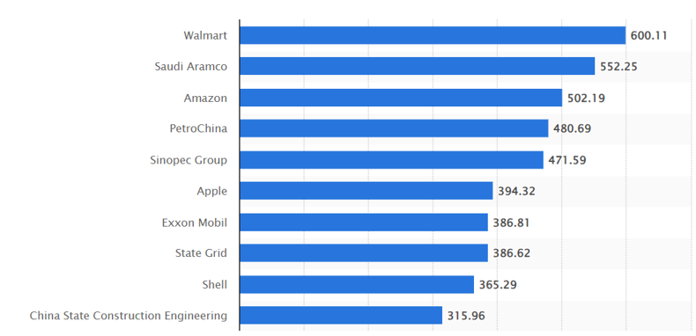
Source: Statista

B2.
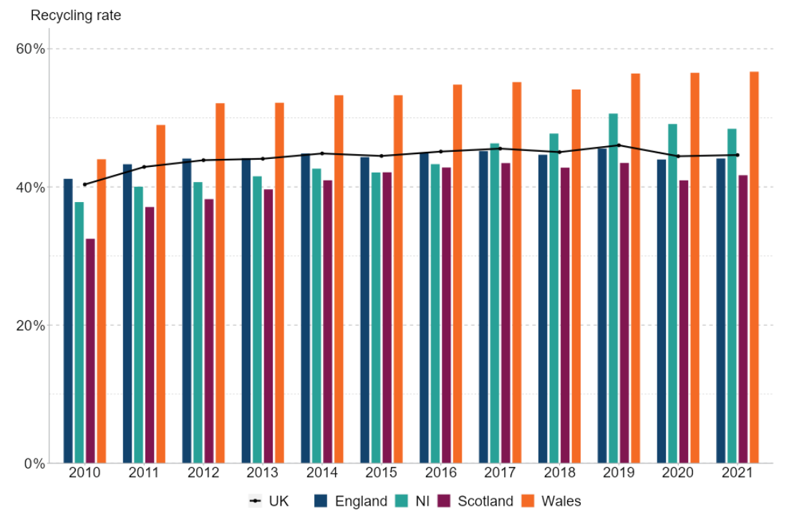
Recycling rate from waste from households, UK and country split, 2010-2021.

Source: Department for Environment, Food and Rural Affairs

C2.
Projected health conditions by type and number in the UK.
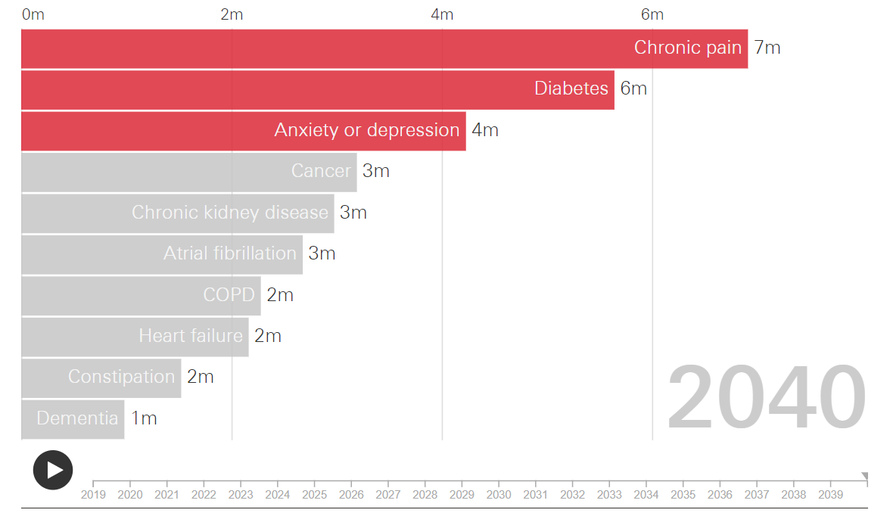
Source: The Health Foundation

D1.
The 10 most popular supermarket chains in the UK in 2023.
