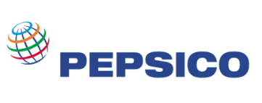

Inventory Management System at PepsiCo India Holdings Pvt Ltd

By

Name: Priyanka G N

USN: CMS21EMBA358

Inventory management is very important for big business and private owned organizations especially where there are a lot of orders are being placed everyday and there are lot of materials and the maintenance is really important which the system will do and also will record the time taken to process an order and this system is really important as it can help the organizations to be alerted when the level of inventory is very low and focuses on the three aspects of inventory management and prevent from failures in the future.

As inventory management system for any company is essential to fulfil customer demands on time and in cost effective manner, I’m going to research and analyze the inventory management system of one of the leading food and beverages business PepsiCo India Holdings Pvt Ltd, with an objective of finding out the efficiency of inventory management system in the organization.

From the data analysis it is found that the company is not doing good since last two years as it’s average current ratio for the year 2022 is 0.80, which is much lower than standard ratio.

The average inventory holding period of PepsiCo is 41 days and the inventory turnover ratio for the three months ending June 2023 is 1.70.

The primary objective of the study is to measure the effectiveness of inventory management system in the company, comparing previous two years data and coming up with measures to be taken to improve the inventory management at PepsiCo.

The company is using ABC classification of items to control inventory in the company which is good for the company as it contains a huge number of engineering spares of different values supporting the production activities every day. It helps in applying the control over high valued items that are very essential for the company.

In this case study the total closing balance and total cost of issues will be calculated under different methods of inventory valuation: FIFO (first in, first out), LIFO (last in, first out) & WAC (weighted average cost).