Database Design and Implementation for a Fitness Center

Note: - Case Study will be evaluated on group work:-
Group Work – 20 Marks

Detail about possible points and weightage for Group Work is given below.

Objective
The objective of the case study is to reinforce the concepts learnt in the course through engaging in a database design process from the development of business rules to the implementation.
The project
In this case study, your team is asked to design and implement the database component of a Fitness Center. Few wireframe screens (you will find them at the end of this document) were made during the requirements analysis of the project and those screens will be your main source of information on the entities, attributes and relationships between the entities. You need to identify the business entities and attributes from the wireframes. Graphical User Interface components such as Windows and Buttons and Lists are not entities. Below are the required tasks from your group:
Conceptual Model
- Conceptual EER model. The model will be done using Visual Paradigm, Visio, Draw.IO or any other equivalent software with crow foot notation. The models will not be accepted if made by hand.
Relational Database
- Relational logical data model: convert the conceptual model to relational logical model and make data structure diagram for the tables make sure that all the tables are in the 3rd normal form. You need to state if every table that you created is in the third normal form or not. If not then you need to convert it to the third normal form.

- Develop the SQL scripts that will create the tables and enforce all the appropriate constraints.
- Develop sample SQL scripts that will insert the data to the database (one row in each table).
- Convert at least 2 entities to MongoDB Collections. Write the scripts that will Create the collection(s).
- Create SQL SELECT statements that will:
- Return all the information displayed on the Locations tab (wireframe 1)
- Return all the information displayed on the Midtown Location tab (wireframe 1)
- Return all the information displayed on the Coaches tab (wireframe 3)
- Return all the information displayed on the Coach Sally tab (wireframe 4)
Deliverables- All deliverables are due at the end of the week (Sunday 11.59 pm) mentioned in the table. There will be a Mid-way checkpoint in week 11, and project presentation in week 13. It is mandatory to attend checkpoint and to present your project, in-order to get it marked.
Deliverable |  |  | Delivery Date | Possible Points | Weightage
1 | Conceptual Model | ER Diagram | Week 9 | 20 | 20 (Group Work)
2 | Relational | Data Structure Diagram | Week 9 | 20
3 |  | Create tables | Week 11 | 20
4 |  | Insert rows | Week 11 | 10
5 | NoSLQ | Convert entities to MongoDB collection | Week 11 | 10
6 | Select statements |  | Week 11 | 20
Total possible points |  |  |  | 100 | 20

Instructions
- All the deliverables will be delivered as one report in Microsoft word format to the Slate Drop Box
- The report should be professionally formatted and it should include a cover page that include the name of the report and the group members, page number in the footer of each place, etc.
- The diagrams must be done using Visual Paradigm or any equivalent software. Hand drawn sketches will not be accepted.
- The wireframes should give you enough information on the needed entity types, attributes and their relation. You can make any assumptions as needed; however, you need to state those assumptions in the EER diagram.
- You will work in a group of 2 to 3 students.
- The case Study has 6 deliverables, you need to consult with each other and agree to assign a deliverable lead to each of the deliverables. Each of you will be a lead of two or three deliverables. The deliverable lead is responsible for coordinating the work on the deliverable with the other team members. Additionally, the deliverable lead is ultimately responsible for the quality and the submission of the deliverable. If I receive a complaint from a group that the deliverable lead is falling short on coordinating and\or delivering his\her deliverable, I reserve the right to interview the group and to give the other members of the group bonus for their ideas on how to improve the deliverable
All the group members will abide to the rules of the group contract.

Appendix: Wireframes

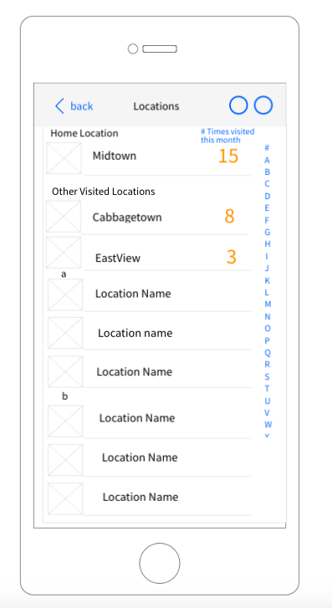 | 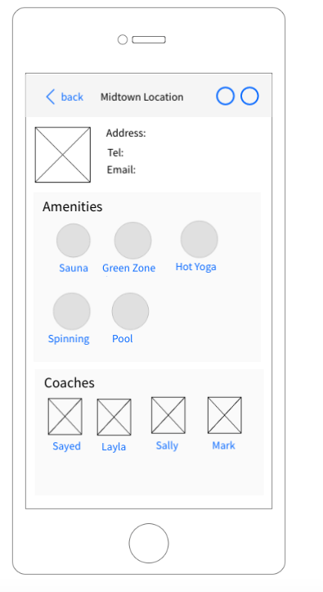
Wireframe 1 | Wireframe 2
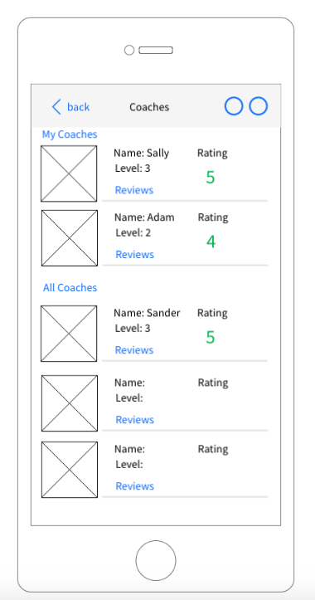 | 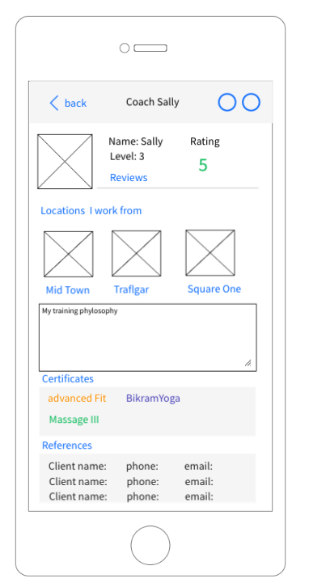
WireFrame 3 | Wireframe 4
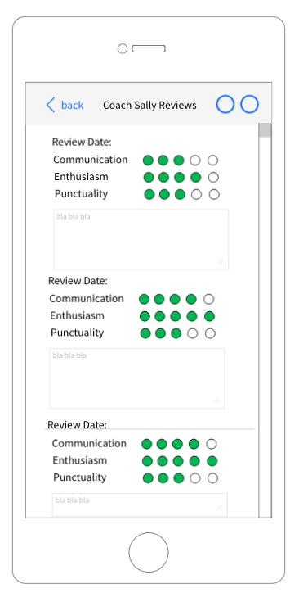 | 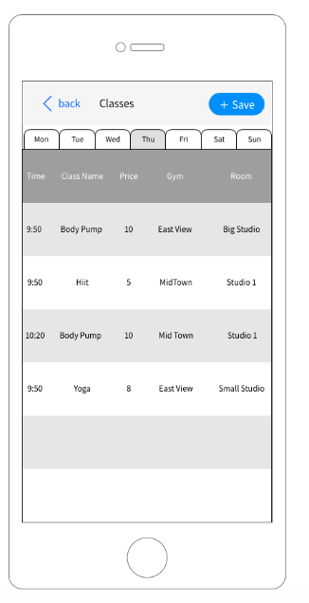
Wireframe 5 | Wireframe 6

