**Final Assignment**

**This is an individual assignment. All the tasks need to be finished by using R. Present your results in the word file, copy and paste all your R code in the end of this word file, and then submit your word file via the Turnitin link in iLearn before Week 13 Sunday Nov 5th 11:57pm. Please note that your report will go through similarity check. Generally, a high similarity would be fine, but nearly identical R code will be considered plagiarism.**

Please read the paper “The Cross-Section of Volatility and Expected Returns” by Ang et al. (2006) carefully and complete the following tasks. (**Be mindful with the different date format**!)

1. Download all stocks return data from CRSP for the period Jan 2009 to Dec 2011. Download Fama French 3 factors (They are all in percentages, be careful!) daily data from French Data Library

(<https://mba.tuck.dartmouth.edu/pages/faculty/ken.french/data_library.html>). Merge the two data sets. Calculate excess return for all stocks, remove observations with negative price, remove observations with return over 30% or under -30%. Report summary statistics (Number of observations, Min, 25% quantile, Median, 75% quantile, Max, Standard Deviation) for the stock excess return, stock market capitalization, MKR (Market risk premium), SMB, and HML. Draw a time-series line plot for MKR, SMB, and HML. **(10 mark)**

1. Download VIX index for the period Jan 2009 to Dec 2011. Calculate the innovation in VIX (in percentage). Report summary statistics (Number of observations, Min, 25% quantile, Median, 75% quantile, Max, Standard Deviation) for VIX and innovation in VIX. Draw a time series line plot for VIX. **(5 mark)**
2. Merge your stock returns, Fama French 3 factors, and VIX data. Test whether aggregate volatility is priced (Table 1 in Ang et al. 2006) as follows:
   1. Estimate the beta on innovation $β_{∆VIX}$ in VIX for each stock in month t-1 by estimating:

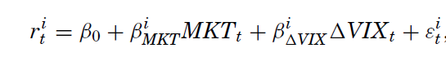

* 1. Form 5 portfolios based on $β_{∆VIX}$ in month t-1 from lowest (quintile 1) to highest (quintile 5).
  2. Calculate and report value weighted average return and $β_{∆VIX}$ for the portfolios in month t.
  3. Conduct a t-test between portfolio 5 and portfolio 1.

Please report the five portfolios return and $β_{∆VIX}$’s Mean and Standard Deviation, t-test statistics between P1 and P5. What conclusion can you get from your results? Is it consistent with Ang et al.’s finding? **(20 mark)**

1. Test whether idiosyncratic volatility is priced (Table VI panel B in Ang et al. 2006) as follows:
   1. Estimate the volatility of the residual for each stock in month t-1 by estimating:

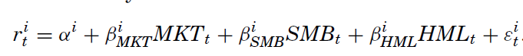

* 1. Form 5 portfolios based on idiosyncratic volatility in month t-1 from lowest (quintile 1) to highest (quintile 5).
  2. Calculate and report value weighted average return and idiosyncratic volatility for the portfolios in month t.
  3. Conduct a t-test between portfolio 5 and portfolio 1.

Please report the five portfolios return’s Mean and Standard Deviation, t-test statistics between P1 and P5. What conclusion can you get from your results? Is it consistent with Ang et al.’s finding? **(10 mark)**

R code: