**Reflection Paper**

Welcome to your assignment **"The Reflection Paper."**

You need to submit a **reflection paper** on the topics covered in modules 1 to 3. You will be graded on your thoroughness, openness, and willingness to risk being open, honest, and professionally vulnerable.

Assignment

| Assignment Number | Topic | Type | Points | Deadline |
| --- | --- | --- | --- | --- |
| 3 | Reflection Paper: Life Story, Values, Strengths, and Aspirations | Individual | 80 | End of Module 3 |

The following parts should be a part of your reflection paper.   
  
**Part 1: Your Life Story in Pictures**  
  
Start your paper with the graphic picture you drew of your life story in Module 1. See the illustration below for ease of reference.

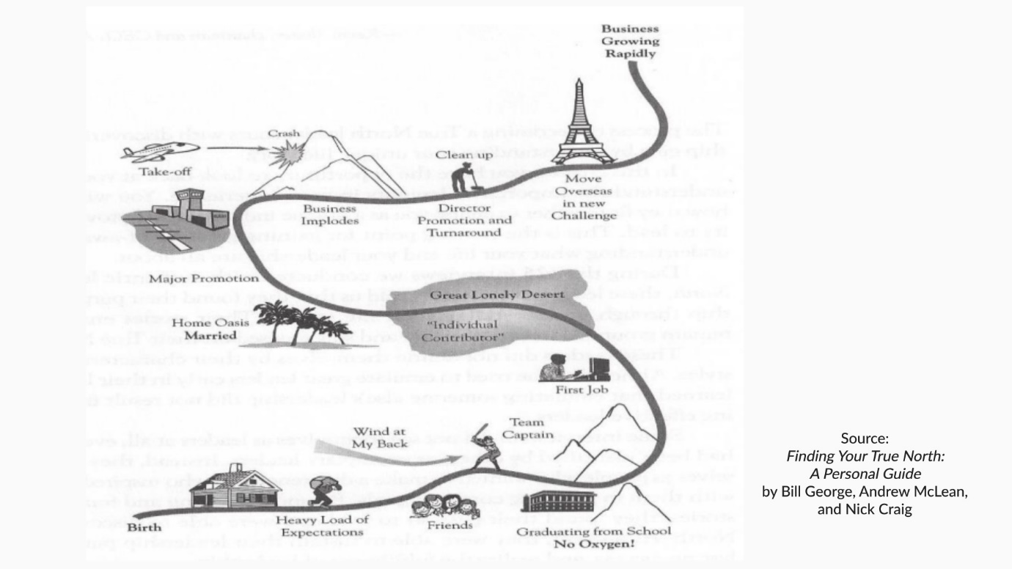

Life Story in Pictures

Is there anything else you would like to add? Take a photo and create a jpeg, or you can draw an electronic picture. In your graphic, include your proudest leadership moment and a time when you were tested. Also, please **save** your drawing. You will need it again for your final paper.   
  
**Part 2: Life Story Up to Now in Words**  
Write about your life story with chapter headings that mark major changes or transitions. Label each chapter with a descriptive title. Please include a short narrative that tells your life story in chapters.   
  
**Part 3: Proudest Leadership Experience**  
Describe your proudest leadership experience when you were at your best. Consider the questions below:

* What happened?
* What was going on in the organization?
* What events led to you stepping up to lead? Be very specific about the behaviors you demonstrated and the impact on others.
* Specifically, call out how your strengths showed up. Name them. For example, my “Achiever” showed up in that project, and I did not give up until I got the desired results.”
* What specific values that you hold dear which enabled this success?
* To what extent were you operating from a sense of purpose? How and why?
* What conditions allowed you to overcome any crucibles?

**Part 4: When You Were Tested, and You Were Not at Your Best**  
Describe a specific leadership experience in which you were tested and when you were not at your best. Consider the questions below:

* What basement behaviors, if any, did you exhibit?
* What kept you from being your best?
* What value that you hold dear would have helped you?
* How might a clear purpose have helped you?

**Part 5: Your Goals—Three Paragraphs**  
In this section, describe how you would like your life story to unfold in as much detail as you can. Include the following:

* Describe the ten-year goal for your life, including career, personal relationships/family, health and physical fitness, community, and finances (high level, e.g., level of financial security, money saved).
* Where do you need to be in five years and then one year in at least three areas of your life?
* Your three to five-year professional goal. Describe in as much detail as possible.

Remember, those with the most specific and vivid goals are the most likely to achieve their goals.

**Part 6: Biggest Opportunities for Your Personal Development**

* What do you see as your biggest areas of personal development as a leader based on what has been covered so far?
* How can you lead more from a sense of purpose?
* What is the one thing you will focus on developing during this course on Personal Leadership?