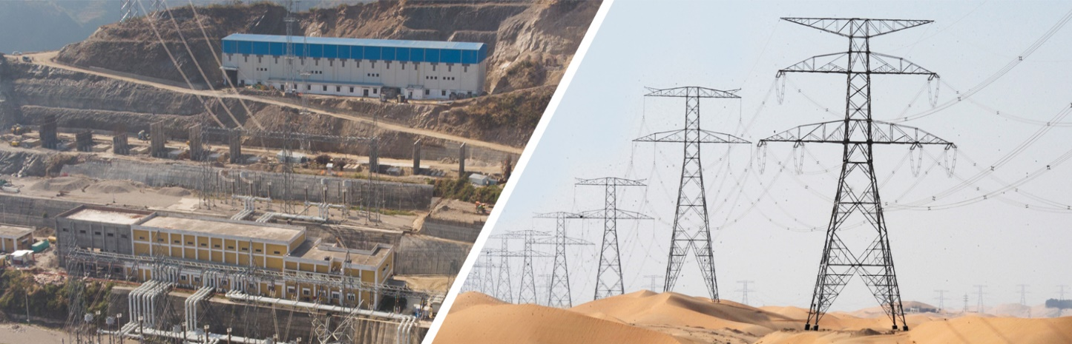

***Consultancy Report on Project Management for EPC Company***

***Engineering, Procurement, and construction Company (EPC)*** – EPC is a form of contracting agreement where the contractor is responsible for all the engineering services on a project. It includes a detailed engineering drawings/designs of the project, procurement and production of construction materials, equipment and includes the commissioning of project, delivery of completed project to client. The EPC service provider is required to complete the construction and delivery of project within agreed time & budget.

***Introduction:***

The organisation selected for this consultancy project is a leading construction company specialising in the development of transmission line projects. With a proven track record in the industry, the organisation has successfully completed several high-value projects. The construction of new project presents a significant opportunity for the company to enhance its reputation and profitability.

***Problem Statement:***

The organisation faces the challenge of efficiently completing the project within the stipulated timeframe and budget. The significance of this challenge lies in the complex nature of the project, which involves many constraints. Failure to meet project objectives could result in delays, cost overruns, and a negative impact on the organisation's reputation and profitability.

***Objectives:***

1. Complete the construction of the project within the specified timeline and budget.
2. Optimise resource allocation and utilisation to maximise profitability while maintaining high quality standards.
3. Minimise the risks associated with project delays, cost overruns, and potential disruptions.
4. Enhance stakeholder communication and engagement to ensure transparency and build trust throughout the project.

***Methodology:***

1. Conduct a comprehensive review of the project requirements, including technical specifications, environmental considerations, and regulatory approvals.
2. Gather data through site visits, consultations with subject matter experts, and analysis of relevant project documentation.
3. Utilise project management techniques such as Work Breakdown Structure (WBS), Critical Path Method (CPM), and Risk Assessment to plan and monitor project activities.
4. Perform a feasibility analysis to identify potential challenges and assess the project's economic viability.
5. Utilise project management software and tools to track progress, manage resources, and facilitate effective communication.

***Proposed Timeline:***

The consultancy project timeline structured as follows.

1. Project Initiation, planning and data collection: Week 1
2. Stakeholder Interviews and Discussions: Week 2
3. Analysis of Project Documentation and Reports: Week 3
4. Identification of Key Challenges and Bottlenecks: Weeks 4- 5
5. Development of Project Management Strategies: Weeks 6-7
6. Review and Refinement of Strategies: Week 8
7. Preparation of Consultancy Report and Deliverables: Weeks 9-10

***Expected Deliverables:***

1. Detailed project management reports outlining the key planning and execution strategies.
2. A concise summary highlighting the main findings, proposed strategies, and key recommendations for effective project management.
3. A visually appealing and informative presentation summarizing the report's contents, suitable for sharing with key stakeholders and management.
4. A set of guidelines and best practices to enhance communication and collaboration among project stakeholders, fostering a culture of effective teamwork.
5. Risk assessment reports and contingency plans.
6. Documentation of quality control measures and testing results.
7. A detailed plan identifying optimal resource allocation strategies to maximize project profitability and efficiency.

***Potential Challenges:***

1. Adverse weather conditions, labour shortages, or material availability issues may cause delays.
2. Complex regulatory processes and environmental clearances may cause bottlenecks.
3. Potential technical issues or design changes may impact project timelines.
4. Budget constraints and potential cost overruns.
5. Lack of alignment among project stakeholders.