**Asavari Sehgal - Essay 1**

Image:

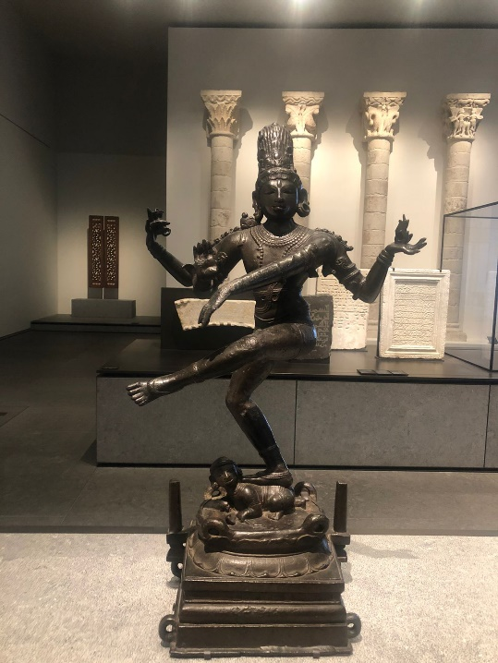

Artwork: *Dancing Shiva*, ca. 950-1000  
from Louvre Abu Dhabi’s collection

Outline:

In my essay, I would like to explore the *Dancing Shiva* through the perspective of form, iconography and the Rasa theory. The essay will delve into the evolution of the representation of Shiva as a Nataraja, from the early representation of the rock cut caves to sculptural forms seen during the epitome of the chola bronzes.

In the body of my essay, I will be research and expand on the following:

* **Form**

The form of Shiva as Nataraja is one of the most significant, complex and widely researched forms of Shiva to exist due to its dynamic and paradoxical nature.

* The form itself is *vyakta*/representational
* In traditional depictions of the Nataraja, there is an arch of flames which represents the cyclical concept of time in Hinduism. This particular sculpture does not include the arch but has many of the key elements of form that were prominently used by sculptors to depict the Nataraja during the Chola bronze period including the dynamic dance posture called ‘tandava’.
* **Iconography**

The iconography of Nataraja is filled with symbolism and each element in the sculpture holds a deeper meaning and significance.

* Most deities in Hinduism have multiple arms which depict their various strengths and characteristics and their overall divine power.
* His third eye represents cosmic knowledge, also supported by his matted locks of hair which reinforce his role as a yogi.
* His left-hand forms the *dandahasta* to indicate sanctuary for the soul of the devotee and the open right palm forms the *abhaya mudra* signifying that the devotee should not have any fear.
* The essay will further expand on some of these key elements and include research into the lotus base, his clothing and earrings, the flame and drum in his hands and the *asura*/dwarfed demon that is pinned down by Shiva in this sculpture.
* **Rasa Theory**
* ‘Tandava’ is the divine dance performed by Shiva and has various forms invoking different rasas and representing Shiva’s five *kriyas* which include Creation, Dissolution, Preservation, Concealment and Salvation.
* The dance of Shiva depicted in the Nataraja is ‘Ananda Tandava’, a gentler and blissful dance or ‘dance of bliss’.
* Most commonly this dance is known to evoke three prominent rasas – Veera, Raudra and Shanta.

To conclude, I would like to highlight the mysterious and paradoxical nature of the sculpture and how the ‘tandava’, a known fierce form of dance transforms into one of bliss in this sculpture.

Sources:

* Coomaraswamy. Ananda Kentish. *The Dance of Siva: Fourteen Indian Essays*. Sunwise Turn, 1918.
* Sivaramamurti. Calambur. *Nataraja in Art, Thought And Literature*.The National Museum New Delhi, 1974.
* Kramrisch. Stella. *Manifestations of Shiva*. Philadelphia Museum of Art, 1981.
* Khandalavala. Karl. *Indian Sculpture and Painting: An Introductory Study.* D. B. Tarapparevala Sons & Co, 1950.