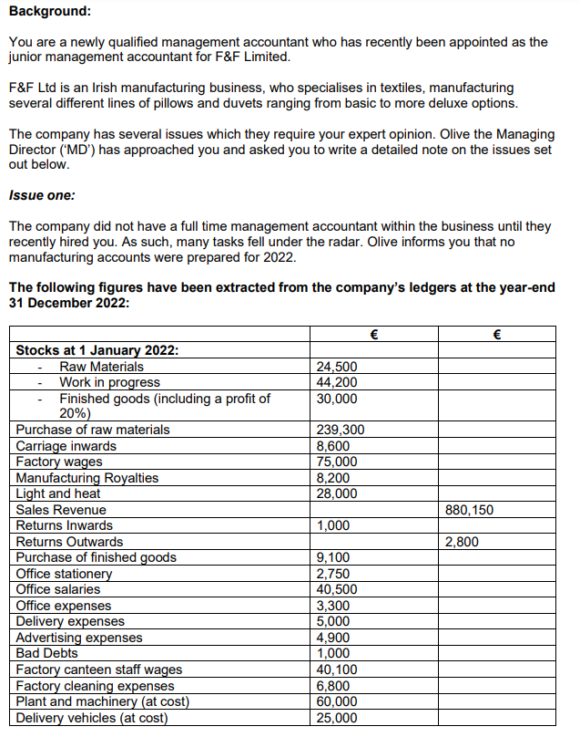

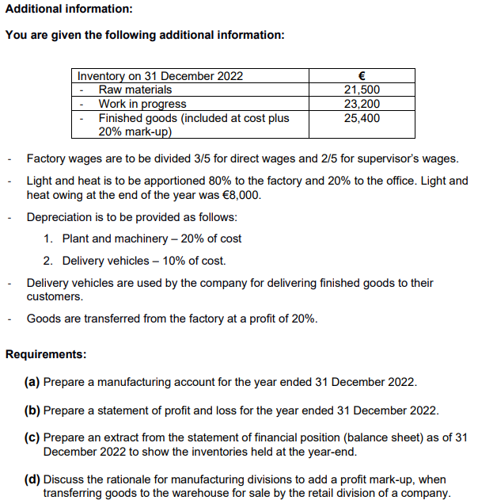

Q2:

Q3;

