**IMPACT OF COVID-19 IN DIFFERENT SECTORS**

Project Report Submitted in Partial fulfilment of the requirement for the award of Degree of

MASTERS OF BUSINESS ADMINISTRATION (MBA)

Submitted by

**NOEL FREEMAN P**

Reg. No: 21BMBAD042

Under the guidance of

NISHA FRANSICS



SCHOOL OF MANAGEMENT

CMR UNIVERSITY

OCTOBER & 2023

**DECLARATION BY THE STUDENT**

I **NOEL FREEMAN P** bearing Reg. No 21BMABD042 hereby declare that this project report entitled **IMPACT OF COVID-19 IN DIFFERENT SECTORS** has been prepared by me towards the partial fulfilment of the requirement for the award of the Masters of

Business Administration (MBA) Degree under the guidance of …..<Guide Name > ………

I also declare that this project report is my original work and has not been previously submitted for the award of any Degree, Diploma, Fellowship, or other similar titles.

Signature

**<Name of Student>**

Reg. No. : <Reg. No>

Place: <Bangalore>

Date: <Date>

**CERTIFICATE**



Certified that this project report titled **“……………………………………………..”** is the bonafide work of “**………..……..<NAME OF THE CANDIDATE(S)>.…………”** who carried

out the project work under my supervision in the partial fulfillment of the requirements for the award of the MBA degree.

**SIGNATURE**

**<Name of the Guide >**

**Acknowledgement**

**Abstract**

The COVID-19 pandemic was caused when SARS-CoV2 virus spread among people all over the world. It created a widespread global shock creating a severe economic slowdown. There has been a slowdown in all economic sectors worldwide and more than one third of global population was placed under lock-down [1].In this paper we analyze the economic impact of COVID-19 on the following sectors, namely, tourism industry, oil industry, aviation industry, financial sector and healthcare sector. we will analyze the economic data from each industry and graphically represent the losses in each industry as a result of COVID-19 pandemic. My research will give readers a clear understanding of the effect of external macroeconomic shocks on the global economy. Keywords COVID-19 · SARS-Cov2 · lock-down · economic impact · slowdown · industry · sector · macroeconomic · global shock

Table of Contents

CHAPTER 1 – INTRODUCTION 7

1.1 Introduction 7

CHAPTER 2 – LITERATURE REVIEW 8

2.1 Introduction 8

CHAPTER 3 – RESEARCH METHODOLOGY 9

3.1 Research method 9

3.2 Sampling 10

3.3 Data collection 11

3.3.1 Types of Data 11

3.3.2 Methods of Data Collection 11

CHAPTER 4 – DATA ANALYSIS & INTERPRETATION 12

CHAPTER 5 – FINDINGS, CONCLUSIONS & RECOMMENDATIONS 13

5.1 Findings 13

5.2 Conclusion 14

5.3 Recommendations 15

CHAPTER 6 – LIMITATIONS AND SCOPE OF FUTURE RESEARCH 16

6.1 Limitation 16

6.2 Scope of Future Research 17

Bibliography 18

Appendix – Questionnaires 19

# CHAPTER 1 – INTRODUCTION

## 1.1 Introduction

Coronavirus disease (COVID-19) is an infectious disease caused by the SARS-CoV-2 virus. It emerged in Wuhan, China, at the close of 2019, caused by the severe acute respiratory syndrome coronavirus 2 (SARS-CoV-2). The world witnessed the rapid spread of this highly contagious virus, leading to a global pandemic that has left an indelible mark on society.

Most people infected with the virus will experience mild to moderate respiratory illness and recover without requiring special treatment. However, some will become seriously ill and require medical attention. Older people and those with underlying medical conditions like cardiovascular disease, diabetes, chronic respiratory disease, or cancer are more likely to develop serious illness. Anyone can get sick with COVID-19 and become seriously ill or die at any age.

The best way to prevent and slow down transmission is to be well informed about the disease and how the virus spreads. Protect yourself and others from infection by staying at least 1 metre apart from others, wearing a properly fitted mask, and washing your hands or using an alcohol-based rub frequently. Get vaccinated when it’s your turn and follow local guidance.

The virus can spread from an infected person’s mouth or nose in small liquid particles when they cough, sneeze, speak, sing or breathe. These particles range from larger respiratory droplets to smaller aerosols. It is important to practice respiratory etiquette, for example by coughing into a flexed elbow, and to stay home and self-isolate until you recover if you feel unwell.

**Features of COVID-19**

**Mode of Transmission:** COVID-19 is primarily transmitted through respiratory droplets, making close human contact a significant risk. It can also spread via contact with contaminated surfaces.

**Symptoms:** The spectrum of COVID-19 symptoms varies, from mild flu-like symptoms to severe respiratory distress. Some individuals remain asymptomatic carriers, unknowingly spreading the virus.

**Vaccination:** The development of multiple vaccines has been a beacon of hope. These vaccines have played a pivotal role in reducing the severity of the disease, and massive vaccination campaigns have been executed worldwide.

**Impact on Healthcare and Public Health Measures**

The healthcare sector bore the brunt of the pandemic. Hospitals strained to accommodate patients, and the demand for personal protective equipment (PPE) and ventilators surged. In response, public health measures like lockdowns, social distancing, mask mandates, and quarantine were implemented globally to mitigate the virus's spread.

**Global Response and Economic Consequences**

International organizations such as the World Health Organization (WHO) spearheaded the global response. They provided crucial guidance to governments and healthcare systems. However, the pandemic's economic consequences were profound. **Job losses, business closures, and economic recessions became widespread**, impacting livelihoods and prosperity.

**Social and Mental Health Impact**

The pandemic had a multifaceted impact on society. Isolation, stress, and disruptions to daily life became the norm. It exposed vulnerabilities in healthcare systems, educational institutions, and social support structures. Mental health concerns also surged.

In my paper I will be talking on Sectors most affected due to Covid -19

1. Tourism Industry
2. Oil Industry
3. Aviation Industry
4. Financial Sector
5. Health Sector

**1. Tourism and Hospitality Industry:**

* **Travel Restrictions:** Lockdowns, travel bans, and quarantines severely restricted international and domestic travel, leading to a sharp decline in tourist arrivals.
* **Revenue Loss:** The tourism industry, including hotels, restaurants, and attractions, experienced a significant loss of revenue. Many businesses faced financial strain and closures.
* **Job Losses:** The industry witnessed massive job losses, affecting a broad range of workers, from tour guides to hotel staff to travel agents

**4. Financial Sector:**

* **Volatility:** Financial markets experienced extreme volatility, with stock prices plummeting and then rebounding. Interest rates were lowered by central banks to stimulate economic activity.
* **Economic Uncertainty:** Uncertainty in the financial sector led to reduced lending and investment, as businesses and individuals became cautious about their financial decisions.
* **Remote Work and Digital Services:** Financial institutions accelerated their adoption of remote work arrangements and digital services to continue operations and serve customers.

# CHAPTER 2 – LITERATURE REVIEW

## 2.1 Introduction

# CHAPTER 3 – RESEARCH METHODOLOGY

## 3.1 Research method

Certainly, let's discuss the research approaches (qualitative, quantitative, mixed-methods) for studying the impacts of COVID-19 on the tourism and hospitality industry and financial sector

**1. Tourism and Hospitality Industry:**

**Quantitative Approach**: Researchers might use quantitative methods to collect numerical data related to the decline in tourist arrivals, revenue loss, job losses, and economic impacts. Surveys, economic indicators, and statistical analysis can provide quantitative insights into the sector's downturn.

**Qualitative Approach**: Qualitative research methods could be employed to explore the human stories behind the statistics. In-depth interviews, focus groups, or content analysis of travel diaries or social media posts can reveal the emotional and social impacts on individuals and communities.

## 3.2 Sampling

## 3.3 Data collection

### 3.3.1 Types of Data

### 3.3.2 Methods of Data Collection

# CHAPTER 4 – DATA ANALYSIS & INTERPRETATION

# TOURISUM & HOSPITALITY INDUSTRY

## Data

On December 31, 2019, the first case of deadly Coronavirus (COVID‐19) was reported in Wuhan, Hubei, China (World Health Organization, [2020](https://www.ncbi.nlm.nih.gov/pmc/articles/PMC8646688/#pa2786-bib-0084)). The deadly virus was transmitted to the whole world‐giving rise to uncertain and unstable situation. As the pandemic spread across the globe, the Sultanate of Oman also became its victim. To mitigate the effects of the pandemic, the Omani government announced the first lockdown on April 10, 2020 and consecutively the lockdown was extended zone‐wise based on the severity of COVID‐19 cases. Many businesses were completely shut down, the stringent measure was announced for conducting business activities in selected sectors only, and the tourism and hospitality sector was not exempted from this regulation. The COVID‐19 pandemic has incurred a significant economic and social impact around the world (United Nations World Tourism Organization (UNWTO), [2020](https://www.ncbi.nlm.nih.gov/pmc/articles/PMC8646688/#pa2786-bib-0080)). Many sectors have been drastically affected but tourism and hospitality industry was one of the hardest hit by the COVID‐19 globally. A recent report by the World Association of Investment Promotion Agencies (IPAs) on May 2020, stated that sectors like hotels and restaurants and other travel and tourism‐related services were among the top five vulnerable sectors during the crisis of COVID‐19. IPAs reported that hotels and restaurants are affected by the pandemic by around 84% followed by other travel and tourism‐related services by around 65%. This pandemic has exacerbated the condition of business owners of the tourism and hospitality industry (Gursoy & Chi, [2020](https://www.ncbi.nlm.nih.gov/pmc/articles/PMC8646688/#pa2786-bib-0031); Hospitality Net, [2020](https://www.ncbi.nlm.nih.gov/pmc/articles/PMC8646688/#pa2786-bib-0033); Qiu et al., [2020](https://www.ncbi.nlm.nih.gov/pmc/articles/PMC8646688/#pa2786-bib-0068)). Similar to other countries around the world, Oman's tourism and hospitality industry also has been drastically affected economically and socially due to the COVID‐19 pandemic. The COVID‐19 has caused direct losses of half‐billion Omani Rial to the tourism sector (Al Nasseri, [2020](https://www.ncbi.nlm.nih.gov/pmc/articles/PMC8646688/#pa2786-bib-0002)). The revenues of 3–5 star hotels have reduced by 60.2% and hotel occupancy rates declined by 50.1%. Oman tourism and hospitality industry continue to face the stifling stemming in hotels, motels, guesthouses, travel booking agents, tour operators, event management companies, restaurant, café, and other tourism‐related services. The continuous ban on the aviation industry with limited flight operational at the national and international level has made the catastrophic impact on allied business activities of the tourism and hospitality industry.

COVID‐19's economic impact on Oman tourism has resulted in more unemployment, reduced consumer purchasing power, and low‐income generation (Al‐Hasni, [2021](https://www.ncbi.nlm.nih.gov/pmc/articles/PMC8646688/#pa2786-bib-0003)). Likewise, economic impact, the social impact was staggering the owners on the survival of their business. Owners are stressed about future business activities as the tourism and hospitality industry is on the brink of collapse. Though, the Oman government took several initiatives to mitigate the economic and social impact of the tourism and hospitality industry by offering monetary and nonmonetary support to the business owners to sustain and survive their business. The Ministry of Tourism assured to provide a relief package for business owners, encouraged banks to invest in the tourism sector, restructured loans schemes for hotel investors, grants, incentives, facilities, introducing new financing policies (Oman Observer, [2020a](https://www.ncbi.nlm.nih.gov/pmc/articles/PMC8646688/#pa2786-bib-0062), [2020b](https://www.ncbi.nlm.nih.gov/pmc/articles/PMC8646688/#pa2786-bib-0063)). Certainly, it is only the assurance, the losses are huge and still, no‐good hope is seen among the business owners in this sector. Several researchers have investigated the economic impact on the hospitality and tourism industry but the social impact has not been investigated from the owner's perspective. This research aims to investigate the economic and social impacts of COVID‐19 on the tourism and hospitality sector of Oman. This study will make a novel contribution through quantitative research by offering rich insights into the economic and social impact of the COVID‐19 on the tourism and hospitality industry in Oman. The finding of this research will support the government to boost the on tourism and hospitality industry in Oman.

## Methodology

This research examined the economic and social impact of COVID‐19 on the tourism and hospitality industry in Oman. In this respect, a structured questionnaire was sent to business owners working in the tourism and hospitality industry of Oman. The questionnaire consisted of four sections; the first section included demographic factor and details of their businesses. The second section included the questions related to economic impact; the third section includes questions related to social impact; and the fourth section includes open‐ended questions related to strategies for the future. The data was collected from September 2020 to January 2021 from micro (<five staff), small (6–25 staff), medium (26–99 staff), and large, size‐companies (99 and above). In Oman, tourism and hospitality business include cafés, restaurants, campings, events management, farms booking, guesthouses, hotels, motels, taxies booking (local travel‐local touring, etc.), tour/holiday packages, tour guides (local sight‐seeing, etc.) and travel booking (airlines‐national/international).

## Results

## By the end of the survey period, data collected from 97 respondents distributed throughout 15 businesses in the tourism and hospitality sector. Around 68% of the business owners were within the age range of 35–55 years old, where most of them has a bachelor (47.4%), postgraduate (23.7%), and secondary school (19.6%) degrees. The majority of responses received belong to hotels sector (34%), followed by motels (15.5%), coffee/restaurants and farm bookings (12.4%), tour/holiday packages (11.3%), and guesthouse (10.3%). Most of those who responded has their businesses in Muscat (the Capital) (43.5%), followed by Al‐Dhakiliyah (14.5%) and Ash‐Sharqiya North (13%) and the remaining are dispersed among the other eight governorates.

### 4.1. Economic impact of COVID‐19 on tourism and hospitality industry

To explore the economic impact of the COVID‐19 on the tourism and hospitality industry, various parameters have been included in the questionnaire related to economic aspects. The analysis of data is presented from Tables [1](https://www.ncbi.nlm.nih.gov/pmc/articles/PMC8646688/table/pa2786-tbl-0001/), [​,2,2](https://www.ncbi.nlm.nih.gov/pmc/articles/PMC8646688/table/pa2786-tbl-0002/), [​,3,3](https://www.ncbi.nlm.nih.gov/pmc/articles/PMC8646688/table/pa2786-tbl-0003/), [​,4,4](https://www.ncbi.nlm.nih.gov/pmc/articles/PMC8646688/table/pa2786-tbl-0004/), [​,5,5](https://www.ncbi.nlm.nih.gov/pmc/articles/PMC8646688/table/pa2786-tbl-0005/), [​,6,6](https://www.ncbi.nlm.nih.gov/pmc/articles/PMC8646688/table/pa2786-tbl-0006/), [​,7,7](https://www.ncbi.nlm.nih.gov/pmc/articles/PMC8646688/table/pa2786-tbl-0007/), [​,8,8](https://www.ncbi.nlm.nih.gov/pmc/articles/PMC8646688/table/pa2786-tbl-0008/), [​,99](https://www.ncbi.nlm.nih.gov/pmc/articles/PMC8646688/table/pa2786-tbl-0009/).

### TABLE 1

**The impact of the COVID‐19 outbreak on the tourism and hospitality businesses**

| **Level of impact areas of impact** | **Insignificant** | **Minor** | **Moderate** | **Major** | **Severe** |
| --- | --- | --- | --- | --- | --- |
| Financial situation | 4.1 | 3.1 | 8.2 | 17.5 | 67 |
| Customer demand for the business products/service | 6.2 | 3.1 | 11.3 | 20.6 | 58.5 |
| Suppliers and supply chain | 7.2 | 6.2 | 16.5 | 25.8 | 44.3 |
| Channels of distribution of the business products/services to customers | 3.1 | 10.3 | 18.6 | 27.8 | 40.2 |
| The overall impact of COVID‐19 on the business | 3.1 | 1.0 | 10.3 | 18.6 | 67 |

### TABLE 2

**Impact of COVID‐19 on international business**

| **Level of impact areas of impact** | **Insignificant** | **Minor** | **Moderate** | **Major** | **Severe** |
| --- | --- | --- | --- | --- | --- |
| Reduction in International visitors | 0 | 3.1 | 7.2 | 4.1 | 85.6 |
| Reduced levels of inquiries/bookings from International visitors | 1 | 6.2 | 6.2 | 5.2 | 81.4 |
| Rearrangement/postponement of future bookings from international visitors | 4.1 | 4.1 | 7.2 | 7.2 | 77.3 |
| Cancelation of future bookings from international visitors | 6.2 | 3.1 | 6.2 | 6.2 | 78.4 |
| Canceled international events | 7.2 | 3.1 | 8.2 | 5.2 | 76.3 |
|  |  |  |  |  |  |

### TABLE 3

**Impact of COVID‐19 on domestic level businesses**

| **Level of impact areas of impact** | **Insignificant** | **Minor** | **Moderate** | **Major** | **Severe** |
| --- | --- | --- | --- | --- | --- |
| Reduction in domestic visitors | 4.1 | 5.2 | 11.3 | 29.9 | 49.5 |
| Reduced levels of inquiries/bookings from domestic visitors | 7.2 | 4.1 | 10.3 | 37.1 | 41.2 |
| Rearrangement/postponement of future bookings from domestic visitors | 5.2 | 3.1 | 19.6 | 35.1 | 37.1 |
| Cancelation of future bookings from domestic visitors | 9.3 | 4.1 | 15.5 | 32 | 39.2 |
| Cancelled National/local events | 4.1 | 5.2 | 19.6 | 16.5 | 54.6 |

### TABLE 4

**Risk of business closure period**

| **Time to close** | **Number of responses** | **% of responses** |
| --- | --- | --- |
| No business closure | 37 | 38.10 |
| Less than a month | 8 | 8.20 |
| 1–2 months | 5 | 5.20 |
| 2–4 months | 11 | 11.30 |
| 4–6 months | 9 | 9.30 |
| 6–12 months | 17 | 17.50 |
| More than 12 months | 10 | 10.30 |
| Total | 97 | 100 |
|  |  |  |

### TABLE 5

**Business expected time to recover from the losses incurred by the Covid‐19 outbreak**

| **Period of business recovery** | **Number of responses** | **% of responses** |
| --- | --- | --- |
| Within 3 months | 14 | 14.40 |
| 3–6 months | 12 | 12.40 |
| 6–9 months | 17 | 17.50 |
| 9 months to 1 year | 18 | 18.60 |
| More than 1 year | 36 | 37 |
| Total | 97 | 100 |

### TABLE 6

**Challenges faced by company due to COVID‐19**

| **Challenges faced by company due to COVID‐19** | **% of responses** |
| --- | --- |
| Reduction of domestic demand for my products and/or services | 71.1 |
| Reduction of international demand for my products and/or services | 62.9 |
| Difficulty in my company's ability to deliver services and/or products to customers | 37.1 |
| Difficulty in the ability of distributors to deliver services and/or goods to customers | 19.6 |
| Difficulty to acquire the supplies and/or services required to produce my products and/or deliver my services | 24.7 |
| Difficulty covering staff salaries and other fixed business costs, such as rent or utilities | 70.1 |
| Challenges in developing new products/innovations | 20.6 |
| Uncertainty over economic conditions | 61.9 |
| Difficulty with staff fulfilling their job requirements due to government restrictions | 19.6 |
| Government regulations suspending business activities, for example, restaurant closure | 39.2 |
| Staff shortages due to sickness | 9.3 |
| Slowing transition of business process improvements | 21.6 |
| Difficulty securing financing for business as usual | 32 |
| Difficulty securing financing for expansion | 25.8 |
| Regulatory barriers and other barriers to exports | 9.3 |
| Challenges with other government regulations (e.g., compliance, technical regulation, patents, and reporting) | 12.4 |
| Tax laws and rules barriers | 35.1 |

### TABLE 7

**Action taken by owners in response to the COVID‐19 outbreak**

| **Action taken by owners in response to the COVID‐19 outbreak** | **% of responses** |
| --- | --- |
| Lay off staff permanently | 22.7 |
| Lay off staff temporarily | 35.1 |
| Scale back on services/products | 37.1 |
| Reduce/stop wages for yourself | 44.3 |
| Reduce/stop wages for staff | 41.2 |
| Request of payment/suspension delay | 37.1 |
| Apply for government financial support | 17.5 |
| No action taken | 15.5 |
| Others | 20.6 |

### TABLE 8

**Type of support required to safeguard company**

| **Type of support required to safeguard company** | **% of responses** |
| --- | --- |
| Financial loan | 32 |
| Cash grant | 61.9 |
| Deferral of tax, rent, expenses (utilities), or debt | 56.7 |
| Technical assistance (i.e., training, digitization, and e‐business infrastructure) | 12.4 |
| Transformation on the logistics | 10.3 |
| Access to supply chain | 13.4 |
| Access to market/value chain/alternative sales channels | 23.7 |
| Legal support | 12.4 |
| None | 5.2 |

### TABLE 9

**Effective strategies to be implemented by businesses to recover from COVID‐19**

| **Scale strategies** | **Very unlikely** | **Likely** | **Neutral** | **Likely** | **Very likely** |
| --- | --- | --- | --- | --- | --- |
| Move business online | 15.5 | 8.2 | 23.7 | 25.8 | 26.8 |
| Special offer for canceled bookings | 11.3 | 9.3 | 23.7 | 24.7 | 30.9 |
| Investment in digital media to make it more visible | 8.2 | 4.1 | 27.8 | 24.7 | 35.1 |
| Planning to merge with other companies | 53.6 | 11.3 | 16.5 | 7.2 | 11.3 |
| Planning to shut down/sell the company | 35.1 | 16.5 | 18.6 | 11.3 | 18.6 |

Table [1](https://www.ncbi.nlm.nih.gov/pmc/articles/PMC8646688/table/pa2786-tbl-0001/) shows the level of impact on financial situation of the business, customer demand for the products and services, suppliers and supply chain, and channels of distributions. It can be clearly seen from Table [1](https://www.ncbi.nlm.nih.gov/pmc/articles/PMC8646688/table/pa2786-tbl-0001/) that tourism and hospitality businesses have been negatively affected by the COVID‐19 outbreak, as majority of the respondents (67%) perceived that there is a large negative impact on their businesses. From the table, 67% responded have agreed the that COVID 19 outbreak has affected the financial conditions of their business, followed by negative impact on the customer demand for the business products/service (58.5%); suppliers and supply chain (44.3%); channels of distribution of the business products/services to customers (40.2%).

Tables [2](https://www.ncbi.nlm.nih.gov/pmc/articles/PMC8646688/table/pa2786-tbl-0002/) and [​and33](https://www.ncbi.nlm.nih.gov/pmc/articles/PMC8646688/table/pa2786-tbl-0003/) show the level of impact on various parameter on the national and international business. From Table [2](https://www.ncbi.nlm.nih.gov/pmc/articles/PMC8646688/table/pa2786-tbl-0002/), it can be observed that the impact has been largely recorded on the international business. Business owners reported reduction in the international business as they have received less number of inquiries/booking (81.4%) and the number of visitors (85.6%) have also declined. The reasons can be attributed due cancelation of international events (76.3%). Many visitors have opted for the cancelation of their visits (78.4%) or decided to postpone their travel plans (77.3%). Comparatively less impact has been reported in the domestic business (Table [3](https://www.ncbi.nlm.nih.gov/pmc/articles/PMC8646688/table/pa2786-tbl-0003/)).

Table [4](https://www.ncbi.nlm.nih.gov/pmc/articles/PMC8646688/table/pa2786-tbl-0004/) shows the perception of business owners toward the expected time period for closure of their business in the future. Most of the business owners (38.10%) are not having plan to close their business where some business owners believe that they can survive till 6–12 months (17.50%) and from Table [5](https://www.ncbi.nlm.nih.gov/pmc/articles/PMC8646688/table/pa2786-tbl-0005/) it can be seen that, business owners perceive that it may take 9 months–1 year to recover from the losses incurred by the Covid‐19 outbreak (37%). Business owners did not show positive response toward the recovery of losses incurred by the COVID‐19 pandemic. They believe that it will take approximately 1 year to recover from the losses. However, 38% of business owners agreed that COVID‐19 outbreak has not created new opportunities while 38% of business owners have expanded their business domestically. This can be due to the restriction imposed on the international travel.

As an outcome of COVID‐19, business owners have encountered several type of challenges due to the outbreak of COVID‐19. It can be seen from Table [6](https://www.ncbi.nlm.nih.gov/pmc/articles/PMC8646688/table/pa2786-tbl-0006/) shows that business owners have faced decline in international demand (71.1%) and domestic demand (62.9%). In addition, 70.1% of business owners agree that they faced difficulty in giving staff salaries and covering up other fixed business costs. The business owners have taken several actions in response to the COVID‐19 outbreak. Table [7](https://www.ncbi.nlm.nih.gov/pmc/articles/PMC8646688/table/pa2786-tbl-0007/). From this table, it can be clearly seen that owner has stopped the wages for themselves (44.3%) and staff (41.2%). In addition, about 37.1% have decided to scale back on services/products to cut down the extra cost. While, around 37.1% have requested payment/suspension delay and 7.5% have applied for the financial support from the various agencies. Business owners have taken action to lay off the staff permanently (22.7%) and temporarily (35.1%) to survive the COVID‐19 outbreak.

Business owners are trying to safeguard their businesses through various measures and support from various stakeholders. From Table [8](https://www.ncbi.nlm.nih.gov/pmc/articles/PMC8646688/table/pa2786-tbl-0008/) it can be understood that companies mainly need cash grants (61.9%); deferral of tax, rent, expenses, utilities, debt (56.7%) to protect their business. Moreover, 32% of business owners are willing to apply for financial loan and exploring access to market/value chain/alternative sales channels (27.7

# FINANCIAL SECTOR IMPACT

## A. Data

In this section, we analyze how increased credit risk from the corporate loan portfolios could affect the balance sheets of scheduled commercial banks (SCBs) and NBFCs. For this purpose, we apply the results of the three stress scenarios discussed in the previous section on aggregate balance sheets of SCBs and NBFCs available from the RBI as of end-March 2020. We further disaggregate the impact on the SCBs by bank type using the aggregate balance sheets of public sector banks, private banks and foreign banks. The balance sheet information we use includes 1) the share of the corporate loan book in the total loan advances; 2) total risk-weighted assets (RWA), capital adequacy ratio (CAR), and total equity capital; and 3) gross non-performing loans (NPAs) and total provisions.

Figure 8 shows the aggregate CAR ratios and the gross NPA ratio by bank type as of March 2020. Prior to the pandemic, public sector banks tended to have weaker asset quality compared with other segments of the financial sector with a relatively high gross NPL ratio of around 10 percent. While having been strengthened with the government’s capital injections in previous years, public sector banks had a weaker solvency position as of endMarch 2020 with a relatively lower capital adequacy ratio of around 13 percent compared with around 15 percent for the banking sector as a whole and 19 percent for NBFCs. The share of corporate loans in the total loan books was around 60 percent for public sector banks and private banks, 87 percent for foreign banks, and 69 percent for NBFCs.

**Figure 8. Banks and NBFC balance sheets pre-COVID**

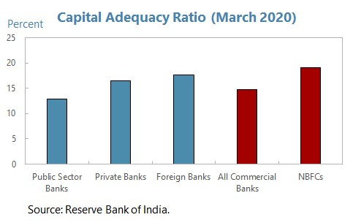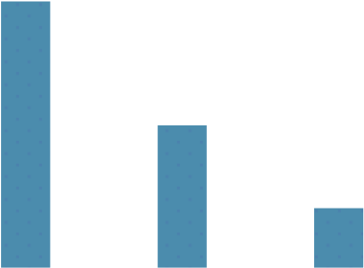

0

2

4

6

8

10

12

Public Sector

Banks

Private Banks

Foreign Banks

All Commercial

Banks

NBFCs

**Gross NPL Ra**

**t**

**io (March 2020)**

Source: Reserve Bank of India.

Percent

## B. Methodology

To map corporate stress to financial sector stress, we consider a sensitivity analysis that focuses on the credit risk stemming from the corporate credit portfolio to bank and NBFC balance sheets. Our methodology is as follows. First, we compute the debt-at-risk for firms that failed the ICR stress tests, that is, the share of debt of firms with an ICR below one. We then compare the after-shock debt-at-risk with the pre-shock debt-at-risk. The change in distressed debt can then be translated into an increase in corporate NPAs based on the historical relationship between debt-at-risk and NPA for banks and NBFCs. Specifically, the historical correlation between the annual changes in debt-at-risk and the annual changes in the aggregate NPA ratio imply that about 40 percent of the increase in debt-at-risk could potentially translate into NPAs. The loan loss provisions for the NPAs imply lower profits for banks and NBFCs, which in turn leads to a reduction in their after-shock capital ratios (Figure 9). The hurdle rate used in our analysis is the regulatory minimum of nine percent. In other words, if the capital ratio were to be fall below nine percent, then the regulatory minimum would be breached. Our approach is consistent with other approaches that examine the impact of corporate stress on financial sector balance sheets, including earlier studies on India, such as Oura and Topalova (2009).

**Figure 9: Mapping Corporate Stress to Financial Sector Balance Sheets**

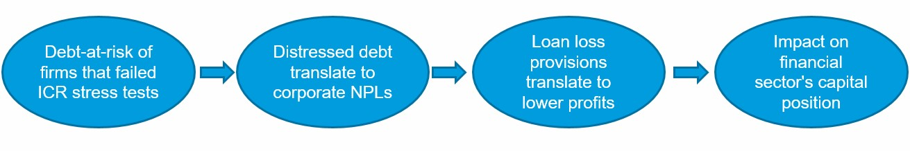

Two key caveats apply. First, our analysis is based on publicly available data due to a lack of access to confidential supervisory information. While we account for the different composition of corporate and retail exposures for each lender type as an aggregate, there is limited public data on the difference in banks’ exposures to various economic sectors by bank type. Similarly, there is no publicly available information on lenders’ exposures by firm size or concentration of loans to large borrowers as this data is highly confidential. For example, NBFCs could be more exposed to corporates in the severely hit industries and/or smaller firms, which would imply that the impact on their balance sheets from corporate stress could be higher than reflected. Second, we focus on the results of the ICR stress tests in analyzing the impact on financial balance sheets. ICR is our preferred measure compared with solvency and cash flows because we can estimate and interpret the historical relationship of the NPA ratios more directly. It should be noted that alternative assumptions regarding the distressed debt and NPAs should not matter for the *relative* impact of the shocks on bank and non-bank balance sheets (e.g. by bank type). As a robustness check, we also consider alternative mappings between an increase in debt-at-risk and NPAs in our analysis.

## Results

Corporate stress could have a sizable impact on bank and NBFC balance sheets, especially in the two adverse scenarios. In the absence of policy support, for banks, the pre-shock capital adequacy ratio of 14.7 percent could decline to 12.3 percent in the baseline scenario, to 10.3 percent in the moderately adverse scenario, and to 8.4 percent in the severely adverse scenario. Similarly, for NBFCs, the capital ratio would decline from the relatively higher starting level of 19.1 percent to 17.6 percent in the baseline, to 16.6 percent in the moderately adverse scenario, and to 15.3 percent in the severely adverse scenario (Figure 10). As mentioned earlier, given a lack of access to confidential supervisory data on the structure of corporate loans, the better performance of the NBFC sector compared with banks is largely driven by their stronger starting capital position.

**Figure 10: The impact of Corporate Stress and Policies on Financial Sector Balance Sheets**

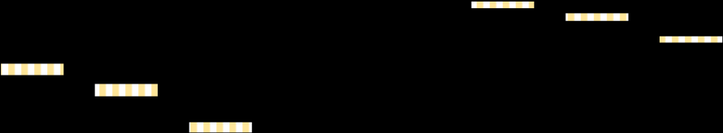

0

%

5

%

10

%

%

15

%

20

%

25

Pre-shock

Baseline

Moderately

adverse

Severely

adverse

Pre-shock

Baseline

Moderately

adverse

Severely

adverse

All commercial banks

NBFCs



No policy



Moratoriu

m



Interest reduction

**Impact of Corporate Stress and Policies on**

**Financial Sector Capital Ratios**

As we have seen earlier in the corporate stress test results, the moratorium is highly effective in cushioning the corporate liquidity stress. Similarly, these policy measures have also provided some buffer to bank and NBFC solvency positions. With policy support, for the banking sector, the capital ratio would only decline to 14.5 percent under the baseline scenario, and to 10.3 percent under the most adverse scenario, which is above the regulatory minimum. Similarly, the capital adequacy for the NBFC sector would only decline to 16.4 percent in the most adverse scenario. Overall, with policy support, the system-wide CAR for the banking sector would remain above the regulatory requirement in the baseline and the most adverse scenario (Figure 10). As mentioned earlier, we consider different mappings between an increase in debt-at-risk and NPAs as a robustness check and find that our results are robust to alternative specifications (Appendix Figure 5).

We also consider the impact of corporate stress on different segments of the banking sector. Here we present the results with policy support, but the relative performance of the three types of banks is similar in the case without policy support. Under the baseline scenario, all three segments of the banking sector would meet the regulatory minimum with or without policy support. Under the most adverse scenario, public sector banks would not meet the regulatory minimum even with policy support, with the capital adequacy ratio declining from 12.9 percent to 7.5 percent (Figure 11). The weaker performance of the public sector banks (PSBs) is in part driven by their weaker starting position compared with private banks and foreign banks (Figure 8).

**Figure 11: The impact of Corporate Stress on Bank Balance Sheets by Bank Type**

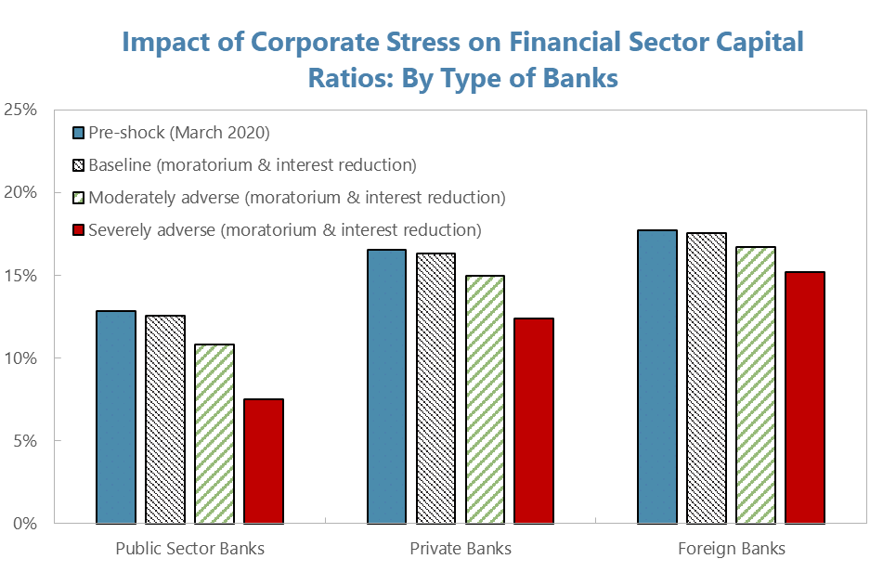

# CHAPTER 5 – FINDINGS, CONCLUSIONS & RECOMMENDATIONS

## 5.1 Findings

## 5.2 Conclusion

## 5.3 Recommendations

# CHAPTER 6 – LIMITATIONS AND SCOPE OF FUTURE RESEARCH

## 6.1 Limitation

## 6.2 Scope of Future Research

# Bibliography

# https://www.who.int/health-topics/coronavirus#:~:text=Coronavirus%20disease%20(COVID%2D19)%20is%20an%20infectious%20disease%20caused,ill%20and%20require%20medical%20attention.

# Appendix – Questionnaires

**NOTE: The coverage/ structure of this format is only indicative and you are expected to take the advice/ guidance of the respective faculty guide before finalising the same**