

Prepared By: Gaurav Chaurasia

Roll No:23053125

Section: B-29

Submitted To: Dr.Jasaswani Tripathy

CHEMISTRY ASSIGNMENT

(SUBJECT CODE: CH10001)

TITLE: Nanostructured Solar Cell



CONTENT

INTRODUCTION TO NANOSTRUCTURED SOLAR CELL

.Organic solar cells based on conjugated polymers have attracted attention in the last 10 years. Since photoexcitations in conjugated polymers show diffusion lengths of only around 5–20 nm, nanostructure and the control of nanophase play a crucial role in device performance and conversion efficiency. As opposed to inorganic materials, conjugated polymers can be processed under ambient conditions, employed with spin coating and 3D printing techniques as thin films of approximately 100 nm. The inherent nanosized structure of conjugated polymers enables low-cost, lightweight, and flexible structures. The efficiency of organic solar cells can rise up to ≈5% and have the potential to achieve 10% efficiencies with the manipulation of nanostructures.

Carbon based nanostructured solar cells utilize fullerene C60, high fullerene C70, and carbon nanotubes (CNTs). In addition to pristine fullerene structures at the scale of ≈100 nm, doped fullerene structures and fullerites are also utilized in solar cell technologies. Crystals and thin films of fullerene show n-type semiconductor behavior and surprisingly high photoconductivity under dark conditions. The optical and electrical properties of fullerene are mostly used in heterojunctions with conjugated polymers or other semiconductor materials. On the other hand, CNTs offer a wide range of bandgaps to match the solar spectrum, enhanced optical absorption, and reduced carrier scattering. These properties of CNTs are used in combination with fullerenes or other semiconducting materials in the hopes of improving the solar cell efficiencies. The highest overall device efficiency of carbon based solar cells is 5% however; studies show that there is room for considerable improvement

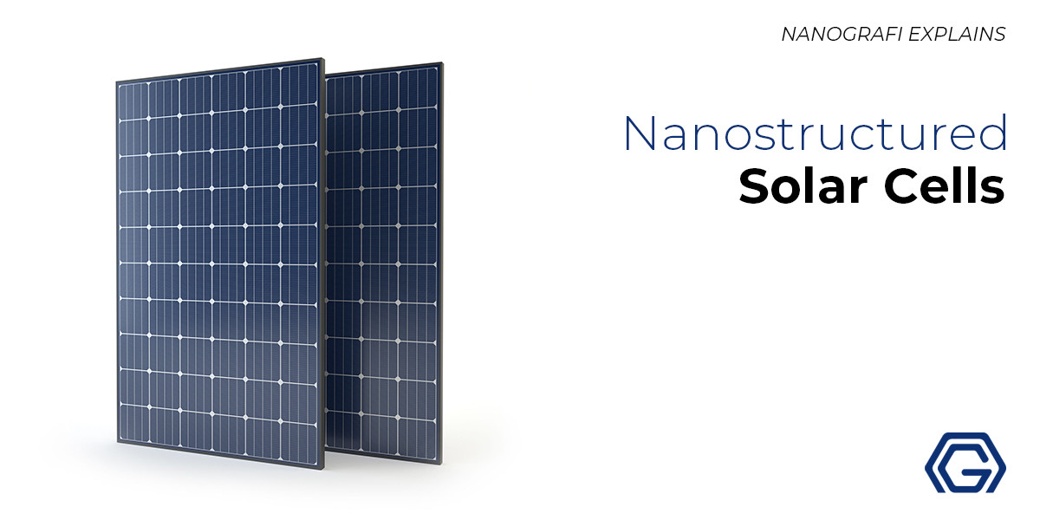

IMPORTANCE OF SOLAR ENERGY

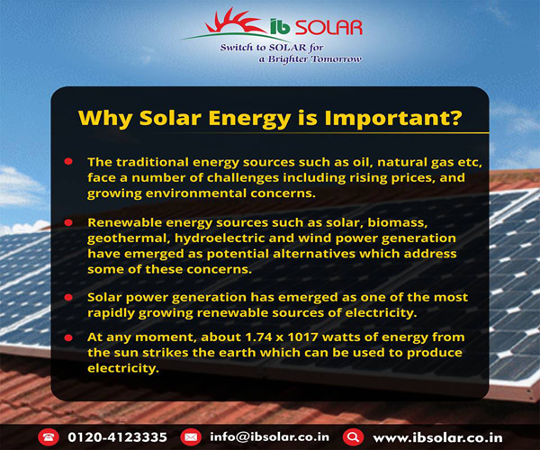 As a renewable source of power, solar energy has an important role in reducing greenhouse gas emissions and mitigating climate change, which is critical to protecting humans, wildlife, and ecosystems. Solar energy can also improve air quality and reduce water use from energy production. Because ground-mounted photovoltaics (PV) and concentrating solar-thermal power installations require the use of land, sites need to be selected, designed, and managed to minimize impacts to local wildlife, wildlife habitat, and soil and water resources. The U.S. Department of Energy (DOE) Solar Energy Technologies Office (SETO) supports research to better understand how solar energy installations, wildlife, and ecosystems interact and to identify strategies that maximize benefits to the local environment.