Table of Contents

**Introduction** 1

**Week 1: Physical intelligence** 1

**Week 2: Cultural intelligence** 2

**Week 3: Cognitive intelligence** 2

**Gibb model** 3

**Conclusion** 5

**Reference** 5

## 

## **Introduction**

## I've grown to understand the value of several types of intelligence and how they affect how I live my life in our always-changing world. During the first three weeks of my journey, I studied physical intelligence, cultural intelligence, and cognitive intelligence. These studies helped me understand different aspects of my talents and how they affect how I interact with the world. It's vital to remember that these intelligences are interwoven parts that collectively constitute my ability to successfully navigate through life; they are not discrete abilities. I am learning more about how these intelligences affect my experiences, decisions, and general well-being as I continue to study them. In the long run, this information will help me advance personally in our complex and interwoven global society.

## **Week 1: Physical intelligence**

Physical intelligence is the capacity to comprehend, regulate, and expertly employ one's own body in a variety of circumstances. Physical agility, coordination, spatial awareness, and adaptability are just a few of the qualities it incorporates. This kind of intelligence is really important to me since it makes it possible for me to react quickly and move precisely, whether I'm playing sports, dancing, or just navigating through crowded cities.

My physical intelligence enables me to do actions like dribbling, carrying out precise passes, and making perfect shots in sports like basketball. Additionally, it helps me to anticipate the moves of my rivals and properly react to them, which improves my performance on the court. Physical intelligence, however, affects daily activities like driving a car, cooking, and typing on a keyboard, in addition to sports. My body's physical capabilities are required for the rapid and accurate performance of these normal chores.

Additionally, there is a strong link between emotional and physical intelligence. Exercises that improve emotional well-being, such as yoga, meditation, or brisk walks, necessitate a thorough awareness of how my body reacts to certain actions and experiences. Physical intelligence is essential for reducing stress, elevating mood, and fostering mental wellness in general.

## **Week 2: Cultural intelligence**

Cultural intelligence (CQ) stands out as a crucial talent in our linked society. It requires a profound grasp of the values, attitudes, and behaviours that shape people and communities rather than simply knowing facts about various cultures. For me, becoming more culturally literate starts with becoming conscious of my cultural prejudices and presumptions. I can now approach talks with people from different backgrounds with an open mind and a sincere desire to learn because of my self-reflection.

I've concentrated especially on deepening my understanding of diverse civilizations' history and social mores. I've been able to forge deep friendships with people from all backgrounds thanks to this effort. Additionally, I've improved my capacity to adapt to different cultural contexts by changing my communication style and honouring regional traditions, which has improved my ability to work with people from different backgrounds.

In daily encounters, business, diplomacy, and education, cultural intelligence has vast ramifications. In addition to enhancing my communication and teamwork abilities, raising my CQ has also helped me become a more compassionate and culturally sensitive person. My worldview has been widened by valuing cultural intelligence, which has helped create a more accepting and peaceful world where various cultures may coexist and prosper.

## **Week 3: Cognitive intelligence**

It's important and exciting to comprehend cognitive intelligence, also known as IQ. My cognitive, logical, and problem-solving talents are all included in it, and it has a big impact on the choices I make every day and how I interact with other people. Critical thinking, a component of brain intelligence, is essential for me to be able to evaluate the accuracy of information, analyze facts and make good decisions in various settings such as my own. Moreover, for the purpose of acquiring knowledge from previous experiences, maintaining new information and adapting to a variety of situations, it is essential that memories are developed.

Mental insight incorporates the capacity to perceive, assess, and settle on choices when confronted with tough spots, like specialized issues or conflicts with companions. It likewise incorporates the capacity to retain and absorb new data, secure new abilities, keep up to date with the most recent patterns in a field, and stay adaptable in a consistently evolving climate.

My mental knowledge, which incorporates memory, critical thinking, learning, and adaptability, has been a vital part of my scholarly turn of events. My commitment to creating and using mental knowledge has empowered me to acquire more prominent affirmation in my capacity to finish regular responsibilities effectively.

## **Gibb model**

Graham Gibbs' "Gibbs Model of Reflection" is a system used to support contemplation and intelligent ideas in a great many expert settings, like training and medical care. This model has specific importance to nursing and medication.

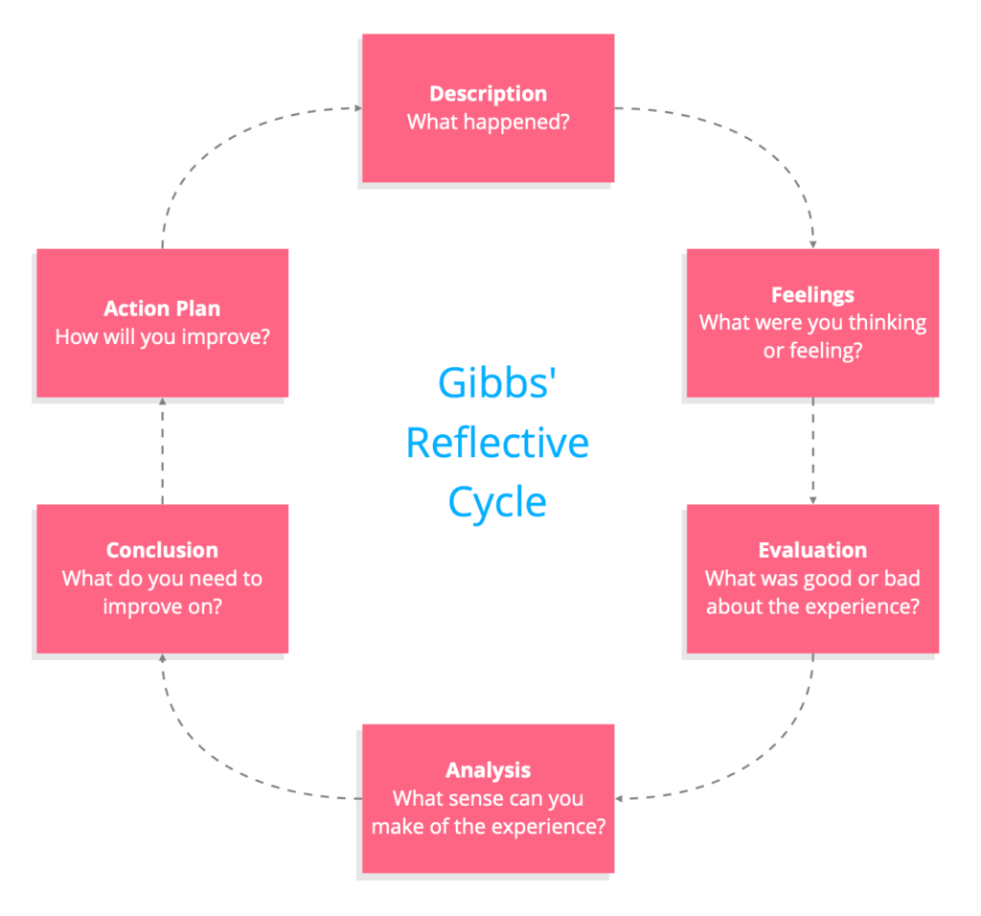

**1. Description:**

During my externship, I faced a variety of mastering expostulations and mastering openings. The literacy terrain offered ingenious generalities, querying assignments, and multitudinous walls to beat. I experienced a combination of challenging and extremely stressful situations during this period. Navigating intricate real-world challenges and accumulating vast amounts of new knowledge is a continuous process of learning and discovery.

## **2. Feelings:**

## I went through a variety of feelings as I was confronted with new and expanded duties. Constant alternations of excitement and anxiety characterized the experience. There were moments of excitement at the educational prospects that awaited me, but there were also moments of struggle with the obvious fear that comes with stepping into unfamiliar territory. Along with these feelings, I sometimes actively sought answers to difficult situations, felt irritated, and lacked confidence. This emotional rollercoaster eventually moulded my ability to overcome obstacles and learn from them.

## **3. Evaluation:**

## It becomes clear from thinking back on my internship experience that it was a double-edged sword. On the plus side, it turned out to be a priceless source of information and useful abilities, acting as a crucial building block for both professional and personal development. I broadened my academic horizons and improved my multifaceted skills thanks to this opportunity. There was a drawback to this voyage, namely the enormous stress that came with managing difficult projects and challenging duties. These demands periodically caused me to experience self-doubt as I struggled with heavy obligations. However, these difficulties ultimately aided in my personal development by strengthening my adaptability and resilience.

## **4. Analysis:**

## Through this life-changing experience, I came to the profound and enduring conclusion that difficulties and hurdles are not impassable barriers to growth but rather essential stepping stones. They act as catalysts, advancing us and providing priceless opportunities for learning and development. I discovered a greater strength in myself as I struggled with the difficulties and uncertainties I faced during my internship. Adversity turned out to be a potent learning stimulant rather than a deterrent, as I had previously thought.

## **5. Conclusion:**

## In light of this experience, there were more steps I could have taken to improve the final result. I now see that I ought to have been even more proactive by actively looking for mentorship and regularly asking more questions. These steps would have been crucial in reducing the negative effects of defeats on both my competence and self-confidence. I might have better prepared myself to deal with the difficulties that came during my internship by actively engaging with mentors and seeking more clarity through questions. This realization emphasizes the value of ongoing development and flexibility in the face of difficulty—a lesson I will apply to my future work.

## **6. Action Plan:**

## I plan to approach challenges in my future undertakings with greater positivity and resiliency, supporting my professional progress. As part of my pledge, I'll take a proactive approach and ask for help and direction as soon as I run into problems because I know that doing so will make it much easier to get over obstacles. I also promise to keep up a constant cycle of reflection, making sure that every experience helps me advance both personally and professionally. This systematic approach tries to turn obstacles into stepping stones, encouraging both my growth and a deeper comprehension of the complex environment of my chosen area.

## **Conclusion**

## In conclusion, my three-week investigation of physical, cultural, and cognitive intelligence has shed light on how intertwined they are and how much they affect my daily life. While cultural intelligence encourages sensitivity and adaptation in a variety of circumstances, physical intelligence facilitates precise and agile movement. My ability to think critically and solve problems gives me the cognitive capacity I need to make wise judgments and adjust to a constantly changing environment. By using the Gibbs Reflective Model to reflect on these elements, I was able to obtain a deeper understanding of my personal development process. As I continue to foster these intelligences, I will develop into a more capable and sympathetic person in our complex, international society.

## **Reference**

Sancoko, R., Setiawan, M. and Troena, E.A., 2019. The influence of organizational culture and spiritual intelligence on employee performance through emotional intelligence. *MEC-J (Management and Economics Journal)*, *3*(1), pp.67-80.

Yari, N., Lankut, E., Alon, I. and Richter, N.F., 2020. Cultural intelligence, global mindset, and cross-cultural competencies: A systematic review using bibliometric methods. *European Journal of International Management*, *14*(2), pp.210-250.

Kuzior, A. and Kwilinski, A., 2022. Cognitive technologies and artificial intelligence in social perception. *Management Systems in Production Engineering*.

Tom Barrett., 2021 (online)., From Awareness to Action: A Complete Guide to Reflective Thinking Cycles for Teachers., available at <https://tombarrett.medium.com/from-awareness-to-action-a-complete-guide-to-reflective-thinking-cycles-for-teachers-f7d9de77aa4b> ., access on 11 sep 2023