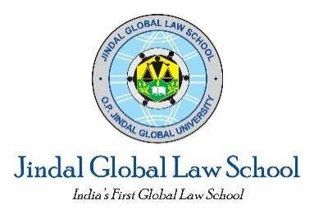
O.P. Jindal Global University
Jindal Global Law School
Internals Exam- II

Course Name : Law & Justice in the Globalizing World
Cohort : 2
Programme : LL.M., Blended Learning Programme
Session : 2023-2024
Time Allowed : 10 days
Date and Time of Release : 10.09.2023, 8:00 pm
Date and Time of Deadline : 20.09.2023, 11:59 pm
Maximum Marks : 25

Instructions to students:

1. This question paper has four (4) questions.
2. Students need to submit the answers within the time period indicated above.
3. A maximum of 25 marks may be awarded in this Exam. This question paper has two parts. Students need to attempt 1 (one) question from Part A (15 marks), and 1 (one) question from Part B (10 marks).
4. Students are required to observe the following word limits:
- Part A – Maximum of 1200-1500 words
- Part B – Maximum of 800-1200 words
5. Students should clearly mention the question number against their answers.
6. Students are required to follow OSCOLA citation style for the footnotes.
7. Mode of submission: UMS Platform
8. Any submissions after the deadline will be subject to penalty.
9. Students undertaking the examination are requested to adhere to the University norms related to examinations.

Warning: Plagiarism in any form is prohibited. Anyone found using unfair means will be penalized severely.

PART A (15 marks)

Question 1: What was the rationale for Rawls to use a ‘veil of ignorance’ while developing a conception of justice. In addition, does the treatment of basic rights and liberties occupy a special place under the Rawlsian framework?

OR

Question 2: In Anarchy, State, and Utopia, Nozick criticizes the Rawlsian approach to distributive justice. What are his main objections to Rawls's theory of justice as fairness, and how does Nozick propose to address these objections in his own theory of justice?

PART B (10 marks)

Question 3: What is meaning of “Globalization Trilemma” according to Dani Rodrik. Do you think that Globalization can flourish under all systems of political governance?

OR

Question 4: Do economic globalization and political globalization travel in separate tracks. How do you respond to this query after reading Rodrik’s "Straight Talk on Trade"?

