CSC 555 / DSC 333
Assignment 1 (due Friday, September 22nd, 2023)
Arth Gadhavi 2115150
Suggested reading:
- Mining of Massive Datasets: Chapter 1, Chapter 2 (sections 2.1, 2.2 only).
- Hadoop: The Definitive Guide: Chapter 3 till NameNodes and DataNodes
Please be sure to submit all python code (if you are using Jupyter notebooks, please export it into the main document or into a .py file before submission).

Part 1
- Compute (you can use any tool or software to compute answers in this part – but if you do not know to perform this computation, please talk to me about your course prerequisites):
2¹¹
(2⁴)⁴
4⁴
8⁵
837 MOD 100 (MOD is the modulo operator, a.k.a. the remainder)
842 MOD 20
23 MOD 112
112 MOD 23
Answer:
We are going to execute above task in Python Spyder. We are going to make all above queries in one go so we can write code something like below and get answers.

Code:
print(2**11)
print((2**4)**4)
print(4**4)
print(8**5)
print(837%100)
print(842%20)
print(23%112)
print(112%23)
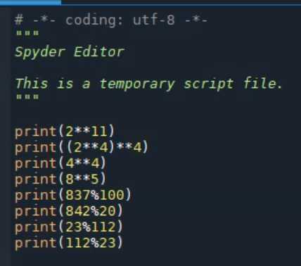
Output:
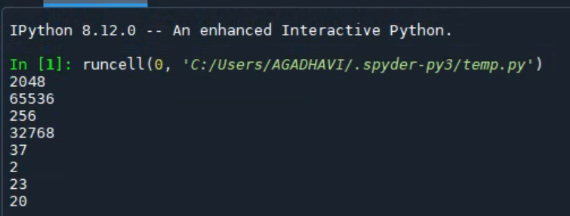

- Given vectors V1 = (1, 1, 3) and V2 = (1, 2, 2) and a 3x3 matrix M = [(2, 1, 3), (1, 2, 1), (1, 0, 1)], compute:
V2 + V1
V1 - V1
|V1| (Euclidean vector length, not the number of dimensions)
|V2|
M * V2 (matrix times vector, transpose it as necessary)
M * M (or M²)
M⁴
Answer:
Above mentioned all queries we are going to solve with Python Spyder. We are going to mention all codes in same.
Code:
import numpy as np

V1 = np.array([1, 1, 3])
V2 = np.array([1, 2, 2])

M = np.array([[2, 1, 3],
[1, 2, 1],
[1, 0, 1]])

# Vector calculations
print(V2 + V1)
print(V1 - V1)

print(np.linalg.norm(V1))
print(np.linalg.norm(V2))

# Matrix vector multiplication
print(M @ V2)

# Matrix multiplication
print(M @ M)
print(np.linalg.matrix_power(M, 4))

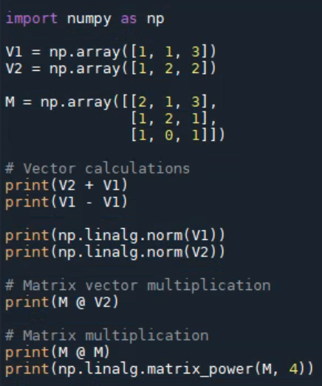

Output:
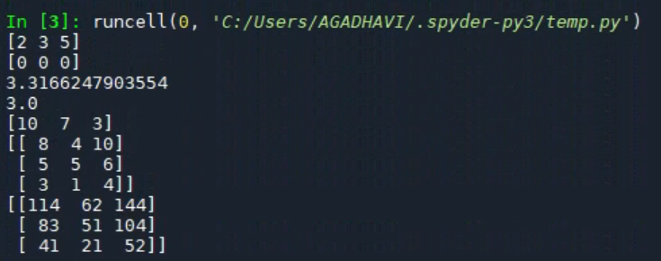

- Suppose we are flipping a coin with Head (H) and Tail (T) sides. The coin is not balanced with 0.4 probability of H coming up (and 0.6 of T). Compute the probabilities of getting:
HTHH
THTT
Exactly 1 Head out of a sequence of 3 coin flips.
Exactly 2 Tails out of sequence of 3 coin flips.
Answer:
As coding is done in Python we can get code and output as below:

Code:
from scipy.stats import binom

# Probability of getting H (Head)
p_H = 0.4

# Probability of getting T (Tail)
p_T = 0.6

# Number of trials (coin flips)
n = 4 # For HTHH and THTT

# Probability of getting HTHH
sequence_HTHH = p_T * p_H * p_T * p_H

# Probability of getting THTT
sequence_THTT = p_H * p_T * p_H * p_T

# Probability of getting exactly 1 Head in 3 coin flips
# P(X = 1) = binom.pmf(1, n, p_H)
exactly_1_head = binom.pmf(1, 3, p_H)

# Probability of getting exactly 2 Tails in 3 coin flips
# P(X = 2) = binom.pmf(2, n, p_T)
exactly_2_tails = binom.pmf(2, 3, p_T)

# Print the probabilities
print("Probability of HTHH:", sequence_HTHH)
print("Probability of THTT:", sequence_THTT)
print("Probability of exactly 1 Head in 3 flips:", exactly_1_head)
print("Probability of exactly 2 Tails in 3 flips:", exactly_2_tails)

Output:
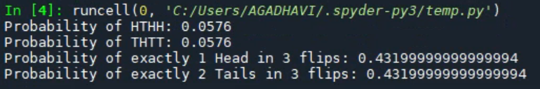
- Consider a database schema consisting of two tables, Employee (ID, Name, Address), Project (PID, Name, Deadline), Assign(EID, PID, Date). Assign.EID is a foreign key referencing employee’s ID and Assign.PID is a foreign key referencing the project.
Write SQL queries for:
- Find projects that are not assigned to any employees (Name and Deadline of the project).

- For each date, find how many assignments were made that day.

- Find all projects that have fewer than 2 employees assigned to them (note that the answer should include 0 or 1 employees to be correct).

- Mining of Massive Datasets, Exercise 1.3.3
Justify your answer (an example only would be worth partial credit)
Answer:
For the hash function h(x) = x mod 15 to work well, the hash keys should be distributed across the 15 buckets 0 to 14 as evenly as possible.

This will happen if the constant c used to generate the hash keys causes them to hit all remainder values 0 to 14 equally likely when divided by 15.

The key criteria is that c and 15 should be relatively prime - i.e. they have no common factors other than 1.

Some examples of good values for c:

c = 2, 3, 7, 11, 13

These values will cause the hash keys to distribute across all buckets.

Some bad values for c:

c = 4, 5, 10, 15

These share factors with 15 so will lead to non-uniform distributions.

In summary, as long as c and 15 are relatively prime, h(x) = x mod 15 will be a good hash function that distributes keys evenly into the buckets. Choosing c to share no factors with the bucket size is the key criteria.

- Hadoop Distributed Filesystem.

  - What are the guarantees offered by a replication factor of 3 (3 copies of each block)?
Answer:
A replication factor of 3 means there will be 3 copies of each block stored in the HDFS cluster. This provides redundancy and fault tolerance - if one machine storing a block fails, there are still two other copies available. It allows continuous availability of data even if a single machine goes down.

  - What action does NameNode have to take when a machine in the Hadoop cluster fails/crashes?
Answer:
When a machine fails in the cluster, the NameNode is notified. The NameNode will then replicate the blocks that were stored on the failed machine to other machines to maintain the replication factor. The NameNode keeps track of block locations and initiates re-replication when needed.

  - What is the overall storage cost for a file of size 950 MBs, when the HDFS replication factor is set to 3?
Answer:
With a replication factor of 3, each block takes 3 times the raw storage space. So for a 950 MB file, the total storage used will be:
950 MB x 3 (replication factor) = 2850 MB = 2.85 GB
So the total storage used will be 2.85 GB to store a 950 MB file with replication factor 3

Part 2
Please be sure to submit all python code with your answers (you can either include it in the same document or as a separate .py file).

- Write python code that is going to read a text file and compute a total word count using a dictionary (e.g., {‘Hadoop’:3, ‘cloud.’: 2, ‘MapReduce’:4}. For our purposes, a word is anything split by space (.split(‘ ‘)), even if it includes things like punctuation.
Test the code on HadoopBlurb.txt (attached to the homework, from Apache Hadoop Wikipedia entry).
How many keys does your dictionary have?
Answer:
We have done coding in Python which is as below and found number of keys as 1085.

Code:
import re

word_counts = {}

with open(r'C:\Users\AGADHAVI\Desktop\HadoopBlurb.txt', encoding='utf-8') as f:
for line in f:
words = line.split(' ')

for word in words:
word = re.sub(r'[^a-zA-Z0-9]', '', word).lower()

if word in word_counts:
word_counts[word] += 1
else:
word_counts[word] = 1

print(word_counts)
print("Number of keys:", len(word_counts))

Output:
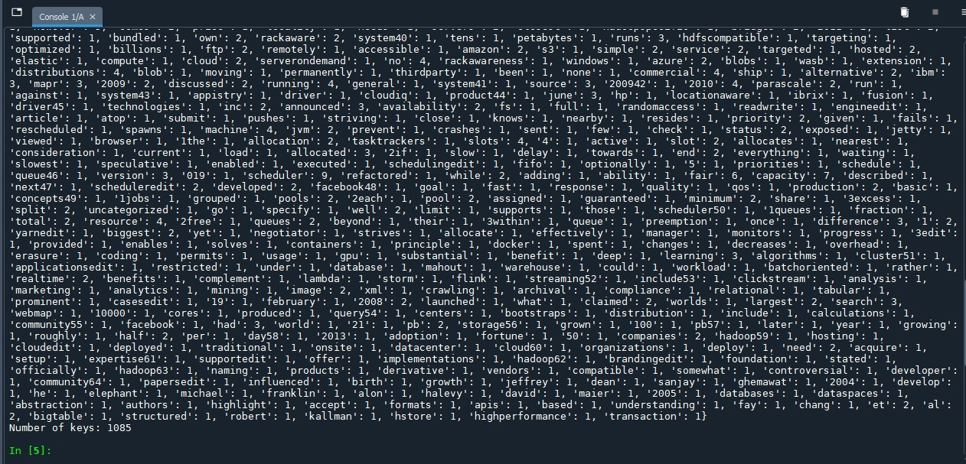

- Write python code that is going to create two different word count dictionaries instead, assigning the words at random. Each time you process a word, choose at random which count dictionary to add it to (that means some words will appear in both dictionaries simultaneously).
How many keys does each dictionary have?
Answer:
By applying above patterns on same data file we are getting two dictionaries and getting word counts of 798 for one dictionary and 792 for another dictionary.

Code:
#2b
import random

word_counts1 = {}
word_counts2 = {}

with open(r'C:\Users\AGADHAVI\Desktop\HadoopBlurb.txt', encoding='utf-8') as f:
for line in f:
words = line.split(' ')

for word in words:
word = word.lower()

# Randomly pick which dict to add to
if random.choice([True, False]):
dict_to_use = word_counts1
else:
dict_to_use = word_counts2

if word in dict_to_use:
dict_to_use[word] += 1
else:
dict_to_use[word] = 1

print("Dict 1 keys:", len(word_counts1))
print("Dict 2 keys:", len(word_counts2))

Output:
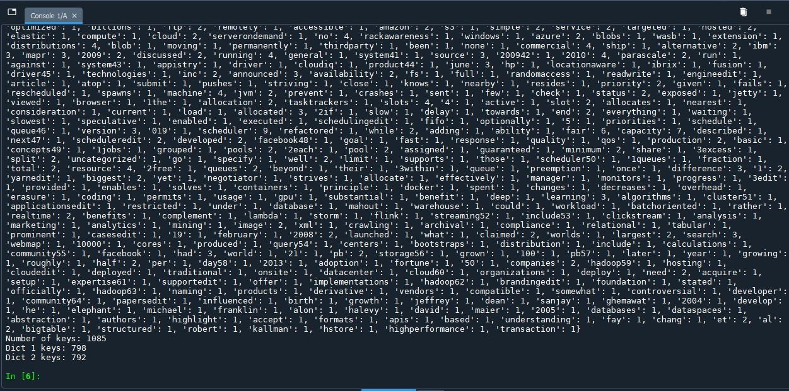

- Write python code to merge the two dictionaries into one (adding the counts) and verify that it matches the dictionary from Part 2-a.
Answer:
By merging two dictionaries we are getting keys of 1300. While is 2a we were getting keys as 1085. Hence the answers are quite different by making two dictionaries and now merging them.

Code:
#2c
merged_word_counts = {}

# Add counts from word_counts1
for word, count in word_counts1.items():
if word in merged_word_counts:
merged_word_counts[word] += count
else:
merged_word_counts[word] = count

# Add counts from word_counts2
for word, count in word_counts2.items():
if word in merged_word_counts:
merged_word_counts[word] += count
else:
merged_word_counts[word] = count

# Print the merged dictionary
print("Merged Dictionary keys:", len(merged_word_counts))

Output:
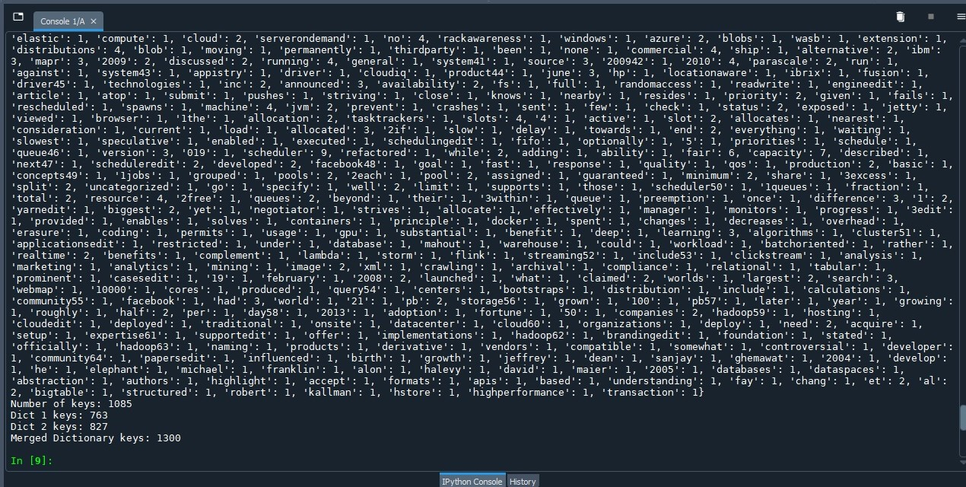

- Write python code that is going to randomly but deterministically assign each word to one of the two dictionaries instead. For example, you can make that assignment using the remainder (YourNumber % 2 will always return 0 or 1 depending on the number). You can convert a word string into a numeric value using hash (e.g., hash('Hadoop.')). We will talk about hashing in more detail later in the quarter.
How many keys does each dictionary have?
Answer:
By applying above all methodologies we are getting word counts for dictionary 1 as 670 and dictionary 2 as 630.

Code:
#2d
word_counts1 = {}
word_counts2 = {}

with open(r'C:\Users\AGADHAVI\Desktop\HadoopBlurb.txt', encoding='utf-8') as f:
for line in f:
words = line.split(' ')

for word in words:
word = word.lower()
word_hash = hash(word) # Get the hash value of the word

# Use the remainder of the hash value to assign to a dictionary
if word_hash % 2 == 0:
dict_to_use = word_counts1
else:
dict_to_use = word_counts2

if word in dict_to_use:
dict_to_use[word] += 1
else:
dict_to_use[word] = 1

print("Dict 1 keys:", len(word_counts1))
print("Dict 2 keys:", len(word_counts2))

Output:
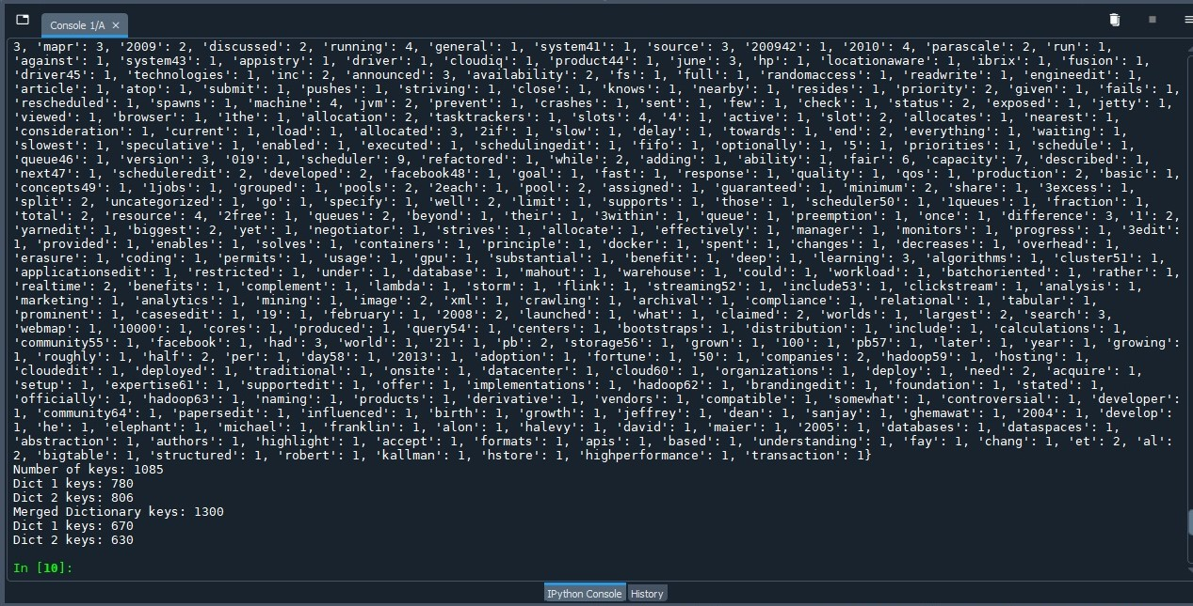

Part 3: Linux Intro

This part of the assignment will serve as an introduction to Linux. Make sure you go through the steps below and submit screenshots where requested – submit the entire screenshot of a command terminal.

Use at least a t2.small instance or Hadoop may not run properly with insufficient memory.
All Linux commands are in Berlin Sans FB. Do not type the “$” symbol. The “$” represents the prompt “[ec2-user@ip-xxx-xx-xx-xxx ~] $ ” in your particular Linux instance.

0. Login to your Amazon EC2 Instance (NOTE: instructions on how to create a new instance and log in to it are provided in a separate file, UsingAmazonAWS.doc)

SUBMIT: The name of the instance that you have created.
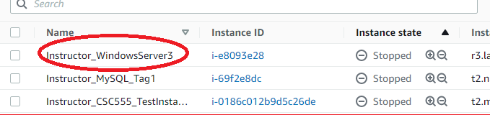

Connect to your instance through PuTTy or a Mac terminal.
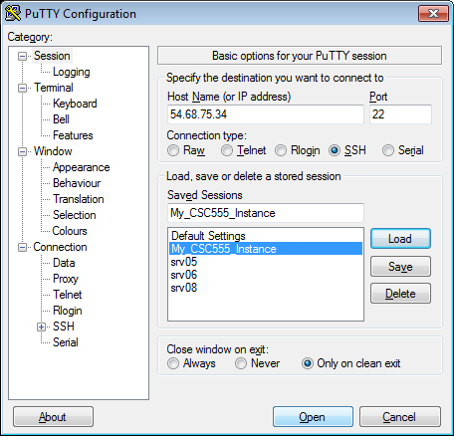

On Windows, your instance would look similar to the following image. On a Mac, you would instead get the same text in an XTerm terminal:

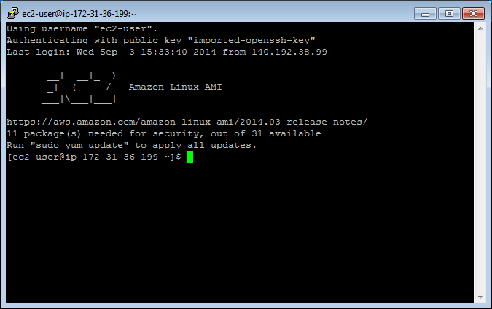

1. Create a text file.
Instructions for 3 different text editors are provided below. You only need to choose one editor that you prefer. nano is a more basic text editor, and is much easier to start. vim and emacs are more advanced and rely on keyboard shortcuts quite a bit and thus have a steeper learning curve.
• Tip: To paste into Linux terminal you can use right-click. To copy from the Linux terminal, you only need to highlight the text that you want to copy with your mouse. Also please remember that Linux is case-sensitive, which means Nano and nano are not equivalent.

Nano Instructions(Option 1):

$ nano myfile.txt
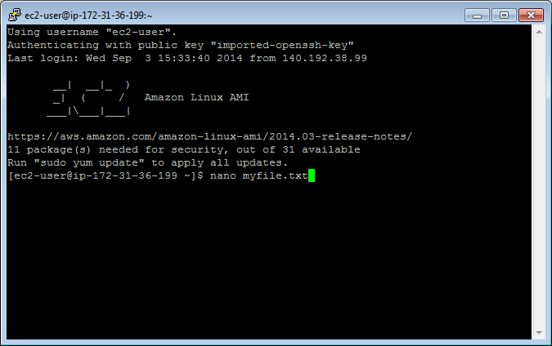

Type something into the file: “This is my text file for CSC555.”
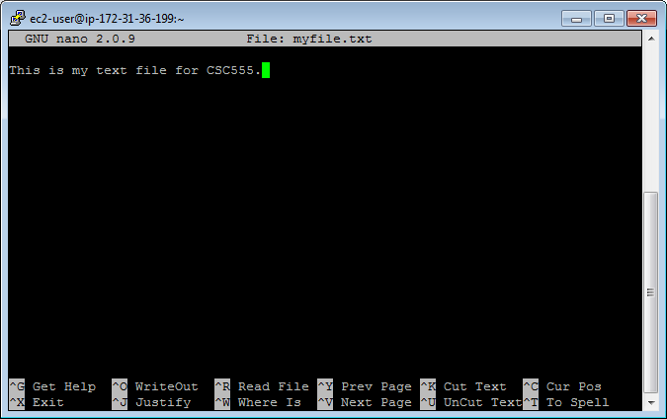
Save changes: Ctrl-o and hit Enter.
Exit: Ctrl-x

Emacs Instructions (Option 2):

You will need to install emacs.
$ sudo yum install emacs
Type “y” when asked if this is OK to install.

$ emacs myfile.txt
Type something into the file: “This is my text file for CSC555.”
Save changes: Ctrl-x, Ctrl-s
Exit: Ctrl-x Ctrl-z

Vim Instructions(Option 3):
• NOTE: When vim opens, you are in command mode. Any key you enter will be bound to a command instead of inserted into the file. To enter insert mode press the key “i”. To save a file or exit you will need to hit Esc to get back into command mode.

$ vim myfile.txt
Type “i” to enter insert mode
Type something into the file: “This is my text file for CSC555.”
Save changes: hit Esc to enter command mode then type “:w”
Exit: (still in command mode) type “:x”

Confirm your file has been saved by listing the files in the working directory.
$ ls
You should see your file.
Display the contents of the file on the screen.
$ cat myfile.txt

Your file contents should be printed to the terminal.
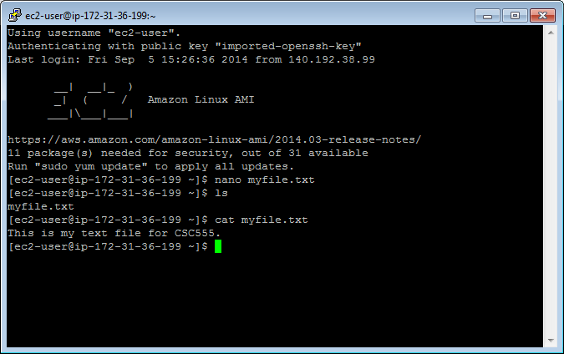

• Tip: Linux will fill in partially typed commands if you hit Tab.
$cat myfi
Hit Tab and “myfi” should be completed to “myfile.txt”. If there are multiple completion options, hit Tab twice and a list of all possible completions will be printed. This also
applies to commands themselves, i.e. you can type in ca and see all possible commands that begin with ca.

2. Copy your file.

Make a copy.
$ cp myfile.txt mycopy.txt
Confirm this file has been created by listing the files in the working directory.
Edit this file so it contains different text than the original file using the text editor instructions, and confirm your changes by displaying the contents of the file on the screen.

SUBMIT: Take a screen shot of the contents of your copied file displayed on the terminal screen.

3. Delete a file

Make a copy to delete.
$ cp myfile.txt filetodelete.txt
$ ls

Remove the file.
$ rm filetodelete.txt
$ ls

4. Create a directory to put your files.

Make a directory.
$mkdir CSC555

Change the current directory to your new directory.
$cd CSC555

Print your current working directory
$pwd

5. Move your files to your new directory.

Return to your home directory.
$cd
OR
$cd ..
OR
$ cd /home/ec2-user/

• NOTE: cd will always take you to your home directory. cd .. will move you up one directory level (to the parent). Your home directory is “/home/[user name]”, /home/ec2-user in our case

Move your files to your new directory.

$ mv myfile.txt CSC555/
$ mv mycopy.txt CSC555/

Change the current directory to CSC555 and list the files in this directory.

SUBMIT: Take a screen shot of the files listed in the CSC555 directory.

6. Zip and Unzip your files.

Zip the files.
$ zip myzipfile mycopy.txt myfile.txt
OR
$ zip myzipfile *

• NOTE: * is the wildcard symbol that matches everything in current directory. If there should be any additional files in the current directory, they will also be placed into the zip archive. Wildcard can also be used to match files selectively. For example zip myzipfile my* will zip-up all files beginning with “my” in the current directory.

Move your zip file to your home directory.
$ mv myzipfile.zip /home/ec2-user/

Return to your home directory.
Extract the files.
$ unzip myzipfile.zip

SUBMIT: Take a screen shot of the screen after this command.

7. Remove your CSC555 directory.

• Warning: Executing “rm -rf” has the potential to delete ALL files in a given directory, including sub-directories (“r” stands for recursive). You should use this command very carefully.
Delete your CSC555 directory.
$ rm -rf CSC555/

8. Download a file from the web.

Download the script for Monty Python and the Holy Grail.
$ wget http://www.textfiles.com/media/SCRIPTS/grail

The file should be saved as “grail” by default.

9. ls formats

List all contents of the current directory in long list format.
• Note: the option following “ls” is the character “l”; not “one”.
$ ls -l

The 1st column gives information regarding file permissions (which we will discuss in more detail later). For now, note that the first character of the 10 total will be “-“ for normal files and “d” for directories. The 2nd Column is the number of links to the file. The 3rd and 4th columns are the owner and the group of the file. The 5th column displays the size of the file in bytes. The 6th column is the date and time the file was last modified. The 7th column is the file or directory name.

List all contents of the current directory in long list and human readable formats. “-h” will put large files in more readable units than bytes.
$ ls -lh

SUBMIT: The size of the grail file.

10. More on viewing files.

If you issue “cat grail”, the contents of grail will be printed. However, this file is too large to fit on the screen.

Show the grail file one page at a time.
$ more grail
Hit the spacebar to go to the next page. Type “b” to go page up, hit “space” key to go page down. Type “q” to quit.

OR

$ less grail
Less has more options than more (“less is more and more is less”). You can now use the keyboard Arrows and Page Up/Down to scroll. You can type “h” for help, which will display additional options.

View the line numbers in the grail file. The cat command has the -n option, which prints line numbers, but you may also want to use more to view the file one page at a time. A solution is to pipe the output from cat to more. A pipe redirects the output from one program to another program for further processing, and it is represented with “|”.

$ cat -n grail | more

Redirect the standard output (stdout) of a command.
$ cat myfile.txt > redirect1.txt
$ ls -lh > redirect2.txt

Append the stdout to a file.
$ cat mycopy.txt >> myfile.txt
mycopy.txt will be appended to myfile.txt.

• Note: “cat mycopy.txt > myfile.txt” will overwrite myfile.txt with the contents output by “cat mycopy.txt”. Thus using >> is crucial if you want to preserve the existing file contents.

11. Change access permissions to objects with the change mode command.

The following represent roles:
u – user, g – group, o – others, a - all

The following represent permissions:
r – read, w – write, x – execute

Remove the read permission for your user on a file.
$ chmod u-r myfile.txt
Try to read this file. You should receive a “permission denied” message because you are the user who owns the file.

SUBMIT: The screenshot of the permission denied error

Give your user read permission on a file. Use the same file you removed the read permission from.
$ chmod u+r myfile.txt
You should now be able to read this file again.

12. Python examples

Install Python if it is not available on your machine.

$ sudo yum install python

Create a Python file. These instructions will use Emacs as a text editor, but you can still chose the text editor you want.

$ emacs lucky.py
(Write a simple Python program)
print "*"*25
print "My Lucky Numbers".rjust(20)
print "*"*25

for i in range(10):
lucky_nbr = (i + 1)*2
print "My lucky number is %s!" % lucky_nbr

Run your Python program.
$ python lucky.py

Redirect your output to a file
$ python lucky.py > lucky.txt

Pipe the stdout from lucky.py to another Python program that will replace “is” with “was”.
$ emacs was.py

import sys

for line in sys.stdin:
print line.replace("is", "was")

$ python lucky.py | python was.py

Write python code to read a text file (you can use myfile.txt) and output a word count total for each word with the number of times that word occurs in the entire file. That is, if the file has the word “Hadoop” occurs in the file 5 times, your code should print “Hadoop 5”. It should output the count of all words occurring in a file.

SUBMIT: The screen output from running your python code and a copy of your python code. Homework submissions without code will receive no credit.

Part 4: Wordcount
For this part of the assignment, you will run wordcount on a single-node Hadoop instance. I am going to provide detailed instructions to help you get Hadoop running. The instructions are following Hadoop: The Definitive Guide instructions presented in Appendix A: Installing Apache Hadoop.

You can download 2.6.4 from here. You can copy-paste these commands (right-click in PuTTy to paste, but please watch out for error messages and run commands one by one)
Install Java 1.8
sudo yum install java-1.8.0
sudo yum install java-1.8.0-devel

(wget command stands for “web get” and lets you download files to your instance from a URL link)
wget http://dbgroup.cdm.depaul.edu/Courses/CSC555/hadoop-2.6.4.tar.gz

(unpack the archive)
tar xzf hadoop-2.6.4.tar.gz

Modify the conf/hadoop-env.sh to add to it the JAVA_HOME configuration
You can open it by running (using nano or your favorite editor instead of nano).
nano hadoop-2.6.4/etc/hadoop/hadoop-env.sh
Note that the # comments out the line, so you would comment out the original JAVA_HOME line replacing it by the new one as below.

NOTE: you would need to determine the correct Java configuration line by executing the following (underlined) command
[ec2-user@ip-172-31-16-63 ~]$ readlink -f $(which java)
which will output something like:
/usr/lib/jvm/java-1.8.0-openjdk-1.8.0.191.b12-0.amzn2.x86_64/jre/bin/java

In my case, Java home is at (remove the bin/java from the path):
/usr/lib/jvm/java-1.8.0-openjdk-1.8.0.191.b12-0.amzn2.x86_64/jre/

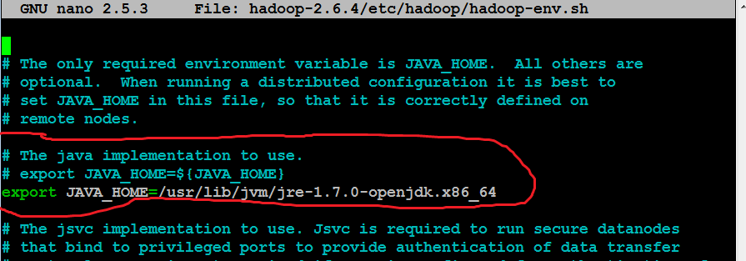

Do not copy the line from this screenshot, your JAVA_HOME path will be different
modify the .bashrc file to add these two lines:
export HADOOP_HOME=~/hadoop-2.6.4
export PATH=$PATH:$HADOOP_HOME/bin:$HADOOP_HOME/sbin

.bashrc file contains environment settings to be configured automatically on each login. You can open the .bashrc file by running
nano ~/.bashrc

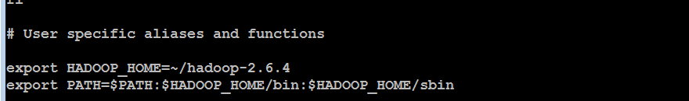

To immediately refresh the settings (that will be automatic on next login), run
source ~/.bashrc

Next, follow the instructions for Pseudodistributed Mode for all 4 files.

(to edit the first config file)
nano hadoop-2.6.4/etc/hadoop/core-site.xml

Make sure you paste the settings between the <configuration> and </configuration> tags, like in the screenshot below. NOTE: The screenshot below is only one of the 4 files, all files are different. The contents of each file are described in the Appendix A in the Hadoop book, the relevant appendix is also included with the homework assignment. I am also including a .txt file (HadoopConfigurationText) so that it is easier to copy-paste.

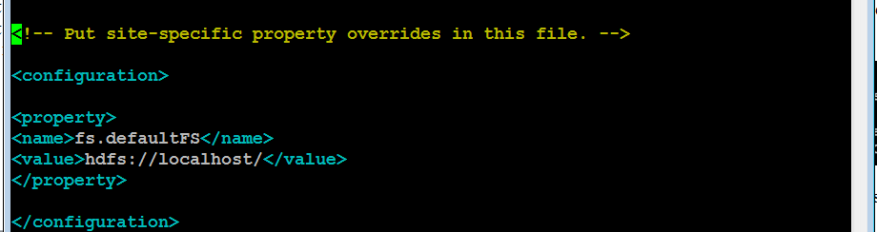

nano hadoop-2.6.4/etc/hadoop/hdfs-site.xml
(mapred-site.xml file is not there, run the following single line command to create it by copying from template. Then you can edit it as other files.)
cp hadoop-2.6.4/etc/hadoop/mapred-site.xml.template hadoop-2.6.4/etc/hadoop/mapred-site.xml
nano hadoop-2.6.4/etc/hadoop/mapred-site.xml
nano hadoop-2.6.4/etc/hadoop/yarn-site.xml

To enable passwordless ssh access (we will discuss SSH and public/private keys in class), run these commands:
ssh-keygen -t rsa -P '' -f ~/.ssh/id_rsa
cat ~/.ssh/id_rsa.pub >> ~/.ssh/authorized_keys

test by running (and confirming yes to a one-time warning)
ssh localhost
exit

Format HDFS (i.e., first time initialize)

hdfs namenode -format

Start HDFS, Hadoop and history server (answer a 1-time yes if you asked about host authenticity)

start-dfs.sh
start-yarn.sh
mr-jobhistory-daemon.sh start historyserver

Verify if everything is running:
jps

(NameNode and DataNode are responsible for HDFS management; NodeManager and ResourceManager are serving the function similar to JobTracker and TaskTracker.)

Create a destination directory
hadoop fs -mkdir /data
Download a large text file using
wget http://dbgroup.cdm.depaul.edu/Courses/CSC555/bioproject.xml

Copy the file to HDFS for processing

hadoop fs -put bioproject.xml /data/

(you can optimally verify that the file was uploaded to HDFS by hadoop fs -ls /data)
Submit a screenshot of this command

Run word count on the downloaded text file, using the time command to determine the total runtime of the MapReduce job. You can use the following (single-line!) command. This invokes the wordcount example built into the example jar file, supplying /data/bioproject.xml as the input and /data/wordcount1 as the output directory. Please remember this is one command, if you do not paste it as a single line, it will not work.

time hadoop jar hadoop-2.6.4/share/hadoop/mapreduce/hadoop-mapreduce-examples-2.6.4.jar wordcount /data/bioproject.xml /data/wordcount1

Report the time that the job took to execute as screenshot
(this reports the size of a particular file or directory in HDFS. The output file will be named part-r-00000)
hadoop fs -du /data/wordcount1/

(Just like in Linux, the cat HDFS command will dump the output of the entire file and grep command will filter the output to all lines that matches this particular word). To determine the count of occurrences of “arctic”, run the following command:

hadoop fs -cat /data/wordcount1/part-r-00000 | grep arctic

It outputs the entire content of part-r-00000 file and then uses pipe | operator to filter it through grep (filter) command. If you remove the pipe and grep, you will get the entire word count content dumped to screen, similar to cat command.

Congratulations, you just finished running wordcount using Hadoop.

Part 5 (Only for CSC 555)

Write (and test) python code that is going to measure the speed of reading from the web (using urllib or similar), reading from a file and writing to a file on your computer.
That means your code will read or write some amount of data, time the operation, and compute the read or write rate (in MBytes/sec). The files have to be sufficiently large so that each of the measuring operations has to execute for at least 4 seconds or more (we’ll check why in Part-a)

- Compute the speed of reading from disk. We will do that in two different ways

- Use the HadoopBlurb file as the file you read and time and compute the MB/sec speed (this one will be less than 4 seconds).
Answer:
Time we have got is 0 MB/Sec for reading this file.

Code:
# -*- coding: utf-8 -*-
"""
Created on Sun Sep 17 15:16:39 2023

@author: AGADHAVI
"""

import time

# Method 1: Reading from the 'HadoopBlurb.txt' file
file_path1 = r'C:\Users\AGADHAVI\Desktop\HadoopBlurb.txt'

def read_from_disk(file_path):
start_time = time.time()
with open(file_path, 'rb') as file:
data = file.read()
end_time = time.time()
elapsed_time = end_time - start_time
return data, elapsed_time

# Measure the speed of reading from disk using 'HadoopBlurb.txt'
data1, elapsed_time1 = read_from_disk(file_path1)
file_size1 = len(data1)
speed1 = 0 # Default speed value

if elapsed_time1 > 0:
speed1 = file_size1 / (elapsed_time1 * 1024 * 1024) # Convert to MB/sec

# Print the result
print("Method 1 (HadoopBlurb.txt) - Speed (MB/sec):", speed1)

Output:
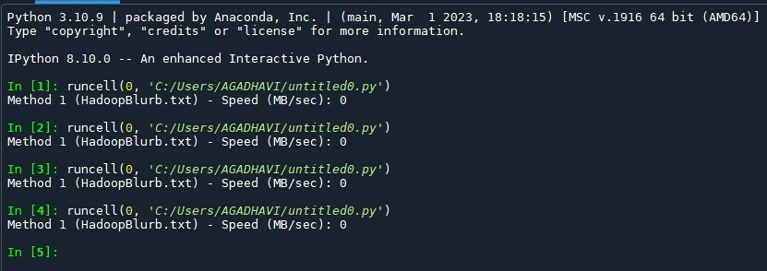

- Use a large file (at least 4 seconds of reading from disk) and compute the MB/sec speed.
Answer:
We have got both time different speeds first we have got 91.68 MB/sec while second time we have got 61.36 MB/sec.

Code:
# -*- coding: utf-8 -*-
"""
Created on Sun Sep 17 15:21:56 2023

@author: AGADHAVI
"""

import time
import urllib.request

# Method 2: Reading from a web file
web_file_url = 'http://dbgroup.cdm.depaul.edu/DSC450/OneDayOfTweets.txt'

def read_from_web(url):
start_time = time.time()
with urllib.request.urlopen(url) as response:
data = response.read()
end_time = time.time()
elapsed_time = end_time - start_time
return data, elapsed_time

# Measure the speed of reading from the web (large file)
data2, elapsed_time2 = read_from_web(web_file_url)
file_size2 = len(data2)
speed2 = 0 # Default speed value

if elapsed_time2 > 0:
speed2 = file_size2 / (elapsed_time2 * 1024 * 1024) # Convert to MB/sec

# Print the result
print("Method 2 (Web Large File) - Speed (MB/sec):", speed2)

Output:
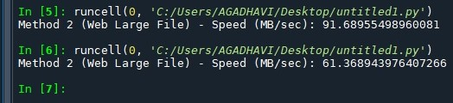

How do they compare? Which one do you think is more accurate?
Answer:
First one text file HadoopBlurb.txt was more accurate as it was got same answer all the time. While another one of tweet was big file so definitely it takes different time each time to read. Second most significant factor is HadoopBlurb.txt was stored on local system while Tweet file depends on server and internet speed. Hence Locally stored file of HadoopBlurb is more accurate.

- Compute the speed of reading from the web (you can use http://dbgroup.cdm.depaul.edu/DSC450/OneDayOfTweets.txt if you need a large file, but remember that you don’t need to read the whole thing).
Answer:
By applying above mentioned methodology we have got download speed which is 112.82.

Code:
import time
import urllib.request

# URL of the web file
web_file_url = 'http://dbgroup.cdm.depaul.edu/DSC450/OneDayOfTweets.txt'

# Function to measure download speed from a web file
def measure_web_download_speed(url, chunk_size=1024 * 1024, duration=10):
try:
with urllib.request.urlopen(url) as response:
total_bytes_read = 0
start_time = time.time()

while True:
data_chunk = response.read(chunk_size)
if not data_chunk:
break

total_bytes_read += len(data_chunk)

current_time = time.time()
elapsed_time = current_time - start_time

if elapsed_time >= duration:
break

download_speed = total_bytes_read / (elapsed_time * 1024 * 1024) # Convert to MB/sec
return download_speed
except Exception as e:
print("Error:", str(e))
return None

# Measure the download speed (adjust chunk_size and duration as needed)
download_speed = measure_web_download_speed(web_file_url, chunk_size=1024 * 1024, duration=10)

if download_speed is not None:
print(f"Download Speed (MB/sec): {download_speed:.2f}")
else:
print("Download speed measurement failed.")

Output:
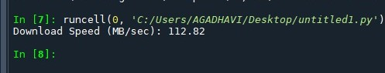

- Compute the speed of writing to disk
Answer:
We have computed and compared speed of writing for both so we have got a result which showcases. Locally saved file HadoopBlurb is taking longer time to write while webfile OneDayOfTweets has taken lesser time than locally saved file.

Code:
# -*- coding: utf-8 -*-
"""
Created on Sun Sep 17 15:48:50 2023

@author: AGADHAVI
"""

import time
import urllib.request

# Local file path
local_file_path = r'C:\Users\AGADHAVI\Desktop\HadoopBlurb.txt'

# Web file URL
web_file_url = 'http://dbgroup.cdm.depaul.edu/DSC450/OneDayOfTweets.txt'

# Function to measure write speed to a local file
def measure_local_write_speed(file_path, data, duration=10):
try:
start_time = time.time()
with open(file_path, 'wb') as file:
while True:
file.write(data)

current_time = time.time()
elapsed_time = current_time - start_time

if elapsed_time >= duration:
break

write_speed = len(data) / (elapsed_time * 1024 * 1024) # Convert to MB/sec
return write_speed
except Exception as e:
print("Error:", str(e))
return None

# Function to measure write speed to a web file
def measure_web_write_speed(url, data, duration=10):
try:
start_time = time.time()
request = urllib.request.Request(url, data=data)
with urllib.request.urlopen(request) as response:
while True:
response.read()

current_time = time.time()
elapsed_time = current_time - start_time

if elapsed_time >= duration:
break

write_speed = len(data) / (elapsed_time * 1024 * 1024) # Convert to MB/sec
return write_speed
except Exception as e:
print("Error:", str(e))
return None

# Read data from the web file
with urllib.request.urlopen(web_file_url) as response:
web_data = response.read()

# Measure the write speed for the local file
write_speed_local = measure_local_write_speed(local_file_path, web_data, duration=10)

# Measure the write speed for the web file
write_speed_web = measure_web_write_speed(web_file_url, web_data, duration=10)

if write_speed_local is not None:
print(f"Write Speed to Local File (MB/sec): {write_speed_local:.2f}")
else:
print("Write speed measurement to local file failed.")

if write_speed_web is not None:
print(f"Write Speed to Web File (MB/sec): {write_speed_web:.2f}")
else:
print("Write speed measurement to web file failed.")

Output:
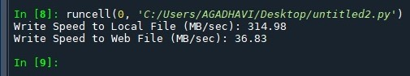

- Finally, add a print statement in part 3-a (i.e., print everything you read from the file) and measure the new throughput in MBytes/sec.

Submit a single document containing your written answers. Be sure that this document contains your name and “CSC 555 Assignment 1” at the top.

