**DISCUSSION OF THE BENEFITS AND LIMITATIONS OF SUPPLY CHAIN AUTOMATION**

**TABLE OF CONTENTS**

Introduction 3

Discussion 3

Benefits 3

Limitations 4

Conclusion 5

Reference List 6

Appendix 7

# Introduction

The study has examined the potential benefits and limitations of the automation process of the supply chain. An essential result of technological advancements has disturbed the operations of the business effectively through supply chain automation. By organizing productive materials, for example, machine learning, blockchain, and IoT devices. Supply chains have discovered excellent updates like transparency, efficiency, and predictive capability. This study can help to get knowledge of various prospects of supply chain automation by investigating its various benefits and expected limitations.

# Discussion

Supply chain automation has emerged as a transformative force in modern business operations by leveraging technologies like blockchain, machine learning, and the Internet of Things to enhance efficiency and transparency. While supply chain automation offers various benefits, the underlying costs of incorporating these advances can be significant. Organizations should invest in hardware, programming, and an expert workforce to configure, execute, and maintain these systems. There have few benefits and limitations discussed in brief which have been faced by the supply chain while implementing the automation process in its business operations. Those benefits and limitations are listed below:

## Benefits

**Improved Transparency:**

The usage of blockchain progression enables real-time tracking of products across the supply chain through strong contracts. This ensures direct and improved records of transactions and advancements in the movement of the supply chain by reducing the risk of fraud and duplication (Chang *et al.* 2019). For example, a medicine shop can utilize the blockchain to investigate the authenticity of medicines by following their journey from manufacturer to the customer effectively.

**Predictive Analytics for Better Decision-Making:**

The capacity of machine learning in expecting hidden connections inside supply chains. By analyzing the vast amount of data the machine learning algorithms can identify standards and relations that human analysts could overlook. This capability allows organizations to work on stock levels, streamline production, and make effective decisions based on attentive forecasts.

**Real-time Monitoring and Inventory Management:**

Detectors have attached to products that can transfer data on factors like temperature, humidity, and location by ensuring that products are controlled and shipped under ideal circumstances (Rejeb *et al.* 2019). This capacity of understanding can prevent damage in short-lived products or distinguish potential blockages in the supply chain ***[Referred to Appendix 1]***.

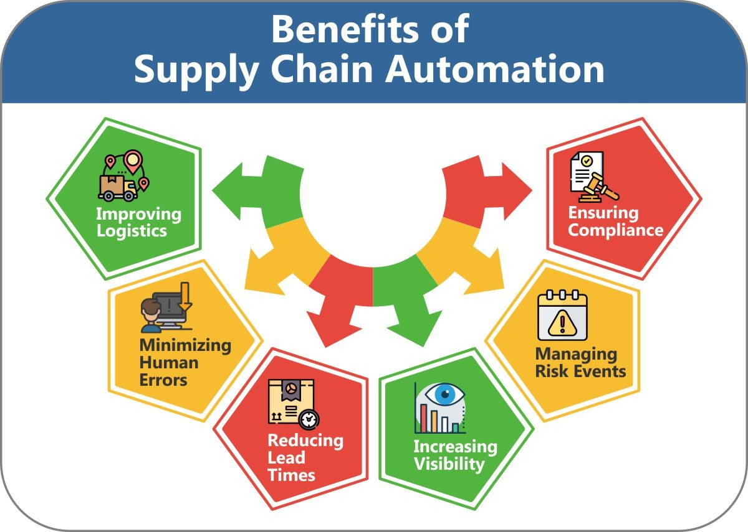

**Figure 1: Benefits of Supply Chain Automation**

(Source: https://media.licdn.com/dms/image/D5612AQGgvpXIrisIrg/article-inline_image-shrink_1000_1488/0/1663137860109?e=1697673600&v=beta&t=BEBhgMYqaEaRFMd35Uhch4HOXY5-duRmeKnqmh3CvUE)

## Limitations

**Data Security and Privacy Policy:**

The increased connectivity and data sharing introduced by automation technologies raise concerns about data security and privacy (Mehta *et al.* 2020). The obligations in supply chains can be taken advantage of by negative characters which require solid security measures. Furthermore, IoT devices gather delicate data which requires a strict routine to protect client data.

**Incorporate Challenges:**

Integrating various automation technologies can be complex and time-consuming. Ensuring logical communication between different platforms and systems requires careful planning and coordination (Kosasih and Brintrup, 2022). Incompatibility issues between legacy systems and newer technologies can lead to disruptions in operations.

**Human Workforce Transition:**

The integration of automation technologies may lead to a shift in the required skill set of the workforce. The streamlined processes of automation need human leadership and intervention which are still essential for the supply chain. Employees may need training to operate and manage automated systems effectively for the sustainable growth of the supply chain.

# Conclusion

The above discussion has described the integration of automation advancements in supply chains. The discussion presents unlimited benefits, from predictive analysis and transparency to determining the security advancements of supply chains and monitoring the advancements properly. Organizations should navigate the challenges, for example, implementation costs, data security, integration complexities, and advancements of the workforce to understand the capacity of supply chain automation.

# 

# Reference List

**Journals**

Chang, S. E., Chen, Y. C., & Lu, M. F. (2019). Supply chain re-engineering using blockchain technology: A case of smart contract based tracking process. *Technological Forecasting and Social Change*, *144*, 1-11. Retrieve From: https://bamasell.com/wp-content/uploads/2022/09/blockchain-1.pdf [Retrieved on: 07.08.2023]

Kosasih, E. E., & Brintrup, A. (2022). A machine learning approach for predicting hidden links in supply chain with graph neural networks. *International Journal of Production Research*, *60*(17), 5380-5393. Retrieve From: https://www.tandfonline.com/doi/pdf/10.1080/00207543.2021.1956697 [Retrieved on: 07.08.2023]

Mehta, D., Lu, H., Paradis, O. P., MS, M. A., Rahman, M. T., Iskander, Y., ... & Asadizanjani, N. (2020). The big hack explained: Detection and prevention of PCB supply chain implants. *ACM Journal on Emerging Technologies in Computing Systems (JETC)*, *16*(4), 1-25. Retrieve From: https://www.researchgate.net/profile/Hangwei-Lu/publication/343892284_The_Big_Hack_Explained_Detection_and_Prevention_of_PCB_Supply_Chain_Implants/links/6113e07e169a1a0103f4fee5/The-Big-Hack-Explained-Detection-and-Prevention-of-PCB-Supply-Chain-Implants.pdf [Retrieved on: 07.08.2023]

Rejeb, A., Keogh, J. G., & Treiblmaier, H. (2019). Leveraging the internet of things and blockchain technology in supply chain management. *Future Internet*, *11*(7), 161. Retrieve From: https://www.mdpi.com/1999-5903/11/7/161/pdf [Retrieved on: 07.08.2023]

# 

# Appendix

**Appendix 1: Automated Supply Chain**

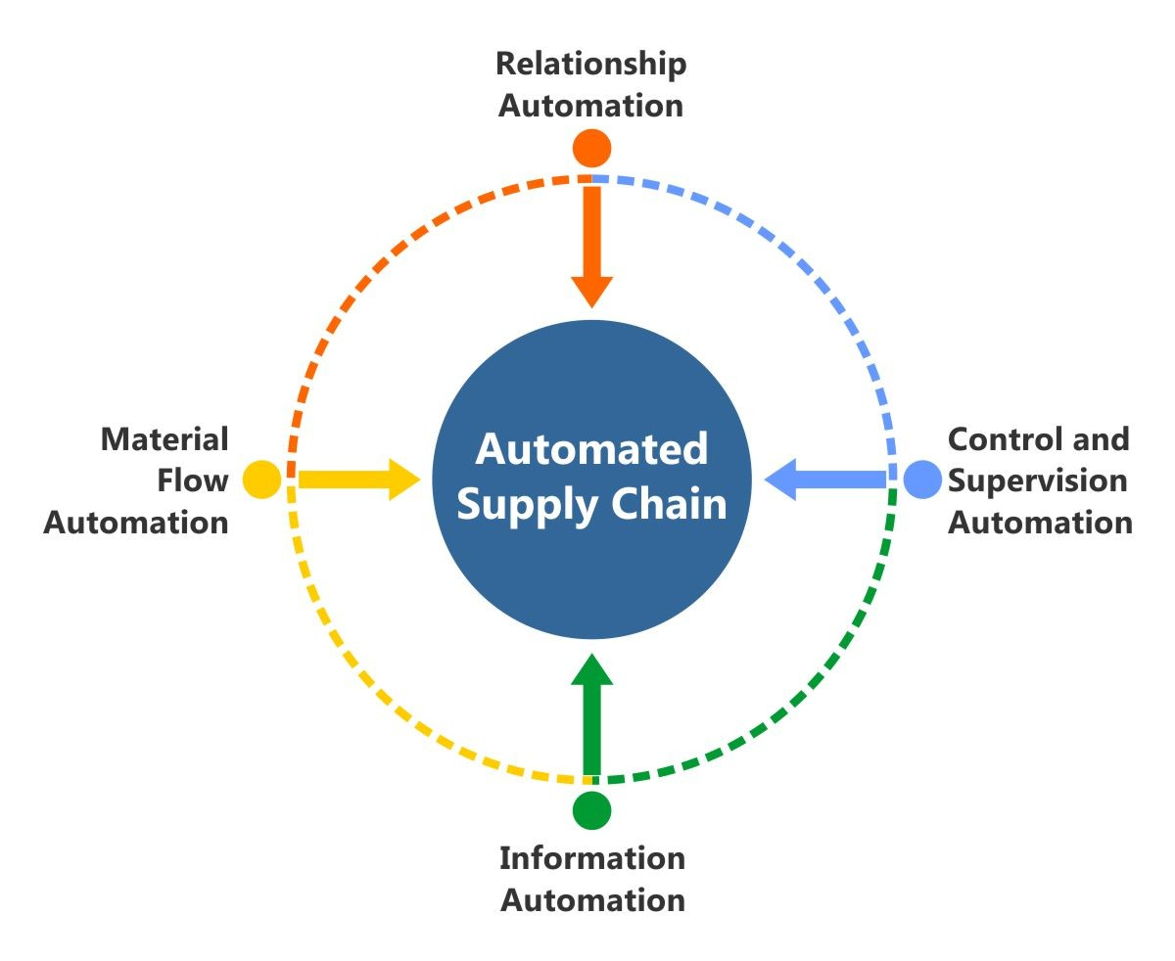

(Source: https://media.licdn.com/dms/image/D5612AQGleuR-8ZWaSA/article-inline_image-shrink_1000_1488/0/1663137790612?e=1697673600&v=beta&t=ySTgiqWgXgkYDpci-Tzspt3_SwFTPlBnDo2-DyJcH-8)