**NEW BUSINESS PLAN FOR BEST COFFEE CO.**

**Executive Summary**

The present study determines that the business initiative of the coffee industry can develop a proper plan for enhancing the profit margin. Furthermore, the business initiative can adopt many essential strategies that help them to improve their competitive advantage over other competitors.

Table of Contents

1. Business Plan Pitch 3

2. Business Opportunity 4

2.1 Customer need, target market and relevant megatrend(s) 4

2.2 Opportunity testing plan 5

3. Sales and Marketing Strategy 6

3.1 Fundamentals 6

3.2 Measurement and information 9

4. Operational Strategy 10

4.1 Operational structure 10

4.2 Outsourcing and Motivation 11

5. Financial Plans 11

5.1 Capital Requirements and funding plan 11

5.2 P&L Statement and Assumptions 12

5.3 Balance Sheet and Assumptions 13

5.4 Valuation and Justification 13

6. References 15

# Business Plan Pitch

A business pitch is defined as the appropriate interpretation or performance of an accurate plan for business in addition to the potential investors. Furthermore, it can be said that a plan for a business pitch is a straightforward explanation with regard to the business and its assistance. A business pitch helps in developing the average revenue or net profit that generally concerns a proper plan that authorizes an organization to generate a reliable profit (Susanto et al. 2021, p. 6). The plan will start in 2023 and follows up to 2025 and basically, the company has established in early 2000. Therefore, it has been understood that a prosperous pitch can assist an initiative of the business to build up a satisfactory connection with the probable partners. In this context, the present study focuses on developing a three-year business plan for creating a modern business venture for ***“Best Coffee Co.”*** in Australia. Furthermore, the study also aims to generate 8% of profits and essential knowledge that may support and enable the poverty cycle by enhancing the profit margins. On the other hand, it can be stated that a business plan can provide a strategic roadmap that assists the organization to perform and describe the current trends in the competitive market. Besides, the business initiative aims to achieve a competitive advantage and attract probable customers. Similarly, it can be stated that the business initiative can regularly manage the expenditure to increase the profitability of this coffee shop in the upcoming three years. There are certain stakeholders can help to improve the margins of the profits. Employees, consumers, vendors, partners of the supply chain, community members and regulatory agencies are the major stakeholders that may help this business plan to properly execute (Hofman et al. 2020, p. 2734-2754). It has been informed the business initiative of ***“Best Coffee Co.”*** has made a partnership with a ***“Bio-pod packer”*** in Queensland to remove the polluting elements that can also help to improve their business strategy. Moreover, the initiative of this enterprise can build up an exact presentation or business model and thoroughly demonstrate the major issue.

# Business Opportunity

## 2.1 Customer need, target market and relevant megatrend(s)

The requirements of customers are the stimulating characteristics that direct individuals to purchase a derivative or utilize an essential service. The business initiative with regard to this mentioned organization in Australia may learn about the needs of consumers. It has been found that points of price, comfort, sustainability, clarity and management or options are the essential needs of customers with regard to the new opportunity of the business (Akram et al. 2021, p. 7533). Therefore, it has been recognized that the satisfaction of customers can enhance after gratifying their basic needs. On the other hand, it can be noted that this mentioned organization can focus on defining the major characteristics of the target market that may improve their profit margins in the next three years. Therefore, the business initiative can focus on the marketing strategy of ***“Gloria Jeans Coffee”, “Hudson’s Coffee”*** and ***“Starbucks Coffee”***. It has been estimated that the net profit of Starbucks coffee has enhanced by approximately ***“$ 96.1 million”*** in 2021 in Australia (Acapmag. com,au, 2021). It has The information has been found that the margin of the profit of the food and beverage industry has improved by approximately 55% in Australia in 2022 (Bbc.com, 2023). Hence, it can be said that the analysis of the business strategy of the target market or competitors can help the business initiative to upgrade the profitability and productivity of the organization.

On the other hand, the business initiative can collect much essential information for ameliorating the net profit of their business. Furthermore, the business initiative of ***“Best Coffee Co.”*** can gather major information from the ***“Australian Bureau of Statistics (ABS)”*** that helps them to estimate a probable decision (Abs.gov.au, 2021). Hence, it can be understood that ABS assist in delivering trusted, reliable and objective statements, data and statistics. The industry report has stated the average revenue with respect to the coffee industry has developed by approximately ***“US$6.93 billion”*** in 2023 (Statista.com, 2023). Therefore, ABS can provide authorised and official statistics in addition to the matters of economic, social and environmental aspects that help the business leader to enhance their profit margins. Furthermore, the megatrends and external data can help the business to recognize the potential hazards and scopes. It may help in understanding to adopt the correct activity to eradicate the severe external factors that can cause harm.

## 2.2 Opportunity testing plan

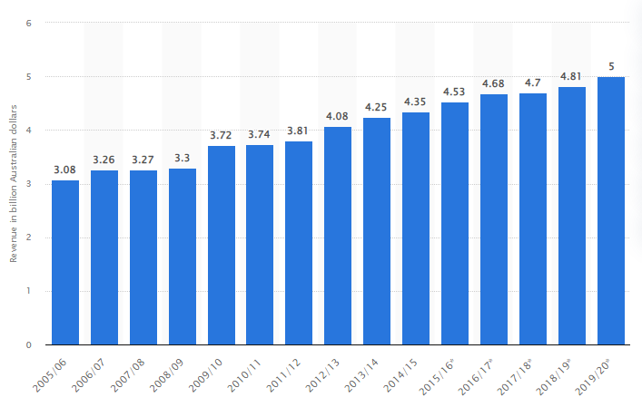

**Figure 1: Total net profit of cafes and coffee industry in Australia**

(Source: Statista.com, 2020)

The above statistical graph has represented that the revenue of the coffee industry has enhanced by around ***“5 billion Australian dollars”*** in 2019-2020 (Statista.com, 2020). The business initiative can improve its relationship with ***“Bio-pod Packer”*** and try to increase the profit margin by approximately 8% to enhance its competitive advantage. Furthermore, the business initiative of ***“Best Coffee Co.”*** can implement around ***“55 million coffee pods”*** in their landfill to improve recycling methods. On the other hand, it can be noted that the business initiative can ask customers regarding their referrals, upgrade their website and apply online reviews to attract a maximum number of customers. Similarly, the business initiative can offer reliable discounts and encouragement, promote their expertise and make a partnership with complementary associations that also help them to improve customer perception. It can be aimed that this coffee industry in the ***“Australian Coffee market”*** has launched to advance a ***“Compound Annual Growth Rate (CAGR)”*** of around 5.2% in the next three years. Hence, it can be said that customers may be excessively engaged in ***“Best Coffee Co.”*** rather than Starbucks or Hudson’s coffee due to getting numerous benefits.

# Sales and Marketing Strategy

## 3.1 Fundamentals

The business initiative can implement a 4P marketing strategy for determining the effective options for marketing that can enhance its competitive advantage.

***Product***

The business initiative can evaluate the quality of coffee by using renewed and whole beans and also apply a proper scale. The amount of coffee segment approximately 2.1 kg in 2021 in Australia (Adepteconomics.com.au, 2022). Therefore, the initiative the business can build up a strong marketing campaign for evaluating the advantages of using fresh water, the proper size of the coffee grind and clean coffee machines.

***Price***

Furthermore, this enterprise may determine the pricing strategy for vending tasty and healthy coffee in the competitive market. It can be said that this coffee industry will determine the cost of coffee by approximately ***“3.96 dollars per cup”*** in Australia (Statista.com, 2023). Therefore, the initiative plans to prepare a reasonable price with respect to the coffee. Furthermore, this pricing strategy can help the business initiative to define the correct expenditures that assist in enhancing the profit margins and the value of stakeholders while assuming the requirements of consumers and markets.

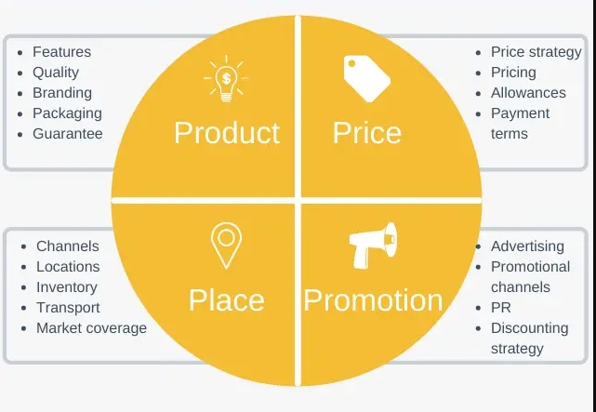

**Figure 2: 4P marketing strategy regarding the new plan for the coffee industry in Australia**

(Source: Sijtsema et al. 2019, p. 286)

***Place***

The business initiative plans to determine a proper place for evaluating the service of its products. The correct place also helps the initiative to improve the perception and engagement of customers towards their shop (Sijtsema et al. 2019, p. 286). The business initiative can estimate approximately ***“300 square feet”*** of location in the congested area, including ***Melbourne,*** for shifting their coffee shop.

***Promotion***

The business initiative can promote their service, that may define the target market in Australia. Furthermore, the business initiative can promote its strategy with the application of various distribution channels, including***“Facebook”*** and ***“Twitter”***. Therefore, the promotional strategy will assist the business initiative to enhance the retention and awareness of the brand.

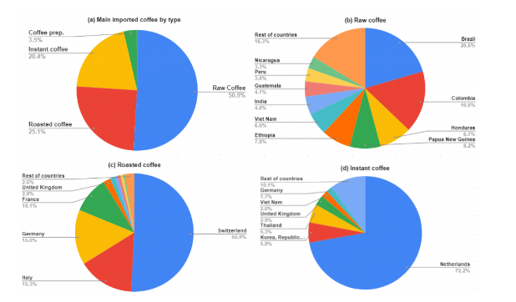

**Figure 3: Australia imports different types of Coffee**

(Source: Adepteconomics.com.au, 2022)

## 3.2 Measurement and information

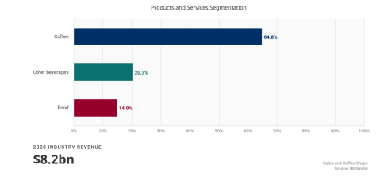

**Figure 4: Enhancement of profitability of coffee shops in Australia**

(Source: Quantumhouse.com.au, 2020)

It has been understood from the above graph that the average revenue of the coffee industry has grown by approximately 64.8% in Australia. Therefore, it can be said that the net profit of ***“Best Coffee Co.”*** can be forecast to enhance to around 5.5% in 2024-25 to approximately ***“$ 10.7 billion”*** (Quantumhouse.com.au, 2020). Furthermore, it is expected that the volume of the coffee segment in this industry will grow by approximately ***“57.39m Kg”*** in 2025 and in 2024; this volume will develop by around 1.9%. Therefore, it can also be measured that the size of marketing of this industry can develop annually by approximately 3.41% as per the basis of CAGR from 2023 to 2025 (Statista.com, 2023).

# Operational Strategy

## 4.1 Operational structure

It has been understood that the business initiative can develop a ***“matrix organizational structure”*** for improving the profit margins of their coffee shop. A ***“matrix organizational structure”*** contains both a ***“vertical”*** and ***“horizontal”*** framework that helps the industry to improve its skills and knowledge (KirubaNagini et al. 2020, p. 270-294). Thus, it can be said that the mentioned coffee shop can upgrade its competitive advantage in comparison to other competitors. Furthermore, the business initiative can implement a business structure that is similar to the ***“Limited Liability Company (LLC)”***. Business initiative can hire a skilled and experienced owner, administrator, leader, assistant, chef, waiters, barista and accountant to improve their operational structure and maintaining the expenditures.

## 4.2 Outsourcing and Motivation

Moreover, the business initiative can collect much valuable information with the application of outsourcing. Besides, the initiative can also motivate employees by providing proper training, skills and encouragement. Furthermore, the initiative of the business can fulfil the basic problems and requirements of employees.

# Financial Plans

## 5.1 Capital Requirements and funding plan

The entire expenditure will be enhanced from 171,500 in 2023 to 2, 65,000 in 2025 in the matter of enhancing the requirements of capital and funding plan. Furthermore, the company can reduce its expenses by 2025 in addition to enhancing additional expenditures. Therefore, it can be said that the coffee industry will decrease its costs in terms of decreasing its severe losses in the market. Furthermore, the ***“net cash flow”*** will enhance by approximately 2,00,000. Besides, a ***“Crowdsourcing campaign”*** can help the business to gather the proper information that enhances the efforts of advertisements. It can help customers to provide their opinions regarding the business can operate thoroughly in a developing way.

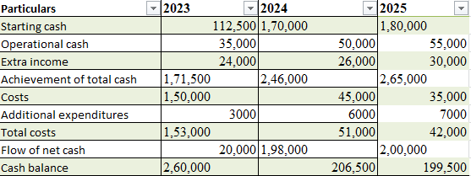

**Table 1: Capital Requirements and funding plan**

## 5.2 P&L Statement and Assumptions

The gross profit of this particular organization will be 240,596 in 2023 which will also enhance by around 456,700 in 2025. The gross profit may determine the selling price of the organization regarding goods. In this context, the cost of transportation and operations will emerge in 2025 in comparison to 2023. Furthermore, the complete costs are 150,000 from 2023 which will reduce to around 85,000 in 2025. Therefore, it indicates that the industry will obtain a sufficient net income compared to 2023.

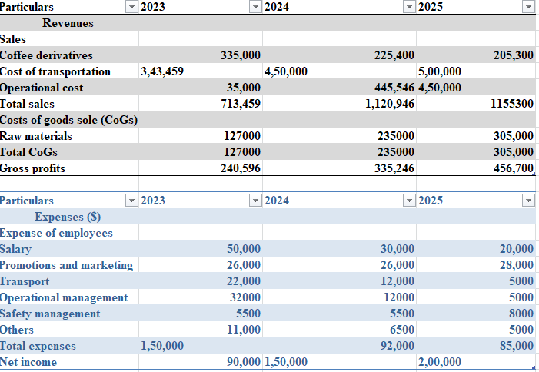

**Table 2: P&L Statement and Assumptions**

## 5.3 Balance Sheet and Assumptions

The total asset of this company will be enhanced in 2025 which generally indicates that the organization can secure the major assets safely in comparison to 2023. The organization can gain the ability to preserve its total assets by administrating appropriate guidelines. On the other hand, present and fixed assets will enhance that compared to the current and fixed assets of 2023, including 32,000 to 24,000. Therefore, the entire disadvantage and equality will correspondingly increase while the organization can generate their contemporary and owner liability.

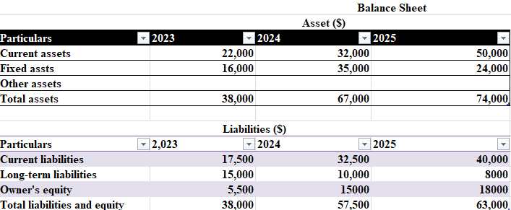

**Table 3: Balance Sheet and Assumptions**

## 5.4 Valuation and Justification

Therefore, it can be stated that the company can achieve the possibility to maintain their infrastructural expenditures, insurance, supplies, automation, marketing and salary or wage of the workers. Hence, it can be said that the business initiative obtains the scope or ability to build up a proper plan for their business. In this context, the company can spend 12,400 dollars to obtain other resources for generating a reliable plan with regard to the business. Moreover, it can be observed that the total expenditure of this mentioned company is 275,400.

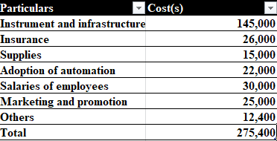

**Table 4: Valuation and Justification**

# References

Abs.gov.au, (2021).*The role of the Australian Bureau of Statistics in data governance and stewardship in Australia - a regulatory perspective*. Available at: <https://www.abs.gov.au/about/our-organisation/australian-statistician/analytical-series/role-australian-bureau-statistics-data-governance-and-stewardship-australia-regulatory-perspective#:~:text=The%20purpose%20of%20the%20ABS,objective%20data%2C%20statistics%20and%20insights>.

Acapmag.com,au, (2021). *Starbucks still losing money in Australia for billionaire Russell Withers of 7-Eleven*. Available at: <https://acapmag.com.au/2021/02/starbucks-still-losing-money-in-australia-for-billionaire-russell-withers-of-7-eleven/#:~:text=Revenue%20rose%20from%20%2486m,loss%20in%20the%20previous%20year>.

Adepteconomics.com.au, (2022).*Coffee’s economic contribution in Australia*. Available at: <https://adepteconomics.com.au/coffees-economic-contribution-in-australia/>

Akram, U., Fülöp, M. T., Tiron-Tudor, A., Topor, D. I., &Căpușneanu, S. (2021). Impact of digitalization on customers’ well-being in the pandemic period: Challenges and opportunities for the retail industry. International Journal of Environmental Research and Public Health, 18(14), 7533.<https://www.mdpi.com/1660-4601/18/14/7533>

Bbc.com, (2023).*Australia sees profits rise more than 55%.*Available at: <https://www.bbc.com/news/business-35592868>

Hofman, P. S., Blome, C., Schleper, M. C., & Subramanian, N. (2020). Supply chain collaboration and eco‐innovations: An institutional perspective from China. Business Strategy and the Environment, 29(6), 2734-2754.<https://onlinelibrary.wiley.com/doi/abs/10.1002/bse.2532>

KirubaNagini, R., Devi, S. U., & Mohamed, S. (2020). A Proposal on Developing a 360 Agile Organizational Structure by Superimposing Matrix Organizational Structure with Cross-functional Teams. Management and Labour Studies, 45(3), 270-294.<https://journals.sagepub.com/doi/pdf/10.1177/0258042X20922108>

Quantumhouse.com.au, (2020).*Industry Report-Café and Coffee Shops in Australia*. Available at: <https://www.quantumhouse.com.au/wp-content/uploads/2020/09/Industry-Performance-and-Outlook_Cafe-and-Coffee-Shops-Services-2021.pdf>

Sijtsema, S. J., Snoek, H. M., Van Haaster-de Winter, M. A., &Dagevos, H. (2019). Let’s talk about circular economy: A qualitative exploration of consumer perceptions. Sustainability, 12(1), 286.<https://www.mdpi.com/606600>

Statista.com, (2020).*Revenue of cafes and coffee shops in Australia 2005-2020*. Available at: <https://www.statista.com/statistics/740410/australia-cafes-and-coffee-shops-revenue/>

Statista.com, (2023).*Average price of a coffee beverage sold Australia 2019, by type*. Available at: <https://www.statista.com/statistics/865324/australia-average-price-for-coffee-beverage-by-type/#:~:text=In%202019%2C%20the%20average%20price,on%20average%204.16%20Australian%20dollars>.

Statista.com, (2023).*Coffee – Australia*. Available at: <https://www.statista.com/outlook/cmo/hot-drinks/coffee/australia#:~:text=Revenue%20in%20the%20Coffee%20segment,(CAGR%202023%2D2025)>.

Susanto, H., Fang Yie, L., Mohiddin, F., RahmanSetiawan, A. A., Haghi, P. K., &Setiana, D. (2021).Revealing social media phenomenon in time of COVID-19 pandemic for boosting start-up businesses through digital ecosystem.Applied system innovation, 4(1), 6.<https://www.mdpi.com/967870>