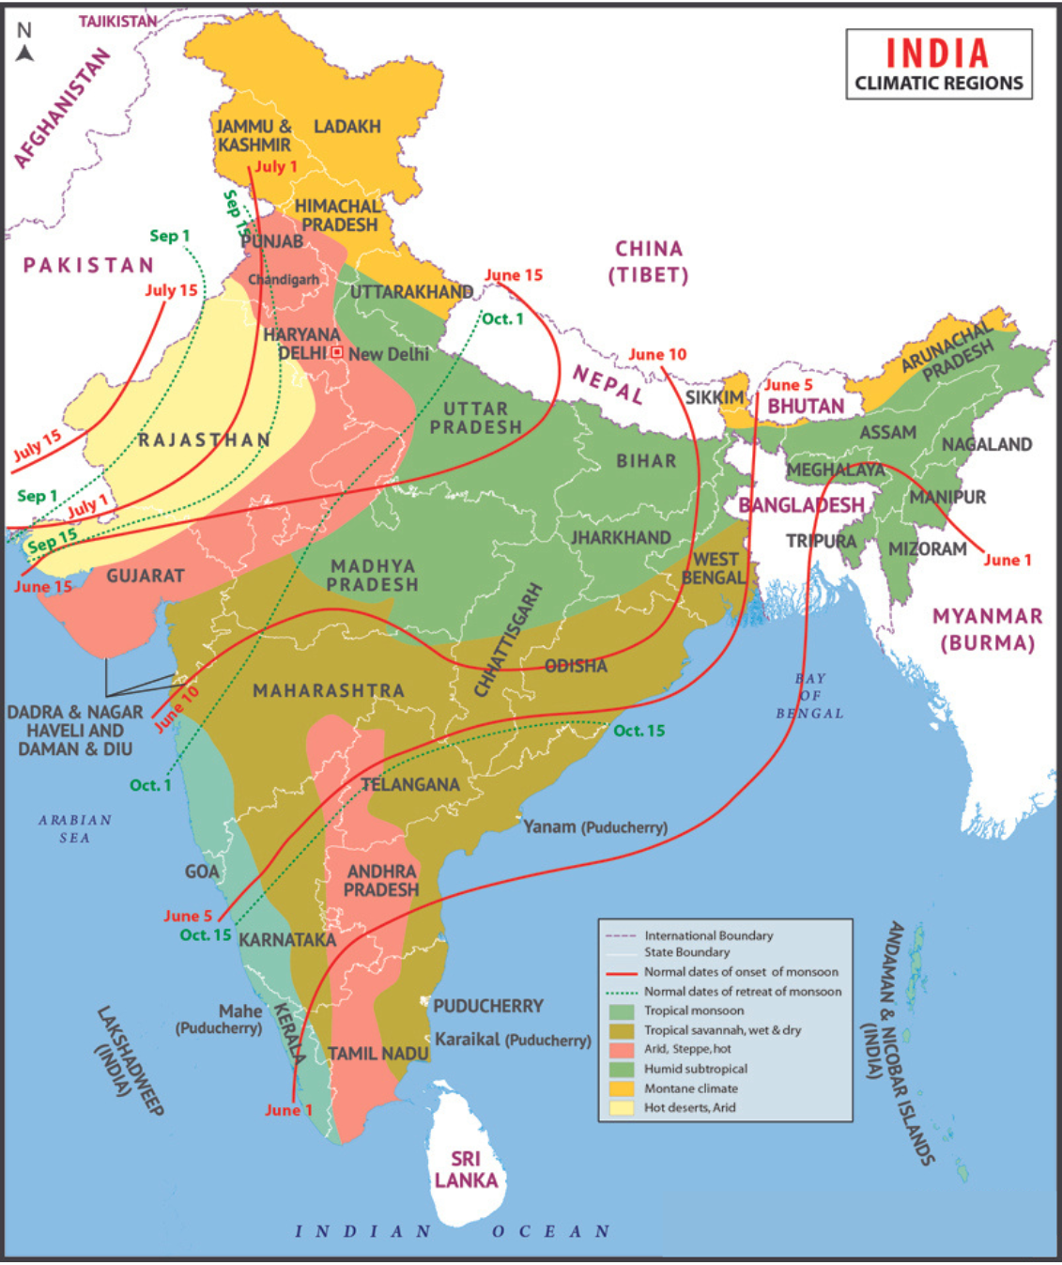

The above mentioned map showcases the various seasons that are experienced across states in India. A key focus of the map is on the onset and retreat of the South West Monsoons in the country across various states and regions.

The climates of India are mainly divided into four different groups. The classification of these groups is based on the Koppen climate classification system.

* + **Tropical Wet (Humid):**The tropical wet (humid) climate group in India is separated into two subparts: the tropical wet and dry climate, often known as the savannah climate, and the tropical monsoon climate. A tropical monsoon climate prevails in the Western Ghats, the Malabar Coast, southern Assam, Lakshadweep, and the Andaman & Nicobar Islands. It has seasonally significant rain and moderate to high temperatures. The wettest months are May through November, and the rain that falls during this time is more than enough for vegetation to grow all year. The most typical climate in the nation is the savannah climate or a tropical wet and dry climate. Except for some areas of the Western Ghats, it is most prevalent throughout the country's inland peninsula. The humid summer months last from June to September, and they are extremely hot.
  + **Tropical Dry:**There are three subgroups of the tropical dry climate group: (a) tropical semi-arid (steppe), (b) subtropical arid (desert), and (c) subtropical semi-arid (steppe). The tropical semi-arid (steppe) climate is found in Karnataka, central Maharashtra, some regions of Tamil Nadu, and Andhra Pradesh. In this type of environment, rainfall is quite unpredictable, and the hot, dry summers last from March through May. Western Rajasthan experiences a subtropical arid (desert) climate with irregular and sparse rainfall. The sub-tropical semi-arid (steppe) climate is present in the tropical desert regions that stretch from Punjab and Haryana to Kathiawar. In this environment, the summertime high temperature can reach 40°C, while rains are unpredictable and typically fall during the summer monsoon season.
  + **Subtropical Humid Climate:**The majority of northern and northeastern India experiences this climate. Summers are quite hot, and winters can see temperatures as low as 0°C. The majority of the time, rain falls in the summer, however certain places also have snowfall or sporadic rain throughout the winter. The hottest months are May and June, while frost can sometimes be found in the winter for a few months.
  + **Mountain Climate:**: In the Himalayas, the temperature drops by 0.6°C for every 100 m of elevation gain, resulting in a variety of climates, from tropical to tundra. The northern side of the western Himalayas, known as the trans-Himalayan region, is chilly, dry, and windswept. In contrast to the well-exposed slopes, the leeward side of the mountains experiences less rain. The months of December through February saw the most snowfall.

**Answer the following questions based on data collection and visualisation of data, using MS-Excel.**

Hotel_Dataset.(click to download).

1. Which state has the highest number of hotels? Depict this via a bar graph that compares all states.
2. Which states have three types of climatic conditions? (convert the map, an unstructured data, to an Excel file in a structured format and mention the number of climates along with the state)
3. Among the northeastern states which are best to set up a hotel? Use Clustered Column Chart and give recommendations for hotel industry investors.
4. Customise the pivot charts to add/change the fields in the fields list with other fields and by using chart styles to customise the charts. (choose the data and parameters according to your choice)
5. Which is the best state for setting up a hotel? Why?
6. What is the average number of days the rainy season lasts in Indian states?

**Instruction Set**

1. Study the map and draw out key indicating parameters in a list format. Also, think about other parameters that indirectly affect our goal.
2. Collection of data.
3. Do descriptive and diagnostic analysis to fill the missing data points and scan the outliers.
4. Creation of separate sheets for each question and creating pivot tables accordingly.
5. Draw out conclusions by observing the visual charts made from the pivot tables.
6. All the best! Submit your answers in a PDF file.