Part I: Optimal Complete Portfolio (30 pts)

James migrated in the 1980s to Germany and has been living in Berlin until his retirement last summer. He still earns a small amount of income from a part-time job as mechanical engineer with the *Berliner Verkehrsbetriebe* (BVG). James lives in his own home in Reinickendorf; his annual expenses are estimated to level out at €30,000. He receives social security payments and collects income from some investments as shown below:

* + Assets: Equities: €300,000; Bonds: €250,000; Home: €473,500.
  + Income: Assets: €8,000; part-time job: €25,000

The equities have an average return of 10% and a standard deviation of 22%. In contrast, the bonds yield a return of 6% against a standard deviation of 10%. The correlation between the equities and bonds is -0.30 and the risk-free rate is 2% p.a.

James envisions optimally readjusting his investment strategy as well as setting an adequate spending policy. Assumingly, James’s utility function is of the form:

*U*  *E*(*r*)  1 *A* 2 , where E(r) is the expected return on the risky portfolio, A measures his

2

degree of risk aversion, and 2 denotes the variance of the returns on the risky portfolio. Acting as a financial advisor, your group asked James to answer the risk tolerance questionnaire provided by *FinaMetrica* in attempts to establish his risk profile. Assume that James score varied with the group that administered the survey:

* + Group 5: He scored 20 points

1. (5 pts) The minimum (maximum) of points achieved by a representative contemporaneous sample of 61 respondents is 8(24) which translate in a risk aversion coefficient of 5 and 1, respectively (see Table below). Please, provide an approximation of James’s degree of risk aversion and clearly qualify his attitude towards risk. Hint: Each group should use their respective score!

**Scores from the Risk Tolerance Questionnaire**

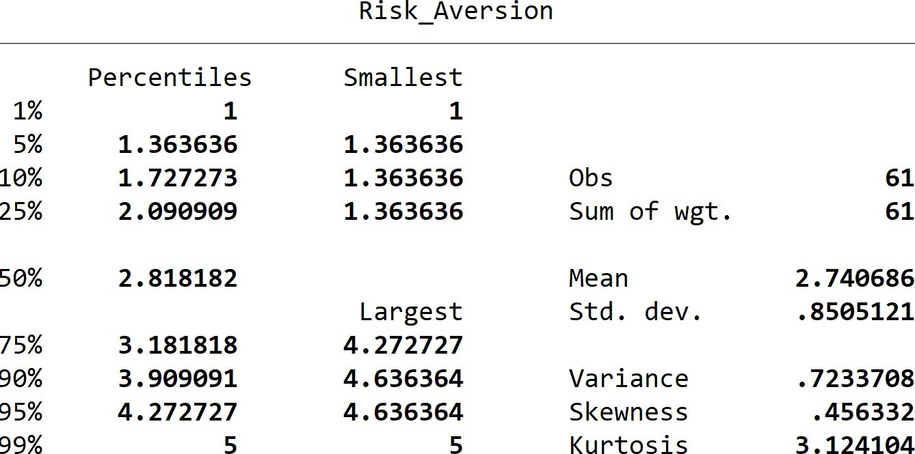

|  |  |  |  |  |  |  |  |  |
| --- | --- | --- | --- | --- | --- | --- | --- | --- |
| **Risk aversion coefficient** | 8 | 15 | 17 | 19 | 21 | 23 | 24 | **Total** |
| **1** | 0 | 0 | 0 | 0 | 0 | 0 | 9 | **9** |
| **?** | 0 | 0 | 0 | 0 | 0 | 8 | 0 | **8** |
| **?** | 0 | 0 | 0 | 0 | 8 | 0 | 0 | **8** |
| **?** | 0 | 0 | 0 | 9 | 0 | 0 | 0 | **9** |
| **?** | 0 | 0 | 11 | 0 | 0 | 0 | 0 | **11** |
| **?** | 0 | 9 | 0 | 0 | 0 | 0 | 0 | **9** |
| **5** | 7 | 0 | 0 | 0 | 0 | 0 | 0 | **7** |
| **Total** | **7** | **9** | **11** | **9** | **8** | **8** | **9** | **61** |

1. (5 pts) What is the risk-return profile of the current portfolio held by James as described in the previous lines?
2. (15 pts) Construct James’s optimal complete portfolio and compute the associated risk-return tradeoff! Hint: Use the specific A computed in question 1!
3. (5 pts) Determine the certainty equivalent (CEQ) rate of return on the optimal risky portfolio, as perceived by James!

Part II: Portfolio Analysis (30 pts)

You are required to replicate the computer lab session completed in class based on the following new information relative to the investment signals to be used:

* + Group 5: Nr_Analysts Nr_Analysts;

In addition, you are required to construct 4 portfolios (not three as we did in class). Once you alter the data this way, you should follow the three steps we used to construct your portfolios. Please, do provide a two-slide pitch for your analysis along your code and log- file.

The various files are provided on Blackboard. These are the same as the ones used in class! You get not only the Excel file but also the Stata code from our lab session, which you need to modify for you to solve your assignment.

END OF TEST