

**CPCCOM1012**

**Work effectively and sustainably in the construction industry**

LEARNER GUIDE

**Version Control**

|  |  |  |  |
| --- | --- | --- | --- |
| **Unit code** | **Document version** | **Release date** | **Comments/actions** |
| **CPCCOM1012** | 1.0 | 09.03.2021 | First draft |

**Copyright**

Copyright © 2021 by CAQA Resources.

Copyright protects this material. No part of this publication may be reproduced, distributed, or transmitted in any form or by any means, including photocopying, recording, or other electronic or mechanical methods, without the prior written permission of the publisher, except in the case of brief quotations embodied in critical reviews and certain other non-commercial uses permitted by Copyright Act 1968 (Cth). For permission requests, write to the publisher, addressed “Attention: Permissions Coordinator,” at the address below.

Enquiries should be addressed to:   
CAQA Resources   
2/10 Lawn Ct   
Craigieburn, Victoria – 3064   
Australia   
www.caqaresources.com.au

**Disclaimer**

Although the author and publisher have made every effort to ensure that the information in this book was correct at press time, the author and publisher do not assume and hereby disclaim any liability to any party for any direct, indirect, incidental, or consequential loss, damage, or disruption caused by errors or omissions, whether such errors or omissions result from negligence, accident, or any other cause. Data and case study examples are intended to be fictional. Any resemblance to real persons or organisations is coincidental.

If you believe that information of any kind in this publication is an infringement of copyright, in material in which you either own copyright or are authorised to exercise the rights of a copyright owner, and then please advise us by contacting the Director, Product, CAQA Resources, 2/10 Lawn Ct, Craigieburn, Victoria - 3064 or Email copyright@careercalling.com.au.

**Acknowledgement**

This is a property of CAQA Resources, A Career Calling Initiative.



# Table of Contents

Table of Contents 2

Introduction 3

CHAPTER 1: WORK EFFECTIVELY IN A TEAM. 4

1.1 Participate in planning work tasks with team members. 6

1.2 Work with team members to review team purpose, roles, responsibilities, goals, plans and objectives. 12

1.3 Work with team members following guidelines, directions and instructions to complete work tasks. 12

1.4 Work with team members to resolve problems that impede the team’s performance. 18

CHAPTER 2: INVESTIGATE CONSTRUCTION INDUSTRY EMPLOYMENT PATHWAYS. 22

2.1 Describe the process for becoming a tradesperson or skilled operator in the construction industry. 24

2.2 Identify own existing skills and the additional skills required for a tradesperson or skilled operator role in the construction industry. 36

CHAPTER 3: IDENTIFY AND FOLLOW ENVIRONMENTAL AND RESOURCE EFFICIENCY REQUIREMENTS. 40

3.1 Identify environmental and resource efficiency requirements that apply to entry level roles in the construction industry. 42

3.2 Follow requirements to identify and report environmental hazards. 44

3.3 Follow requirements to identify and report resource efficiency issues. 46

Glossary 56

References 58

# Introduction

This unit of competency specifies the skills and knowledge required to work effectively and sustainably in the construction industry.

The unit is suitable for those with basic skills and knowledge undertaking routine work tasks under the direction of more experienced workers.

Completion of the general construction induction training program specified by the model Code of Practice for Construction Work is required for any person who is to carry out construction work. Achievement of unit *CPCCWHS1001*Prepare *to work safely in the construction industry*meets this requirement.

No licensing, legislative or certification requirements apply to this unit at the time of publication.



What will I learn?

This learning guide will provide you the skills and knowledge required to:

1. Work effectively in a team.
2. Investigate construction industry employment pathways.
3. Identify and follow environmental and resource efficiency requirements.

# CHAPTER 1: WORK EFFECTIVELY IN A TEAM.



What will I learn?

In this chapter, you will learn about the following:

1. Participate in planning work tasks with team members.
2. Work with team members to review team purpose, roles, responsibilities, goals, plans and objectives.
3. Work with team members following guidelines, directions and instructions to complete work tasks.
4. Work with team members to resolve problems that impede the team’s performance.

## Participate in planning work tasks with team members.

Group members will include other members of the organisation, including peers/work colleagues, your supervisor or manager and your coach/mentor. All these people are expected to work within the organisation’s team structure which includes:

* Organisational code of conduct
* Organisational procedures and policies
* Supervision and accountability including OHS
* Job description and specification relevant to work role
* Using a courteous and helpful manner at all times
* Completing allocated tasks as and when required
* Seeking assistance from an appropriate person if difficulties arise
* Using active and effective listening and questioning to clarify instructions and responsibilities.

**Group norms:** These are known behaviours that are expected by all members of a group/team. These are unwritten ‘rules’ and ‘standards’ which develop within a specific group/team as people react with one another. Norms help a group to avoid a state of utter confusion and disorder as the inputs of different individuals are organised into a collective group. These norms usually include the following.

**Behave in a courteous and helpful manner**

In any workplace you will be involved with other people. Some people get on really well together, but other people appear to have personality clashes. But cooperation is necessary to work as a group or team in order to complete work tasks and reach the corporate goals.

Mutual respect means treating other people as you would like to be treated yourself, including acknowledging other people’s cultural and religious beliefs.

Cooperation is essential for developing the ability to relate effectively to management, customers/clients and colleagues, to work as a team and to communicate well at an interpersonal level. For example, when one section of the business is working to complete a large order, staff from other sections will help out.

Reciprocal effort at a personal level means that if you have a quiet period you will help someone who has a deadline to meet, and they will then help you when you have a large volume of work.

**Complete allocated tasks as and when required**

As you are working as part of a team or group, how you complete your tasks affects the completion of tasks by other people. You should therefore identify and plan and prioritise your work goals linked to organisational goals.

**Seek assistance when difficulties arise**

Effective group performance is very important to the organisation if the goals of the company are to be achieved. If groups of people are not working well together, this is an indication of internal problems within the group and ultimately within the organisation. Therefore, assistance should be sought from a supervisor or manager to help solve the problems before production is affected.

**Questioning techniques to clarify instructions**

Active and effective listening is the process of receiving a message and relaying back to the sender exactly what the sender intended. This prevents misinformation, improves morale, rapport and trust levels with other people, and improves teamwork. For example, if you are not listening correctly when you are working with other people, you will not perform your tasks effectively.

**Active and effective questioning**

Many people speak very badly, or have a different accent to yours, and it might be difficult to understand what they are saying. If you have to ask someone to repeat what they have said, particularly on the telephone, they are sometimes impatient and think you are being stupid. This is very far from the case. If you repeat what someone has said to you at work, it shows that you are working efficiently and effectively. You are clarifying what they have said to make sure you do not make any mistakes.

**PLANNING YOUR CONSTRUCTION WORK**

Planning tasks before you begin a new activity is essential because it helps you to work out what’s to be done, how you’re going to do it and what you’ll need. Planning also lets you identify who else is involved and how others will be affected by your activities.

The builder or project manager of a construction project must plan all work tasks and consider the contribution of every worker to select the best and safest way of completing the project on time, within budget, and according to the required standards.

For a tradesperson in the construction industry, planning may consist of deciding on the steps required to complete a task set by a supervisor, organising the materials, tools and equipment, and communicating with others in the team to get a task done.

**Priortisation**

Priortisation is deciding on the order in which to do your work tasks by identifying what’s important or urgent and what can be postponed. The priority of construction tasks will depend on how it affects:

* your ability to complete another task
* the ability of others to complete their tasks
* when other workers need to be on site
* the overall project plan
* site safety

Some tasks, like phone calls and meetings, can seem urgent because they demand your immediate attention but part of good planning and working efficiently is identifying what’s important, what can wait and what is just wasting time.

Prioritising helps you to make the best use of your time and makes sure that the tasks that affect others are completed when necessary to avoid delays.

Priorities can change as a project progresses or when something unexpected occurs. For example, if Tom and John were told that the plumberwas arriving and the site must be cleared as soon as possible, cleaning the house and packing up all tools and equipment would become the highest priorities.

**Schedules and deadlines**

Schedules are organised sequences of activities with a timeline indicating when tasks start and finish and when certain actions or events (like the delivery of materials) will occur. Schedules are essential on construction projects because there are many different workers involved on different tasks that must be completed in order and within a set timeframe.

A deadline is the latest possible time by which a task or project must be completed. They are put in place to allow:

* other work to begin
* materials and equipment to be delivered when required
* pays to be finalised
* completed projects to be handed over to clients

For tradespeople, deadlines need to be set in order to complete one job and move on to the next, without holding up or slowing down the timeline set by the builder, supervisor or client.

**Construction Operations Schedule**

The term 'construction operations' might refer to any activity that contributes to the delivery of a construction project.  '[Construction operations](https://www.designingbuildings.co.uk/wiki/Construction_operations)' include a very wide range of construction and [engineering](https://www.designingbuildings.co.uk/wiki/Engineer) operations such as alteration, repair, [maintenance](https://www.designingbuildings.co.uk/wiki/Maintenance), extension, [demolition](https://www.designingbuildings.co.uk/wiki/Demolition) or dismantling of buildings, or [structures](https://www.designingbuildings.co.uk/wiki/Structure) forming part of the land.

The construction operation should be performed in a logical sequence; thus, they must be planned. We will discuss planning and sequencing of construction operations in the next section.

* Part of the planning for a construction process involves thinking about organising the many tasks which comprise the project. Construction operations must be planned and executed in sequence.
* Two major methods of organising tasks will be investigated in this topic: PERT charts and Gantt charts. Both are tools for scheduling tasks in a project, but each has a different emphasis

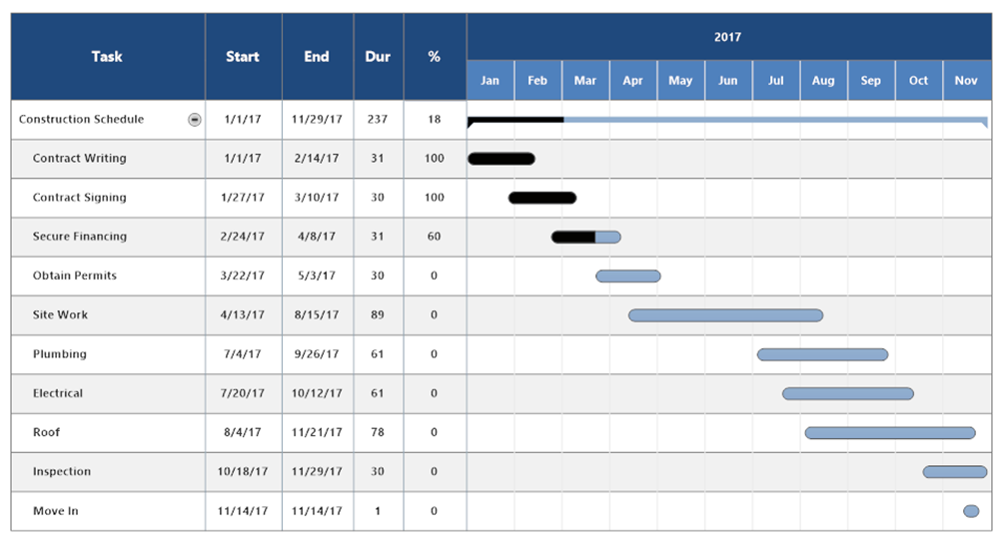

**A Gantt Chart showing schedule of a construction project**

**Work group members include:**

* coach or mentor
* employee representative
* peers, work colleagues, team, enterprise and other members of the organisation
* supervisor or manager

**Working to plan**

The work plan on a construction project is a bit like a map telling you where the project is going, how to get there and what time to arrive. It’s usually created by the project manager or contractor and it provides the information everyone needs to make sure they’re working efficiently and effectively toward a common goal. ‘Working to plan’ means following the map by completing tasks within the expected timeframe, and using the materials, tools and equipment available to produce the agreed outcome.

The project manager or contractor allocates tasks to teams and individual tradespeople. You will usually get instructions from your employer or supervisor for most of the work you do when you first start out on a construction site. You have to be clear about what’s expected so you’ll need to:

* listen carefully
* ask as many questions as you need to
* read and understand any documentation you’re given
* confirm your understanding
* ask for help when you need it
* follow safety procedures at all times

**Personal protective equipment (PPE**) – PPE refers to protective clothing, helmets, goggles, or other garments or equipment designed to protect the wearer's body from injury or infection. Personal protective equipment is to include:

* aprons
* arm guards
* caps
* dust mask/respirators
* ear muffs/plugs
* gloves
* hard hats
* high visibility retro reflective vests
* jackets
* overalls
* safety glasses/goggles
* steel capped boots
* UV protective clothing and sunscreen

Likewise, for the understating of construction engineers, supervisors, professional tradespersons, it becomes important to use abbreviation in construction terminologies. Depending on site conditions and what your on-site duties are, you’ll be provided with a range of PPE. You can get information about what you should be using from your supervisor and the safe work method statement (SWMS). Safety signs on site may also indicate what PPE you require.

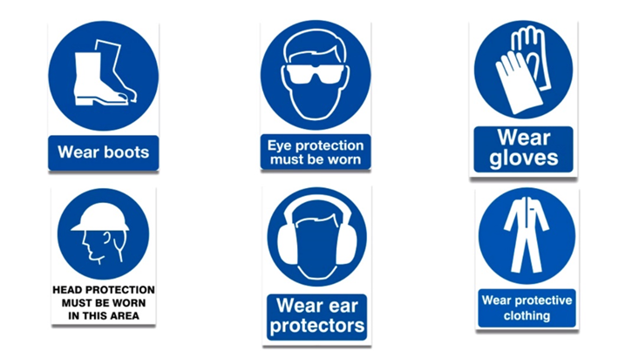

**Head protection -** Where there’s a risk of a person being struck on the head by a falling object at work, a safety helmet must be worn. On sites where this hazard exists, a ‘mandatory’ safety sign will be visible to tell you that you must wear a helmet at all times.

**Eye protection -** Where there’s a risk of getting dust, grit, sparks, irritating liquids or the like in your eyes, you must wear eye protection. Safety glasses are suitable for most situations you’re likely to encounter, but full-face masks are available for workers who need them. Sun damage is also considered a hazard in Australia. Note that eye protection must comply with the relevant Australian Standard® so your everyday sunglasses won’t be adequate.

**Hearing protection -** Excessive noise can damage hearing. Construction sites are very often noisy environments so there are many situations where you’ll need hearing protection. Earmuffs and/or earplugs/ear buds should be worn in any situation where you have to shout so that a person a metre away can hear you.

**Foot protection -** Most construction sites require all personnel to wear safety footwear. There are numerous styles of steel-cap boots and shoes available.

**Hand protection -** You should wear gloves for most tasks carried out on a construction site, so that your hands are protected. The material used to make the gloves may vary depending on the object or substance being handled.

**High-visibility clothing -** Also known as ‘hi-vis’, these bright, fluorescent, coloured vests and jackets are required on most large sites, especially where vehicles are moving about.

**Breathing protection -** Dust masks and respirators may be required if the environment on the construction site contains hazardous dust and fibres, or fumes that can be inhaled.

**Sun protection -** Protection against harmful radiation from the sun is a normal part of PPE. Hats, long-sleeved shirts, full-length pants, snap brims for hard hats, sunglasses and sunscreen are all part of being sun safe.

**Other PPE -** Depending on site conditions and what your on-site duties are, you may be required to wear other PPE, such as aprons, overalls and arm guards.

## Work with team members to review team purpose, roles, responsibilities, goals, plans and objectives.

**Reviewing goals and objectives**

Setting professional goals is a delicate balancing act. On the one hand, your workplace objectives must be aligned with the company's aim. They must, on the other hand, be your own. Otherwise, goal-setting becomes a routine, box-checking activity.

Another problem is that some firms (and managers) are better at assisting their employees in setting and achieving work goals. The good news is that there are things you can do to get some value out of the annual goal-setting session, even if you work for someone who views it as a necessary evil. If your boss truly understands the importance of goal alignment, goal planning, and goal achievement, you have a tremendous opportunity to leverage the dialogue to further your career.

**Reviewing team purpose, roles and responsibilities**

Preparation and organisation are the first steps in forming a team. Setting clear expectations encourages everyone to strive towards the common objective of completing a project successfully and securely. Workers on the jobsite should be aware of the following:

* The project’s priorities of safety, teamwork, and quality.
* The project's safety, teamwork, and quality goals.
* The required safe work procedures, so that everyone on the job site follows the same standards.
* Each employee's position and duties, so they can identify their resources and contacts.
* The placement and ability to operate emergency equipment..

Everyone can express themselves when there is good communication. Building trust allows employees to feel comfortable discussing their ideas and concerns. Successful teams enable their members to:

* Take part in danger identification, site inspections, and safety training.
* Encourage team members to share and learn in order to improve the team's performance and the quality of their work.
* Speak up and offer suggestions for ways to improve the jobsite, equipment, or processes.
* If you have any questions or concerns about how to conduct a work safely, ask for training or guidance.
* When it is safe to do so, correct dangers right away.
* Discontinue the use of any malfunctioning tools or equipment.
* If required, call a "timeout" for safety.

When individuals work together, even the most difficult building tasks become easier. Workers who keep an eye on one other can get more work done in a safer and more effective manner. The following are examples of worksite collaboration:

* Seeking assistance rather than taking shortcuts, taking unnecessary risks, or "winging" it.
* Providing assistance when extra hands or a better way would make a work safer.
* Making positive comments when coworkers observe others engaging in risky behaviour.
* Keeping a clean house at all times, even if it's someone else's mess.
* Cleaning the jobsite and preparing equipment and supplies for the success of the next shift.

Sharing knowledge and creating trust are the foundations of good teams. Injuries are reduced, and productivity and quality are enhanced, when individual workers make the commitment to operate as a team. To complete successful projects, construction teams must work together to include safety into every task.

**Contribution of teams**

Good things begin with objectives, both in business and in life. Setting challenging but achievable goals allow teams to reach their full potential. Without them, progress and development are haphazard, if they happen at all. One of the most difficult aspects of management is goal planning.

Teamwork is defined as a series of duties and activities carried out by persons who work together to attain a common goal. The goal could be to create a product, provide a service, write a report, or make a judgment. Individual labour varies from teamwork in that it entails shared accountability for a final result.

**Teamwork processes**

While the duties involved in cooperation may differ from one team to the next, three processes are universal to all teams: transition, action, and interpersonal. Various actions take place throughout each of these stages.

1. The formation of a team occurs during the transition process. Among the activities are:

* Establishing a clear knowledge of the overarching goal is the first step in mission analysis.
* Goal setting: determining and prioritising the actions and activities required to complete the mission.
* Formulation of a strategy: deciding on a course of action to fulfil the mission's objectives.

2. Action processes are the stages in which a team completes its tasks. Among the activities are:

* Monitoring milestones and objectives: keeping track of how far tasks and activities have progressed.
* Monitoring systems: keeping track of how people, technology, and information are used.
* Coordination is the process of organising and controlling the flow of activities and tasks within a team.
* Monitoring and assistance for the team: supporting individuals with their work by providing feedback and coaching.

3. Interpersonal processes encompass actions during both the transition and action phases. These are some of them:

* Setting settings to avoid disagreement and resolving conflict when it arises are important aspects of conflict management.
* Motivation and confidence building generate individual willingness and the ability to work together to attain the purpose.
* Affect management entails assisting team members in managing their emotions while working together.

**Tips for setting successful team goals**

* Identify what you want to achieve
* Make the goals measurable
* Set team goals first
* Set individual goals second
* Establish deadlines and stick to them
* Track progress
* Support your team

Every construction project has a certain purpose in mind, usually the construction of a structure or facility. This is the project's goal and the result that everyone involved strives for. Because construction projects are frequently huge and complex, the overall goal is divided into tasks accomplished by tradesmen with specialised skills such as bricklayers, carpenters, and tilers.

Depending on the firm's size, Jobsite, or project, a trade team may consist of a single tradesperson with an apprentice, or a small team may consist of a single tradesperson with an apprentice. Each trading team contributes to the site's overall goal. For example, when constructing a brick and tile house, trade teams do the following duties.

* Earth workers
* Concreters
* Plumbers
* Electricians
* Carpenters
* Bricklayers
* Cabinet makers
* Painters etc.

A project manager or supervisor is in charge of overseeing the entire project or site and coordinating all trade teams' operations and schedules. Regular site meetings are held for members of each trade team to discuss the progress of the work activities and any issues or problems that may occur during construction.

**Individual contributions and responsibilities**

Individuals in a team are usually assigned specific roles so that the work can be carried out more efficiently. All team members have different skills and strengths, and a team is most effective when everyone is doing what they do best. The tasks performed by individuals within a trade team depend on:

* their skills and experience, eg an apprentice might be restricted to simple tasks while they’re learning new skills and gaining experience
* the size of the team, eg in a large team, roles may be very specific and fixed whereas in a small team, everyone may have to do a bit of everything
* the type of work being completed, eg some tasks can only be done (or are done better) by someone with specialised training
* the project requirements, eg if a particular task is urgent, everyone may work together to get it done quickly.

The subcontractor (lead tradesperson) usually allocates tasks to team members at the start of the project or during team meetings. It’s essential that everyone on the team is clear about who’s responsible for each task or part of a task. This helps to avoid confusion and duplication of effort and makes sure that the workload is distributed fairly, and everything gets done.

**Working together**

There are many advantages to working in a team. To make the most of the experience, it’s important to remember that everyone brings their own knowledge, skills, experiences and history to the work environment. By choosing to accept and support your team mates, you can increase the effectiveness of the team and improve your own working experience.

Consider the following tips when you’re working in a team.

* Communicate openly and constructively.
* Use active listening skills.
* Be reliable.
* Be cooperative and willing.
* Support and encourage team mates whenever you get a chance.
* Offer assistance when it’s needed.
* Value differences of opinion and use them to make better decisions.
* Be respectful of others.

One of the most important responsibilities you will have on any worksite will be helping your team mates when they need it and encouraging them to improve their own skills and performance.

## Work with team members following guidelines, directions and instructions to complete work tasks.

A team is any group of people working together towards a common goal. In the construction industry, most work is completed by teams of tradespeople. Construction or trade teams are usually made up of workers with a variety of skills and experience which contribute to faster and more efficient completion of work activities. Being able to work in a team is one of the most important skills you can develop for finding employment and working in the construction industry.

Each construction project starts with a goal – usually the erection of a building or facility. This is the purpose of the project and the outcome that everyone involved is working to achieve. Because construction projects are often large and complicated, the overall goal is broken down into activities that are completed by teams of tradespeople with specialised skills such as bricklayers, carpenters and tilers.

A trade team can consist of many workers, depending on the size of the company, worksite or project, although a small team may consist of a single tradesperson with an apprentice.

Each trade team contributes to achieving the site goal. For example, the tasks completed by trade teams when building a brick and tile house include the following.

‘Teams’ is a generic term that refers to the site work organisation. It may be known/titled locally as crews, gangs, shifts or other industrially and historically acceptable term

Trade teams come and go throughout the construction process. A bricklaying team, for example, might build retaining walls and then return to build the house walls after the plumbers have installed the drainage pipes and the concreters have poured the concrete slab. A project manager or supervisor oversees the entire project or site and coordinates the activities and schedules of all trade teams. Members of each trade team attend regular site meetings to discuss the progress of the work activities and any issues or problems that arise during construction.

**Improving teamwork**

It’s important for workers to discuss any improvements that may be required within a team. These discussions can be initiated by anyone, from a labourer to the most qualified worker. Making improvements to the way a team works is not done to blame or point a finger at an individual or group of people, but to improve the overall wellbeing and efficiency of the team itself. Identifying areas of improvement within the team can provide the following benefits:

* better team morale
* working more efficiently as a group
* passing on skills and knowledge
* achieving site goals faster
* more work being offered in the future.

**How to set goals for your team in construction**

Research shows that setting specific and challenging goals leads to higher performance. In order for them to be effective, there should be alignment between those of the organization, the team's, and individual ones. Everyone should be working towards the same outcome and understand how their work is contributing to the bigger picture.

Here are 7 steps to set goals for your team and ensure they're as effective as possible.

**1. Know what you want to achieve**

Before you communicate to your team, think about why you want to set goals and what you hope to achieve with them. If the wider team goal is completed, what are the implications? How will it benefit your organization? An important part of goal setting is measurement, so ensure you know how you will track and evaluate progress as well as completion, and how this impacts what you want to achieve.

**2. Set goals at the team level**

Once you've determined what you want to achieve, start by setting goals for the team. When teams have challenging, meaningful goals to work towards, they come together as a more effective and collaborative unit. It helps them be aligned and have a common focus, rather than trying to outperform each another. Of course, team goals can (and should) be broken down into individual ones.

**3. Let people develop their own goals**

After determining team goals, give people the autonomy to develop their own goals - sitting underneath team ones. Based on their function, they should be able to determine key initiatives and goals that will support the greater team objectives.

Make sure you are available to provide support: help them learn how to develop meaningful and achievable goals by using a framework such as SMART goals. Guide them so they are aligned with the team (and organizational) goals, and ensure they understand the importance of measurement.

**4. Set deadlines**

Deadlines help the team develop accountability - both to you and with themselves, making the goals more meaningful. A goal with no deadline won't serve its purpose as it could end up constantly pushed back and never achieved. If people start to feel the goals aren't being taken as a serious assignment, they will become discouraged and disengaged.

Commonly people work by quarters so you could set goals on a quarterly basis. This is a relatively long period of time during which to run projects allowing you to set bigger goals, yet short enough to change course if need be. It also means that you can work on a bigger variety of initiatives throughout the year that support company objectives.

If quarters don't work for you, you could try setting project-based goals for example.

**5. Track progress on goals**

As mentioned previously, goals should be tangible and measurable so you can determine success.

Help your team stay focused by tracking progress. Checking in will allow you to know where to course correct, which initiatives are going faster than planned, and therefore help you re-allocate resources if need be.

Tracking goals also helps teams stay motivated when they see progress, and when they're getting close to completion. Knowing you've achieved something you set out to do, coupled with the sense of accomplishment, are very strong motivators for your people.

**6. Help people meet their goals**

As a manager and team leader, it's your responsibility to help your people achieve their goals in addition to giving the team direction. There are several ways you can do this:

* Help them understand how to define an achievable goal
* Have [regular 1-on-1s](https://www.impraise.com/blog/1-on-1s-for-engaged-employees-how-good-managers-run-them) to see how things are going
* Show your team that you're open to questions and to giving guidance
* Support them with advice on how to achieve their initiatives
* Help your team define milestones as they work towards [team or individual goals](https://www.impraise.com/platform/goal-management)
* Give your team [regular feedback](https://www.impraise.com/platform/real-time-feedback-and-employee-recognition) so they know what's going well, and what could be improved

**7. Learn from your mistakes**

Not all goals are going to be met. Some may have been set too high on purpose, some may not have been realistic (in hindsight), and some may suffer from unpredictable changes throughout the quarter. That's just the reality of work and the unknowns you have to contend with.

Make sure the team understands it's ok to fail; the goal shouldn't be the be all and end all, it's a way of guiding people's work. Being open to the possibility of failure doesn't mean accepting mediocrity; or that goals don't matter. It simply means no one can guarantee things will succeed. The important thing is to learn from our mistakes: what will we do differently next time? Is there a way this could have been prevented? And move on to do better things.

**Conclusion**

Above all, the important thing is to remember why you're setting goals and how you can use them to do better work. Each team is different, so try various formats of goal setting until you find one that works for you.

Throughout the process, communication is key to ensure everyone is aligned and understands why goals are being set. And of course, team goals should always be aligned with the company ones, as well as the company vision.**Effective Teamwork in Construction**

The first rule of team building is an obvious one: to lead a team effectively, you must first establish your leadership with each team member. Remember that the most effective team leaders build their relationships of trust and loyalty, rather than fear or the power of their positions.

1. **Consider each employee's ideas as valuable**. Remember that there is no such thing as a stupid idea.
2. **Be aware of employees' unspoken feelings**. Set an example to team members by being open with employees and sensitive to their moods and feelings.
3. **Act as a harmonizing influence**. Look for chances to mediate and resolve minor disputes; point continually toward the team's higher goals.
4. **Be clear when communicating**. Be careful to clarify directives.
5. **Encourage trust and cooperation among employees on your team**. Remember that the relationships team members establish among themselves are every bit as important as those you establish with them. As the team begins to take shape, pay close attention to the ways in which team members work together and take steps to improve communication, cooperation, trust, and respect in those relationships.
6. **Encourage team members to share information**. Emphasize the importance of each team member's contribution and demonstrate how all of their jobs operate together to move the entire team closer to its goal.
7. **Delegate problem-solving tasks to the team**. Let the team work on creative solutions together.
8. **Facilitate communication**. Remember that communication is the single most important factor in successful teamwork. Facilitating communication does not mean holding meetings all the time. Instead it means setting an example by remaining open to suggestions and concerns, by asking questions and offering help, and by doing everything you can to avoid confusion in your own communication.
9. **Establish team values and goals; evaluate team performance**. Be sure to talk with members about the progress they are making toward established goals so that employees get a sense both of their success and of the challenges that lie ahead. Address teamwork in performance standards. Discuss with your team:
   * What do we really care about in performing our job?
   * What does the word success mean to this team?
   * What actions can we take to live up to our stated values?
10. **Make sure that you have a clear idea of what you need to accomplish**; that you know what your standards for success are going to be; that you have established clear time frames; and that team members understand their responsibilities.
11. **Use consensus**. Set objectives, solve problems, and plan for action. While it takes much longer to establish consensus, this method ultimately provides better decisions and greater productivity because it secures every employee's commitment to all phases of the work.
12. **Set ground rules for the team**. These are the norms that you and the team establish to ensure efficiency and success. They can be simple directives (Team members are to be punctual for meetings) or general guidelines (Every team member has the right to offer ideas and suggestions), but you should make sure that the team creates these ground rules by consensus and commits to them, both as a group and as individuals.
13. **Establish a method for arriving at a consensus**. You may want to conduct open debate about the pros and cons of proposals, or establish research committees to investigate issues and deliver reports.
14. **Encourage listening and brainstorming**. As supervisor, your first priority in creating consensus is to stimulate debate. Remember that employees are often afraid to disagree with one another and that this fear can lead your team to make mediocre decisions. When you encourage debate you inspire creativity and that's how you'll spur your team on to better results.
15. **Establish the parameters of consensus-building sessions**. Be sensitive to the frustration that can mount when the team is not achieving consensus. At the outset of your meeting, establish time limits, and work with the team to achieve consensus within those parameters. Watch out for false consensus; if an agreement is struck too quickly, be careful to probe individual team members to discover their real feelings about the proposed solution.

## Work with team members to resolve problems that impede the team’s performance.

**10** **common problems in construction projects**

**1. Lack of trust**

Trust is crucial to teamwork, and it starts with people knowing each other. Team members absolutely need to be acquainted, both professionally and personally, particularly in projects where tensions will run high at some point. Otherwise members won’t understand each other, they won’t want to engage because they haven’t made that human connection and they won’t fully trust each other.

**2. Conflict and tension**

Conflict or a difference of opinion can be healthy and, if carefully managed, can trigger useful debates. It can make people think differently, expanding knowledge and insight; innovation can happen and results flourish. Different opinions are not a bad thing. It’s how we handle the conflict that makes a difference.

**3. Not sharing information**

Knowledge is not power – unless it’s shared. Project team members all bring a unique set of skills, knowledge, experience and wisdom to the table. Effective project teams fearlessly share regularly and generously for the benefit of everyone and for the benefit of the project’s success. This makes the capability of the whole team grow and gives the team more power.

**4. Low engagement**

Team engagement is crucial to business success. If engaged, team members on a given project will be interested in what they do, committed to the project mission and willing to go the extra mile. They are there in body as well as mentally and emotionally. The key to engagement is involvement – by involving others you make it impossible to stay detached.

**5. Lack of transparency**

Without transparency, trust will suffer – both within the project team and with the end client. Transparency is becoming the presumed norm in project and programme management and expectations are growing. It starts at the top: the more senior you are, the more responsibility you have to be a role model for this. Employees will follow the leader’s behaviours, good or bad. When this is done well it can have a positive cascade effect throughout the organisation.

**6. No long-term thinking**

Project managers have to get beyond day-to-day urgencies, see the big picture and consider how all parts of the project fit together. For a project team, this means being able to think beyond your own area, about how you fit into the wider change programme or project and how you impact the end client’s experience. This is about business sustainability and long-term success. Everyone is busy, but just being busy is not enough. Long-term project success requires long-term thinking.

**7. Badly perceived, not delivering**

A project team has a brand, an image and a reputation created by the actions and behaviours of the team members. A large part of the perception is driven by how well the team delivers on expectations and promises made. As a project team, you need to make sure that everyone understands and takes responsibility for their roles in creating the perception of the team. This includes both what is delivered on the project and how it is delivered.

**8. Poor change management**

Change is constant and unless carefully managed, it can be detrimental to teamwork and results. Change starts and ends with communication. Whenever you think you’ve communicated enough, you need to communicate some more – and it needs to be interactive: listen, talk and involve. Be aware of the change curve, or the four predictable stages of change: denial/resistance, emotional, hopeful, commitment. Each stage is needed, but how long someone stays at each stage can be managed and kept to a minimum.

**9. Working in silos**

Silo working is a reality for many project teams. Team members may sit side by side but not really work together. A great project team can be like the three musketeers – all for one and one for all. So if you are in a team, you may as well really be in it. Working together in earnest is about making the most of the fact that you are a team. Honour your time and efforts by seeing yourself as a full-time member of the team, not just an individual contributor. Imagine how great it would feel to be part of a team where everyone is thinking of the team and not just themselves – make that project a success by working together.

**10. Not going in the same direction**

To walk in the same direction, a team needs to know where it is going or what it is contributing to (vision) and why (purpose). Spend time on this with your team. This clarity provides a framework and ‘reason to be’ that can rally any given project team to work together. Keep in mind that visions need to be compelling and purposes meaningful. People respond to the importance of both.

**Barriers to teamwork**

There are obstacles to good teamwork that can affect workers’ performance and slow down or prevent site goals from being achieved. These obstacles include:

* poor communication
* unclear or unrealistic goals
* lack of skills or knowledge
* poor leadership
* poor organisation.

You’re unlikely to be able to fix these issues yourself, so it’s important to identify the appropriate person to talk to if you think the team’s being negatively affected.

One of the most common barriers to effective teamwork is conflict or disharmony within the group. This can be caused by, for example:

* misunderstandings
* differences of opinion
* intolerance, prejudice and discrimination
* harassment and bullying
* overwork and stress
* doubts about success.

Conflict in the workplace, especially in a team environment, must be dealt with quickly to stop the problem from growing and becoming worse. When a solution can’t be found by the people involved, it can be dealt with by a mediator; that is, an employer, supervisor or team leader whose opinion is respected and who can listen to all sides of the story to help find a fair and acceptable resolution.

**How to Handle Conflict in the Workplace**

1. [Talk with the other person.](https://blink.ucsd.edu/HR/supervising/conflict/handle.html)
2. Ask the other person to name a time when it would be convenient to meet.
3. Arrange to meet in a place where you won't be interrupted.
4. [Focus on behavior and events, not on personalities.](https://blink.ucsd.edu/HR/supervising/conflict/handle.html)
5. Say “When this happens …” instead of “When you do …”
6. Describe a specific instance or event instead of generalizing.
   * + [Listen carefully.](https://blink.ucsd.edu/HR/supervising/conflict/handle.html)
7. Listen to what the other person is saying instead of getting ready to react.
8. Avoid interrupting the other person.
9. After the other person finishes speaking, rephrase what was said to make sure you understand it.
10. Ask questions to clarify your understanding.
    * + [Identify points of agreement and disagreement.](https://blink.ucsd.edu/HR/supervising/conflict/handle.html)
11. Summarize the areas of agreement and disagreement.
12. Ask the other person if he or she agrees with your assessment.
13. Modify your assessment until both of you agree on the areas of conflict.
    * + [Prioritize the areas of conflict.](https://blink.ucsd.edu/HR/supervising/conflict/handle.html)
14. Discuss which areas of conflict are most important to each of you to resolve.
    * + [Develop a plan to work on each conflict.](https://blink.ucsd.edu/HR/supervising/conflict/handle.html)
15. Start with the most important conflict.
16. Focus on the future.
17. Set up future meeting times to continue your discussions.
    * + [Follow through on your plan.](https://blink.ucsd.edu/HR/supervising/conflict/handle.html)
18. Stick with the discussions until you’ve worked through each area of conflict.
19. Maintain a collaborative, “let’s-work-out-a-solution” attitude.
    * + [Build on your success.](https://blink.ucsd.edu/HR/supervising/conflict/handle.html)
20. Look for opportunities to point out progress.
21. Compliment the other person’s insights and achievements.
22. Congratulate each other when you make progress, even if it’s just a small step. Your hard work will pay off when scheduled discussions eventually



Self-check assessment

**QUESTION 1**

Explain the importance of communication at construction workplace. ____________________________________________________________________________________________________________________________________________________________________________________________________________________________________________________________________________________________________________________________________________________________________________________

**QUESTION 2**

List 5 types of visual communication you have observed at your work placement and state why this was a good way to communicate this information. ____________________________________________________________________________________________________________________________________________________________________________________________________________________________________________________________________________________________________________________________________________________________________________________

**QUESTION 3**

Explain the benefits of two-way radio communication on construction sites. ____________________________________________________________________________________________________________________________________________________________________________________________________________________________________________________________________________________________________________________________________________________________________________________

# CHAPTER 2: INVESTIGATE CONSTRUCTION INDUSTRY EMPLOYMENT PATHWAYS.



What will I learn?

In this chapter, you will learn about the following:

1. Describe the process for becoming a tradesperson or skilled operator in the construction industry.
2. Identify own existing skills and the additional skills required for a tradesperson or skilled operator role in the construction industry.

## Describe the process for becoming a tradesperson or skilled operator in the construction industry.

Construction workers assist on building and construction sites by doing a range of manual labouring jobs. Construction workers may help erect rigging or structural frameworks to allow construction to occur safely and efficiently.

**Construction Trades List: A Guide to Construction Jobs and Salaries in Australia**

**Types of Construction Trades**

There are many types of trades that are classified as “construction trades”, which essentially refers to those primarily concerned with the construction and completion of buildings. For anyone looking to start their construction career, or make a career change, the construction industry has been experiencing a skills shortage within certain trades in Australia, as highlighted in the Department of Jobs and Small Business report from November 2018. We profile this list of trades (and others), alongside their hourly rates.

**List of Construction Trades**

**Boilermaker**

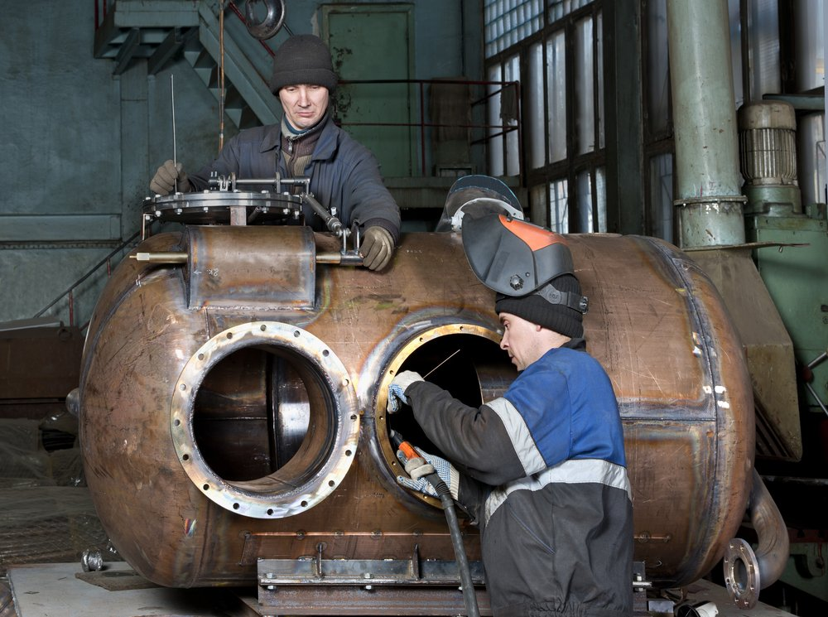

**Average hourly rate: $40.48.**

A Boilermaker assembles, installs and repairs boilers, tanks, vats and other large containers that hold liquids and gases. Boilers are used extensively in buildings, factories and ships to heat water or other fluids under extreme pressure to generate electric power and heat, while vats and tanks are used to store and process a wide variety of products such as chemicals, oil and even beer. Being a boilermaker is physically demanding work.

**Brickwork**

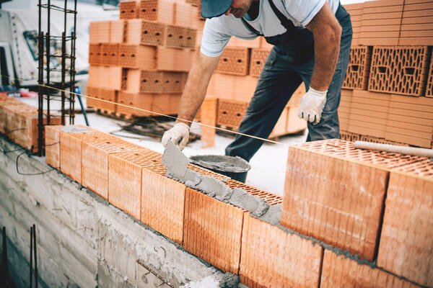

**Average hourly rate: $30.70**

The term “brickwork” is used to encompass both bricklaying and masonry and refers to the process of creating walls and barriers through the laying of brick and mortar. The difference between the two is primarily the skill level, as bricklaying is part of masonry and considered more entry-level, whereas a true mason is more specialist. Masons work with a greater variety of materials (for example stone) and are trained in more complex cutting techniques. Becoming a stonemason is often the progression after completing a bricklaying apprenticeship. Bricklayers and Stonemasons are both listed as being in shortage in the Construction Trades report by the Department of Jobs and Small Business.

**Carpenter**



**Average hourly rate: $39.95**

Despite being one of the oldest skilled trades, carpentry is still widely required in modern construction. Carpenters construct, erect install and repair fixtures and structures using wood and other materials. There are a number of different types of carpenter, including:

* Rough carpenters: who perform framing, roofing and formwork
* Joister: who lays floor joists for a floor surface to be fixed
* Trim carpenter: who specialise in mouldings and trims
* Cabinet maker: who makes furniture such as cabinets, wardrobes and dressers
* Framer: who specialises in erecting the framework for buildings

The average hourly rate for a carpenter is $39.95 and joiners, cabinet makers and carpenters were all listed in the Construction Trades report as “in shortage”.

**Electrician**



**Average hourly rate: $45.77**

An electrician is a skilled tradesperson who plans, installs and maintains electrical wiring systems spanning a number of environments including residential homes, commercial properties, machinery and transmission lines. Electricians typically focus on construction (such as installing wiring into new homes, factories and businesses) or maintenance (such as fixing or upgrading existing electrical systems and repairing equipment). In Australia, electrical work that involves fixed wiring is heavily regulated due to the inherent risk involved and must be carried out by a licensed electrician or electrical contractor.

**Fencer**



**Average hourly rate: $27.49**

Fencers construct and repair fences, walls or barriers made from timber, wire, metal, chain-link or other types of material. The regulations surrounding fencing differ from state to state, with Victoria (for example) not requiring fence builders to have a specific licence, while in NSW, any contractor carrying our work valued at over $1,000 must have a correct and current licence.

**Glazier**



**Average hourly rate: $32.91**

A glazier is responsible for cutting, installing and removing glass and glass substitutes. Common types of installation jobs include into windows, doors, storefronts and skylights, but may also include the installation of sashes or moldings and secure them with fasteners. Glaziers are skilled at preparing glass for both structural and non-structural purposes in commercial and residential buildings. Additionally, they may work on high-rise construction sites where cranes lift large panels into place to be secured to the building frame by a skilled glazier. Glaziers are listed as “in shortage” in the Construction Trades report.

**Heavy Equipment Operator**

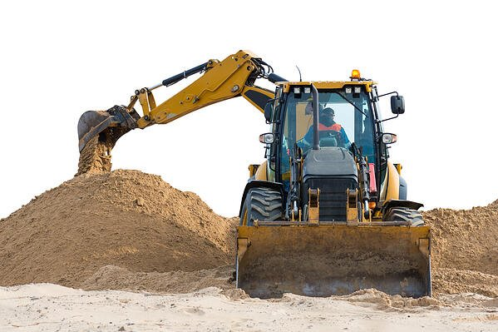

**Average hourly rate: $28.95**

Heavy equipment operators drives or controls equipment used in engineering and construction projects. The types of machines that they operate include bulldozers, backhoes, forklifts, dump trucks, cargo trucks and cranes. Heavy equipment operators often choose to specialise in construction equipment, paving and surface equipment or pile-driver based equipment.

The average heavy equipment operator in Australia earns $28.95 per hour, although there can be a significant variance due to the differing types of machines and associated licences required to operate them.

**Labourer**



**Average hourly rate: $27.61**

Labourers perform a variety of manual tasks, usually on construction sites, which do not require a trade profession. While most labourer tasks can be completed after some on-the-job training, some labourers are often skilled in a particular area, such as scaffolding or bricklaying. The kinds of tasks that labourers complete might include equipment and material loading and unloading, operating machinery or tools and worksite clean-up. Labourers in Australia earn an average hourly rate of $27.61.

**Landscaper**

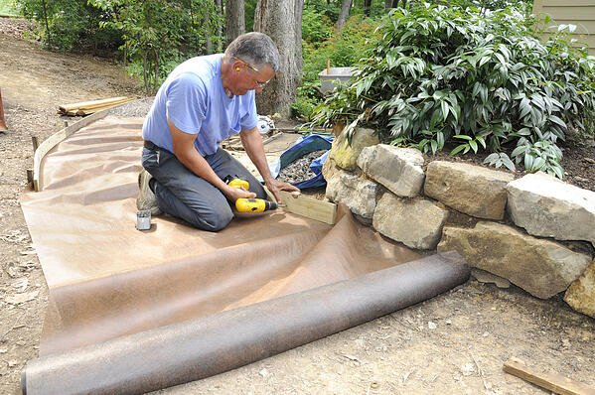

**Average hourly rate: $32.50**

A landscaper manipulates both earth and water materials to create a range of outdoor scenes such as gardens, squares and parks. They design, plan, construct and maintain these natural environments for both residential and commercial purposes. Landscapers perform physical work that might include maintenance of lawns, hedges and plant growth, bush rehabilitation, “hardscaping” (creation of pavements and pathways) and irrigation system installation. The average landscaper hourly rate in Australia is $32.50.

**Painter**



**Average hourly rate: $32.30**

Painters are responsible for the application of paint, varnish and other special coatings to the surfaces of buildings, residential homes, schools and other structures. Some of the key tasks that a painter will undertake are assessment of materials needed to complete a job, preparation of walls and surfaces through washing, scraping, filling and removal of old paint and applying decorative finishes such as stenciling and lettering. In Australia, painters earn an average hourly rate of $32.30 and of the trades featured in the Department of Jobs and Small Business report, it was the only one identified as having “no shortage”.

**Pile Driver Operator**

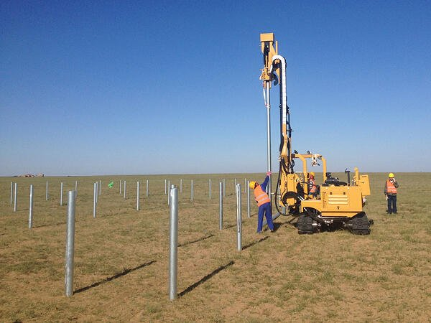

**Average hourly rate: $46.00**

A pile driver operator controls a pile driver mounted on skids, crawler treads, barges or cranes to drive pilings for bulkheads, retaining walls and structural foundations for buildings, piers and bridges. They also shift hand and foot levers of hoisting equipment to position piling leads, hoist pilings into the leads and position hammers over these pilings. Operators are quite often some of the first people on site as many large structures rely on pilings for support. The average hourly rate for a pile driver operator in Australia is $46.00.

**Plasterer**



**Average hourly rate: $39.14**

A plasterer is someone who applies plaster or stucco to walls, partitions or ceilings to for either functional or decorative purposes. Plastering provides a protective function, ensuring buildings are more robust and visually appealing. They work on a number of different buildings, including offices, new home developments and residential houses. In addition to working on new constructions, they also repair or restore existing plasterwork. The Construction Trades report listed plasters as one of the “in shortage” trades and the average hourly rate for a plasterer in Australia is $39.14.

**Plumber**



**Average hourly rate: $39.26**

Plumbers are responsible for planning, installing, maintaining and repairing all systems which facilitate the flow of gas, water, steam, air or other liquids. They perform their job at a number of different sites including residential, commercial and industrial properties. Some of the key tasks performed by plumbers are pipes and fixtures (such as sinks and toilets), assembling fittings and valves for installation, modifying lengths of pipe or fixtures as required and installation of air-conditioning systems and water heaters. Plumbers were highlighted as “in shortage” by the Construction Trades report in November 2018 and the trade has an average hourly rate of $39.26 in Australia.

**Roofer**



**Average hourly rate: $39.26**

Using a wide range of materials including tiles, shingles, bitumen and metal, roofers install, repair and replace the roofs of buildings. As part of their tasks, roofers analyse construction plans to ensure roofing is conducted in strict accordance with the plans, define the specifications of beams, trusses and rafters in a build and determine the materials to be utilised in roofing installations. In Australia, the average hourly rate for a roofer is $39.62.

**Steel Fixer**

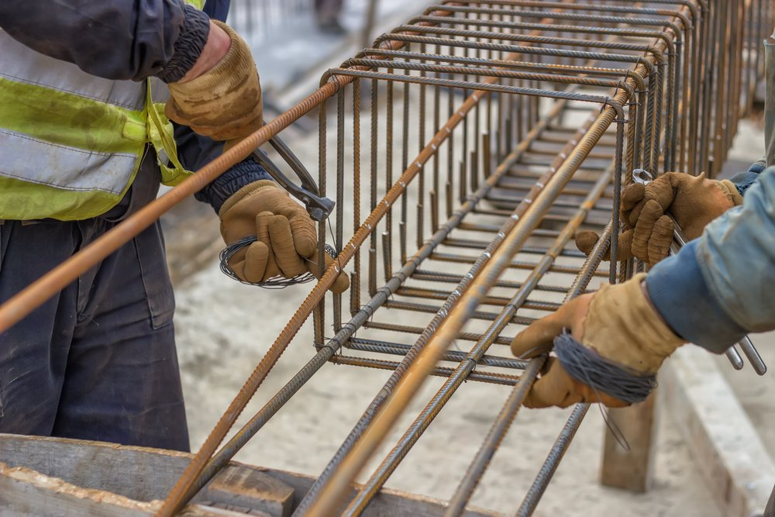

**Average hourly rate: $35.18**

Steel fixers position and secure steel fixings and reinforcing to bolster the strength of buildings and other structures. Often working on high rise buildings, they work closely with engineering designers to ensure overall structural integrity. Day-to-day, steel fixers are responsible for reading building or engineering plans, join steel with clips, wire or welding, fix steel to solid bases and fix and set steel beams. The Australian average rate for a steel fixer is $35.18 per hour.

**Welder**



**Average hourly rate: $34.00**

The primary role of a welder is to join metal together, or fill and repair holes on metal elements through the use of intense heat and gas. Welding work is found in a wide variety of environments including industrial, commercial and manufacturing applications and even underwater to repair oil rig foundations, the hulls of ships and other subaquatic structures. There are over 100 different welding techniques at the disposal of an experienced welder. The average rate in Australia for a welder is $34.00 per hour.

**Personal requirements for a Construction Worker**

* Able to cope with the physical demands of the job
* Enjoy practical and outdoor work
* Able to work as part of a team
* Able to work at a constant pace
* Able to read and understand safety instructions
* Able to follow precise directions
* Effective communication skills

**Skills and knowledge required**

There are two different types of skills that you’ll need to develop to work effectively in the construction industry – those directly connected to your trade, such as mixing mortar or laying bricks, and general employability skills like time management, problem solving and teamwork.

Having the right skills will help you to:

* be more employable
* perform better in the workplace
* expand your role
* progress into higher positions within a company or workplace
* stay up-to-date with industry changes
* help your organisation to achieve its goals

**Opportunities to learn**

* Learning new information or skills is not restricted to schools and trade colleges. There are many organisations and sources of information that exist to support your development as a tradesperson. These include industry associations, trade magazines and the internet.
* Your employer or supervisor might organise specific skills training for you or send you to a trade event or presentation. However, it’s important for you to participate in your own career development by actively seeking out learning opportunities.

## Identify own existing skills and the additional skills required for a tradesperson or skilled operator role in the construction industry.

**Essential skills you need to succeed in your career?**

Many people can be surprised to learn they don’t have the level of Essential Skills they need to succeed in the workplace. For example, many skilled trades, including carpenters and millwrights, require advanced math (numeracy) skills.

When you begin your apprenticeship, you’ll want to make sure you’ve got the required level of Essential Skills necessary for your chosen career. If you begin your apprenticeship as a carpenter, for example, your instructor will assume you already know geometry – this is a foundation skill – and will only focus on teaching you the technical skills you require.

The Essential Skills related to construction skilled trades are as follows:

|  |  |
| --- | --- |
| **Continuous Learning** | Improving your skills and knowledge on a regular ongoing basis |
| **Decision Making** | Making a choice among options |
| **Digital Technology** | Using computer applications or technical tools to operate machinery or to input/extract information |
| **Document Use** | Reading and interpreting documents to extract information |
| **Job Task Planning and Organizing** | Working independently to plan and organize daily tasks |
| **Numeracy** | Working with numbers to perform calculations |
| **Oral Communication** | Conveying or exchanging information verbally |
| **Problem Solving** | Coming up with solutions to challenges |
| **Reading Text** | Reading various types of documents of varying complexity |
| **Significant Use of Memory** | Performing tasks that call upon greater memory use than most jobs |
| **Thinking Skills** | Finding and evaluating information to make decisions, solve problems, and plan and organize job tasks |
| **Working with Others** | Interacting with co-workers to get the job done |
| **Writing** | Conveying ideas by writing text |

**Identifying your learning needs**

At the beginning of your career in the construction industry, you’ll need to complete formal training to be eligible for employment in your chosen trade. This usually involves completing a recognised qualification at a registered training organisation (RTO) or college.

Learning needs and development processes include competency achievement/maintenance processes, which include:

* assessment processes
* formal vocational education and training
* on-the-job training and job rotation
* recognition of prior learning
* refresher training.

Learning the skills you need for a construction trade doesn’t stop when you complete a qualification. Depending on your situation, work requirements or career goals, you may need:

* a higher qualification
* extra skills, eg first aid, time management
* job-specific skills developed by on-the-job training
* expanded skills learned through job rotation
* to refresh skills you haven’t used in a while

**Recognisation of prior learning (RPL)**

Recognition of prior learning is an assessment process that involves assessment of an individual’s relevant prior learning (including formal, informal and non-formal learning) to determine the credit outcomes of an individual application for credit.

RPL is one of a number of processes for establishing credit or advanced standing. RPL broadens access into formal learning by enabling credit to be given for student achievement though other formal, non-formal or informal learning. RPL involves issuing organisations undertaking an assessment of each individual who applies to determine the extent to which that individual’s previous learning is equivalent to the learning outcomes of the components of the destination qualification.

Your training provider will formally assess your employees’ existing skills and knowledge so that they can count towards their qualification and shorten the period of training. Employee RPLs can be completed at your workplace. RPL takes into account:

* work-related training courses
* on-the-job skills and work experience
* volunteer and community work
* a combination of all of the above

**Test your Essential Skills**

Testing your Essential Skills can identify gaps that you can improve upon before starting your apprenticeship

There are many reasons why your Essential Skills may be lacking in some areas. Perhaps you’ve been out of school for a while and haven’t needed to use certain Essential Skills so you’ve forgotten them. Or maybe you just haven’t learned a specific Essential Skill yet. Whatever the reason, don’t think it has anything to do with how intelligent you are. Just know that you can improve them with a number of tools available to you. It’s never too late to learn!

And even if you already have experience in the trades, you could still have gaps in your Essential Skills, so it doesn’t hurt to do a self-assessment.



Self-check assessment

**QUESTION 1**

What do you understand by the ‘duty of care’? ____________________________________________________________________________________________________________________________________________________________________________________________________________________________________________________________________________________________________________________________________________________________________________________

**QUESTION 2**

What shall be included in a code of conduct on a construction site? ____________________________________________________________________________________________________________________________________________________________________________________________________________________________________________________________________________________________________________________________________________________________________________________

**QUESTION 3**

What is a ‘white-card’? ____________________________________________________________________________________________________________________________________________________________________________________________________________________________________________________________________________________________________________________________________________________________________________________

# CHAPTER 3: IDENTIFY AND FOLLOW ENVIRONMENTAL AND RESOURCE EFFICIENCY REQUIREMENTS.

The construction industry has a significant impact on the environment. Most construction projects consume a lot of natural resources in both materials and the energy used during the building process. Construction projects can also produce a lot of waste. Working sustainably means adopting work practices that:

* make the best use of materials and natural resources
* maximise efficient energy use
* minimise harm to the environment
* produce efficient buildings

Companies and individuals need to adopt these work practices while maintaining on-the-job efficiency. When you start out in the construction industry, you might not have a say on the design of a building or the management of a project, but you can still play an important part in what happens on site.



What will I learn?

In this chapter, you will learn about the following:

1. Identify environmental and resource efficiency requirements that apply to entry level roles in the construction industry.
2. Follow requirements to identify and report environmental hazards.
3. Follow requirements to identify and report resource efficiency issues.

## Identify environmental and resource efficiency requirements that apply to entry level roles in the construction industry.

**Sustainable work practices**

Companies, employers or work teams create policies and procedures to let workers know how tasks should be done and what standards of work, equipment and materials are required. They ensure that laws and Regulations are followed, and company requirements are met. These include:

* how resources should be managed on site
* how energy should be used on site
* how waste should be managed on site.

Some workplaces are committed to making improvements to sustainability and environmental protection above and beyond those required by legislation or Regulations.

**Using materials sustainably**

Choosing the right building materials and managing the way in which they’re used is one of the most important factors in reducing the consumption of natural resources and minimising environmental damage. Sustainable building materials are materials that have less impact on the environment than their traditional equivalents. This means they meet one or more of the following criteria. They:

* are made from a raw material that is renewable
* are a recycled product or contain recycled materials
* are a salvaged material
* have improved performance.

**Using energy efficiently**

Energy use affects the environment by using up limited natural resources like coal and oil and by releasing greenhouse gases that damage the atmosphere. There are two types of energy used in the construction industry – operating and embodied. You’re probably more familiar with operating energy which is the energy you use when you plug tools directly into the main power supply. Embodied energy is all the energy used in producing or making something. For example, the diagram below shows the embodied energy used in brick production.

Environmental and resource efficiency issues include:

* minimisation of environmental risks and maximisation of opportunities to improve environmental performance and to promote more efficient production and consumption of natural resources on the work site, for example by minimising waste, through participation in or use of a waste minimisation system
* using resources efficiently, including reducing material usage and supporting efficient energy and water use, such as:
* air testing pipes
* efficient fittings
* insulation
* site management to minimise stormwater pollution
* strategic use of materials to reduce off-cuts and wastage
* tool maintenance
* transportation
* using alternative practices, procedures and materials/products that reduce or eliminate resource consumption.

Appropriate techniques for recording resource use include:

* examination and documentation of resources on work site
* examination and measurement of resources, materials and products from suppliers
* examination of relevant information and data on efficiency and resource reduction
* instructions and reports from other parties involved in the process of identifying and implementing improvements.

## Follow requirements to identify and report environmental hazards.

**Environmental hazards include:**

* substances (e.g. resource, waste, by-product) that are dangerous to living things in the environment, such as humans, animals, plants and water, including storage, handling and disposal of the following substances:
* toxic
* corrosive
* flammable
* explosive

**Safe handling of hazardous material**

Tradespeople in the construction industry regularly use materials that can be hazardous; that is, handling, storing and disposing of some materials and products can harm people, animals, plants, soil and waterways. Before you use any materials, you need to know how they will affect the environment and how you should handle them or dispose of any by-products or waste. There should be documentation for any hazardous material used and stored on a construction site. You can find information in:

* safety data sheets (SDSs)
* chemical registers
* safe work method statements (SWMSs)
* warning signs and symbols
* manufacturers’ specifications
* product labels

Here are 11 basic rules all employees who handle hazardous materials should know and follow.

Rule #1. Follow all established procedures and perform job duties as you’ve been trained.

Rule #2. Be cautious and plan ahead. Think about what could go wrong and pay close attention to what you’re doing while you work.

Rule #3. Always use required PPE—and inspect it carefully before each use to make sure it’s safe to use. Replace worn out or damage PPE; it won’t provide adequate protection

Rule #4. Make sure all containers are properly labelled and that the material is contained in an appropriate container. Don’t use any material not contained or labelled properly. Report any damaged containers or illegible labels to your supervisor right away.

Rule #5. Read labels and the material safety data sheet (MSDS) before using any material to make sure you understand hazards and precautions.

Rule #6. Use all materials solely for their intended purpose. Don’t, for example, use solvents to clean your hands, or gasoline to wipe down equipment.

Rule #7. Never eat or drink while handling any materials, and if your hands are contaminated, don’t use cosmetics or handle contact lenses.

Rule #8. Read the labels and refer to MSDSs to identify properties and hazards of chemical products and materials.

Rule #9. Store all materials properly, separate incompatibles, and store in ventilated, dry, cool areas.

Rule #10. Keep you and your work area clean. After handling any material, wash thoroughly with soap and water. Clean work surfaces at least once a shift so that contamination risks are minimized.

Rule #11. Learn about emergency procedures and equipment. Understanding emergency procedures means knowing evacuation procedures, emergency reporting procedures, and procedures for dealing with fires and spills. It also means knowing what to do in a medical emergency if a co-worker is injured or overcome by chemicals.

## Follow requirements to identify and report resource efficiency issues.

Environmental requirements are to cover workplace quality management and include:

* clean-up protection
* stormwater protection
* waste management.

**Environmental Pollution due to Construction**

The construction industry is a major source of pollution, responsible for particulate emissions and water pollution and noise pollution. Construction activities may also pollute the soil, but the main areas of concern are: air, water and noise pollution.

**Air Pollution**

Construction activities that contribute to air pollution include: land clearing, operation of diesel engines, demolition, burning, and working with toxic materials. All construction sites generate high levels of dust (typically from concrete, cement, wood, stone, silica) and this can carry for large distances over a long period of time. Construction dust is classified as PM10 - particulate matter less than 10 microns in diameter, invisible to the naked eye.

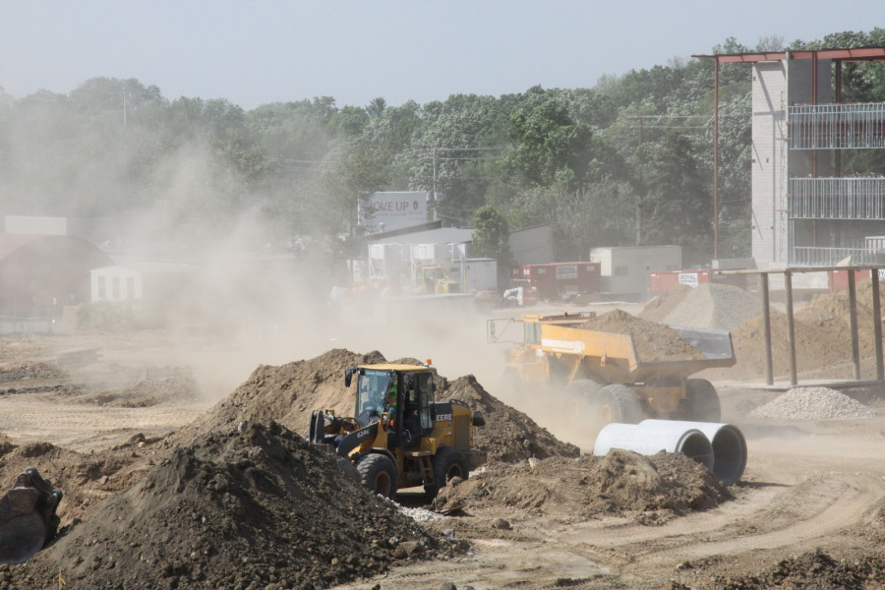

Research has shown that PM10 penetrate deeply into the lungs and cause a wide range of health problems including respiratory illness, asthma, bronchitis and even cancer. Another major source of PM10 on construction sites comes from the diesel engine exhausts of vehicles and heavy equipment. This is known as diesel particulate matter (DPM) and consists of soot, sulphates and silicates, all of which readily combine with other toxins in the atmosphere, increasing the health risks of particle inhalation.

Diesel is also responsible for emissions of carbon monoxide, hydrocarbons, nitrogen oxides and carbon dioxide. Noxious vapours from oils, glues, thinners, paints, treated woods, plastics, cleaners and other hazardous chemicals that are widely used on construction sites, also contribute to air pollution.

**Water Pollution**

Sources of water pollution at building sites include: diesel and oil; paint, solvents, cleaners and other harmful chemicals; and construction debris and dirt. When land is cleared it causes soil erosion that leads to silt-bearing run-off and sediment pollution. Silt and soil that runs into natural waterways turns them turbid, which restricts sunlight filtration and destroys aquatic life.

Surface water run-off also carries other pollutants from the site, such as diesel and oil, toxic chemicals, and building materials like cement. When these substances get into waterways they poison water life and any animal that drinks from them. Pollutants on construction sites can also soak into the groundwater, a source of human drinking water. Once contaminated, groundwater is much more difficult to treat than surface water.

**Noise Pollution**

Construction sites produce a lot of noise, mainly from vehicles, heavy equipment and machinery and radios turned up too loud etc. Excessive noise is not only annoying and distracting, but can lead to hearing loss, high blood pressure, sleep disturbance and extreme stress. Research has shown that high noise levels disturb the natural cycles of animals and reduces their usable habitat.

**Waste management**

Most worksites have policies for safely managing waste to reduce environmental damage. Waste management plans should include procedures for:

* minimising landfill waste
* separation of recyclable materials
* safe disposal of hazardous waste
* protection of stormwater drains
* safe clean-up procedures.

Stormwater protection is a particularly important issue on many construction sites. Litter, hazardous substances and building materials like gravel and concrete can get into stormwater drains and ultimately end up in the ocean or wetlands.

Clean-up and waste management can actually cause damage if correct procedures aren’t followed. Some environmental hazards like asbestos can only be cleaned up by removing the topsoil along with the hazard which damages soil structure and removes plants and seeds. These kinds of hazards can be cleaned up only by specialists.

Companies and individuals face serious penalties for allowing waste into the stormwater system or for damaging the environment with ineffective waste management practices

**Environmental Control during Construction**

**Measures to Prevent Pollution**

Good construction site practice can help to control and prevent pollution. The first step is to prepare environmental risk assessments for all construction activities and materials likely to cause pollution. Specific measures can then be taken to mitigate these risks:

1. To prevent erosion and run-off, minimise land disturbance and leave maximum vegetation cover.
2. Control dust through fine water sprays used to dampen down the site.
3. Screen the whole site to stop dust spreading, or alternatively, place fine mesh screening close to the dust source.
4. Cover skips and trucks loaded with construction materials and continually damp down with low levels of water.
5. Cover piles of building materials like cement, sand and other powders, regularly inspect for spillages, and locate them where they will not be washed into waterways or drainage areas.
6. 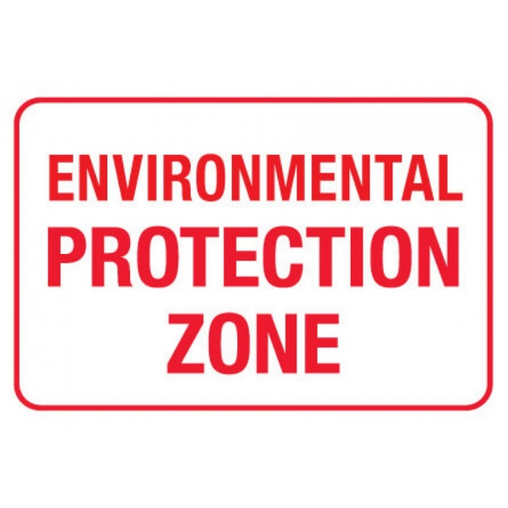Use non-toxic paints, solvents and other hazardous materials wherever possible
7. Segregate, tightly cover and monitor toxic substances to prevent spills and possible site contamination.
8. Cover up and protect all drains on site.
9. Collect any wastewater generated from site activities in settlement tanks, screen, discharge the clean water, and dispose of remaining sludge according to environmental regulations.
10. Use low sulphur diesel oil in all vehicle and equipment engines and incorporate the latest specifications of particulate filters and catalytic converters.
11. No burning of materials on site.
12. Reduce noise pollution through careful handling of materials; modern, quiet power tools, equipment and generators; low impact technologies; and wall structures as sound shields.



**Wear Ear Protection Aids while working with machinery that causes excessive noise**

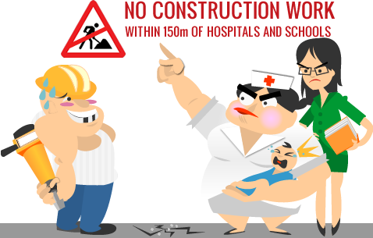

**Restriction of Construction works at specified locations**

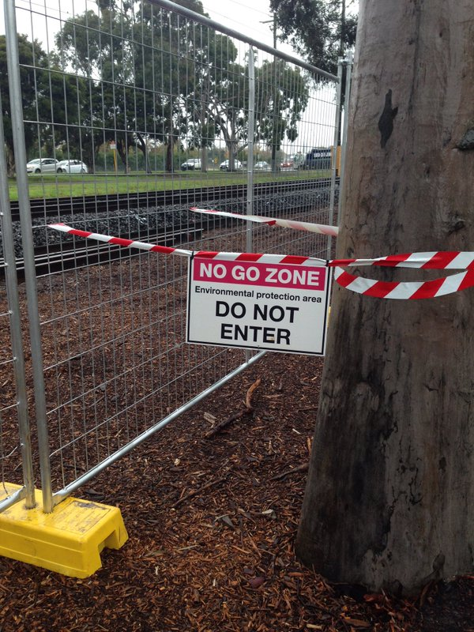

**Environmental Protection Signs at a Construction Site**

**Environmental management**

General responsibilities included in the pollution avoidance guidelines are outlined in the following table:

|  |  |  |
| --- | --- | --- |
| **Environmental Issue** | **Management** | **Action/Complete** |
| Induction | Induct supervisors, employees and subcontractors, where necessary, in the general environmental issues covered by this plan and in the environmental issues specific to the respective site. |  |
| Identification of Hazards | Prior to commencing work on site undertake a hazard identification assessment to identify any hazards on the site. Develop Environmental Work Method Statements for hazards not covered by this plan. |  |
| Competency | Ensure that where licenses and certificates of competency are required to perform work we, any employees or trade contractors have proof of those qualifications. Furthermore, ensure that any people employed are sufficiently trained and skilled to perform work in an environmentally responsible manner. |  |
| Emergency Procedures | Ensure Emergency Procedures are documented for each possible environmental emergency. Ensure supervisors and employees are trained in these emergency procedures. |  |
| Personal Protective Equipment (PPE) | Where necessary use items of personal protective equipment. |  |
| Maintenance and use of equipment | Maintain plant and equipment in safe operating condition and maintain and use the plant and equipment in accordance with applicable standards and manufacturer’s instructions. |  |
| Rubbish | As work progresses remove rubbish and dispose of it as instructed by the site supervisor. |  |
| Hazardous Substances | Maintain a register of material safety data sheets (MSDS) for each hazardous substance that is used. Ensure all employees are aware of and follow the precautions outlined in the MSDS’s and know how to find information in an emergency. |  |
| Materials | Where material is stockpiled store the material or work with the principal contractor to ensure the material is stored on site in a manner that is secure and does not contribute to environmental damage. More specifically,   * cover material where necessary to minimise losses * locate storage behind sediment controls * protect the material from run-off water by up-slope diversions * locate the storage at least 2m from likely areas of high velocity flows * store to a maximum height of 2m |  |
| Managing sediment erosion and run-off | Manage sediment erosion and run-off by:   * the use of sediment fencing and/or * the use of straw bales and/or * diversion of up-slope water and/or grass filter strips |  |
| Dust control | Control dust from the sites by:   * regularly and lightly watering dust prone areas and/or * limiting the movement of soil, excavating or using dust creating activities during windy conditions and/or * minimising the lifting height of loader buckets and/or * controlling the speed of dumping from tip trucks and/or * covering or stabilising materials during transport into, within or away from site and/or * lightly watering access roads regularly and compacting (where possible) and/or * limiting vehicle traffic and speeds |  |
| Transporting mud or soil onto public roadways | Where possible minimise the exit points to a site and treat the exit point, as necessary based on the traffic leaving the site, to minimise the amount of mud/soil deposited on the public roadway, e.g. provide a gravel entry, washdown area or equivalent. Where necessary sweep the public roadway and remove debris back to the site. |  |
| Concrete waste | Prevent residues and waste from concrete activity from entering the stormwater system:   * containing all excess water, waste and residue from on-site concrete mixing * providing temporary bunds where concrete pumps or unloading from mixers occurs on public roadways. Remove all spillage on completion of pumping or unloading. * providing designated washdown facilities for concrete equipment with appropriate drying and removal facilities |  |
| Brickwork activity | Retain waste water from brick cutting on site with the residue collected and placed in a waste disposal bin. Mix mortar for brick laying in a way to minimise the possibility of entry into the stormwater system. Contain cleaning residue on site. |  |
| Noise control | Take all reasonable and practical measures to minimise noise impact on other people. In particular restrict regular construction activity to between 7am and 7pm Monday to Saturday and 9am to 6pm on Sundays and public holidays. Maintain noise levels in residential areas below 45dB outside of these hours where practical. |  |
| Painting waste | Painting waste and wash waters will not be discharged into the stormwater system. Water based paint cleaning will be disposed of into the sewer system or diverted into contained area lined with absorbing material, e.g. newspaper. The waster will be disposed of in a solid waste bin. Oil-based clean up material will be filtered to re-use the solvent or disposed of at a waste depot. |  |
| Plastering waste | Plastering waste will be allowed to dry and the residue placed in a waste disposal bin. |  |
| Pesticide management | Where pesticides are proposed for use a pesticide management plan will be developed based on the Code of Practice for Stormwater Pollution Prevention. |  |
| Roofing – temporary downpipes | Where possible guttering downpipes and drainage will be installed as soon as the roof is installed to minimise the surface water run-off from roof collection. |  |
| Transportation | The transport of materials to and from site will be managed to prevent accidental spills or leakage. Spills or leakage will be cleaned up as soon as practical after detection or notification. |  |
| Services installation | Where possible we will coordinate the installation of underground services to:   * use the minimal number of trenches * keep trenches open for no more than three days and * trench in roadways prior to the road bed being established * trench spoil will be stored on the site and uphill of the trench if appropriate   Backfilling will be to 95% standard Proctor compaction and revegetated with the original sod or other vegetation if appropriate. |  |
| Air conditioning waste | Evaporative air conditioning bleed water will not be allowed to enter the stormwater system. Wastewater from air conditioner dump valves and cooling towers will be directed to the sewer system or suitable garden area. |  |
| Design considerations | The following considerations will be taken into account when designing the site layout and project management plan:   * maintenance or natural watercourses * stabilisation and rehabilitation plans * soil erosion and drainage plan * stabilised entry and exit point/s * location of stockpiles * location of waste management facility * area of brick cutting and concrete work * paint and plaster waste containment facility * wash down areas for plant and equipment * location of noisy equipment |  |
| Native vegetation | Where native vegetation is to be cleared approvals as required by the Native Vegetation Act 1991 and Amendment Act 2002 will be sought. |  |



Self-check assessment

**QUESTION 1**

What do you understand by sustainable work practices? Why is it important to follow sustainable work practices in the construction industry? ____________________________________________________________________________________________________________________________________________________________________________________________________________________________________________________________________________________________________________________________________________________________________________________

**QUESTION 2**

Prepare a list of measures used to demolish dust and pollution on construction sites. ____________________________________________________________________________________________________________________________________________________________________________________________________________________________________________________________________________________________________________________________________________________________________________________

**QUESTION 3**

Why is it important to reduce energy usage in construction? Explain with some examples how the amount of energy on construction projects could be reduced. ____________________________________________________________________________________________________________________________________________________________________________________________________________________________________________________________________________________________________________________________________________________________________________________

# Glossary

* **ALARP:** ALARP stands for "as low as reasonably practicable", and is a term often used in the regulation and management of safety-critical and safety-involved systems. The ALARP principle is that the residual risk shall be reduced as far as reasonably practicable.
* **Consequence** The injury, ill-health or damage resulting from an event, or sequence of events, which may be expressed quantitatively or qualitatively. There may be a range of possible consequences for a specific event or scenario.
* **Consultation:** A process of seeking information or the informed opinions from one or more people prior to decision-making. Should particularly include those who may affect the outcomes or be affected by the decisions made but may also include specialist sources. Consultation does not necessarily mean reaching agreement.
* **Due diligence:** The taking of all reasonable precautions in the circumstances to protect the health and safety of employees and others who may be affected by actions or omissions of the individual or corporation.
* **Event:** The point in time when a particular set of circumstances occur that results in loss of control of a hazard.
* **Hazard:** A source of potential harm in terms of human injury, ill-heath, damage to property, the environment or a combination of these. A source of potentially damaging energy.
* **Hazard identification:** The process of identifying sources of harm.
* **Incident** An event that has caused or has the potential for injury, ill-health or damage. (Note that ‘incident’ is the preferred term rather than ‘accident’). Refer also to ‘occurrence’.
* **JSA:** A job safety analysis (JSA) is a procedure which helps integrate accepted safety and health principles and practices into a particular task or job operation. In a JSA, each basic step of the job is to identify potential hazards and to recommend the safest way to do the job.
* **MSDS:** A Material Safety Data Sheet (MSDS) is a document that contains information on the potential hazards (health, fire, reactivity and environmental) and how to work safely with the chemical products (chemicals, chemical compounds, and chemical mixtures). It is an essential starting point for the development of a complete health and safety program. The MSDS should be available for reference in the area where the chemicals are being stored or in use.
* **OHS:** Occupational health and safety, also commonly referred to as OH&S, or workplace health and safety, is a multidisciplinary field concerned with the safety, health, and welfare of people at work. The goals of occupational safety and health programs is to foster a safe and healthy work environment
* **Procedures:** Documents that describe an approach and method for undertaking certain activities or processes. Those relevant to OHS may include:
* hazard and incident reporting, OHS communication, consultation, issue resolution and risk management;
* standard operating procedures, work instructions;
* operator’s manuals;
* employee and contractor handbooks;
* job/task statements;
* documents describing how tasks, projects, inspections, jobs and processes are to be undertaken;
* quality system documentation; and
* purchasing and contracting procedures.
* **Risk:** The potential for unwanted, negative consequences of an event**.**
* **Stakeholders:** A Stakeholder is any person, organization, social group, or society at large who can affect or is affected by an organisation, strategy or project. They can be internal or external and they can be at senior or junior levels. In workplace OHS, stakeholders include:
* managers;
* supervisors;
* health and safety and other employee representatives;
* OHS committees;
* employees and contractors; and
* the community.
* **SWMS:** A Safe Work Method Statement (SWMS) is a document that outlines the high-risk construction work activities to be carried out at a workplace, the hazards that may arise from these activities, and the measures to put in place to control the risks. SWMS are required for high risk construction work activities, as defined in the WHS Regulations.
* **Sustainability:** A the ability to be maintained at a certain rate or level.
* **PPE:** Personal protective equipment (PPE) are equipment that will protect the user against health or safety risks at work. It can include items such as safety helmets, gloves, eye protection, high-visibility clothing, safety footwear and safety harnesses.
* **PCBU:** A 'person conducting a business or undertaking' (PCBU) is a legal term under WHS laws for individuals, businesses or organisations that are conducting business. A person who performs work for a PCBU is considered a worker. Types of PCBUs can include: public and private companies.

# References

1. Safe work instructions - Workshop safety - Occupational .... <https://www.monash.edu/ohs/info-docs/safety-topics/laboratories,-studios-and-workshops/safe-work-instructions-workshop-safety>
2. Types of Workplace Hazards - Protocol Rescue. <https://protocolrescue.com/types-of-workplace-hazards/>
3. Occupational Health and Safety Act and Regulations - WorkSafe. <https://www.worksafe.vic.gov.au/occupational-health-and-safety-act-and-regulations>
4. Personal protective equipment (PPE) - worksafe.qld.gov.au. <https://www.worksafe.qld.gov.au/injury-prevention-safety/managing-risks/personal-protective-equipment-ppe>
5. Barricading & Signage - OHS-PROC-134 - Stanwell. <http://www.stanwell.com/wp-content/uploads/Barricading-and-Signage-Procedure.pdf>
6. TOOLS AND EQUIPMENT - International Labour Organization. <http://www.ilo.org/wcmsp5/groups/public/---asia/---ro-bangkok/documents/genericdocument/wcms_101009.pdf>
7. Code Of Conduct – Carpentry Australia. <https://www.carpentryaustralia.com.au/membership/code-of-conduct/>
8. Planning of materials in Construction Project management. <https://www.slideshare.net/AravindSamala/planning-of-materials-in-construction-project-management>
9. Inventory Management for the Construction ... - EMERGE App. <https://emergeapp.net/traditional-businesses/inventory-management-for-construction/>
10. Manual Handling Training | DeltaNet. <https://www.delta-net.com/health-and-safety/manual-handling/faqs/manual-handling-training>
11. Materials handling - Safety+Health Magazine. <https://www.safetyandhealthmagazine.com/articles/materials-handling-4>
12. A Guide to Stacking, Storing and Handling Bulk Materials. <https://www.cisco-eagle.com/blog/2015/11/10/a-guide-to-stacking-bulk-materials/>
13. Responsible Waste Management - HSS Blog. <https://www.hss.com/blog/trade-updates/trade-news/responsible-waste-management/>
14. Site storage - Designing Buildings Wiki. <https://www.designingbuildings.co.uk/wiki/Site_storage>
15. Safe Stacking and Storage - University of Auckland. <https://cdn.auckland.ac.nz/assets/science/for/current-students/HR/health-safety-wellness/documents/SafestackingandStorage.pdf>
16. Safe Stacking and Storage - studylib.net. <https://studylib.net/doc/8305002/safe-stacking-and-storage>
17. Material Handling and Storage Safety Topics - SafetyInfo. <https://www.safetyinfo.com/material-handling-and-storage-safety-index/>
18. Site clearance - Designing Buildings Wiki. <https://www.designingbuildings.co.uk/wiki/Site_clearance>
19. How to reuse and recycle materials from a building site. <http://www.level.org.nz/material-use/minimising-waste/reuse-and-recycling/>
20. How Do I Work Safely with - Toxic Materials : OSH Answers. <http://www.ccohs.ca/oshanswers/prevention/toxic_safe.html>
21. Construction and demolition waste - NSW Environment & Heritage. <https://www.epa.nsw.gov.au/your-environment/waste/industrial-waste/construction-demolition>
22. Dust Mitigation | Global Environmental Solutions. <https://globalenvironmentalsolutions.com/what-we-do/dust-mitigation/>
23. How to Control Dust at a Construction Site. <https://www.thebalancesmb.com/control-dust-at-construction-site-844446>
24. How to Effectively and Efficiently Clean Construction .... <https://www.waste2water.com/effectively-and-efficiently-clean-construction-equipment/>