How AI Is Impacting Industries Worldwide

[By Stuart Rauch](https://www.simplilearn.com/authors/stuart-rauch)



Table of Contents

[AI on the Fast Track](https://www.simplilearn.com/ai-artificial-intelligence-impact-worldwide-article#ai_on_the_fast_track)

[IT Is a Big AI Beneficiary](https://www.simplilearn.com/ai-artificial-intelligence-impact-worldwide-article#it_is_a_big_ai_beneficiary)

[But AI Is Cross-enterprise Too](https://www.simplilearn.com/ai-artificial-intelligence-impact-worldwide-article#but_ai_is_crossenterprise_too)

[Examples of Companies Taking the Lead in AI Adoption](https://www.simplilearn.com/ai-artificial-intelligence-impact-worldwide-article#examples_of_companies_taking_the_lead_in_ai_adoption)

[Impact of Artificial Intelligence in 2023](https://www.simplilearn.com/ai-artificial-intelligence-impact-worldwide-article#impact_of_artificial_intelligence_in_2023)

View More

A common goal among companies in today’s data-driven world is to become smarter—to know where the market opportunities lie, where supply chain logjams are and where process improvements can be found. Data science has been the fuel behind this trend, and now data science is itself becoming smarter. Thanks to astonishing advancements in [artificial intelligence (AI)](https://www.simplilearn.com/tutorials/artificial-intelligence-tutorial/what-is-artificial-intelligence) and its sub-segments machine learning and deep learning, companies are achieving new levels of efficiency in data analysis that impact their entire business. The rising tide of AI adoption across industries will drive significant growth in the next decade, with [AI software revenue](https://www.tractica.com/newsroom/press-releases/artificial-intelligence-software-market-to-reach-89-8-billion-in-annual-worldwide-revenue-by-2025/) set to reach almost $90 billion by 2025. AI’s presence is tantalizing to data scientists and business managers alike who seek to let machines do the number crunching to make the business smarter on a holistic level.

AI on the Fast Track

A leading indicator of a market segment’s growth path can usually be found by following the money trail. Investors and venture capital (VC) firms are always looking for big growth opportunities, and they are finding one now in the AI business. Forbes recently reported that there has been a [14x increase in the number of active AI](https://www.forbes.com/forbes/welcome/?toURL=https://www.forbes.com/sites/louiscolumbus/2018/01/12/10-charts-that-will-change-your-perspective-on-artificial-intelligences-growth/&refURL=&referrer=#d110d4047583) startups since 2000, and investment into these [startups by VC firms has increased 6x](https://www.forbes.com/sites/louiscolumbus/2018/01/12/10-charts-that-will-change-your-perspective-on-artificial-intelligences-growth/#2b9f2b364758) in that period. Meanwhile, companies that both build and utilize AI applications are on a similar growth path, with [jobs requiring AI skills increasing 4.5x since 2013](https://www.forbes.com/sites/louiscolumbus/2018/01/12/10-charts-that-will-change-your-perspective-on-artificial-intelligences-growth/#43c019004758). If you are looking to start your AI journey, then check out our [AI & Machine Learning Bootcamp.](https://www.simplilearn.com/ai-machine-learning-bootcamp?source=GhPreviewCoursepages)

IT Is a Big AI Beneficiary

It should come as no surprise that the department that deals full-time with data—namely the IT organization—is perhaps the biggest beneficiary of AI’s capabilities. A [Harvard Business Review study](https://hbr.org/2017/04/how-companies-are-already-using-ai) reports that between 34 and 44 percent of global companies they surveyed are using AI to help resolve employee technical support issues (imagine a smart response system to streamline common questions and troubleshoot others), automate internal system enhancements (machine codes can be used to calculate where bottlenecks can be fixed), and ensure that employees only use technology from approved vendors (picture a smart authorization engine that keeps up with daily updates and knows vendor subsidiaries and partners).

Artificial Intelligence Engineer

Your Gateway to Becoming a Successful AI Expert



But AI Is Cross-enterprise Too

Where else is AI finding a home? Among the [most common examples of AI in the enterprise](https://www.statista.com/statistics/607612/worldwide-artificial-intelligence-for-enterprise-applications/) are image recognition and tagging, patient data processing, localization and mapping, predictive maintenance, predicting and thwarting security threats, and intelligent recruitment and HR management techniques. But perhaps the most active adoption is being seen in the marketing and sales operation, where intelligent use of data and the ability to learn from human interactions can produce big financial benefits. In a Statista worldwide survey, [87 percent of current AI adopters](https://www.statista.com/statistics/607612/worldwide-artificial-intelligence-for-enterprise-applications/) said they were using or considering using AI for sales forecasting and for improving e-mail marketing. While sales forecasting is often automated by technology to a point, it can be vastly improved with an AI agent that monitors and reacts to customer interactions and shifting market patterns. Email marketers similarly can create a sense of one-to-one marketing through more intelligent targeting and content creation for various audiences.

The bottom line is also important. McKinsey found that companies who benefit from AI initiatives and have invested in infrastructure to support its scale achieve a [three to fifteen percentage point higher profit margin](https://www.forbes.com/sites/louiscolumbus/2017/07/09/mckinseys-state-of-machine-learning-and-ai-2017/#7e8e989575b6). Healthcare, financial services, and professional services are seeing the greatest increase in their profit margins as a result of AI adoption.

Examples of Companies Taking the Lead in AI Adoption

Here are a few examples of how specific companies in various industries are leveraging AI in their businesses:

According to the [McKinsey study](https://www.forbes.com/sites/louiscolumbus/2017/07/09/mckinseys-state-of-machine-learning-and-ai-2017/#35af31b175b6), tech giants including Baidu and Google spent between $20B to $30B on AI in 2016, with 90 percent of this spent on R&D and deployment, and 10 percent on AI acquisitions. The current rate of AI investment is 3x external investment growth since 2013.

Netflix has also [achieved impressive results](https://www.forbes.com/sites/louiscolumbus/2017/07/09/mckinseys-state-of-machine-learning-and-ai-2017/#19ff956e75b6) from the AI algorithm it uses to personalize recommendations to its 100 million subscribers worldwide, improving search results and avoiding canceled subscriptions from frustrated customers who couldn’t find what they wanted (with a potential impact of $1B annually).

Financial data specialist [Bloomberg](https://www.computerworlduk.com/galleries/it-business/uses-of-ai-machine-learning-in-business-3639749/) uses techniques like computer vision and natural language processing to improve the breadth of information available through their ubiquitous terminals that financial staff use to access market information. Users can use natural language in queries instead of specialized technical commands, which is analyzed and executed by AI.

Uber has a core team providing [pre-packaged machine learning algorithms](https://www.computerworlduk.com/galleries/it-business/uses-of-ai-machine-learning-in-business-3639749/) 'as-a-service' to its team of mobile app developers, map experts, and autonomous driving teams. These capabilities are used to better predict traveling habits and improve maps using computer vision, and to create algorithms for its autonomous vehicles.

And Royal Bank of Scotland recently launched a [natural language processing AI](https://www.computerworlduk.com/galleries/it-business/uses-of-ai-machine-learning-in-business-3639749/) bot that will answer its banking customer questions and perform simple banking tasks such as money transfers, with the goal to make digital customer support as powerful as face-to-face interaction.

[AI and Machine Learning](https://www.simplilearn.com/pgp-ai-machine-learning-certification-training-course) are revolutionizing the way companies access and process data to become smarter and more efficient organizations. And IT and data science teams are gearing up for the immense benefits of AI in their enterprises.

Artificial Intelligence Engineer

Your Gateway to Becoming a Successful AI Expert



Impact of Artificial Intelligence in 2023

The impact of artificial intelligence on modern culture are hotly contested. Others believe that AI positively impacts people's daily lives because it can perform mundane and even complex activities more efficiently and effectively than humans can. Yet some worry that AI will lead to increased levels of unemployment, invasion of privacy, and racial profiling.

Can AI Replace Human Intelligence?

The eventual takeover of humanity by AIs and our eventual extinction are not an impossibility.

* To assume that the current limitations of AIs in reasoning and decision-making are not indicative of their future capabilities.
* It's not out of the question that AI computers trained to respond appropriately to new situations would one day cease to need human supervision.
* Artificial intelligence has displaced human labour in today's factories and workshops. In the packing sector, for instance, machines have mostly taken over tasks that were once performed by hand.
* Artificial intelligence has mostly supplanted human workers in telemarketing and customer support. The constant availability and low barriers to entry of chatbots have made them popular in these sectors.

Impact of AI

Voice-Based Search

The development of artificial intelligence (AI) has had a profound impact on nearly every area of human existence. One AI technology that benefits from AI's ability to streamline processes for its users is speech recognition. The latest innovation can transcribe your voicemails into text for you. It can also teach your speech to issue commands with your voice. As a result, Apple, Microsoft, Amazon, Google, Facebook, etc., have given this AI-powered speech recognition technology a lot of attention. Devices and software with built-in voice recognition are already commonplace; examples include Amazon's Echo, Apple's Siri, and Google's Home.

AI In Healthcare

The use of AI in healthcare has only recently begun. Machine learning (ML) offers promise in identifying trends within a population, similar to how computer vision (CV) can diagnose diseases using X-rays and NLP (natural language processing) can in medication safety. All of these advancements for patients will come together once we achieve real information interoperability, which supports the safe interchange of health data.

The Impact of AI on Jobs

Artificial intelligence (AI) will have future repercussions for your company. There is the possibility of a significant effect on how your business functions, yet there is no apparent downside. It calls for an optimistic outlook and an eagerness to try something new.

Many sectors of the economy are experiencing profound shifts due to the advent of AI. When applied to commercial processes, AI's ability to recognise patterns and spot anomalies in massive volumes of digital information ushers new avenues of opportunity. It can perform a wide variety of everyday activities competently if trained.

Employees are freed from mundane, repetitive work so they may focus on higher-level technical difficulties or enhance the quality of customer care made possible by the advent of AI.

Business Intelligence

Data produced by customers, tools, and procedures is overwhelming for businesses. People find that the standard business intelligence tools they've been using still need to cut it. Artificial intelligence-driven solutions will soon replace traditional methods like spreadsheets and dashboards. These instruments can automatically probe the data, learn insights, and make recommendations. These resources will transform how businesses leverage information and make decisions.

Education

An area where AI is expected to have a significant impact on education. AI will significantly assist the education sector and system, which needs a considerable overhaul. All that must be done is pinpoint what needs to change and lay out a plan for implementing that change. One factor that could prove to be a game-changer in this regard is the use of AI easy writer in creating a unique, practical, and practically applicable learning path for any subject or topic.

Retail

Artificial intelligence will have profound effects on the retail sector. Retailers will invest heavily in artificial intelligence (AI) to provide superior customer service in the following years. Marketers in the retail industry are anticipated to start using AR/VR capabilities. The popularity of interactive, aesthetically pleasing product catalogues, where the final consumer can try out an item before buying it, is predicted to skyrocket.

Artificial Intelligence Engineer

Your Gateway to Becoming a Successful AI Expert



Final Thoughts

The market for AI is growing steadily with no signs of slowing down. Artificial intelligence (AI) will be used in nearly every industry to streamline operations. Faster data retrieval and decision-making are two ways AI may help businesses expand.

With multiple industry applications and future potential, AI and ML are currently the hottest markets for careers. If you want to jumpstart your career in this field, then we’ve got the perfect course to help you get started.Start your new [AI and ML](https://www.simplilearn.com/post-graduate-program-ai-machine-learning?source=GhPreviewCoursepages) career today!

**Meet Artificial Intelligence: About the Technology in Plain**

Since the 1950s, AI has remained a rather vague term. Thanks to Hollywood, it is associated in popular minds with many things – from Terminator, C-3PO, Sonny, and other robots to omnipotent cybernetworks like the Matrix.

“Artificial Intelligence” is applied to describe any human-like activity performed by a program or machine to accomplish some task. Some of them we credit with a certain independence of decision-making and action – like strategic computer games, autonomously operating cars, or military simulations.

However, whatever guise is assumed by these silent assistants, their ability to plan, learn, make conclusions, solve problems, move, perceive, and manipulate objects in real-time makes them indispensable in various domains.

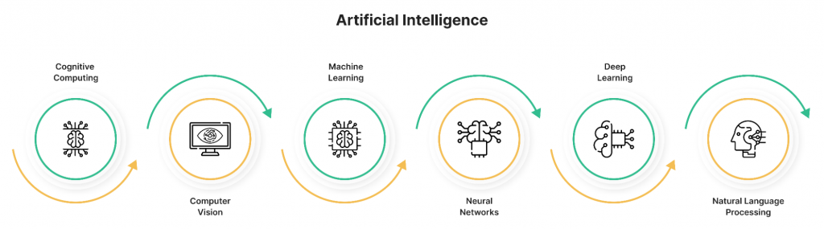

Related: [**Machine Learning vs Artificial Intelligence vs Deep Learning**](https://idapgroup.com/blog/machine-learning-vs-artificial-intelligence-vs-deep-learning/)

**What Business Benefits Got Industries that Use AI**

**1. Elimination of Human Factor**

We are social beings, so we prefer to deal with humans, not machines. However, being humans, your colleagues, partners, employees, and managers may fail in their promises or make mistakes.

Machines and systems powered by Artificial Intelligence reduce or eliminate the opposing sides of human participation. Properly programmed and acting according to a prescribed set of algorithms, AI can solve problems with a precision undreamed of for people.

**2. Round-the-Clock Availability**

People can’t work without pauses, which are necessary to refresh and recharge batteries for a new activity. AI doesn’t need any rest and can work 24/7, doing its job incessantly and tirelessly. Some processes require this ceaseless vigilance that humans can’t provide. It is vital for life support systems and continuous production cycles, where AI reigns supreme.

**3. Reducing Manual Work**

Work routine is still a leader among the reasons talents feel burnout and have poor employee experience. Meanwhile, AI can work productively no matter how often it repeats the same operation. So such mundane jobs as verifying bank documents, sending thank-you emails, and so on can be relegated to AI to handle.

**4. Prompt Decision-Making**

Humans tend to weigh many factors before opting for a course of action, which takes quite a time. AI does all that in a split second, which enhances productivity immensely. Moreover, Artificial Intelligence is free from doubt, exasperation, or doldrums. Emotions don’t interfere where strict algorithms are applied. Therefore, all decisions by AI will be not only fast in adoption but more correct as well.

**5. Functioning in Hazardous Conditions**

Robots powered by AI can work in places where humans don’t venture – in outer space, under water and ground, or in conditions of biocidal radiation. Such robots are also of great help in assignments fraught with risks for human health or life, like defusing a bomb or lifting heavy weights.

Realizing the numerous assets Artificial Intelligence brings, companies and individual entrepreneurs invest in AI-related projects for substantial sums, expecting them to have yielded about [**$100 billion by 2025**](https://omdia.tech.informa.com/topic-pages/artificial-intelligence). Today, the ushering of AI into their regular workflow beckons dozens of industries.

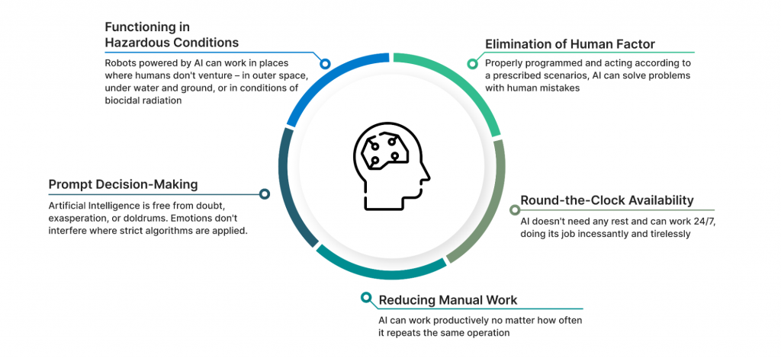

Related: [**Artificial Intelligence In Business: Its Impact and Future Prospects**](https://idapgroup.com/blog/artificial-intelligence-in-business/)

**What Industries Use Artificial Intelligence to Save a Competitive Advantage**

**1. Healthcare**

When it comes to AI in healthcare, our imagination readily conjures an image of a robotic surgery arm performing high-precision operations, after which patients can leave the hospital within a few hours. Yes, AI also partakes in this process, but its scope of employment is far greater. Companies like Cambio Health Care, Coala, and Aifloo, develop innovative software that can track people’s physical and mental condition helping to spot the symptoms of cardiac diseases and strokes or keep a close eye on patients in nursing homes and hospices.

Artificial Intelligence is also instrumental in diagnosing illnesses – the application that has come to the fore in our COVID-ridden world of 2020. Special computer programs working via image recognition can inform people far from the doctor about their health problems and help the physician choose a treatment method. Moreover, some apps (like the one launched by [**Babylon Health**](https://www.babylonhealth.com/)) can act as a doctor, inquiring about a person’s symptoms and providing an instant free consultation on what should be done.

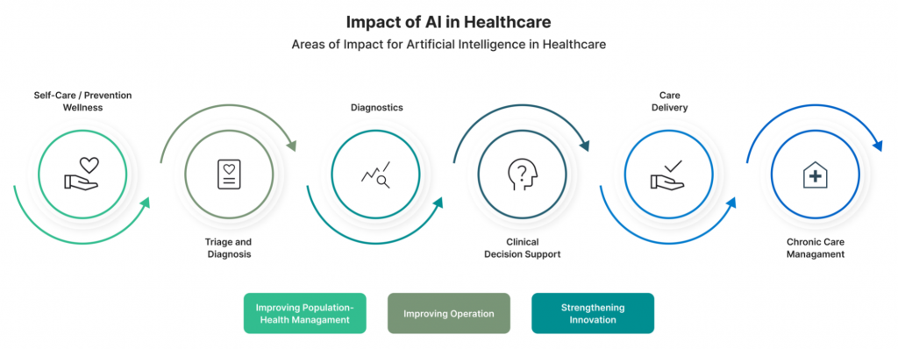

Related: [**Artificial Intelligence For Healthcare: 5 Trends To Watch**](https://idapgroup.com/blog/artificial-intelligence-for-healthcare-5-trends-to-pay-attention-to/)

**2. Education**

The pandemic was a powerful fuel for e-learning. Developers started to create educational apps where AI can map a personalized and efficient path for every learner to acquire knowledge in different domains. The latter isn’t limited to classical math or science. The capabilities of AI, augmented and virtual reality technologies can be helpful even in physical education, to say nothing of history or languages.

While Artificial Intelligence is an excellent help in conventional classrooms, it is indispensable for teaching physically and mentally disadvantaged people. AI-fueled tactile robots do exceedingly well in such cases, helping students not only in certain subjects but with social interactions in general.

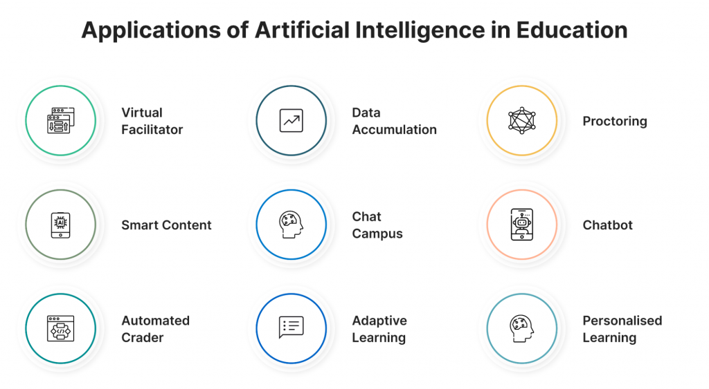

**3. Marketing**

This field is extremely susceptible to the introduction of AI, which can streamline numerous business processes. For example, Responsive Search Ads by Google help to calculate various marketing parameters, including conversion and click-through rates. Other tools are used to optimize:

* the ordering procedure
* customer support
* data analytics
* refund practices
* other elements of the sales workflow

Artificial Intelligence allows enterprise marketers to manage thousands of campaigns in real-time without developers’ participation. The technology tailor offers to each customer to make them client-oriented.

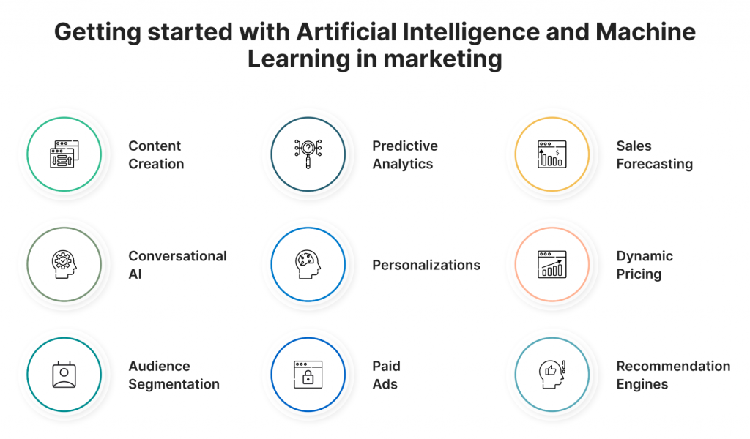

Related: [**Artificial Intelligence As the Main Tool to Make Marketing Campaigns More Effective**](https://idapgroup.com/blog/artificial-intelligence-for-marketing/)

**4. Banking & Finance**

This sector is notorious for its vast amounts of paperwork and documentation. AI is leveraged to reduce them to a necessary minimum, transferring most of them into digital format. Software tools are also applied in banking and finance for data arrangement and subsequent analysis.

For instance, a chatbot by Kami sifts through chat conversations to determine each customer’s tastes and preferences. Thus, financial companies can provide more targeted consultation services and plan their future steps based on AI-obtained insights.

Related: [**Artificial Intelligence In Financial Services: 6 Improvements Of A Lifetime**](https://idapgroup.com/blog/artificial-intelligence-in-financial-services/)

**5. Agriculture**

Here the application of AI is incredibly challenging since it has to consider many hard-to-predict factors related to weather conditions. However, current achievements in this domain are astounding. DOT Technology Corp produced an automatic seeder that can sow a large area without human interference. Other companies feature similar innovative machines whose AI enables them to plant, fertilize, cultivate, and harvest crops and monitor soil moisture levels to determine the necessity of watering them.

Artificial Intelligence is leveraged to literally elevate agriculture to a new level by employing pre-programmed drones that can not only watch the fields form on high and detect possible problems but also spray weedicide or fungicide or even mechanically remove moisture from ripe cherries after a heavy rain to prevent them from bursting.

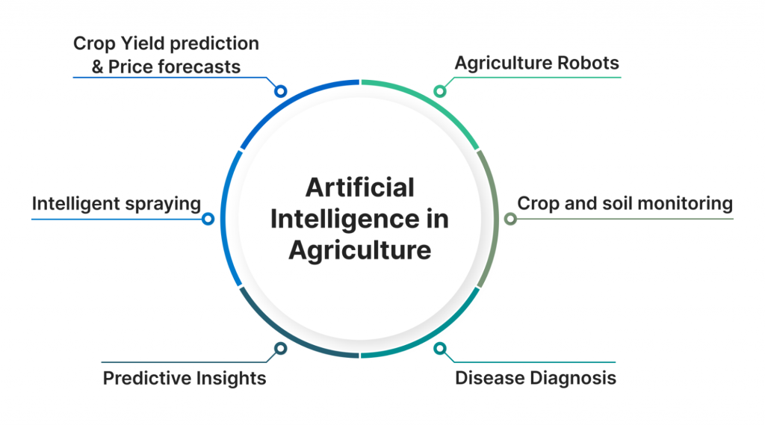

Related: [**Artificial Intelligence & IoT in Agriculture: 6 Smart Ways to Improve the Industry and Gain Profit**](https://idapgroup.com/blog/artificial-intelligence-in-agriculture/)

**6. Transportation**

The world is abuzz talking about self-driving cars, and the first pioneer models have already been tested. Some companies (like [**Waymo**](https://waymo.com/)) have even introduced a public ride-hailing service employing autonomous vehicles. AI in them collects all data from the radar, GPS, cameras, and cloud facilities, which are analyzed to give orders to the control system setting the vehicle into motion and navigating it in the traffic.

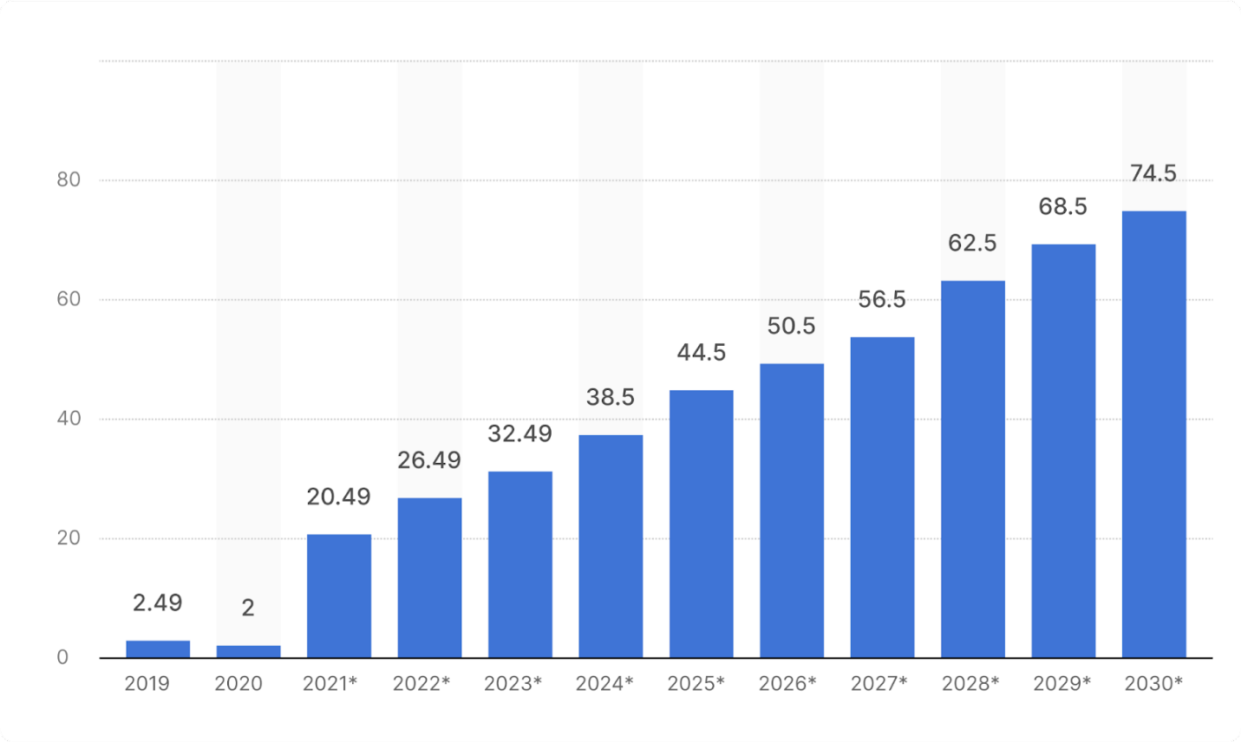Size of the global automotive artificial intelligence market in 2019 and 2020, with a forecast for 2021 through 2030.  
*(in billion U.S. dollars)*

Related: [**How Machine Learning Can Enhance the Supply Chain**](https://idapgroup.com/blog/machine-learning-in-logistics-and-supply-chain/)

**7. Gaming**

The contemporary entertainment industry relies heavily on AI, and gaming is no exception. A modern computer or mobile game is workmanlike software that provides total immersion and creates complex simulations. Moreover, such games stopped being considered an amusement and are widely applied for more serious purposes. For instance, Arctic Shores produces custom games leveraged by blue-chip organizations like Xerox and Citi to evaluate their prospective employees.

**8. Cybersecurity**

Keeping all their activities in digital form, organizations become vulnerable to cyberattacks. AI is employed to protect the huge existing databases against viruses or penetration attempts by wrongdoers who want access to some valuable or sensitive information.

The most [**advanced AI security sy**](https://www.balbix.com/product-overview/)[**s**](https://www.balbix.com/product-overview/)[**tems**](https://www.balbix.com/product-overview/) monitor the network permanently to identify any suspicious activity, nip possible security breaches in the bud, or alert humans who will patch the security hole themselves.

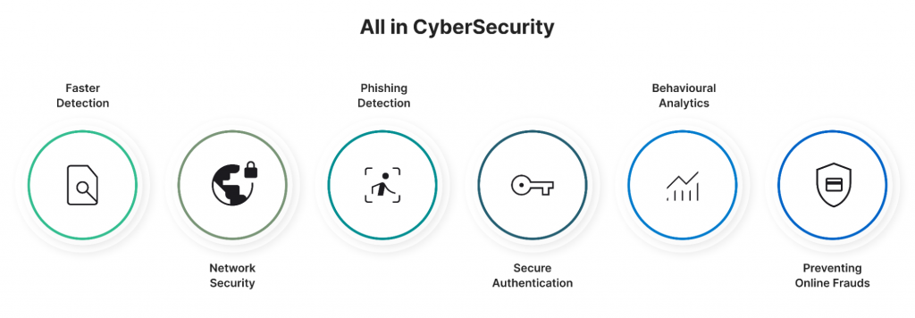

**9. Space Explorations**

Scientists here deal with vast quantities of data that can be processed and analyzed effectively only if AI comes into play. However, Artificial Intelligence finds its primary application in space explorations, not on Earth. While our reach remains too short of sending human expeditions to other planets, AI-powered autonomous machines have to do most of the work, serving as our eyes, ears, and hands where humans don’t dare to set foot so far.

**10. Lifestyle**

Employing AI on a large scale at work and carrying virtual assistants with us on smartphones, we have let it inside our premises as well. Smart homes, integrated living, and the Internet of Things are only starting their advance into everyday housekeeping. Yet, people are ready to delegate to AI numerous household chores, including shopping, cooking, washing, etc. The sophistication and extensive application of image recognition algorithms will make it possible soon.

**Summary**

The world of the early 21st century undergoes rapid changes, quickly transforming into a highly digitalized one. Artificial Intelligence is increasingly penetrating an ever-growing number of industries, making them more human-friendly and turning our planet into a comfortable place to live in.

The list we offered is in no way exhaustive, with AI finding new realms ever to conquer. The [**experts of IDAP**](https://idapgroup.com/about-us/) can accompany you on this exciting journey and create top-notch custom software that will streamline your business activities and boost revenues.