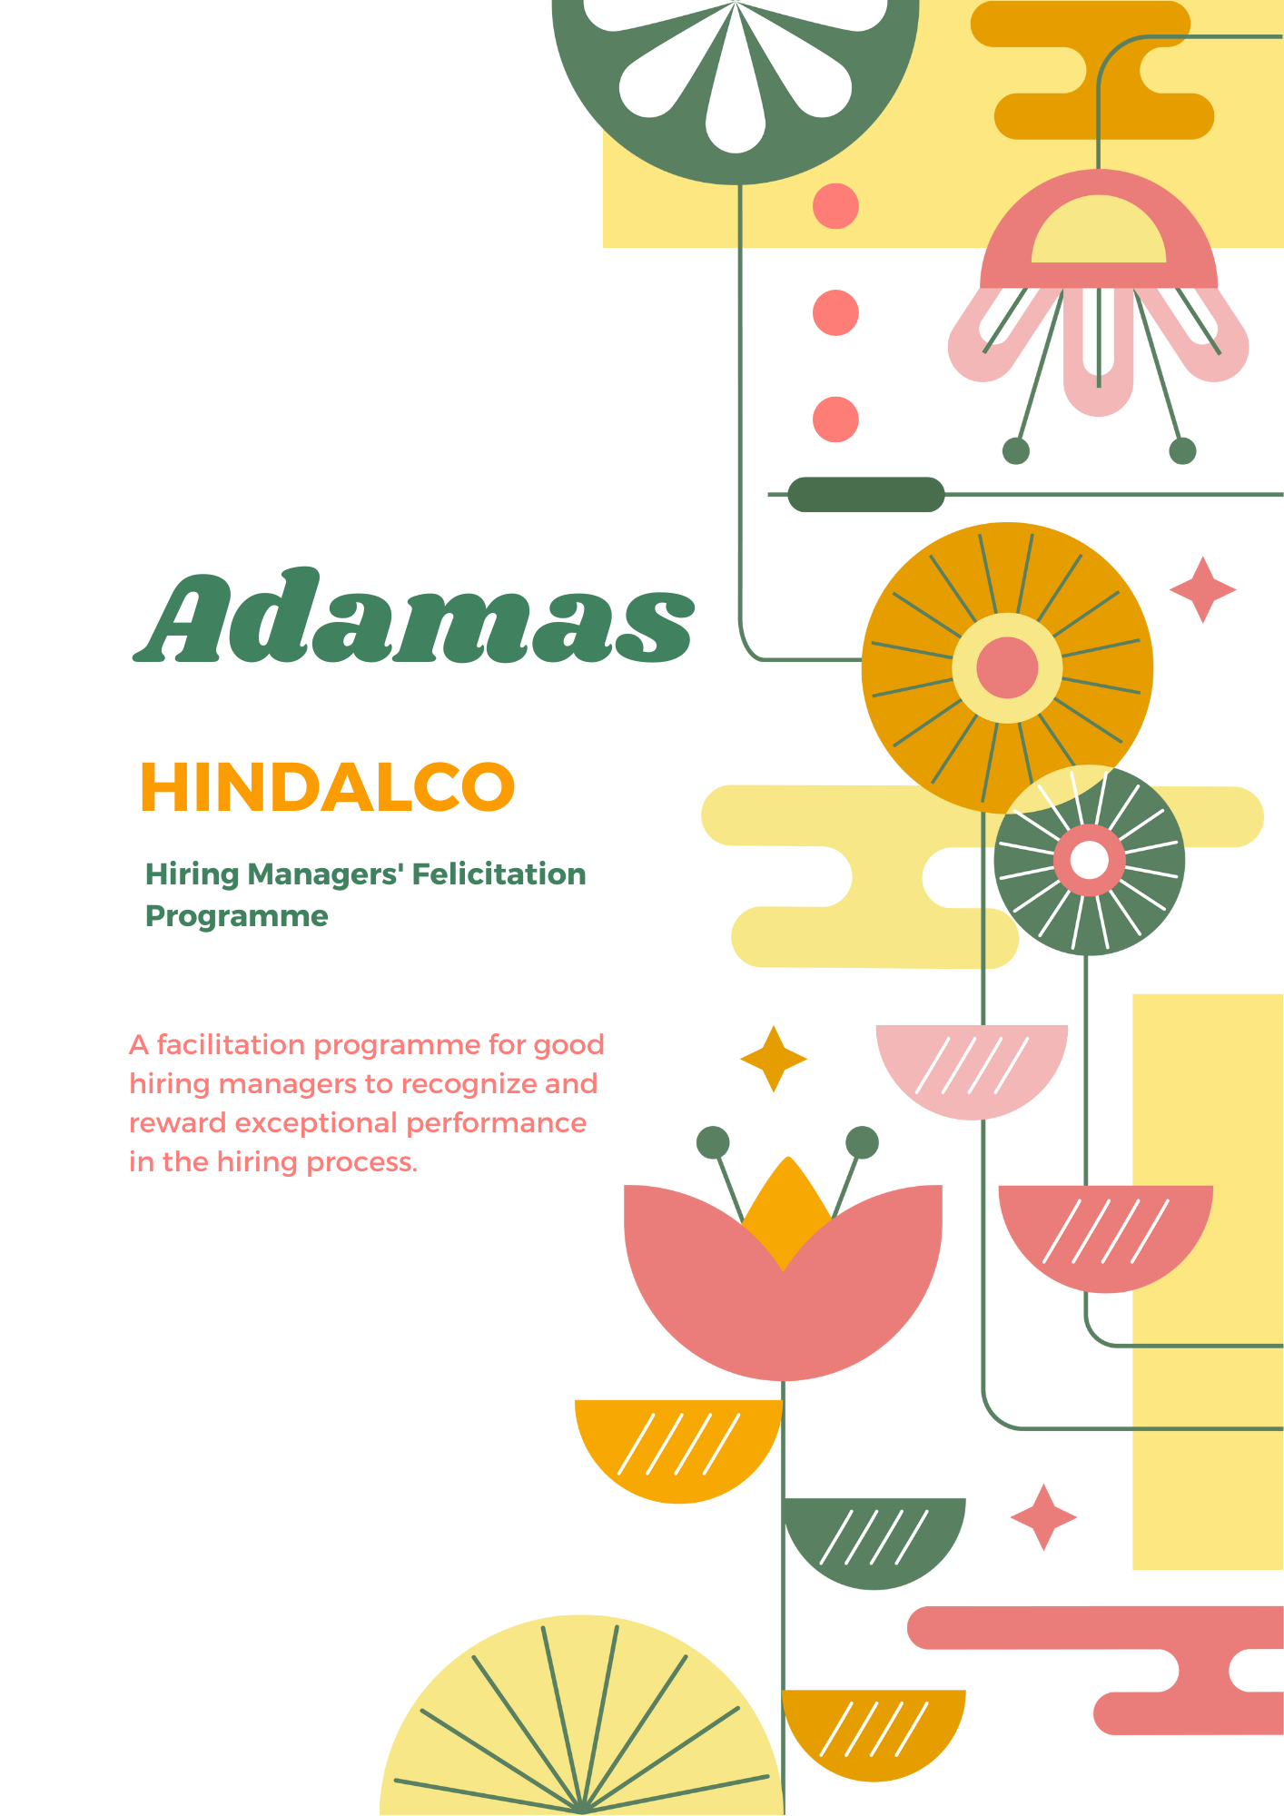This program aims to identify and reward the best performing hiring managers by enhancing their skills, knowledge, and abilities; to ensure that they consistently make informed and effective hiring decisions. By implementing this program, we seek to improve the overall quality of our workforce, increase employee satisfaction, and contribute to the long-term success of our organization.

The Adamas Programme would be two pronged:

**Unit Level**: Unit HR Heads to nominate winners in consultation with Unit Head

* Small (<250 employees): 3 for each unit
* Mid (250-750 employees): 5 for each unit
* Large (>750 employees): 10 for each unit

**National** **Level**: Business HR Heads to nominate winners in consultation with Business Head

* Downstream: 3
* Upstream: 3
* Copper: 2
* Chemicals: 1
* Head Office: 2

*(Note: The National Level winners will obviously be one among the unit level)*

**Evaluation:** Hiring managers will be evaluated based on key performance indicators related to their hiring activities. These KPIs include:

1. **Quality of Hires**: Assessing the performance and fit of candidates hired by the manager.
2. **Yearly Attrition:** Minimizing the yearly attrition for new joiners by deeper engagement.
3. **Time-to-Fill**: Measuring the speed and efficiency of the hiring process.
4. **Time-of-Vacancy**: How much it costs a position to remain unfilled over time.
5. **Cost per Hire:** Total cost required to source, select, and onboard the hire.
6. **Interview-Hire ratio:** The no. of interviewees who get hired.
7. **Offer Acceptance rate:** The no. of hires who accept the offer.
8. **Diversity and Inclusion**: Encouraging the hiring of candidates from diverse backgrounds and promoting equal opportunities.
9. **Candidate Experience**: Evaluating the feedback and satisfaction of candidates throughout the recruitment process in accordance with the Hiring Right Document

* Timely availability for interview
* Interview and interaction with candidates
* Preparation of Job Specs
* Explanation of Job Specs

1. **Recruiter Experience**: Evaluating the feedback and satisfaction of candidates throughout the recruitment process in accordance with the Hiring Right Document

* Preparation of Job Specs
* Explanation of Job Specs

**Rewards:** The facilitation program for good hiring managers will offer the following rewards to recognize their exceptional performance:

* **Performance-Based Incentives:** Hiring managers who consistently demonstrate outstanding performance in their hiring activities will be eligible for performance-based incentives. These incentives may include monetary rewards, bonuses, or additional benefits commensurate with their contributions.
* **Recognition and Appreciation:** Good hiring managers will be publicly recognized and appreciated for their achievements. This recognition can take various forms, such as: a. Shout-outs and appreciation emails from senior leaders. b. Best practices sharing in the company newsletter or website. c. Special mentions at company-wide meetings or events.
* **Best Practices Sharing:** Hiring Managers will be encouraged to share best practices, success stories, and lessons learned with their peers in other units/businesses. This knowledge-sharing aspect of the programme will foster collaboration and enable continuous improvement across the organization.
* **Career Advancement Opportunities:** Exceptional hiring managers may be considered for career advancement opportunities within the organization. Their accomplishments in the facilitation program will be considered during performance reviews and succession planning processes.
* **Professional Development Support:** To support the growth and development of the best hiring managers, Adamas will provide access to training resources and professional development opportunities, like workshops, seminars, online courses, mentorship programmes, aimed at enhancing their skills in areas such as:
  + - Effective interviewing techniques
    - Candidate Assessment and Evaluation
    - Diversity and Inclusion in Hiring
    - Building Empathy with Candidates/Hires

This support will enable them to stay updated with the latest trends, techniques, ______and best practices in the field of talent acquisition.Bottom of Form