|  |  |
| --- | --- |
|  | SUBMITTED TO: PROF.SHRUTHI PATEL |

INTERNATIONAL BUSINESS MINI PROJECT

# DONE BY GAGAN KV

## PES1202201992

CONTENTS TABLE

|  |  |
| --- | --- |
| Topic | Pg no |
| Introduction (International business, Modern world of IB, Opinions) |  |
| Business Environment  Intro of Business environment |  |
| Company Identification (Info about company) |  |
| SWOT Analysis |  |
| PESTAL Analysis |  |
| Functional Areas of the company |  |
| BODY OF THE PROJECT |  |
| E POSTER |  |
| CONCLUSION |  |

**INTRODUCTION**

What is international business? How has it evolved, and what are challenges it has faced? Most importantly what drives international business?

Let’s discuss about it in detail:

International business refers to economic activities that involve cross-border deals of goods, services, and resources between two or further countries. These activities can take various forms, similar as foreign investment, international trade, and cross-border combinations and accessions.

International business has evolved significantly over the once many decades due to various factors, similar as globalization, advances in technology, liberalization of trade programs, and the emergence of new economic powers. Globalization has eased the integration of economies, making it easier for businesses to expand their operations beyond their domestic requests. Advances in technology have also played a significant part in the development of international business, making it possible for companies to communicate, unite, and distribute across borders with ease.

still, the international business also faces several challenges, including political and economic insecurity, cultural differences, legal and regulatory issues, and environmental enterprises. For illustration, companies must comply with colourful laws and regulations when operating in different countries, which can be complex and expensive. also, cultural differences can lead to misunderstandings and miscommunication, making it challenging to do business in foreign markets.

Several factors drive international business. One of the primary drivers is the potential for increased profits and growth openings. By expanding into new markets, companies can tap into new client bases, access new resources and technologies, and diversify their operations. also, companies may engage in international business to reduce their costs of product or to gain access to specialized resources or gift that may not be available in their domestic request.

**MODERN WORLD OF IB**

International business has come an essential part of the modern world's economy. With globalization and technological advancements, the walls to conducting business across borders have been significantly reduced, and companies of all sizes can now easily engage in international business.

Today, numerous companies operate globally, with their operations spanning across multiple countries and continents. These companies engage in various activities, similar as international trade, foreign investment, and cross-border mergers and acquisitions, to expand their reach, tap into new markets, and increase their gains.

One of the crucial drivers of transnational business in the modern world is the adding demand for goods and services from different parts of the world. As further and further people around the world gain access to information and technology, they're getting more apprehensive of the products and services available in other countries. This has led to a growing demand for goods and services from different parts of the world, creating new openings for international business.

Another significant driver of transnational business in the ultramodern world is the adding competition in the global request. As companies expand their operations globally, they're exposed to increased competition from other players in the same industry. This has led to a growing focus on invention, quality, and cost effectiveness, as companies strive to stay ahead of their challengers.

**OPINION**

International business has both advantages and disadvantages. On the one hand, it can give companies with access to new requests, resources, and technologies, allowing them to expand their operations and increase their gains. It can also promote profitable growth and development in countries by creating employment openings, generating profit, and promoting innovation.

On the other hand, international business can also produce challenges, similar as cultural differences, language barriers, legal and regulatory issues, and political insecurity. These challenges can make it delicate for companies to operate in foreign requests and can increase their risks and costs.

Overall, the impact of international business depends on how it's conducted and the extent to which it takes into account the requirements and interests of all stakeholders, including local communities and the terrain. When done responsibly and sustainably, international business can have positive impacts on both companies and societies. still, when conducted without proper consideration for social and environmental enterprises, it can have negative consequences for all parties involved.

**What is business environment?**

The business environment refers to the external factors that affect a company's operations and performance. These factors include economic, political, legal, social, and technological factors, as well as the competitive landscape and the natural environment.

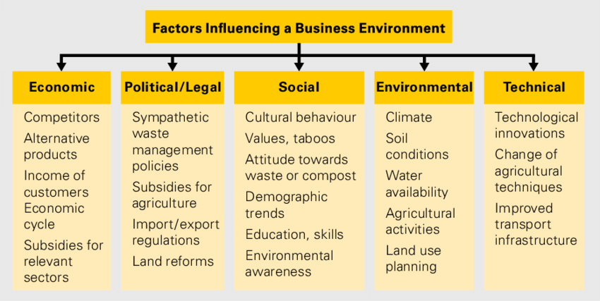

**COMPANY IDENTIFICATION**

Honda Motor Company., generally referred to as Honda, is a Japanese multinational pot that specializes in the manufacturing of motorcars, motorcycles, and power equipment. The company was innovated in 1948 by Shichiro Honda and Takeo Fujisawa, and it has since grown to come one of the largest automobile manufacturers in the world.

Honda is known for its invention and high- quality products. The company has a long history of developing new technologies and introducing new approaches to design and engineering. Some of Honda's notable inventions include the development of the first mass- produced motorcycle with an overhead camshaft, the first mongrel electric vehicle in the United States, and the first hydrogen- powered energy cell vehicle to be certified for marketable use.

Honda's product line-up includes a range of automobiles, motorcycles, and power equipment. In the automotive sector, Honda produces a variety of buses, exchanges, and SUVs, including popular models similar as the Civic, Accord, and CR- V. In the motorcycle sector, Honda produces a wide range of bikes, including sport bikes, traveling bikes, and sedans. Honda is also a major manufacturer of power equipment, including generators, lawnmowers, and snow blowers.

In addition to its products, Honda is also known for its commitment to environmental sustainability. The company has set ambitious goals to reduce its environmental impact and increase its use of renewable energy. Honda has also invested heavily in the development of alternative energy vehicles, including hybrid and hydrogen- powered buses. information of the company

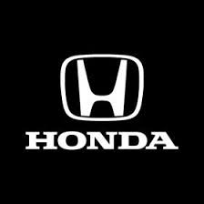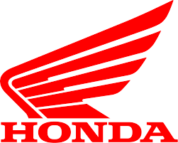

**Evolution of Honda**

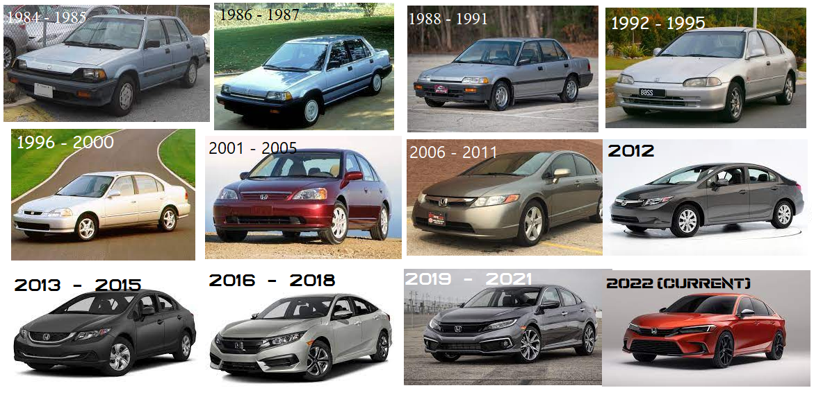

Honda has gone through a significant evolution since its founding in 1948. originally, the company focused on producing small, effective motorcycles for the Japanese market. still, by the 1960s, Honda had started to expand into other markets, including the United States and Europe.

Throughout the 1970s and 1980s, Honda continued to expand its product line-up, introducing a range of automobiles, including the popular Civic and Accord models. The company also developed a character for innovation and engineering excellence, with a focus on developing new technologies and approaches to design.

In the 1990s, Honda began to place a greater emphasis on environmental sustainability, launching its first hybrid electric vehicle, the Insight, in 1999. The company also continued to introduce in areas similar as safety, with the preface of its Advanced Compatibility Engineering (ACE) body structure in 1998.

In the 2000s, Honda continued to expand its product line-up, introducing a range of new vehicles and technologies, including the first hydrogen- powered energy cell vehicle to be certified for marketable use, the Honda FCX. The company also continued to prioritize sustainability, setting ambitious goals to reduce its environmental impact and increase its use of renewable energy.

In recent times, Honda has continued to concentrate on innovation and sustainability, with a particular emphasis on electrification. The company has announced plans to electrify all of its European models by 2025 and has introduced a range of new electric and cold-blooded vehicles, including the Honda e and the Honda Clarity Plug- In Hybrid.

**SWOT ANALYSIS OF HONDA**

Strength:

1. Brand Reputation: Honda has a strong brand reputation globally due to its high- quality products and innovative technologies.
2. Diversified Product Portfolio: Honda offers a diversified product portfolio that includes motorcycles, automobiles, and power equipment, which helps to reduce the risks associated with a single product line.
3. Strong Focus on Research and Development: Honda has a strong focus on research and development, which has led to the development of innovative and dependable products that have helped to establish the brand as a leader in the industry.
4. Strong Distribution Network: Honda has a strong distribution network that covers various countries and helps to reach a larger client base.

**Weaknesses**

1. Limited Global Presence: While Honda has a strong presence in Japan and the United States, the company has a limited global presence compared to its challengers.
2. Dependence on Japanese Market: Honda is heavily dependent on the Japanese request for its profit, which makes it vulnerable to economic fluctuations in Japan.
3. Limited Focus on Marketing: Honda has a limited focus on marketing compared to some of its challengers, which may limit its capability to reach new customers and increase market share.

**Opportunities**

1. Growth in Electric and Hybrid Vehicles: The demand for electric and hybrid vehicles is growing globally, which presents an opportunity for Honda to expand its product portfolio and tap into new markets.
2. Increasing Demand for Energy Efficiency: The adding demand for energy-efficient vehicles presents an opportunity for Honda to influence its expertise in this area and expand its request share.
3. Growing Emerging Markets: The growing arising markets in Asia, Africa, and South America present an occasion for Honda to expand its global presence and increase profit.

**Threats**

1. Intense Competition: The automotive industry is largely competitive, and Honda faces intense competition from established players and new entrants.
2. Economic Fluctuations: The automotive industry is sensitive to economic fluctuations, and a downturn in the global economy could impact Honda's deals and profit.
3. Trade Barriers and tariffs imposed by governments can increase the cost of doing business and impact Honda's profitability.

**Pestle analysis**

Here's a PESTLE analysis of Honda

**Political**

1. Government Regulations Honda is subject to regulations governing the automotive industry in various countries, including regulations on emissions and safety norms.
2. Political Instability: Political instability in countries where Honda operates can impact the company's operations, including supply chain disruptions and changes in trade programs.

**Economic**

1. Economic Cycles: Honda's deals and profit are impacted by economic cycles, with the company's revenue and gains declining during economic downturns.
2. Exchange Rates: Honda's operations are subject to fluctuations in exchange rates, which can impact the cost of product and the pricing of products in different markets.

**Social**

1. Changes in demographics, similar as an growing population, can impact the demand for Honda's products.
2. Shifts in Consumer Preferences Changes in consumer preferences, similar as a growing preference for electric and hybrid vehicles, can impact the demand for Honda's products.

**Technological**

1. Advancements in Electric and Autonomous Vehicles: Advancements in electric and independent vehicles are changing the automotive industry and creating new opportunities for Honda.
2. Digital Technologies: Digital technologies are changing the way consumers interact with automotive brands, and Honda must adapt to these changes to remain competitive.

**Legal**

1. Intellectual Property Lawsuits: Honda may be subject to suits related to intellectual property, which can impact the company's character and fiscal performance.
2. Product Liability suits: Product liability suits can impact Honda's character and fiscal performance, especially in the event of a widespread recall.

**Environmental**

1. Climate Change Regulations: Honda is subject to climate change regulations in various countries, which may bear the company to reduce emissions and develop further sustainable products.
2. Sustainable Supply Chain: Consumers are increasingly concerned about sustainability, and Honda must ensure that its supply chain is sustainable to meet these demands.\

**Functional areas of Honda**

Here are the main functional areas of Honda

1. Research and Development: This department is responsible for developing new products and technologies. It includes masterminds and designers who work on perfecting the performance, energy efficiency, safety, and design of Honda's products.
2. product and Manufacturing: This department is responsible for the product of Honda's products. It includes manufacturing shops, assembly lines, and quality control teams.
3. Marketing and Sales: This department is responsible for promoting Honda's products and generating sales. It includes advertising, public relations, request research, and deals teams.
4. Human Resources: This department is responsible for managing Honda's workforce. It includes hiring, training, compensation, benefits, and employee relations.
5. Finance and Accounting: This department is responsible for managing Honda's financial operations. It includes account, budgeting, fiscal analysis, and duty compliance.
6. Information Technology: This department is responsible for managing Honda's technology structure. It includes developing and maintaining software and tackle systems, data management, and cybersecurity.
7. Supply Chain and Logistics: This department is responsible for managing the flow of materials and products throughout Honda's supply chain. It includes procurement, logistics, force operation, and supplier operation.
8. Legal and Compliance: This department is responsible for ensuring Honda's compliance with legal and regulatory requirements. It includes managing contracts, intellectual property, and litigation.

**Cross cultural issues**

As a global company, Honda must navigate cross-cultural issues in various areas of its operations, including

1. Communication Effective: communication is essential in any business, but it can be challenging when working across different cultures. Honda must navigate language barriers, cultural differences in communication styles, and different social norms that can impact communication.
2. Business Practices: Business practices and customs vary across societies, and Honda must understand and adapt to these differences when doing business in different countries. For example, in some societies, building particular connections is critical to doing business, while in others, it's less important.
3. Legal and Regulatory: Differences Laws and regulations vary across countries, and Honda must insure that it complies with all applicable laws and regulations in the countries where it operates. For example, laws related to intellectual property and data privacy can differ significantly between countries.
4. Employee Diversity: Honda has a different pool, with workers from numerous different countries and cultural backgrounds. Honda must ensure that all workers are treated fairly and respectfully, and that cultural differences are understood and admired in the plant.
5. Consumer Preferences: Consumer preferences vary across different societies, and Honda must understand and adapt to these differences when designing and selling its products. For example, preferences for vehicle size, color, and features can vary significantly between countries

**Managing cross border teams**

1. Building Cultural Awareness Honda recognizes the importance of cultural awareness and understanding in managing cross-border teams. The company provides cultural training to its workers to help them more understand different societies and work effectively across borders.
2. Effective Communication Honda places a strong emphasis on effective communication to ensure that teams working across borders are suitable to unite effectively. The company uses technology, similar as video conferencing and collaboration tools, to facilitate communication between team members in different locations.
3. Leadership Development Honda invests in leadership development programs to ensure that its directors have the skills and knowledge necessary to manage cross-border teams effectively. The company provides training on cultural mindfulness, communication skills, and team operation to help its directors succeed in a global environment.
4. Shared Goals and objects Honda ensures that cross-border teams have participated goals and objects, so that all team members are working towards the same outcome. This helps to ensure that teams are aligned and working together effectively, indeed if they're located in different countries.
5. Regular Team Meetings Honda ensures that cross-border teams hold regular team meetings to bandy progress, share ideas, and address any issues that may arise. This helps to insure that team members stay connected and informed, indeed if they're working in different locations.

**Global marketing strategies**

1. Global Branding: Honda has established a strong global brand that's recognizable and trusted by consumers around the world. The company's marketing efforts concentrate on reinforcing this brand through consistent messaging and visual identity across all markets.
2. Localized Marketing: While Honda has a consistent global brand, the company also recognizes the significance of localizing its marketing efforts to appeal to consumers in specific regions. For illustration, Honda may adapt its marketing messages and product offerings to reflect original preferences and cultural differences.
3. Product Innovation: Honda is known for its innovative products, and the company's marketing strategies frequently concentrate on pressing these inventions to consumers around the world. For illustration, Honda may promote the energy efficiency or safety features of its vehicles in different markets, depending on the requirements and preferences of original consumers.
4. Digital Marketing: Honda has embraced digital marketing to reach consumers around the world. The company's digital marketing efforts include social media advertising, hunt machine optimization, and online video campaigns, among other tactics.
5. Sponsorships and Partnerships: Honda has established partnerships with sports brigades, events, and other associations to reach consumers and make brand mindfulness. For illustration, Honda sponsors the National Football League (NFL) in the United States and the World traveling Car Championship (WTCC) in Europe

**INTERNATIONAL STRATEGIES FOR BRAND DEVELOPMET**

1. Honda is a global brand that has established itself as a leader in the automotive industry. The company has a strong focus on innovation, quality, and client satisfaction, and has built a character for trust ability and performance. To continue to develop its brand, Honda should consider the following international strategies
2. Focus on global branding: Honda should continue to concentrate on developing its brand globally by emphasizing its core values of innovation, quality, and client satisfaction. The company should use harmonious branding across all of its markets to support its global image and make brand equity.
3. Adapt to local markets: While Honda should maintain a consistent global branding strategy, it should also adapt its branding to local markets. The company should research the cultural and social morals of each market it operates in and tailor its branding to resonate with local consumers.
4. Emphasize environmental sustainability: Honda is known for its commitment to environmental sustainability and should continue to emphasize this in its branding. The company should promote its Eco-friendly products and enterprise to make a character as a responsible and environmentally conscious brand.
5. Leverage social media and digital marketing: Honda should work social media and digital marketing to make brand mindfulness and engage with consumers. The company should use social media platforms to partake content and connect with guests, and invest in digital advertising to reach new audiences.

**Study of import export procedure**

Import and import procedures are an important aspect of Honda's global operations. The following is an overview of the import and import procedures that Honda generally follows

Import procedure

1. Obtain necessary import licenses and permits Honda must obtain the necessary import licenses and permits from the applicable government agencies to export its products from one country to another.
2. Secure a freight forwarder Honda generally works with a freight forwarder to handle the logistics of dispatching its products overseas. The freight forwarder helps with customs clearance, documentation, and transportation.
3. Prepare the necessary documents Honda must prepare various documents, including commercial checks, packing lists, bill of lading, and export declaration, to comply with the customs regulations of both the exporting and importing countries.
4. Load the products onto the vessel Once the products are ready for shipment, Honda loads them onto the vessel or aircraft for transport to the destination country.
5. Submit needed documents to customs Honda submits the needed documents to customs at the port of departure and ensures that all customs procedures are followed before the products are exported.

Import procedure

1. Obtain necessary import licenses and permits Honda must obtain the necessary import licenses and permits from the applicable government agencies to import its products from another country.
2. Hire a customs broker Honda generally hires a customs broker to handle the customs clearance process, which includes filing import declarations and paying import duties and levies.
3. Arrange for transportation Honda arranges for transportation of its products from the port of entry to its warehouse or distribution center.
4. check the products Once the products arrive at the port of entry, they're audited by customs officers to ensure compliance with safety and quality norms.

**E-POSTER**

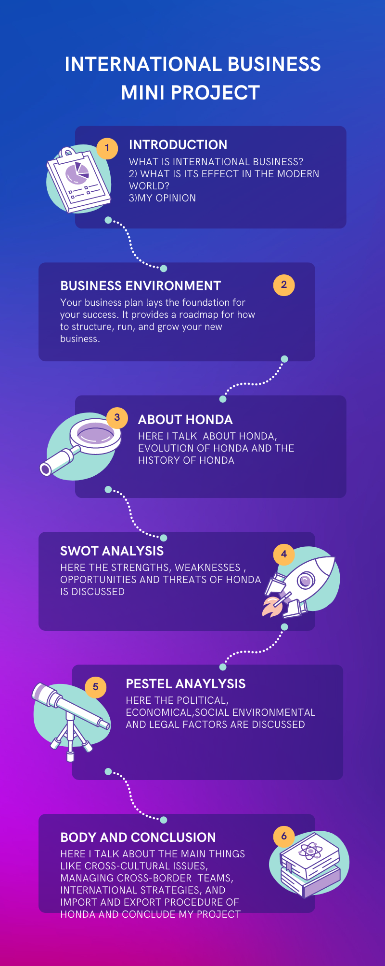

**Conclusion**

Honda is a well- known and admired multinational corporation that has a strong character for producing high- quality motorcars, motorcycles, power equipment, and aircraft.

Honda has been a leader in the automotive industry for numerous times, particularly in the development of energy-efficient and environmentally friendly vehicles. The company has also made significant strides in the area of independent driving technology and has invested heavily in research and development to stay at the forefront of this emerging field.

Overall, Honda is a well- established and innovative brand that continues to evolve and acclimatize to meet the changing requirements of its clients and the broader market. Its commitment to quality, trustability, and sustainability has made it a popular choice for consumers around the world.