INSTRUCTIONS:
This written assignment consists of two questions which will let you demonstrate your communication skills and abilities as a business analyst.
You have until Wednesday April 12th at 12:00PM PST to complete and submit your response.
- Include your name on each page of your written response. Your response should be no more than two pages.
- Save your completed assignment as a single PDF document using the naming convention: Lastname-Firstname-98422-Written.
- Document any assumptions that you make.
- Email your completed assignment as an attachment to: Jennifer.Todd@gov.bc.ca
- Late submissions will not be accepted. If you do not submit your response document within the allowed time, it will be taken as an indication that you have withdrawn from the competition.

QUESTION 1:
Scenario: As a Business Analyst, you are responsible for coordinating user acceptance testing (UAT) for various software applications.
Over the next month, there will be several projects that you need to provide support on:
1. UAT for bug fixes for the main software application that requires extensive testing
2. UAT for a newly created web tool called SalaryCalculator
3. Content updates in the content management system for the website
4. Project support for several internal projects
Question: How will you prioritize the projects and create the UAT plan for the test teams?
In your answer, please explain the following:
- what factors you will consider;
- the actions you will take to manage this situation and why;
- any communication methods you will use;
- any specifics you will discuss with the UAT testers.
QUESTION 2:
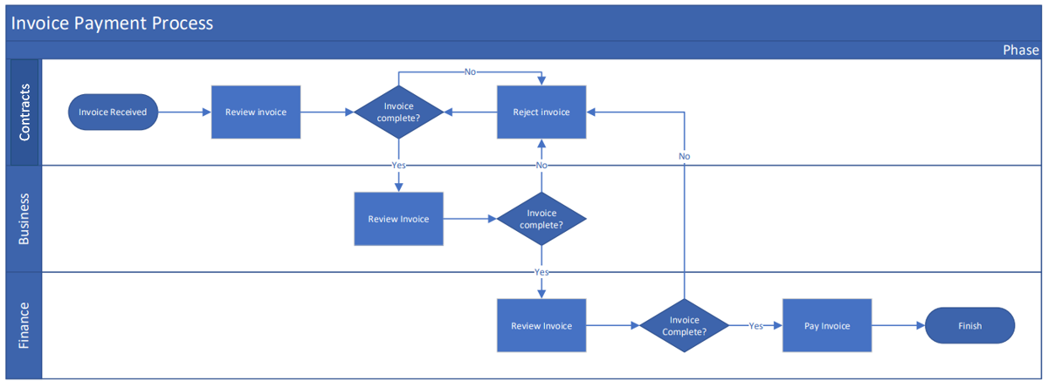You have received the above process flow describing how invoices are received and paid. You’ve been asked to make the following edits:
- Update the diagram to include a new stakeholder, the vendor. The vendor is the stakeholder that issues the invoice which starts the current workflow.
- The Finance area has asked you to review the invoice before the business. Update the diagram to reflect this.
- Update anything you think will improve readability and address any flaws you find within the current process.
- Include with your updated diagram a bulleted list of the changes you have made, briefly describing your reasoning for the change.

