

**UNIVERSITY OF PETROLEUM & ENERGY STUDIES**

**School of Business, Dehradun**

# Synopsis On

**Analysis of Recovery in Airline Transport Industry Post Covid- 19**

# BBA

**Aviation Operations 2020-2023**

**Submitted To:**

**Dr.** Prasoom Dwived

Course Coordinator

School of Business

University of Petroleum and Energy Studies

# Submitted By:

Mohammad Ali

BBA Aviation Management 2020-2023

R460220017 500084450

**Table of Contents**

Rationale, purpose, importance of research 1

Overview: Conceptual Framework 1

Purpose of the study 5

Importance of Study 6

Literature Review 7-11

Research Gap 12

Problem Definition 13

Research Objectives 14

Research Design & Methodology 15

Research Approaches 16

Research Methodology 16

Expected Result(s) 17

Limitations of the study 18

Time Plan 22

ANNEXURE A, B, C .26

References 29

* 1. **Overview:**

By 2020, COVID-19 has evolved into a full-fledged pandemic, posing a threat to our health and global economies. It was first discovered in 2019 near Wuhan and is caused by the Severe Acute Respiratory Syndrome Coronavirus 2 (SARCov-2).   
On March 11,2020, it was declared as pandemic by the WHO. COVID-19 has caused 105.8 million confirmed cases and more than 2.3 million fatalities as of February 9th, 2021.

Among all the industries, aviation sector faced the hardest fall. The unprecedented drop in passenger demand forced almost all the airlines to halt their operations. Companies had to ground entire fleets and runways were closed to make room for aircraft parking. Strict rotations were done with minimal staffing and production lines were shut down.

We can’t overlook the fact that aviation sector did play a key role in disease transmission turning an epidemic (local) into a pandemic (global). Looking into previous major diseases like: Ebola, SARS/MERS, seasonal influenza, and Malaria/Dengue fever, most of which were contained before becoming a full pandemic on the scale of COVID-19.

The number of flights reduced is the evidence of the effects of COVID-19. However, the aviation industry has proven to be resilient in major setbacks like oil crises, financial crises, wars and earlier diseases, and will almost certainly find a way to overcome COVID-19.

It should be noted that our review focuses primarily on papers published after the outbreak, with only brief references to important earlier papers provided when absolutely necessary for understanding the context. For a complementary review of air transportation literature up to COVID-19, as well as how this literature may define and lead to a post-COVID-19 aviation future.

The rest of this study is organized as follows. Section 2 provides an overview of the existing literature for air transportation as a system, with a focus on how flight suspensions affect the global network. Section 3 focuses on the passenger-centric experience of flying, including airport processing, boarding, and in-flight activities. Section 4 examines the literature on the long-term impact of COVID-19 on aviation. Section 5 concludes our research and makes recommendations for future work based on the findings of our literature review.

# Purpose of the study:

* To find out the challenges face by the airline faces in Post Covid-19
* To find out the measures adopted by Airline industry, to recover after the Pandemic and regain operations.

# Importance of Study:

A novel coronavirus, which many believe is far worse than the 2008 tragedy, had a significant impact on the aviation industry. Large airlines, which represent the entire industry, are the only ones with accurate information. While specific regions are highlighted, the Asia Pacific region's developing aviation sector has been left out. The research aims to highlight the airlines industry that faces the most challenges, with a focus on a well-known carrier in airlines that filed for bankruptcy and went bankrupt during the pandemic but received little attention or scrutiny. The study prioritizes the airline industry, its challenges, and pandemic recovery techniques and measures, considering airlines and their challenges and giving them appropriate prominence.

# Literature Review

In recent years aviation industry has grown steadily, owing primarily to tourism and cargo demand around the world. As a matter of fact, in many sections, the industry has been a key contributor to social development and economic growth. Millions of skilled and semi-skilled workers are employed directly and indirectly throughout the aviation value chain.

In the last two years, studies related to the Covid-19 pandemic in aviation industry have been published. Some of the studies are listed below in the table.

In Abate et al. research paper, they began by exploring the factors that influence government’s willingness to support airlines. Secondly, they started examining the outcomes of government support for air transport policy.

Albers and Rundshagen investigated how the airline responded to the COVID-19 crisis in the spring of 2020. Czerny et al. conducted a study on the post-pandemic aviation market recovery, experience, and lessons from China, the world's first aviation market severely affected by COVID-19.

The COVID-19 outbreak is discussed in this study as an opportunity to reconsider the fundamentals of the global aviation system.

Using the event study methodology, Maneenop and Kotcharin [30] investigated the short-term impact of the 2019 COVID-19 pandemic on 52 globally listed airlines. As a result of the three major COVID-19 announcements, airline stock returns fell more than market returns. In terms of pre-Covid-19, Massaro and Rossetti [31] investigated the links between tourist traffic at some airports and the related development of the cities where they are located.

According to the data, many studies have been published analyzing the negative impact of Covid-19 on the aviation industry. This research enhances the existing literature by providing a detailed analysis of Covid-19’s effect on various airlines.

This research introduces the changes in the aviation industry’s business environment in terms of airline economics, market competition, labour relations, and health preventive measures as a result of the Covid-19 pandemic.

**Table-1 Literature Review**

|  |  |  |  |  |
| --- | --- | --- | --- | --- |
| **S. No** | **Title** | **Author(s)/ Year** | **Country/Airport(s)** | **Tools/ Methods** |
| 1. | Government support to airlines in the aftermath of the COVID-19 pandemic | Abate et al. (2020) | General | Statistical analysis |
| 2. | Investigation of extent of grounded aircraft at UK airports | Adrienne et al.  (2020) | United Kingdom | Statistical Analysis |
| 3. | Analysis of airline reactions to the COVID-19 crisis | Albers and Rundshagen  (2020) | European Airlines | Statistical Analysis |
| 4. | Post pandemic aviation market recovery | |  |  | | --- | --- | | Czerny et al. | 2020 |   (2020) | Chinese Airlines | Statistical Analysis |
| 5. | Examination of the short-term impact of the COVID-19 | Maneenop and Kotcharin  (2020) | 52 airline companies | Statistical Analysis |

# Research Gap:

• There is a lack of accurate analysis of the effects of novel coronaviruses on airlines, particularly in the global context.

• Furthermore, research on the effects and difficulties of the coronavirus lacks information on self-defense tactics that the aviation industry should employ aside from government involvement and investor-related remedies.

• Most studies leave out the failures and issues that the aviation industry faced during the Pandemic, as well as the difficulties it is currently facing, as well as viable options for dealing with all the debts and losses.

# Problem Definition:

According to statement made by Airbus' Guillaume Faury, EasyJet's Johan Lundgren, United Airlines' Oscar Munoz, and Qantas' Alan Joyce in early 2020, the Covid-19 crisis was worst in the aviation industry’s history. The industry faced lot of situations like travel restrictions and drop in customer demand.

Decrease in number of passengers resulted in flight cancellations or planes flying empty between airports, this resulted in massive revenue reductions for airlines and forcing them to lay off employees and declare bankruptcy. To overcome those losses, some airlines attempted to avoid refunding cancelled trips, employees from airline manufacturers and operators were laid off.

Comparing the stats with 2019, 10% of all flights were cancelled in early March 2020. As pandemic made progressed around 40-60% flights were forced to cancel, with international flights being the most affected. By the start of April over 80% of flight movements were restricted due to worldwide lockdown. Fig 1.

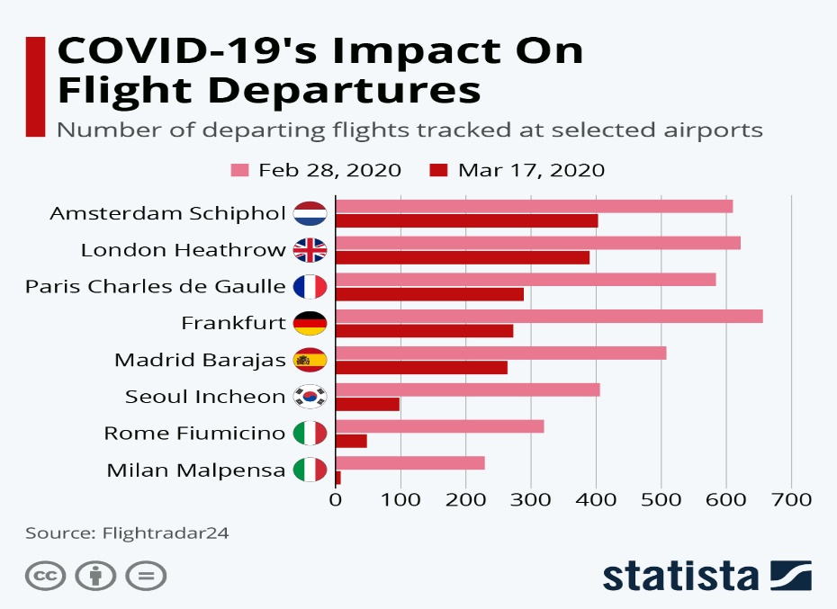

**Figure 1**

Talking about consequences, when passenger flights were cancelled cost of shipping cargo by air fluctuated dramatically. In February 2020, cargo capacity fell by 4.4% while on the other hand, air cargo demand fell by 9.1% but the near halt in passenger traffic reduced capacity even further, as commercial aircraft carries half of global air cargo.

Resulting in air cargo prices arising from ₹65.31/kg for transatlantic cargoes to ₹204/kg, alluring passenger airlines to operate cargo-only flights using freighters, whereas cargo carriers reactivated fuel-guzzling stored aircraft, aided by falling oil prices.

At the end of March 2020, cargo capacity was 35% lower than the previous year.

Due to suspension of domestic service many countries' international mail stopped completely.

Due to unexpected and large losses in revenue, airlines began declining to refund cancelled flights ticket in order to save money despite government regulations. In Europe, airlines successfully negotiated a $1.2 billion delay in air traffic control charges. Overall, we can say airline traffic was less affected than business aviation.   
According to research, global passenger demand recovery to pre-COVID-19 levels is expected to take 2.4 years (recovery by late 2022), with the most optimistic estimate being 2 years (recovery by mid-2022) and the most pessimistic estimate being 6 years (recovery in 2026). There are significant regional differences: Asia-Pacific has the shortest estimated average recovery time of 2.2 years, followed by North America in 2.5 years and Europe in 2.7 years. When compared to passenger demand, air freight demand is expected to recover in 2.2 years on average. Europe and North America have comparable average recovery times of 2.2 years, while Asia-Pacific is expected to recover faster in 2.1 years.

# Research Objectives:

* To learn how Covid-19 has affected airline industry
* To learn about the challenges that airline industry faced in Post Covid-19, go here.
* This research is meant to specify how airlines change during covid and will focus upon how business revived as revenue was low and expenses remained same so to increasing revenue through other sources was a challenge