**LEFT SHIFT ASSIGNMENT SAP PART 2**

1. Create Smart form with driver program (USING OOPS CONCEPTS: Create global class to fetch data) with the below template.

Selection Screen: Invoice Number

NOTE: Every level should be dynamic. USE TCODE: SO10 for dynamic labels)

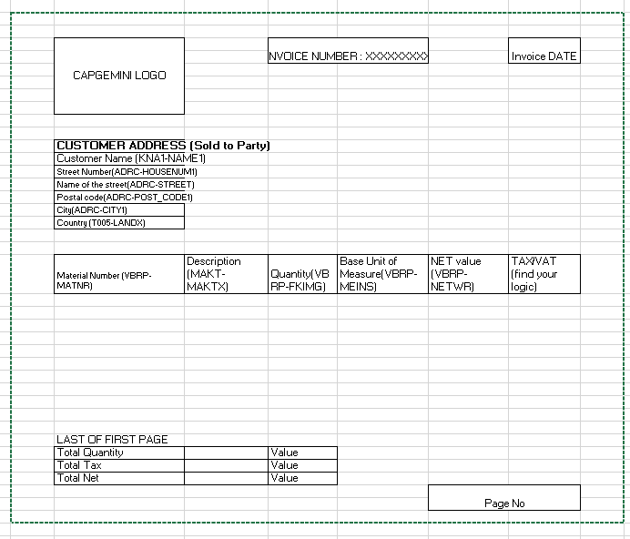

1. Create a Function Module to read the line items of purchase order

INPUT: Purchase Order Number (Optional / if empty then it should fetch all purchase order).

Output: An Internal table with all the Line Item Details (1tem No, Material No,

Quantity and Net Price) for the given Purchase Order.

1. Create module pool program for with custom tables

|  |  |  |
| --- | --- | --- |
| Screen No. | Purpose | Type |
| 100 | Logon details | Normal screen |
| 200 | Change password | Normal screen |
| 300 | Create Trainee initial screen | Normal screen |
| 400 | Create Trainee main screen | Normal screen with tab strips |
| 500 | Trainee general details | Tab1 - Sub screen |
| 600 | Trainee Education details | Tab2 - Sub screen |
| 700 | Trainee Professional Details | Tab3 - Sub screen |
| 800 | Trainee Course Details | Tab4 - Subs Screen |

On screen 100 – fields: Username, Password

On screen 200 – fields: Old password, new password, confirm password

On screen 300 – fields: Trainee ID

On screen 400 – fields: Trainee ID

On screen 500 – Fields: Name , Date of Birth , city ,House No , Country , Email Id , Mobile number , Landline number .

On screen 600 –Fields: Qualification , Proficiency , Year of pass , University.

On screen 700 – Fields: Total year of Exp , and table End date , form date , Organization

On screen 800 – Fields: Course , Faculty, Date of join