**INTRODUCTION**

**ABOUT ZOMATO:**

Zomato is a food delivery and restaurant discovery platform based in India. The company was founded in 2008 by Deepinder Goyal and Pankaj Chaddha, and is headquartered in Gurugram, India. Zomato is one of the largest food delivery companies in India and operates in over 24 countries globally.

Zomato provides a range of services related to food, including online ordering and delivery, restaurant discovery, and table reservations. The platform has a database of over 1.5 million restaurants across 24 countries, making it one of the largest restaurant search engines in the world.

Zomato has a strong focus on customer experience and has built a robust technology platform to support its operations. The company uses data analytics and machine learning algorithms to optimise its food delivery operations and provide personalised recommendations to its customers.

Zomato has also diversified its business by launching additional services such as Zomato Gold, a premium membership program that offers discounts and other benefits at select restaurants. In addition, the company has expanded into the grocery delivery space with the launch of Zomato Market, a service that delivers groceries and household essentials.

Zomato has raised significant funding from investors, including Alibaba's Ant Financial, Info Edge, and Sequoia Capital. The company went public in July 2021 and its shares are listed on the National Stock Exchange of India and the Bombay Stock Exchange.

Despite facing intense competition from other food delivery platforms, Zomato has been able to maintain its position as a market leader in India and expand its operations globally. The company has a strong brand reputation and is known for its customer-centric approach to business.

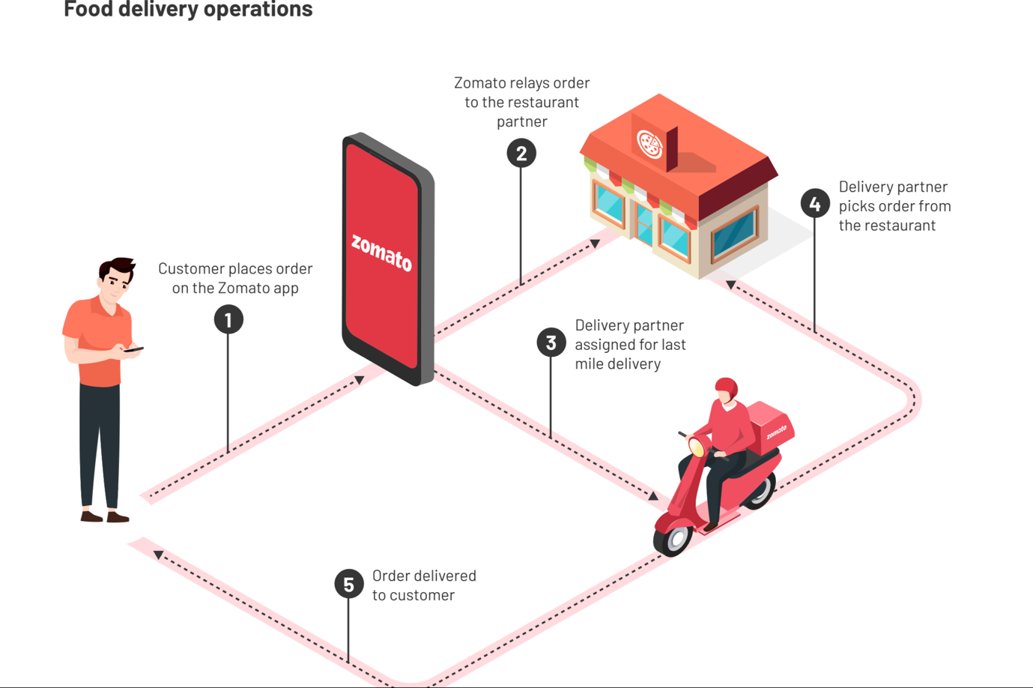

Here are some important statistics about Zomato as of 2021:

1. Zomato operates in 24 countries, including India, the United States, Canada, and Australia.
2. Zomato has over 1.5 million restaurant listings on its platform.
3. Zomato has over 150 million monthly active users.
4. Zomato has over 2 million registered food delivery partners.
5. Zomato is valued at over $5 billion as of 2021.
6. Zomato has processed over 1 billion food orders since its inception.
7. Zomato's revenue for the year 2020-21 was INR 2,743 crores.
8. In 2021, Zomato went public with its IPO, raising INR 9,375 crores ($1.3 billion).
9. Zomato's mobile app has been downloaded over 150 million times.
10. Zomato employs over 6,000 people across its various offices and locations.

**Hyper-pure operations:**

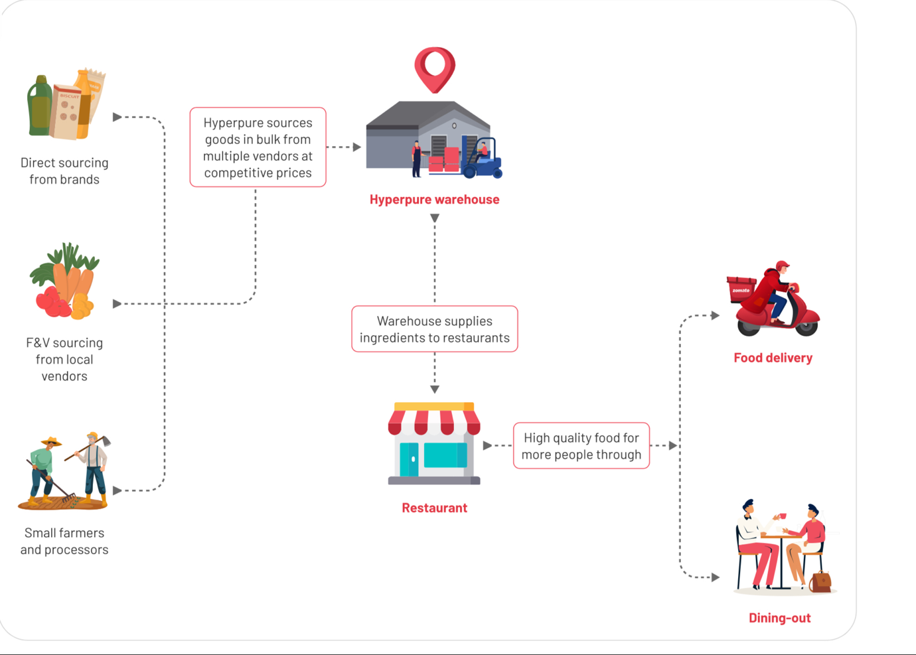

**TYPES MARKETING TECHNIQUES:**

Marketing techniques can be broadly categorised into traditional and digital methods. Here are some of the most commonly used marketing techniques under each category:

Traditional Marketing Techniques:

**Print Advertising**: Print advertising is a type of marketing communication that uses printed materials such as newspapers, magazines, brochures, flyers, posters, billboards, and direct mail to promote a product, service, or brand. Here are some important aspects of print advertising:

1. Target audience: Print advertising allows businesses to reach their target audience effectively. For example, a company that sells luxury watches can advertise in high-end magazines that cater to affluent consumers.
2. Visual impact: Print advertising uses eye-catching visuals, typography, and colour to grab the attention of the target audience. A well-designed print ad can make a lasting impression on the reader.
3. Message: Print advertising must convey a clear message that resonates with the target audience. The message should be concise, relevant, and compelling.
4. Call-to-action: A call-to-action is an essential part of any print ad. It is a message that urges the reader to take action, such as making a purchase or visiting a website.
5. Placement: The placement of a print ad is critical to its success. Advertisers need to choose the right publication or medium that reaches their target audience. They also need to consider factors such as ad size, location, and frequency.
6. Measurable results: Print advertising can be tracked and measured, allowing businesses to evaluate the success of their campaigns. For example, businesses can track the number of sales generated from a print ad or the number of website visits from a direct mail campaign.
7. Cost-effectiveness: Print advertising can be cost-effective, especially for small businesses. Compared to other forms of advertising such as television and radio, print advertising is often less expensive and can still reach a wide audience.

Overall, print advertising remains an important part of the marketing mix. While digital advertising has gained popularity in recent years, print advertising still has its place in reaching certain audiences and delivering powerful messages.

This includes newspapers, magazines, brochures, flyers, billboards, and posters.

1. **Broadcast Advertising**:

Broadcast advertising refers to the practice of promoting a product, service, or brand through television or radio broadcasts. It involves creating ads that are aired during specific time-slots on various TV or radio stations. Broadcast advertising is a traditional form of advertising that has been used for decades to reach a wide audience.

Television ads are usually 30 seconds to 60 seconds in length and can be produced in various formats, including animation, live-action, or a combination of both. Radio ads are typically shorter and rely more on audio creativity to capture the audience's attention.

Broadcast advertising can be a highly effective way to reach a large audience, particularly when targeting a specific demographic. It allows advertisers to create compelling visual or auditory content that can capture the viewer or listener's attention and leave a lasting impression.

However, broadcast advertising can be expensive, and it may not always be the best option for all businesses. With the rise of digital advertising, many companies are shifting their advertising budgets towards online platforms, which can offer greater targeting capabilities and measurable results.

Overall, broadcast advertising remains an important part of many businesses' advertising strategies, particularly for those targeting a mass audience. However, with the growth of digital advertising, it's important for businesses to consider all advertising options available to them and choose the ones that are most effective for reaching their target audience. This includes radio and television advertisements.

1. **Direct Mail**:

Direct mail is a form of marketing where businesses or organisations send promotional materials, such as flyers, brochures, postcards, catalogs, or letters, directly to a targeted group of people through mail. The targeted group may be selected based on demographics, interests, or previous purchase behavior.

Direct mail marketing can be an effective way for businesses to reach their target audience, as it allows them to tailor their message to the specific needs and interests of the recipients. It can also be highly measurable, as businesses can track the response rates and conversions from their direct mail campaigns.

Direct mail can be expensive compared to other forms of marketing, but it can be a worthwhile investment if done correctly. To create a successful direct mail campaign, businesses need to develop a strong mailing list, create attention-grabbing designs and messages, and carefully track the results to improve future campaigns.

With the rise of digital marketing, some may argue that direct mail is an outdated form of marketing. However, many businesses still use direct mail as part of their marketing mix, especially for targeting certain demographics or for promoting high-value products or services.This includes sending marketing messages via mail, such as postcards or catalogs.

1. **Telemarketing**:

Telemarketing is a marketing technique where businesses or organizations use phone calls to directly contact potential customers or clients with the aim of selling a product or service or to collect information. The approach can be either inbound, where customers call a business, or outbound, where businesses make calls to potential customers.

Telemarketing can be highly effective when done correctly, as it allows businesses to reach a large number of potential customers quickly and efficiently. It is also highly measurable, allowing businesses to track metrics such as call volume, conversion rates, and customer feedback.

However, telemarketing can also be highly intrusive and annoying to customers, leading to a negative perception of the business. It is also highly regulated in many countries, with strict laws around unsolicited calls and the use of automated dialing systems.

To be successful in telemarketing, businesses need to follow best practices to ensure that they are providing a positive experience for customers. This includes using professional and polite language, respecting customers' time and preferences, and ensuring that the products or services being offered are relevant and valuable to the customer.

Businesses should also ensure that they are complying with all relevant laws and regulations, such as the National Do Not Call Registry in the United States, which allows consumers to opt-out of receiving telemarketing calls.

Telemarketing can be a cost-effective way to generate leads and sales, but it is important for businesses to balance the potential benefits with the potential risks and costs. It is also important to consider other forms of marketing, such as email marketing, social media marketing, and content marketing, which can be more targeted, less intrusive, and offer greater potential for engagement and relationship-building with customers.This involves calling potential customers to promote products or services.

1. **Outdoor Advertising**:

Outdoor advertising refers to any type of advertising that is displayed outdoors, such as billboards, posters, digital displays, and signage. The goal of outdoor advertising is to reach a large audience and create brand awareness. Here are some examples of outdoor advertising:

1. Billboards: Billboards are one of the most common forms of outdoor advertising. They are large, eye-catching displays that can be found on highways, city streets, and other high-traffic areas. Billboards can feature text, images, or a combination of both.
2. Digital Displays: Digital displays are becoming increasingly popular as outdoor advertising. They can be found in busy urban areas, shopping malls, and other high-traffic locations. They can display animated or video content, allowing for more creative and engaging ads.
3. Posters: Posters are another common form of outdoor advertising. They are typically found on walls, bus stops, and other public spaces. They can be used to promote a variety of products and services, and are relatively inexpensive to produce.
4. Transit Advertising: Transit advertising involves placing ads on public transportation, such as buses, trains, and subway cars. These ads can be seen by thousands of people each day, making them an effective way to reach a large audience.
5. Street Furniture Advertising: Street furniture advertising refers to ads that are placed on public amenities, such as bus shelters, benches, and kiosks. These ads are often eye-catching and can be seen by people as they go about their daily routines.

Overall, outdoor advertising can be an effective way to reach a large audience and create brand awareness. By using creative and eye-catching designs, advertisers can capture the attention of potential customers and drive sales.

This includes billboards, signage, and other displays in public areas.

Digital Marketing Techniques:

1. **Search Engine Optimisation (SEO):**

SEO (Search Engine Optimization) is a process of optimising a website or web page to rank higher in search engine results pages (SERPs) such as Google, Bing, and Yahoo. The goal of SEO is to increase the visibility of a website or web page and attract more organic traffic from search engines.

The process of SEO involves a combination of on-page and off-page optimization techniques. On-page optimization includes optimising the website's content, HTML structure, and user experience to make it more search engine friendly. Off-page optimization involves building high-quality backlinks to the website from other authoritative websites in the same industry or niche.

Some of the benefits of SEO include:

1. Increased visibility: SEO can help a website or web page rank higher in search engine results pages, leading to more visibility and exposure to potential customers.
2. More traffic: As a website or web page ranks higher in search engine results pages, it is likely to receive more organic traffic from search engines.
3. Improved user experience: SEO involves optimising a website's content and user experience, making it more user-friendly and improving the overall user experience.
4. Cost-effective: SEO can be a cost-effective way of driving traffic to a website or web page as it does not require paying for ads or other forms of paid traffic.
5. Long-term benefits: SEO can deliver long-term benefits as it can take time to build up a website's authority and improve its search engine rankings, but once it does, it can maintain its position for an extended period.

Overall, SEO is an important part of digital marketing that can help businesses increase their online visibility, attract more organic traffic, and ultimately drive more leads and sales.

This involves optimising a website or web content to rank higher in search engine results pages.

1. **Pay-Per-Click (PPC) Advertising:**

PPC (Pay-per-Click) advertising is a form of online advertising where advertisers pay each time a user clicks on their ad. These ads appear at the top of the search engine results pages (SERPs) or on other websites that are part of the advertising network.

PPC advertising works on a bidding system, where advertisers bid on specific keywords or phrases that are relevant to their business or product. The highest bidder for a particular keyword or phrase will have their ad displayed at the top of the search engine results pages.

Some benefits of PPC advertising include:

1. Increased visibility: PPC ads appear at the top of search engine results pages, increasing visibility and exposure to potential customers.
2. Highly targeted: Advertisers can target specific keywords and demographics to reach their target audience more effectively.
3. Cost-effective: Advertisers only pay when someone clicks on their ad, making it a cost-effective form of advertising.
4. Measurable results: PPC advertising allows advertisers to track and measure their results, including the number of clicks, impressions, and conversions.
5. Flexibility: Advertisers can quickly adjust their PPC campaigns to respond to changing market conditions and optimise their results.

Overall, PPC advertising can be an effective way for businesses to increase their online visibility, attract more traffic, and ultimately drive more leads and sales. However, it requires careful planning, management, and optimization to ensure the best results and return on investment (ROI).

This involves paying for ads that appear at the top of search engine results pages or on social media platforms.

1. **Social Media Marketing:**

Social media marketing is the process of using social media platforms such as Facebook, Twitter, Instagram, LinkedIn, and others to promote a product or service. It involves creating and sharing content on social media platforms, engaging with users, building relationships with followers, and analysing metrics to track success.

Social media marketing can be an effective way to reach a large audience, build brand awareness, and drive traffic to a website. It can also help to increase customer loyalty and engagement with a brand, and provide valuable insights into consumer behaviour and preferences.

To succeed in social media marketing, it is important to develop a clear strategy that aligns with business goals and target audience. This can involve creating engaging content that resonates with users, using targeted advertising to reach specific demographics, and monitoring and responding to feedback from followers.

Overall, social media marketing can be a powerful tool for businesses of all sizes to connect with customers and build their brand. However, it is important to approach it with a well-planned strategy and a focus on providing value to the audience.

This involves promoting products or services on social media platforms, such as Facebook, Twitter, and Instagram.

1. **Email Marketing:**

Email marketing is a type of digital marketing that involves sending promotional messages or newsletters via email to a list of subscribers or customers. Email marketing campaigns can be used to promote products or services, build brand awareness, generate leads, and nurture relationships with customers.

To create an effective email marketing campaign, it's important to segment your email list based on demographics, interests, or behaviour. This allows you to tailor your messaging to specific groups and increase the relevance of your emails.

It's also important to focus on creating engaging subject lines and content that encourages recipients to open and engage with your emails. Including visually appealing graphics and a clear call-to-action can also improve the effectiveness of your emails.

Finally, make sure to regularly analyze and track the performance of your email campaigns, and adjust your strategies accordingly. This can include metrics such as open rates, click-through rates, and conversion rates.

This involves sending marketing messages to a list of subscribers via email.

1. **Content Marketing:**

Content marketing is a marketing strategy that involves creating and distributing valuable, relevant, and consistent content to attract and retain a clearly defined audience, with the goal of ultimately driving profitable customer action. The content can take various forms, such as blog posts, articles, videos, social media posts, webinars, e-books, and more.

The main purpose of content marketing is to educate, inform, and entertain the target audience, rather than overtly promoting products or services. By providing useful information and building a relationship of trust with the audience, content marketing aims to attract potential customers and retain existing ones, leading to increased brand loyalty and sales.

To create a successful content marketing strategy, it's important to understand your target audience and their needs, interests, and preferences. You should also define your content goals, such as increasing website traffic, generating leads, or boosting brand awareness.

You should create a content plan that outlines the type of content you will create, the channels you will use to distribute it, and the frequency of publication. The content should be optimized for search engines and social media platforms to maximize visibility and engagement.

Finally, you should regularly analyze the performance of your content marketing efforts and adjust your strategy based on the results. Metrics to track may include website traffic, engagement rates, lead generation, and sales.

This involves creating and sharing valuable content (such as blog posts, videos, and infographics) to attract and engage potential customers.

1. **Influencer Marketing:**

Influencer marketing is a type of marketing that involves partnering with individuals who have a large following on social media or other digital platforms to promote products or services. Influencers are typically individuals who have established themselves as experts or authorities in a particular niche and have built a loyal following of engaged followers.

The main purpose of influencer marketing is to leverage the influencer's credibility and influence to reach a larger audience and build brand awareness. Influencer marketing can be especially effective in reaching younger generations who tend to be more distrustful of traditional advertising methods.

To create an effective influencer marketing campaign, it's important to identify the right influencers for your brand and target audience. This involves researching the influencer's content, engagement rate, and audience demographics to ensure that they are a good fit for your brand and can effectively reach your target audience.

Once you have identified potential influencers, you can reach out to them with a proposal for a partnership or collaboration. This can involve providing them with free products or services, paying them for sponsored content, or offering them a commission on sales generated through their promotion.

It's important to work closely with influencers to ensure that the content they create aligns with your brand's values and messaging. You should also establish clear goals and metrics for the campaign and regularly track and analyze its performance to optimize results.

This involves partnering with influential individuals or organisations to promote products or services to their followers.

1. **Affiliate Marketing:**

Affiliate marketing is a performance-based marketing strategy in which an advertiser pays commission to an affiliate for promoting and driving traffic or sales to their website. In affiliate marketing, an affiliate partners with an advertiser to promote their products or services, and earns a commission for each successful referral or sale made through their unique affiliate link.

Affiliates can be individuals or companies, and they can promote products or services through various channels, such as social media, email marketing, websites, blogs, and more. The commission rates and payment terms for affiliates vary depending on the advertiser and the affiliate program.

Affiliate marketing is popular because it allows advertisers to expand their reach and increase their sales without spending a lot of money on advertising, while affiliates can earn passive income by promoting products or services they believe in.

This involves paying a commission to affiliates who promote and sell products on behalf of a company.

1. **Mobile Marketing:**

Mobile marketing refers to the practice of reaching and engaging with customers or potential customers through mobile devices such as smartphones and tablets. Mobile marketing can take many forms, including mobile advertising, SMS marketing, mobile apps, mobile-responsive websites, and mobile-first social media campaigns.

The use of mobile devices has skyrocketed in recent years, and as a result, mobile marketing has become an essential component of many businesses' marketing strategies. Mobile marketing allows companies to reach their target audience where they spend the majority of their time - on their mobile devices. It enables brands to create personalised and engaging experiences for their customers, resulting in increased engagement, loyalty, and ultimately, conversions.

Mobile marketing also provides a unique opportunity for businesses to leverage location-based services, allowing them to target customers based on their physical location and provide them with relevant and timely messaging.

Overall, mobile marketing can be a highly effective way to engage with customers and increase brand awareness, as long as it's done in a way that's respectful, relevant, and valuable to the target audience.

This involves promoting products or services on mobile devices, such as smartphones and tablets, through mobile apps or SMS messaging.

These marketing techniques can be used in combination to create a comprehensive marketing strategy that targets a specific audience and achieves business objectives.

**DIFFERENCE BETWEEN TRADITIONAL AND DIGITAL MARKETING TECHNIQUES:**

Marketing is a crucial aspect of any business, as it helps to promote the products and services offered by the business to the target audience. Marketing techniques can be broadly categorised into traditional and digital methods. In this essay, we will discuss the differences between traditional and digital marketing techniques in detail.

Traditional marketing techniques refer to the marketing methods that have been used for decades, such as print advertising, broadcast advertising, direct mail, telemarketing, and outdoor advertising. These marketing methods involve promoting products or services through various channels that are not necessarily connected to the internet. Traditional marketing is often referred to as offline marketing or outbound marketing because it involves reaching out to potential customers rather than waiting for them to come to the business.

On the other hand, digital marketing techniques refer to the marketing methods that have emerged with the advent of the internet and technology. These marketing methods involve promoting products or services through various online channels such as search engines, social media, email, content marketing, influencer marketing, affiliate marketing, and mobile marketing. Digital marketing is often referred to as online marketing or inbound marketing because it involves attracting potential customers to the business through online channels.

One of the primary differences between traditional and digital marketing techniques is the reach and targeting capabilities. Traditional marketing techniques often have a limited reach and cannot be precisely targeted to specific audiences. For example, a billboard advertisement can be seen by a large number of people, but it cannot be targeted to a specific demographic. In contrast, digital marketing techniques have a wide reach and can be precisely targeted to specific audiences based on demographics, interests, and behaviour. This enables businesses to reach their target audience more effectively and efficiently.

Another significant difference between traditional and digital marketing techniques is the level of personalisation. Traditional marketing techniques often involve a one-size-fits-all approach, where the same message is delivered to a large number of people. In contrast, digital marketing techniques allow for personalised messaging based on the preferences, behaviour, and interests of the target audience. This level of personalisation makes digital marketing more effective in engaging with the target audience and converting them into customers.

Measurement and tracking are also critical differences between traditional and digital marketing techniques. Traditional marketing techniques often rely on estimated audience size and the effectiveness of the campaign cannot be precisely measured. In contrast, digital marketing techniques provide real-time data that can be tracked and measured to evaluate the effectiveness of the campaign. This allows businesses to adjust their marketing strategies in real-time based on the results of the campaign.

Cost is also a significant difference between traditional and digital marketing techniques. Traditional marketing techniques are often more expensive than digital marketing techniques. For example, a television commercial or a print advertisement can cost a lot of money, and it may not even reach the target audience effectively. In contrast, digital marketing techniques can be relatively inexpensive and have a higher return on investment. This makes digital marketing more accessible to small and medium-sized businesses that may not have the budget for traditional marketing methods.

The level of engagement is also a crucial difference between traditional and digital marketing techniques. Traditional marketing techniques often involve a one-way communication approach, where the business delivers the message to the audience. In contrast, digital marketing techniques involve a two-way communication approach, where the business and the target audience can engage in a conversation. This level of engagement makes digital marketing more effective in building relationships with the target audience and promoting brand loyalty.

Finally, the level of creativity is also a significant difference between traditional and digital marketing techniques. Traditional marketing techniques often have limited creativity because they are bound by the medium and format. For example, a print advertisement can only be presented in a particular size and format. In contrast, digital marketing techniques offer more creative opportunities, such as video content, interactive content, and user-generated content. This level of creativity makes digital marketing more engaging and memorable for the target audience.

**COMPARISON BETWEEN TRADITIONAL AND DIGITAL MARKETING TECHNIQUES ON BASIS OF:**

1. **TIME CONSUMPTION**
2. **ROI**
3. **COST**
4. **REACH**
5. **ENGAGEMENT**

Here is a comparison between digital and traditional marketing techniques on the basis of time consumption, ROI, cost, and other factors:

Time Consumption: Digital marketing techniques, such as social media marketing, email marketing, and pay-per-click advertising, can be set up quickly and easily, allowing businesses to reach their target audience almost instantly. On the other hand, traditional marketing techniques, such as print advertising and direct mail, may take longer to set up and may require a longer lead time to produce results.

ROI: Digital marketing techniques often provide a higher ROI than traditional marketing techniques, mainly due to their ability to target specific audiences and track campaign performance in real-time. Digital campaigns can be adjusted and optimised quickly to improve results. Traditional marketing techniques, such as TV and print advertising, may not be as easily measurable and may require a larger investment upfront.

Cost: Digital marketing techniques are often less expensive than traditional marketing techniques. For example, social media marketing and email marketing can be done with a small budget, while TV and radio advertising can be expensive. Additionally, digital marketing techniques often have more cost-effective options for testing and optimising campaigns, such as A/B testing and data analysis tools.

Reach: Traditional marketing techniques, such as TV and radio advertising, have a broad reach, allowing businesses to reach a large audience quickly. However, digital marketing techniques can also have a wide reach, especially with social media and search engine marketing. Additionally, digital marketing techniques allow businesses to target specific demographics and interests, increasing the likelihood of conversion.

Engagement: Digital marketing techniques, such as social media marketing, allow for more engagement with customers through comments, shares, and likes. This engagement can help build brand loyalty and encourage customers to advocate for the brand. Traditional marketing techniques, such as print advertising, may not allow for as much engagement with customers.

Overall, the choice between digital and traditional marketing techniques will depend on the specific goals, budget, and audience of a business. Both have their advantages and disadvantages and can be effective when used appropriately. It is important to consider the ROI, cost, time consumption, reach, and engagement of each technique before making a decision.

**MARKETING TECHNIQUES USED BY ‘ZOMATO’ :**

Zomato is one of the most popular food delivery and restaurant discovery platforms in India, and has rapidly expanded its presence across the globe in recent years. With a customer base of over 80 million users, Zomato has implemented a range of marketing techniques to attract and retain its users. In this answer, we will discuss some of the most effective marketing techniques used by Zomato.

1. Referral Programs: One of the most effective marketing techniques used by Zomato is its referral program. The program encourages users to invite their friends to join the platform, and both the referrer and the referee receive a discount on their next order. This technique is particularly effective in attracting new users, as people are more likely to trust recommendations from their friends.
2. Social Media Marketing : Zomato has a strong presence on social media platforms like Instagram, Twitter, and Facebook. They regularly post pictures of food, interesting restaurant recommendations, and promotional offers. This helps to keep their brand at the forefront of people's minds and encourages engagement from their followers.
3. Discounts and Promotions : Zomato frequently runs discounts and promotions to incentives users to order from their platform. They offer discounts on certain restaurants, cash-back on orders, and special offers for festivals and holidays. These promotions not only attract new customers but also help to retain existing ones.
4. Collaborations with Restaurants: Zomato has partnered with thousands of restaurants across India and the world. These partnerships allow Zomato to offer exclusive deals and discounts to its users, which in turn helps restaurants to attract more customers. This is a win-win situation for both parties, as Zomato is able to offer its users a wide range of restaurants to choose from, while restaurants can increase their customer base.
5. Personalisation :Zomato has implemented a range of personalisation techniques to provide a better user experience. They use machine learning algorithms to suggest restaurants and dishes based on a user's preferences, order history, and location. They also send personalised notifications to users about new restaurants and promotions in their area.
6. User Reviews: Zomato's user review system is an important part of their marketing strategy. Users are encouraged to leave reviews and ratings for the restaurants they order from. This helps other users to make informed decisions about where to order from and also helps Zomato to identify popular restaurants to feature on their platform.
7. Influencer Marketing : Zomato has collaborated with several influencers in India to promote its brand. These influencers have a large following on social media platforms like Instagram and YouTube, and their promotion of Zomato has helped to increase the platform's reach and attract new users.
8. Mobile App : Zomato has a user-friendly mobile app that makes it easy for users to order food and discover new restaurants. The app has a simple and intuitive interface and allows users to track their orders in real-time. This convenience has helped to attract and retain users.
9. Gamification : Zomato has implemented a range of gamification techniques to engage users and encourage them to order more frequently. For example, users can earn points for ordering from certain restaurants or inviting friends to join the platform. These points can be redeemed for discounts on future orders.

In conclusion, Zomato has implemented a range of effective marketing techniques to attract and retain its users. Referral programs, social media marketing, discounts and promotions, collaborations with restaurants, personalisation, user reviews, influencer marketing, a user-friendly mobile app, and gamification are just some of the techniques used by Zomato to stand out in the highly competitive food delivery industry.

**REAL LIFE EXAMPLES OF MARKETING TECHNIQUES USED BY ZOMATO:**

Zomato is a popular food delivery and restaurant discovery platform that operates in many countries. Here are some real-life examples of marketing campaigns that Zomato has launched:

1. **Zomato Treats:**

Zomato Treats is a subscription-based loyalty program offered by Zomato, an online food ordering and delivery platform. The program provides its members with exclusive discounts and deals on food and drinks at select restaurants across India.

Here's how Zomato Treats works:

1. Membership: Users can sign up for Zomato Treats by purchasing a membership for a certain period of time, usually one year.
2. Discounts and Deals: Once a member, users can avail exclusive discounts and deals on food and drinks at select restaurants listed on the Zomato app. These deals can range from a complimentary dish or beverage to a percentage off the total bill.
3. Validity: The discounts and deals can only be availed at the participating restaurants during their valid time period, which is usually between certain hours on specific days.
4. Redemption: Members can redeem the deals and discounts by showing their Zomato Treats membership code to the restaurant staff before ordering.
5. Availability: Zomato Treats offers are limited and are available on a first-come, first-served basis. Members may not be able to avail the offer if it has already been fully redeemed.

Benefits of Zomato Treats:

1. Savings: The program offers members a chance to save money on dining out, making it an attractive option for frequent diners.
2. Convenience: Members can easily find participating restaurants and offers on the Zomato app, making it easy to plan meals and save money.
3. Variety: The program includes a variety of restaurants across different cuisines and price ranges, offering something for everyone.
4. Exclusive: The deals and discounts offered are exclusive to Zomato Treats members, providing a sense of exclusivity and special treatment.

Overall, Zomato Treats is a valuable loyalty program for frequent diners, offering a variety of exclusive deals and discounts on food and drinks at select restaurants across India.

Zomato launched a loyalty program called "Zomato Treats" in India, which offers subscribers one free dish for every order they place at a partner restaurant. This incentives users to order from Zomato's platform and increases customer loyalty.

1. **#OrderForAFriend:**

#OrderForAFriend is a campaign initiated by Zomato, which is an Indian online food delivery and restaurant discovery platform. The campaign encourages people to order food online for their friends who may be feeling lonely, isolated, or going through a tough time.

To participate in the #OrderForAFriend campaign, a Zomato user needs to follow these steps:

1. Log in to the Zomato app or website
2. Select the food items they want to order
3. Enter the delivery address of their friend
4. Pay for the order
5. Share the order details with their friend

Zomato has also made it easier for people to participate in the campaign by introducing a dedicated #OrderForAFriend section on their app and website. This section features a curated list of restaurants that are participating in the campaign, making it easier for users to choose from a variety of food options.

The #OrderForAFriend campaign has received positive feedback from users as it not only helps in spreading happiness and positivity but also supports local restaurants and food delivery partners during the COVID-19 pandemic.

Zomato launched a social media campaign in India called #OrderForAFriend, which encouraged users to order food for their friends and share the experience on social media. The campaign was a hit and garnered a lot of engagement on social media.

**Zomaland**:

Zomaland is an annual food and entertainment festival organized by Zomato, an Indian online food delivery and restaurant discovery platform. The festival features a wide range of food vendors and culinary experiences from different regions of India and the world. Along with the food, Zomaland also includes live music performances, interactive installations, and other activities to keep attendees entertained.

The first edition of Zomaland was held in Delhi in December 2018 and since then, the festival has been organized in several other cities across India, including Mumbai, Pune, Bengaluru, and Hyderabad.

Zomaland aims to bring together food lovers, chefs, restaurateurs, and food vendors to showcase their culinary skills and creations. It offers a platform for local vendors to showcase their unique food and beverages, and also helps promote the food and hospitality industry in the country.

The festival is usually spread over a weekend and attracts thousands of visitors. Tickets to the festival can be purchased online through the Zomato app or website. The ticket price includes entry to the festival and access to all the food stalls, live music performances, and other activities.

Zomaland has become one of the most popular food festivals in India and has helped in promoting the country's diverse food culture and culinary traditions. Zomato launched an event called "Zomaland" in India, which is a food and entertainment festival that showcases food from various restaurants and food vendors. The event is designed to attract food lovers and promote Zomato's brand.

1. **Hyperlocal Advertising:**

Hyperlocal advertising is a marketing strategy that targets customers within a specific geographic location. Zomato, an Indian online food delivery and restaurant discovery platform, offers hyperlocal advertising to restaurants and food-related businesses.

Zomato's hyperlocal advertising feature enables businesses to target their advertisements to specific geographic areas, such as a particular locality or city. This ensures that their ads are seen by potential customers who are most likely to visit their establishment.

To use Zomato's hyperlocal advertising feature, businesses can log in to their Zomato for Business account and create an advertisement campaign. They can choose the geographic location, the type of advertisement (such as banners, pop-ups, or videos), and the target audience (such as age group, interests, and behavior). Zomato's hyperlocal advertising feature also allows businesses to track the performance of their ads in real-time, making it easier to measure their return on investment.

Hyperlocal advertising by Zomato is a cost-effective way for businesses to promote their offerings to a targeted audience. It helps restaurants and food-related businesses to reach potential customers in their immediate vicinity, thereby increasing footfall and revenue. Zomato's hyperlocal advertising feature is an effective way for businesses to boost their visibility and increase their customer base.

Zomato has a hyperlocal advertising platform that allows restaurants to target customers based on their location, search behaviour, and other demographic factors. This helps restaurants to reach their target audience more effectively and drive more sales.

1. Zomato Gold:

Zomato Gold is a subscription-based dining membership program offered by Zomato, an Indian online food delivery and restaurant discovery platform. The program provides users with exclusive deals and discounts on food and drinks at thousands of restaurants and bars across India and other countries.

Zomato Gold members can avail of a variety of offers, such as 1+1 on food or 2+2 on drinks, depending on the restaurant's participation and the membership plan. Zomato Gold offers a range of plans, including monthly, quarterly, and yearly subscriptions. Members can also use Zomato Gold at partner restaurants when traveling to other cities where Zomato Gold is available.

Zomato Gold is beneficial for both customers and restaurants. Customers can enjoy exclusive discounts on food and drinks at their favourite restaurants, while restaurants can attract more customers and increase their revenue. Restaurants can also offer exclusive deals to Zomato Gold members to promote their establishment.

Zomato Gold has received criticism from some restaurant owners who claim that the program encourages users to seek out deals instead of exploring new dining options. However, Zomato maintains that the program helps promote restaurants and supports the food and hospitality industry by encouraging customers to dine out more often.

Overall, Zomato Gold is a popular program among foodies and frequent diners who enjoy exploring new restaurants and trying out different cuisines. It offers an excellent value proposition for customers who want to save money on their dining expenses and support their favourite restaurants.

Zomato launched a subscription-based program called "Zomato Gold" that offers users discounts on food and drinks at partner restaurants. This program incentivises users to order from Zomato's platform and increases customer loyalty.

**CONCLUSION:**

Zomato, an Indian online food delivery and restaurant discovery platform, uses a variety of digital marketing techniques to promote its services and support its partner restaurants.

Zomato's digital marketing techniques include search engine optimization (SEO) to ensure that its website and app appear at the top of search engine results when users search for food-related keywords. They also use social media marketing to engage with their customers and build brand loyalty.

Zomato's hyperlocal advertising feature allows businesses to target their advertisements to specific geographic areas, which helps increase visibility and attract more customers. The company also offers Zomato Gold, a subscription-based dining membership program that provides users with exclusive deals and discounts on food and drinks at thousands of restaurants and bars across India and other countries.

Zomato's #OrderForAFriend campaign encourages people to order food online for their friends who may be feeling lonely, isolated, or going through a tough time. This campaign not only helps in spreading happiness and positivity but also supports local restaurants and food delivery partners during the COVID-19 pandemic.

Overall, Zomato's digital marketing techniques have been successful in promoting their services and supporting their partner restaurants. They have helped Zomato become a well-known brand in the food and hospitality industry in India and beyond.