**Case Study 1: When WHS training, supervision and communication fail**

*This Case Study report has been adapted for the QIBA PYP Program and is used for the assessment of Module 2: Australian Workplace Culture (Work, Health and Safety)*

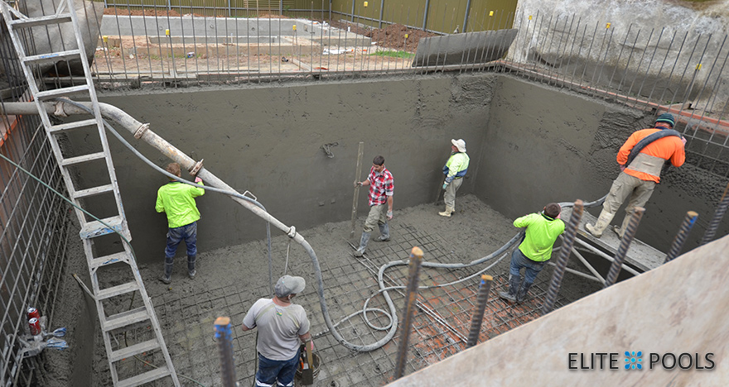

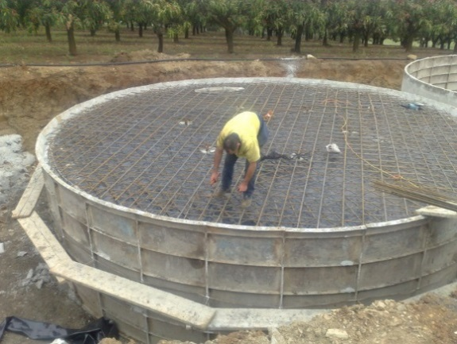

*Extract from Workplace OHS (based on NSW IRC File 1446 of 2008)*

A **State Government Public Works Department** worked closely with an external company to design and construct an **on-site water storage facility**. As workers began concreting the roof of a tower at the site, the underlying structure failed and collapsed, and the working deck fell into the reservoir. It was found that the department’s safety management systems were comprehensive "on paper" but had not been adequately implemented which resulted in the death of two contractors.

***Background***

During a visit to the site two months prior to the incident, the department's project manager, who was both trained and authorised to direct work being performed on the site by the external companies employees, directed one minor change to the structures support, but failed to identify other obvious high risk safety issues.

It was later noted that even a cursory examination of the site by an adequately trained officer should have been sufficient to halt work on the site long before this incident occurred.

The government department admitted to awarding the contract to the external company on the basis of price alone. It also confessed to a "widespread failure" to supervise the site, but said it was not responsible for the creation, provision or maintenance of the external companies system of work.

A construction worker and the external company’s director were killed. Three other workers standing on the deck suffered serious injuries.

The department was charged with, and pleaded guilty to, breaching their duty of care obligations. In an **Industrial Relations Court** decision, the presiding Justice found that the government department had failed to:

* undertake adequate safety inspections and safety audits (State requirement);
* ensure the scaffolding access tower and formwork were safe;
* ensure the formwork was properly certified before the concrete pour; and
* properly supervise, train and instruct its project manager/superintendent's representative.

**The department's response**

In an immediate response to the incident, the Department issued a circular introducing a new requirement to strengthen the safety management procedure. That circular drew attention to the high risk of the erection of concrete suspended slabs and that risk required a standard approach to be introduced for all project management group contacts. Following a review of the effectiveness of measures introduced in response to this incident, the Department held a full day workshop with its senior managers to discuss safety management and identify areas for improvement.

**System changes – A new program introduced**

In response the outcomes of the investigation and court proceedings, a new comprehensive programme was developed known as the **‘Construction Safety Improvement Programme’**. This Programme included changes in procedures, contract clauses and training for all Departmental staff. It also included a review of management responsibilities, reporting responsibilities and standard contract safety provisions and procedures to ensure they were appropriate and if necessary, improved

**Construction Safety Co-ordinators** were appointed to all regions and branches where they had not already been appointed and specialists were to undertake audits, inspections and provide training and support to project managers

**Safety networks and regular review meetings introduced**

A **Construction Safety Network** was established to meet monthly to allow sharing of information and enable staff to learn from the experiences of others

**Communication strategies**

The Department introduced an **intranet based project management programme** entitled **"The** **Roadmap"**, the Roadmap is able to be utilised by staff every day to effectively manage projects. Staff were provided with training in the use of the Roadmap and became an integral part of their induction process. The Roadmap was available at every site in state and enabled easy access by project managers to a wide range of safety information, including the project details. The Roadmap operated to required regular reviews during its four phases and, at particular stages, the project manager referred to documents and information that may be needed to manage the project.

**Management review**

A strengthening of the Department's management review (including the introduction of the **Deputy Director-General Safety Forum**) and commitment to safety leadership.

A substantial increase in the number of **Project Safety Advisors** employed by the Department. The employment of additional Project Safety Advisors was an outcome of the Construction Safety Improvement Program. The increase in the number of Project Safety Advisors means that at least one Project Safety Advisor is based in each office or branch.