Design and Implement a Interactive Application to be completed in Stages.

50% of unit grade– Small teams (3-4 students/team)
(25 pages max)

The assessment items have been designed to allow you to acquire and use the concepts in the unit to better understand your world - with an emphasis on the quality of design and implementation.

Please note that

- This is a group assignment, and you are required to work in a team of 3-4 members.
- The assignment has different stages, and you are required to deliver all of them on time within your team.
- You will submit this assignment as a group. All students will submit individual copies (replicas) of the group solution. Apart from the cover page (first page of each assessment as described in Lec-1), your solution will need to preceded by a peer-review form page, where you will (a) describe the contribution of each of your peers towards your group submission, and (b) provide a score (out of 10) for each peer based on their contribution with a brief justification.
- Please inform your tutor to put you in a group if you don’t have it yet, and if you have one make sure you have registered your group information on Canvas.
- You are required to take note of your team meetings and/or decisions you make and update your HCI project plan and submit this as part of deliverables.
- Read all four pages of this document carefully.

To effectively work in a group:

- Please make sure you have University contact details of your team member (such as University email address, not Facebook!)
- Plan and engage with your team to come up with a good report.
- Meet or contact them regularly, if needed, to discuss your concerns.
- Be committed to your group and add value to your teamwork.
- You’re responsible for your own team communications.
- Discuss your concerns with your team and/or tutor as early as possible to solve any issues.

The table below is a brief representation of your teamwork for this assignment:

Assessment |  | due (consult Canvas for exact deadline) | Grade
Conduct a design review |  | Week 7, Sun | 20%

Broad Scenario

You team will be the Interaction Design Team to analyse the 'human activity system' described below, and to design and implement a set of new interactions between the system's actors and technologies that will allow the system to function effectively considering Usability and UX. Please read the scenario details below carefully.

Drone Delivery System
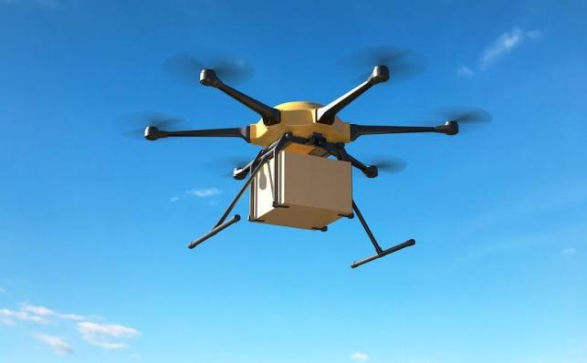
Source: https://www.radio.com/kluv/blogs/miles-in-the-morning/amazon-wins-approval-to-begin-delivering-packages-by-drone

We have faced the Covid pandemic, which has caused most of people’s day-to-day activities to go online. To proactively deal with such future situations, your task is to design a mobile application that supports drone pickup and delivery of items. In this mobile application design, you should consider all different users (actors) who might be involved in this system.

The aim is to provide information such as delivery and pick-up time, location, real-time delivery information and updates due to weather conditions, etc. (there are many more examples which the design team should identify them). The system should automatically identify your current location and send updates in-time. However, the user should also be able to edit the mobile app manually.

One major aspect of this drone pickup and delivery system should be human-interaction and engagement. Users should be able to easily navigate and use the system and find the required information. In addition, other users can provide updates such as time/date/location updates, etc.

Points to consider:
- How will this system efficiently enable the delivery and pick up of items during Covid situation? e.g. How can we protect people and keep them safe during the pandemic?
- How effective and efficient your interaction design will be? Why your design is the most interactive and effective one?
- What types of users and requirements should we consider?
- How does your design relate to IoT and smart environments?
- How would your design be different from other similar applications? and, why?
Final Deliverables

The breakdown of your teamwork assessment is as follows:

Stages |  | Due | Deliverables | Grade
Stage 1:  Design Review |  | Sunday 11:59pm,  Week 7 | - Description of at least three major (different use purpose) personas and their scenarios.  - Planning and identifying processes and techniques involved in designing the prototype (please list the steps you followed to design the prototype, some of which are be listed below).  - A detailed object and action analysis for at least one activity performed by each of the identified personas.  - Architecture and broad design of the complete system (using wireframes and storyboards for each persona and one navigation map for the overall system). | 20%

Submission Guidelines

This recommended page-limit for this assignment (over all three deliverables) is 25 pages, excluding references, diagrams, table of contents. A rough division would be Design Review (10 pages), Poster (3-4 pages) and Design Package Documentation (11 pages). Note that longer solutions may result in lower scores and assessors may not have time to read all your material. So, a thumb rule (or friendly recommendation) would be keep your solutions to-the-point and concise.

Please include an assignment cover sheet including Assessment Name, Tutor name and submitter name(s), and provide the word count.

To get a good mark, please consider the following:

- Write your answers as you are producing a professional report.
- Use clear headings for each part of your answer.
- Be innovative in your answers.
- Please be specific in your answers to each stage.
- Make sure your answers to each stage are consistent.
- Please make sure that you are aware of final deliverables in each stage and submit each stage on-time in Canvas.
- Ask any questions or concerns you have from your tutor/lecturer.
- Research and use principles of human-centred designing interactive systems and appropriately reference them.
- Refer to marking criteria to make sure that you have answered each part appropriately.
- Please use an appropriate referencing style.

