AERO 694: Advanced Space Materials & Structures

MID TERM 2023
(Take Home)

Question 1. Draw a comprehensive table of your topic (as given to you in the beginning of the course), in which compare different state-of-the-art technologies (materials) from the literature in terms of their performance, pros, cons, uses etc. You can come up with an innovative idea of representing this table in a different way than this, but it should provide a comprehensive comparison of different technologies (materials) related to your topic. You have explain (with citations) your table in no less than 1000 words.

Question 2. Draw Ashby Plot(s) with performance parameters of your topic. You can take one or more performance parameters and draw one or more Ashby plots on your topic. You need to explain your plot (with citations) in no less than 500 words.
Examples of Ashby Plots are shown below:
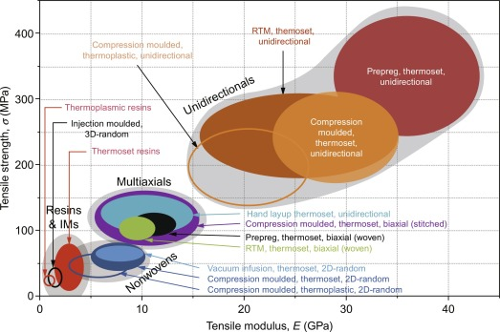

NOTE: You can replace an Ashby Diagram with another plot such as Spider Diagram

