SIT102 – Introduction to Programming

Answers for 1.1P Hello SIT102 & Hello World

Student Name:
Student ID:

Part A: Hello SIT102 section
Question 1: Paste the screenshot of your full mark result (8/8 = 100%) of Hello SIT102 (OnTrack 1.1P - Part A requirements) in the answer box.
- Guideline 1/2: The score for auto-mark sections will be available in unit site >> Assessment >> Quizzes in 1 – 2 minutes after your submission. Click the downward arrow next to the corresponding quiz item and select Submissions.
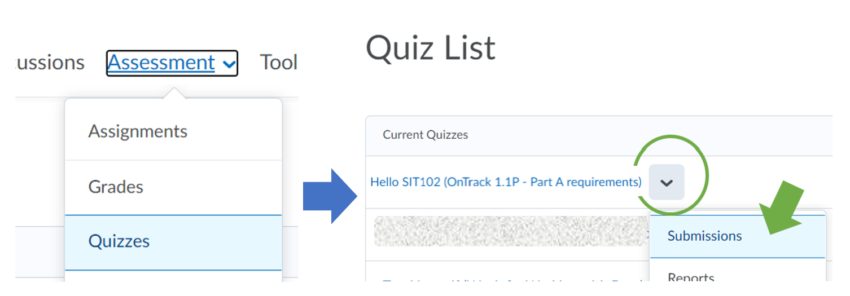
- Guideline 2/2: Then, you can reach this in the following page with your quiz’s auto-marked score.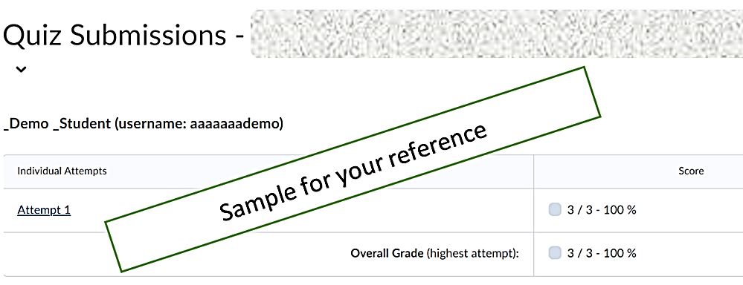

Paste your screenshot (with your name and score on it) here.
You have unlimited attempts for this Hello SIT102 quiz. Make sure you scored 100% in the quiz before you submit your screenshot here.

Question 2: [Set up your goal to achieve in this unit at the beginning would help you progress on the track] What grade are you going to aim for, and why? Share your reason(s) to us.

Part B: Hello World section

Question 3: Up to now, you should have gone through the week 1 pre-class and class materials as well as 1.1P tasksheet regarding the installation, the process and concepts for building a program, compilation and execution for a program.

Now, you are asked to build a new programming project with the following (source) file names. Given the program file named “sit102_code.cpp” and the expected output file “sit102_executable”.

- 3a: By providing a screenshot (Screenshot 1) of your Terminal screen, to demonstrate that you have worked out a correct command to compile the program successfully with the SplashKit library using the above-given information (parameters).

Put your Screenshot 1 here.

- 3b: To further demonstrate your understanding of the compilation command, you are now required to output a new executable with a new name where your student id is a part of it. Provide a screenshot (Screenshot 2) of your Terminal to show (i) your compilation command has worked and (ii) your executable has been successfully generated in your project folder by using a ls command.

Put your Screenshot 2 here.

Question 4: Which parameter in your compilation command in question 3 indicates a compiler? Explain what is the role of a compiler in a program creation process in 1 to 3 sentences.

-- End of questions (4) --

