# POLICY MEMO

**PROBLEMS**

1 – Launching electric scooters and cars is a great add-on to India’s automobile market. The skyrocketing fuel expenses are encouraging or forcing people to buy electric vehicles. But the recently reported accidents with regard to its usage are a big threat to human life. As a concerned citizen, draft a policy memo to the Ministry of Road Transport and Highways regarding the issue.

2 – Another concern you have as a citizen. Give an outline of the issue and then proceed.

**FORMAT**

1. 1 page of PESTEL (feasibility analysis)
2. 1 page of SWOT
3. 1 page of a policy memo

3+3=6 pages in total.

**Pestel model format and example**

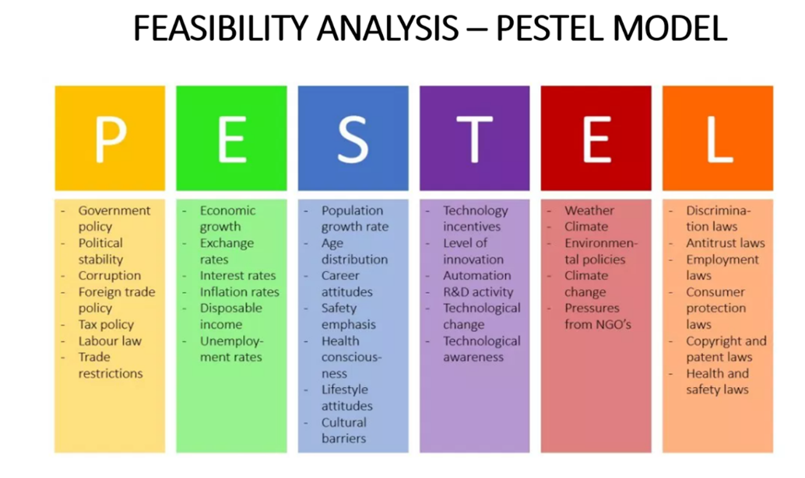

**SWOT ANALYSIS (an example)**

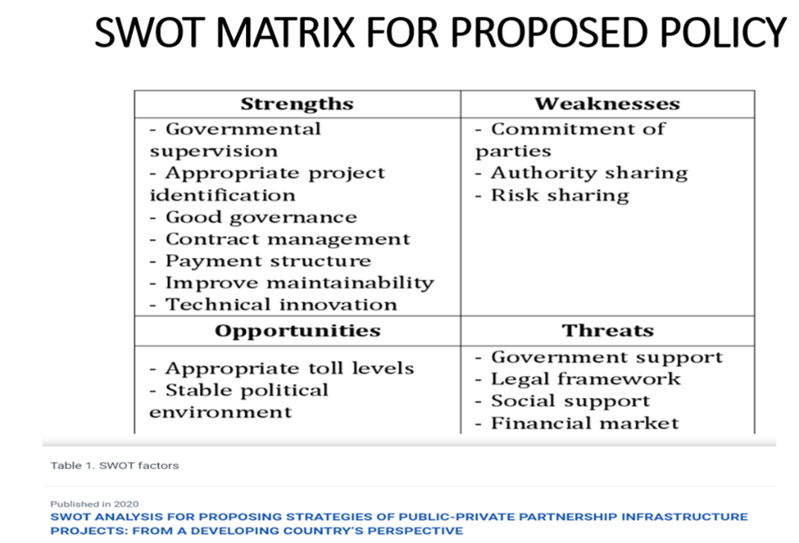

**POLICY MEMO FORMAT**

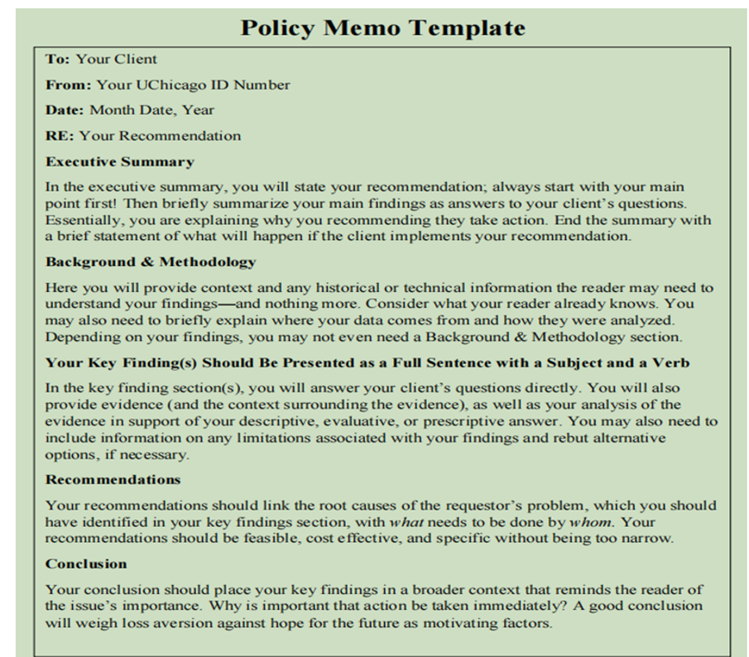

Two recommendations with evidence are enough

