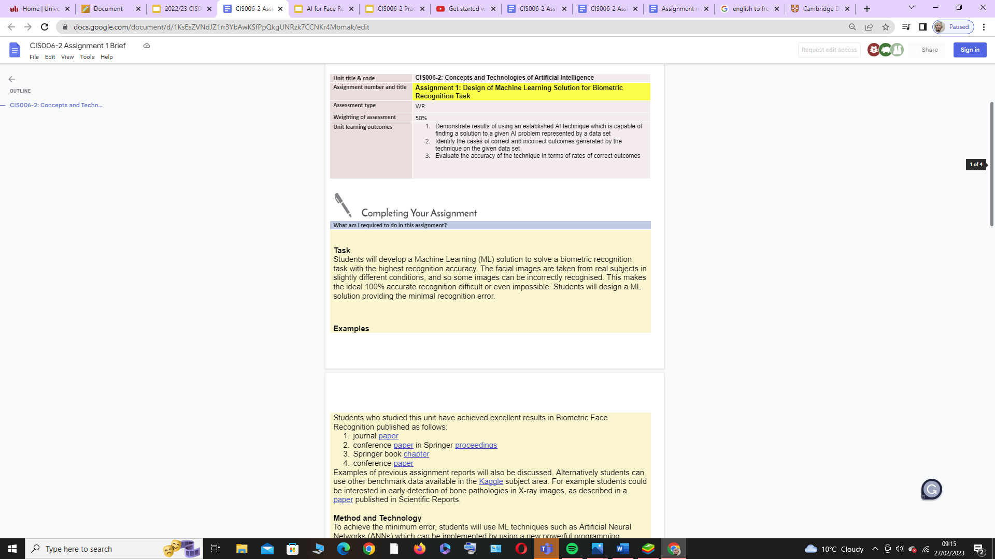

|  |
| --- |
| **1. Introduction**  {analyse solutions known from the literature which are related to the assignment task} |

|  |
| --- |
| **2. Designing a Solution**  {describe your design of solutions and how the assignment goals are achieved} |

|  |
| --- |
| **3. Experiments**  {describe your motivation for individual experiments, as discussed in tutorials} |

|  |
| --- |
| **4. Conclusions**  {analysis of the main results achieved in individual experiments, comparison results obtained in a group and/or with known from the literature} |

|  |
| --- |
| **5. References**  {literature sources cited in the [Harvard style](https://www.mendeley.com/guides/harvard-citation-guide)} |

