Different Layouts of Kitchen(Shape)

Every person has their big dream kitchen, where the love for cooking is exposed. But some are confused about choosing the best version that suits their house well. The Kitchen's luxuriousness depends on the size, shape of the house, and ability of the house owners. Some of them needed a costlier Kitchen, and some of them required a budget-friendly kitchen. So, according to your requirement, you can choose the shape of the kitchen that you need.

Depending on the shape of the layouts, there are 6 types of Kitchen. Here in this article, we describe the structures of modern kitchens we construct for convenience.

## 

## One Wall Kitchen

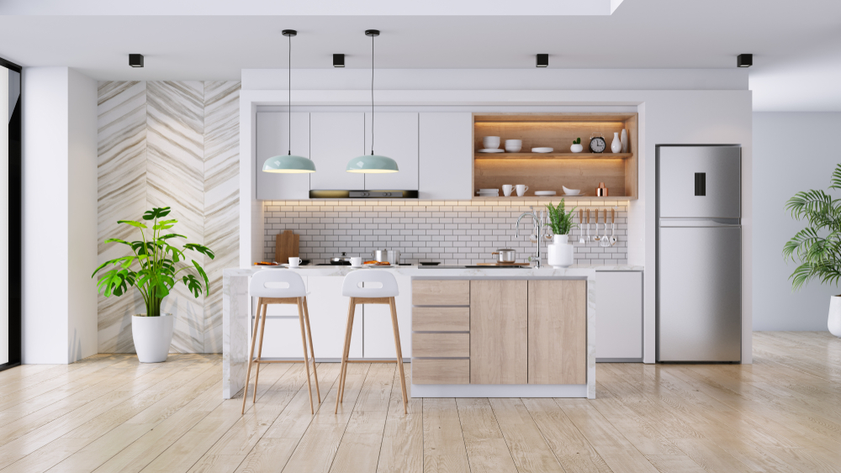

This kitchen layout is also known as a single-wall kitchen or In-line Kitchen. This kitchen shape or layout is found in smaller kitchens to save more floor space or workspace. Even if it reduces the costs, like to say budget-friendly, though this is a minor space work, it doesn't give up the Kitchen aesthetic, utility, and facility. Nowadays, modern kitchens are offered additionally with an island countertop which provides more workspace and strengthens the theme of your kitchen look.

Every layout has its pros and cons, the same way, this layout doesn't provide extra space, so you have to cook and clean up in a single area. But this layout boosts your efficiency substantially with a good workflow.

### Installation tips

Since you don't have much space, you can install cabinets and shelves on one wall. Keep often used items on lower shelves and rarely used items on upper shelves. Install the refrigerator on one end and sink to the other end. You can keep hobs or a stove or range in the middle space.

## 

## Galley Kitchen

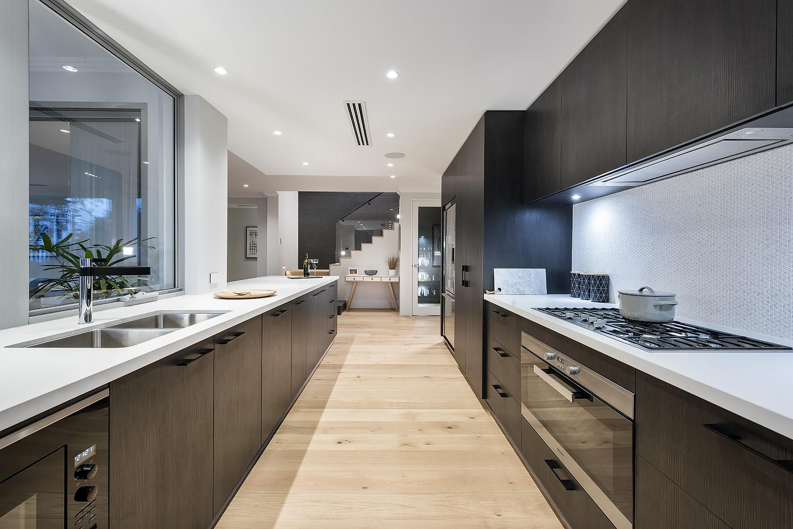

The galley is a type of kitchen layout with more flexibility in terms of storage space. Two rows of cabinets face each other with no wastage of the area, which offers a more efficient workspace. It is a narrow, comprehensive kitchen layout with a central walkway or a galley. These layouts are more efficient and compact, and cost-friendly as well. Since galley kitchens provide two rows of space in one kitchen, multiple cooks can do their business without the risk of any injuries, even in prominent families.

### Installation tips

A kitchen work triangle can be applied here, as it eliminates the need for corner cupboards which provides more space. Place the refrigerator, sinks, and cabinetry in the countertop space—the stove or oven, or range in the opposite row.

## The L-shaped Kitchen

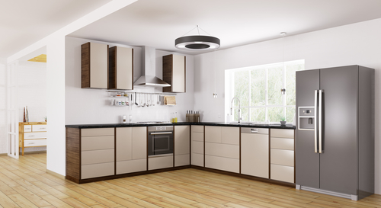

The best layout for both small and large kitchens offers two adjacent walls, a more suitable and efficient kitchen layout for modern homes, and open plan designs. If you are planning to make an open kitchen with this layout, you will get great flexibility in the placement of appliances, ample workspace, and a good looking Kitchen.

### Installation tips

While installing, apply the kitchen work triangle method, suitable and required distances between the sink, stove, and refrigerator. If you are thinking about dealing with corners since they lose some workspace, you can solve that problem by installing a walk-in pantry cupboard. This cupboard saves your corner space and turns this into a massive asset to your Kitchen.

## 

## 

## 

## 

## 

## 

## 

## 

## 

## The U- shaped Kitchen

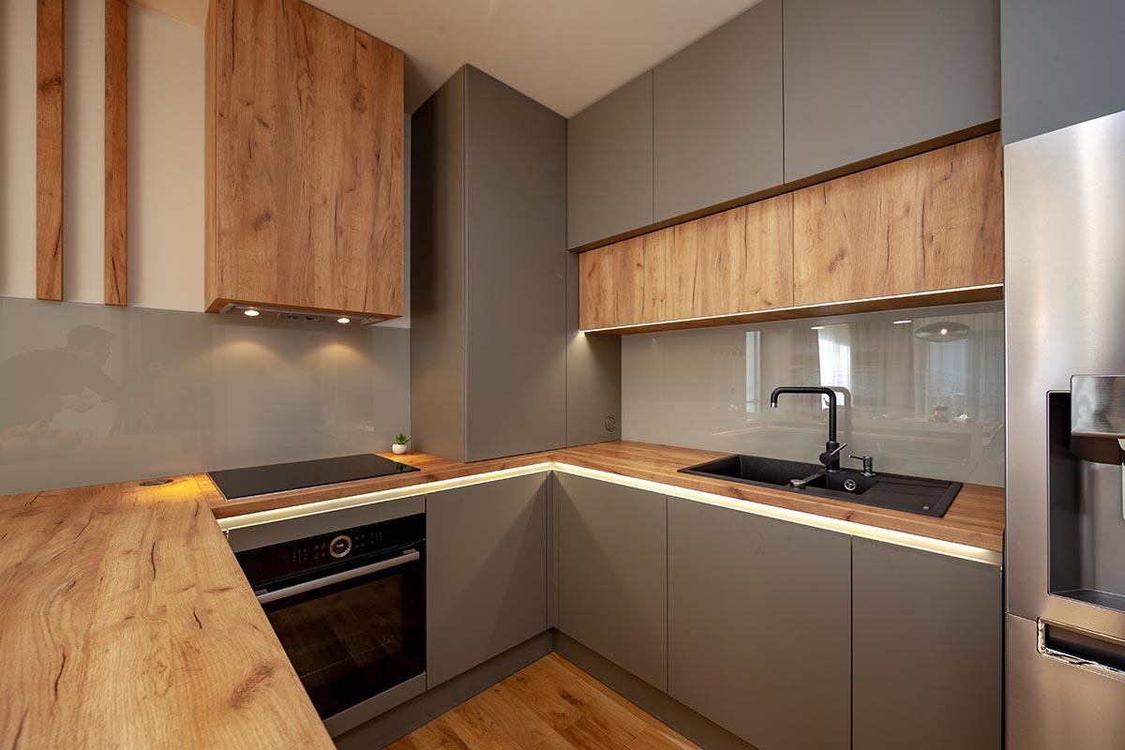

A great kitchen layout with three adjacent walls is great for a bigger house and a more prominent family. This layout allows for great workflow and multi-users at a time, is the most efficient kitchen layout, and offers the perfect setup for a work triangle. If you create a benchtop in U-layout, it separates the work area from the kitchen and allows guests to chat while cooking.

### Installation tips

Easy installation by keeping the window area open gives a tidy and luxurious look, and don't install cabinets on all three walls because it makes you feel enclosed and has a clumsy look. So to prevent this, install cabinets only in two of them. You can quickly shift between refrigerators, sinks, and ovens.

## 

## 

## 

## 

## 

## 

## 

## 

## The G -shaped Kitchen

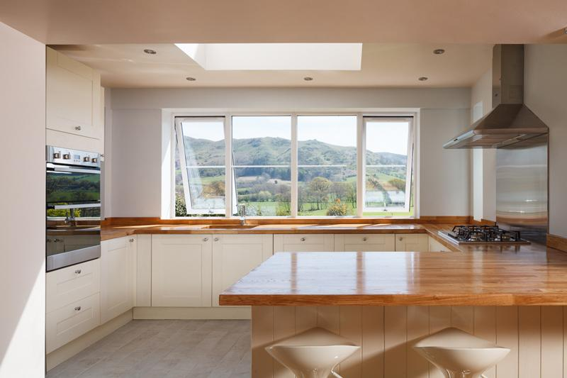

As the name indicates, this layout is G in shape. This kitchen layout is also known as the peninsula kitchen. It has three adjacent walls, which are similar to the U-shaped kitchen layout but with the addition of a countertop or a dining space just out from the fourth wall or cabinetry.

### Installation tips

This counter space or dining space or peninsula can be used for food preparation and eating while the cook is busy cooking. This layout provides more storage space, including a dishwasher. If you need more privacy, you can close the peninsula part of the Kitchen. It offers sufficient and efficient space for multi-cooks simultaneously, avoiding injuries.

## 

## 

## 

## 

## 

## Island Kitchen

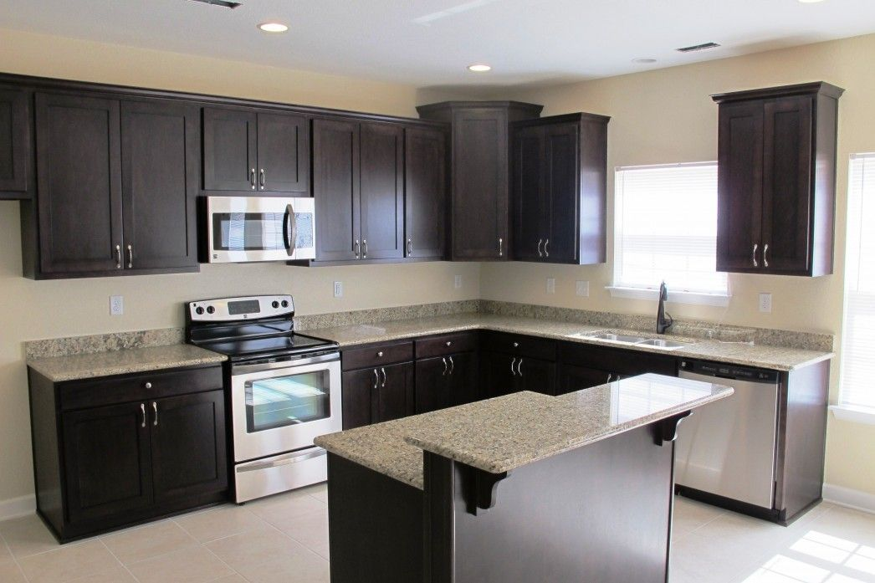

We are well verse with the word 'island,' which means the land will be in the center and surrounded by water. In the same way, the countertop or dining space is located in the center and surrounded by the adjacent walls. It is most useful for a bigger and open kitchen. The Kitchen has to be big to incorporate an island to create a natural traffic flow in the area. The island placement is a great way.

### Installation tips

We can use the center part of the layout, i.e., the island part of the dining space where guests or friends can interact while the meal has been prepared. Since it has three adjacent walls, it offers more flexibility and storage space.

### Conclusion

Finally, after this long discussion, we can say that we have many choices to make our dream kitchen good in shape and successful according to our requirements.