Best Hot Tub for Cold Weather

Hot tubs are useful during cold weather, but we get confused and we question ourselves which is the best hot tub to buy during cold weather. Let’s have a look at those characteristics that we should check while purchasing a hot tub which is the best for cold conditions.

The characteristics of the hot tub are

* Insulation
* Energy efficiency
* Adjustable vents
* Cover

## 1. Coleman SaluSpa Inflatable Hot Tub

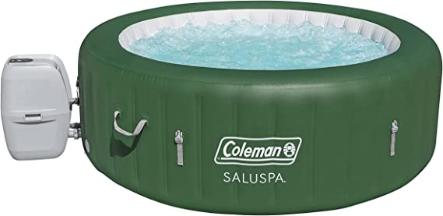

* One of the best hot tubs for cold climates provides a warm, comfortable, and relaxing bath.
* You can share a comfortable, and luxurious relaxation bath with at least four-six people at a time.
* This spa has a built-in heater that maintains the temperature as low as 20 degrees Fahrenheit.
* This hot tub has a built-in filter to keep the water clean.
* This hot tub has an additional feature that makes it a brilliant standout from other hot tubs. This hot tub provides 140 bubble jets that release bubbles for massage purposes which enhances a hot environment.
* A reinforced cover that is present in this hot tub locks the heat while not in use, along with this it keeps the dust and debris from collecting on water.
* One more unique feature, this hot tub offers an easy setup with a digital control panel- which can control preferable temperature and pressure, and also with a timer that can preserve the temperature for 3 days.
* This hot tub offers less space for storage, easy installation, timer function, temperature control, and simple setup.

## 2. Essential Hot Tubs 67- Jets

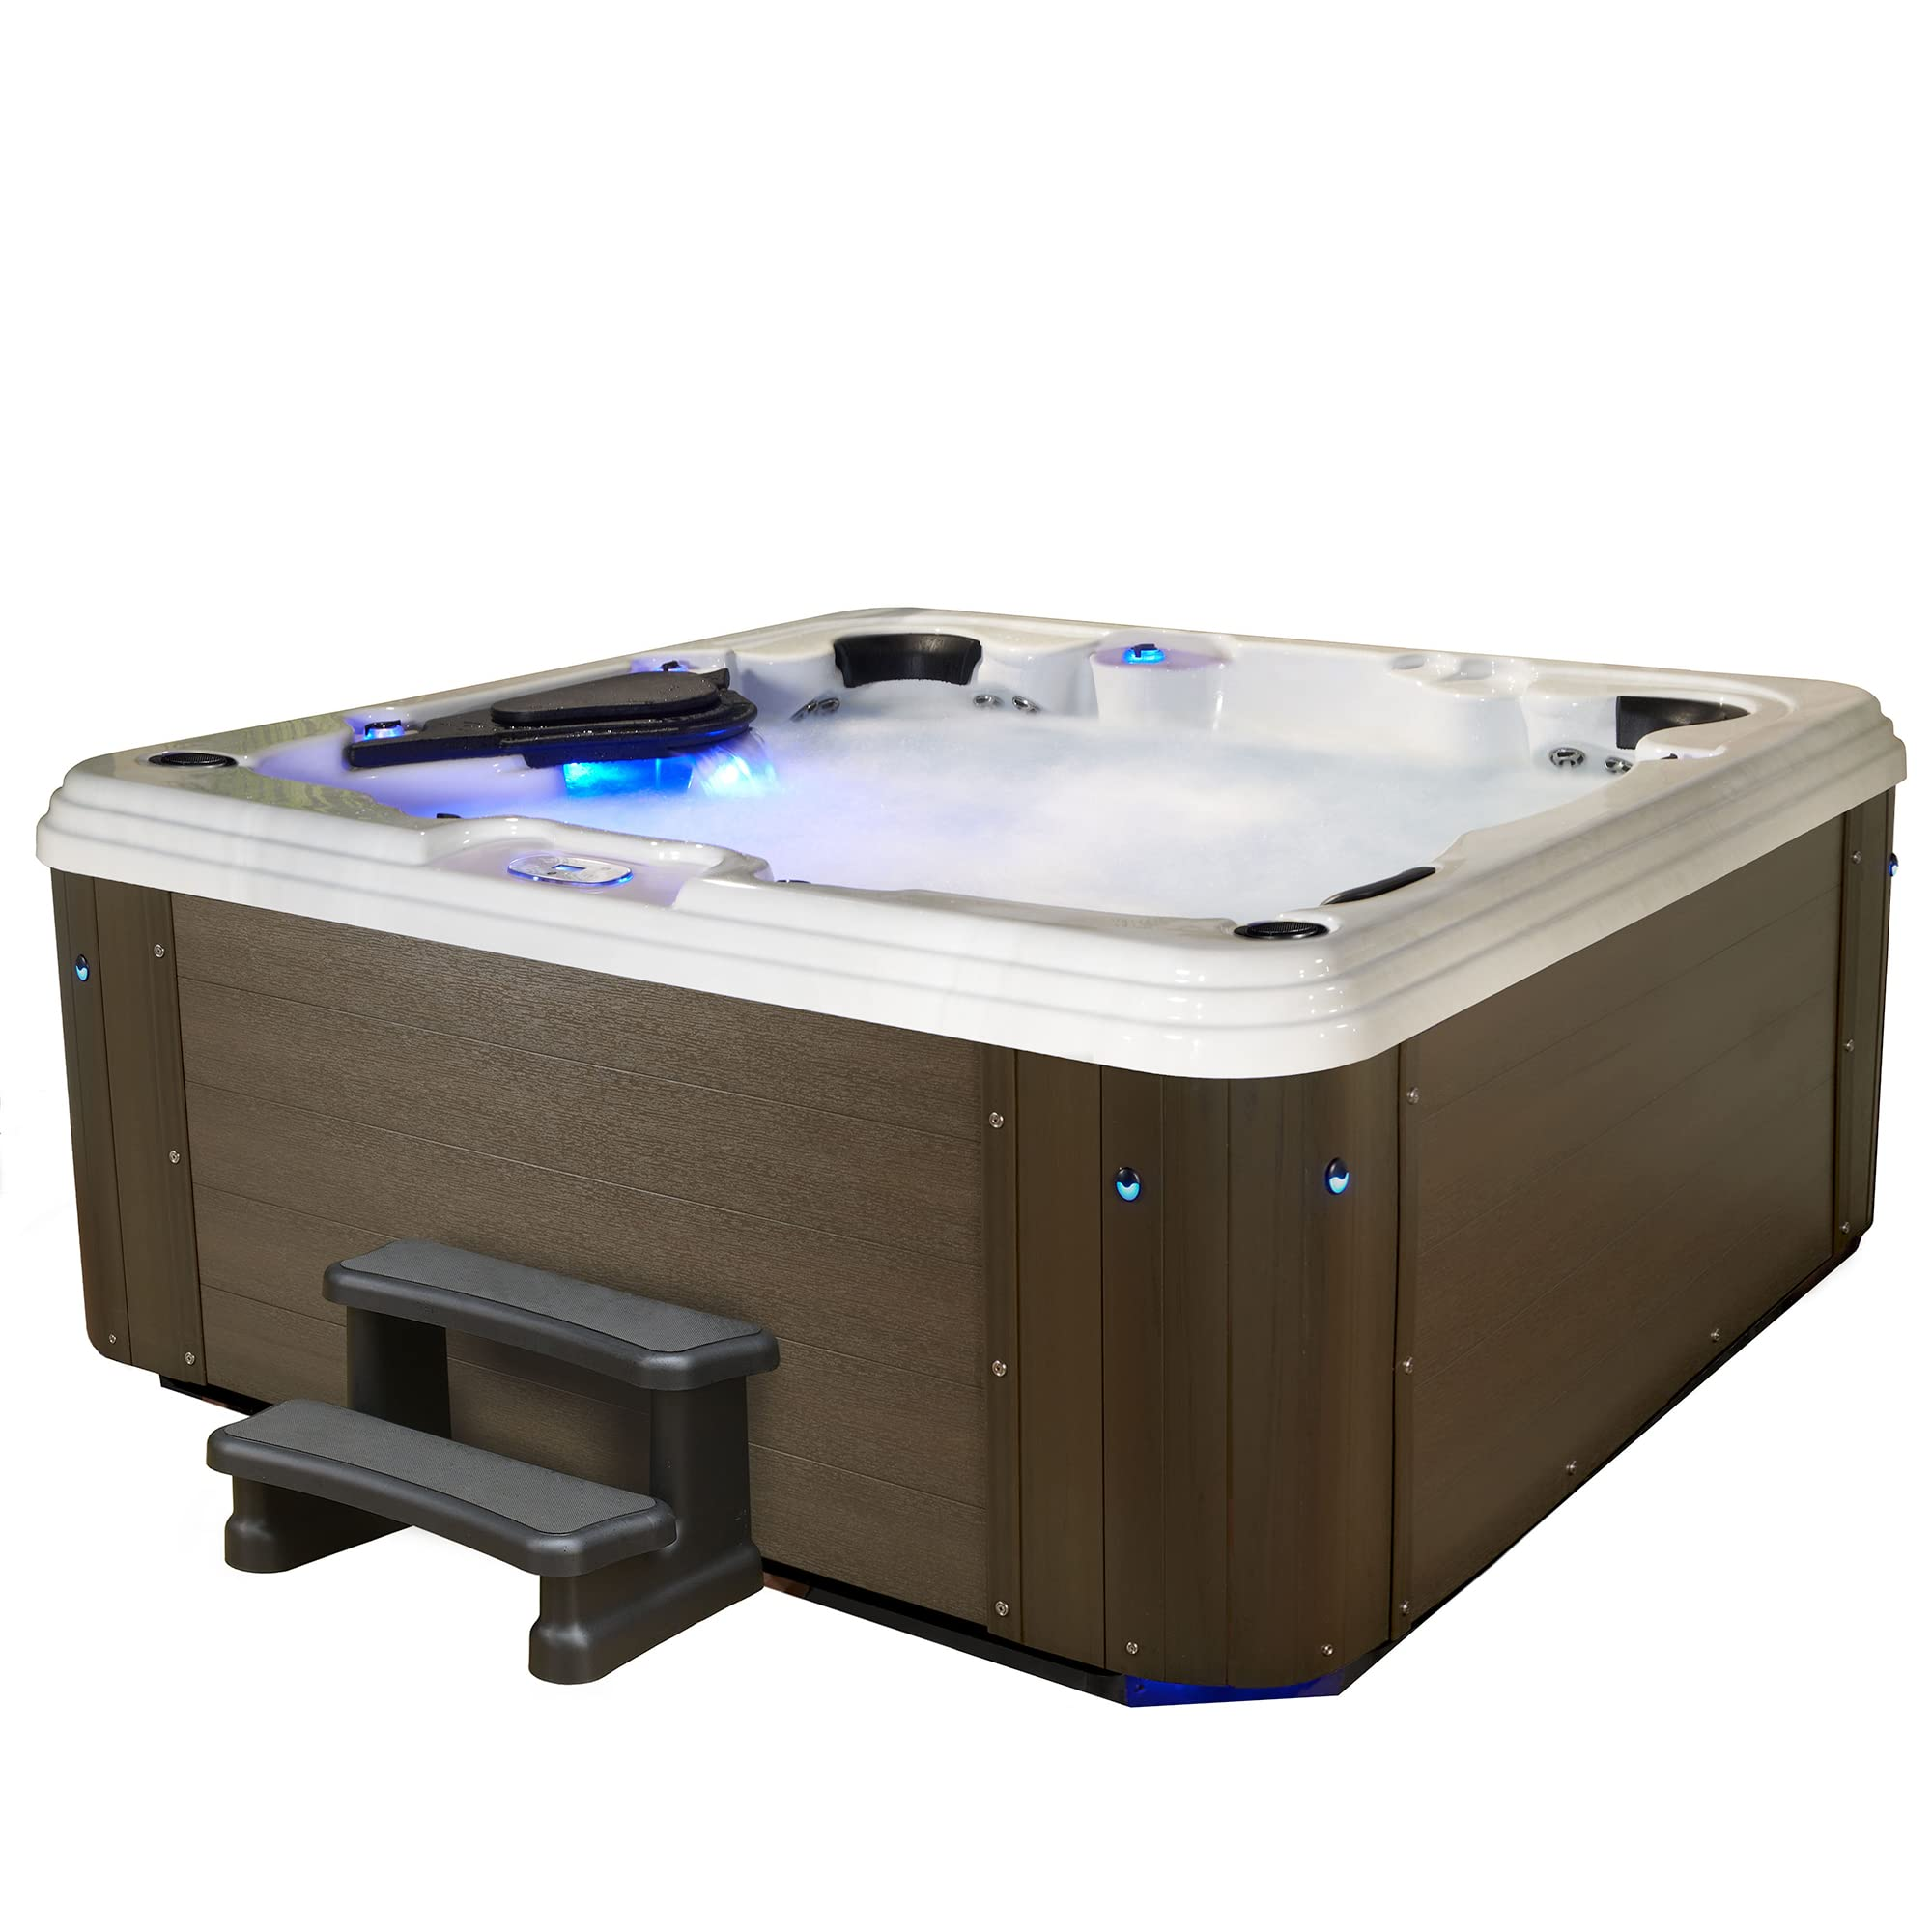

* These Essentials have a wide range of spa options that you can choose according to your budget. This essential brand hot tub main factory is situated in Pennsylvania, USA.
* These hot tubs are built with good quality and durable materials with quality components that every customer looks for.
* This hot tub gives you a rigorous massage switching from soft passive massage using these 50 adjustable powerful stainless-steel jets. During massaging, the heat gets enhanced and rises the temperature of the water to resist the cold temperature.
* You can share a luxurious relaxation with your friends and family, whereas it offers you lounge seats that can accommodate 6 persons at a time.
* It also has 100 - a total water jet stream, a Bluetooth sound system, LED lights are there for underwater color-changing, 400-gallon capacity, a waterfall, a controllable panel, and a comfortable headrest.

## 3. Aleko 2-Person Oval Inflatable High-Powered Bubble Jetted Hot Tub

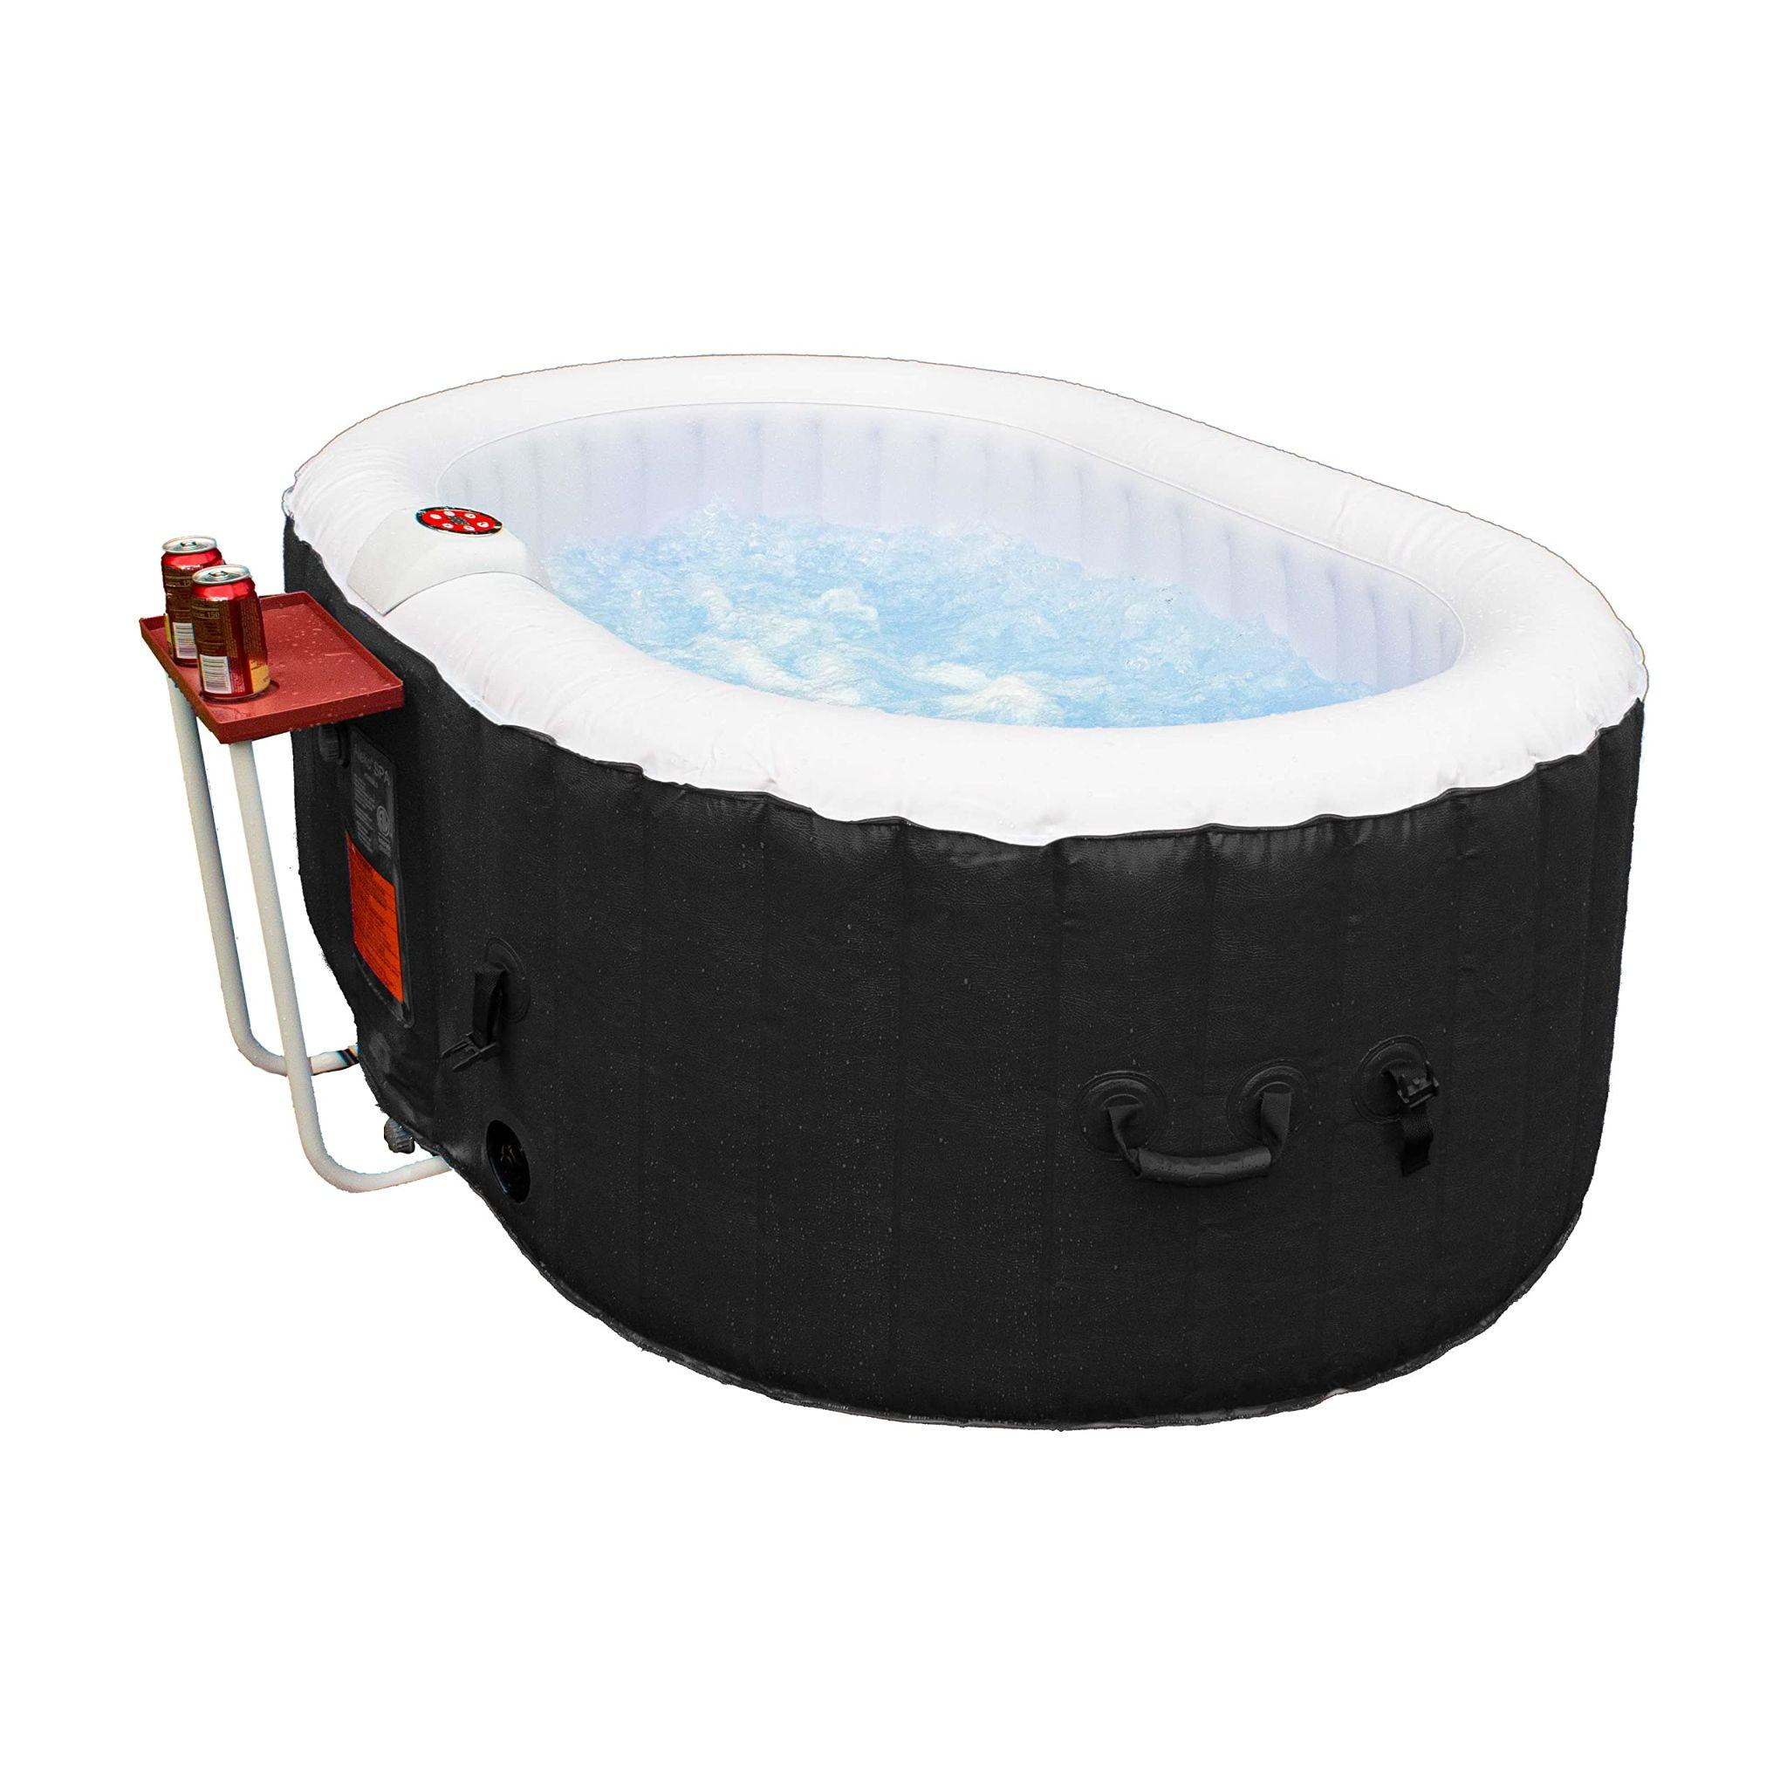

* As the name indicates, this hot tub is specially made for 2 adult persons. Because of its small size, it offers easy maintenance.
* It has a double comfortable and barrier-free seat, also this hot tub is known for its durability due to its tough highly resistant polyethylene shell.
* It has an attractive shape that one who makes it turn around, as well as it, has 145 gallons of water capacity.
* It has an in-built filter to keep the water clean, and ozone purification systems.
* Features 100-130 high-powered bubble jets, a 1200-watt heater, efficient heat recovery system.

## 4. Intex PureSpa Inflatable Spa

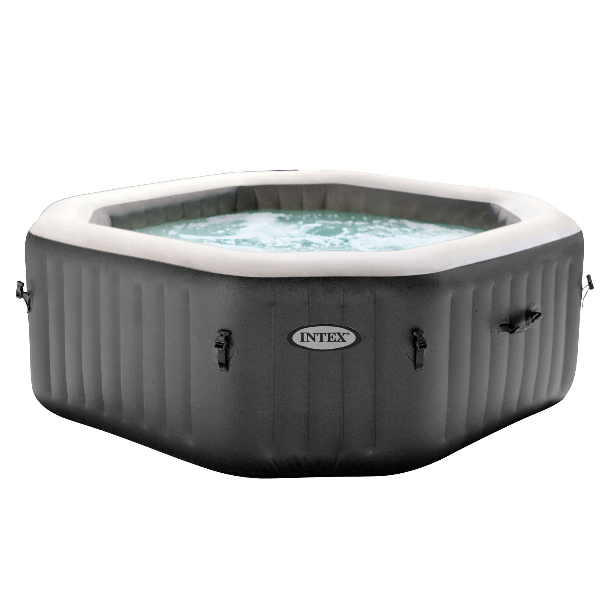

* This hot tub looks out to be a great option for buyers because of its features like its insulated cover is a highly resistant three-ply laminated inflatable wall made up of high-quality traditional vinyl.
* This hot tub has a 290-water gallon capacity, along with 140 powerful bubble jets to give a good massage and a preferable amount of warmth. Comfortable for 6 adult persons to enjoy the warmth.
* This hot tub comes with two replaceable filter cartridges and is used to remove dirt particles from the tub.
* This in-built water filtration system gives you great water quality by filtering often and on.

* This hot tub offers a floating chlorine dispenser that disinfects the spa
* Consists of a carry bag for easy storage and transportation.
* A heating system to control the temperature for the one preferable.

## 5. Bestway SaluSpa Helsinki AirJet Inflatable Hot Tub

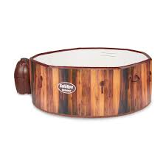

* It soothes the mind and gives uttermost relaxation to the body, using a 180-air bubble jet system that releases the bubbles from the bottom of the hot tub.
* The space of the hot tub is broad and can accommodate 5-7 people with easy set-up and maintenance.
* This hot tub protects the inner components from damage by automatically turning the heater on using a frozen shield when the temperature is very low.

* It also has a ground cloth, cover, and a chemical dispenser.

## Conclusion

The hot tubs that we discussed above are the best hot tubs for cold weather, where we solve questions and confusion about how to choose the best one. We can choose the best hot tub according to our requirements and budget.